ONR Project assessment report
PR-01695 - Mk A2 AGR Flask (Design No. 2834) Assessment of Modification N0270 – Increased graphite weight loss safety case adjustments


ONR Project Assessment Report
Project name: PR-01695 Mk A2 AGR Transport Flask (Design No. 2834)
Report title: Assessment of Modification N0270 – Increased graphite weight loss safety case adjustments

Dutyholder/Applicant: EDF Energy Nuclear Generation Limited
Authored by:
Report issue no.: 1
Publication date: Sept-2026
Document ID: ONRW-2019369590-30053

Circulation list (latest issue)
Organisation | Recipient | Date report sent

© Office for Nuclear Regulation, 2026
For published documents, the electronic copy on the ONR website remains the most current publicly available version and copying or printing renders this document uncontrolled. If you wish to reuse this information visit www.onr.org.uk/copyright for details.

Executive summary
This report presents the findings of the ONR assessment of Modification N0270 for the Mk A2 AGR transport flask, Design No. 2834 that was submitted by EDF Energy Nuclear Generation Limited. The modification extends the allowable graphite weight loss from 30% to 45%, reflecting updated graphite weight loss predictions associated with plant life extension and enabling continued operation of AGR stations to end of generation.
EDF has submitted Modification N0270 as a Category A modification in line with ONR guidance and processes. The application concerns the following extant certificates:
- GB/2834A/B(M)F (expires 30/09/2027)
- GB/2834B/B(M)F (expires 30/09/2027)
- GB/2834C/B(M)F (expires 30/09/2027)
In line with the agreed permissioning strategy, ONR has undertaken a proportionate and targeted assessment, focussing on the criticality and shielding implications of increased graphite weight loss for AGR fuel transported in the Mk A2 AGR flask. The assessment has considered the applicant’s claims, arguments and evidence to confirm compliance with ADR and RID requirements, as implemented in UK law, including statutory external dose rate limits. No mechanical engineering or human factors assessment was considered necessary because the modification introduces no changes to the physical package design or operational arrangements.
Based on the work carried out by ONR, it is concluded that the applicant’s safety case and the package design comply with the applicable transport regulations.
It is recommended that ONR’s Head of Regulation for the GB Transport Competent Authority:
- accepts this report to confirm support for the ONR technical and regulatory arguments that justify granting competent authority approval of the requested Modification N0270; and
- grants approval of the modification by signing the competent authority approval section of the applicant’s modification sheet, Modification Number N0270.

Table 1: List of abbreviations.
Term/Acronym | Description
ADR | Agreement concerning the International Carriage of Dangerous Goods by Road
AGR | Advanced Gas-cooled Reactor
CA | Competent Authority
DA | Design Authority
EDF | EDF Energy Nuclear Generation Limited
GB | Great Britain
GWL | Graphite Weight Loss
HPB | Hinkley Point B
IAEA | International Atomic Energy Agency
INA | Independent Nuclear Assurance
ODV | Optimum Differential Voidage
ONR | Office for Nuclear Regulation
PAR | Project Assessment Report
PDSR | Package Design Safety Report
POMM | Package Operation and Maintenance Manual
RID | Regulations concerning the International Carriage of Dangerous Goods by Rail
RQ | Regulatory Query
SSR-6 | Regulations for the Safe Transport of Radioactive Material (IAEA SSR-6)
TCA | Transport Competent Authority
UK | United Kingdom
WIReD | ONR’s Well-Informed Regulatory Decisions system

Table of contents
Executive summary 3
1. Permission requested 6
2. Background 6
2.1. EDF’s application 6
2.2. Overview of Package Design 7
2.3. Regulatory history 8
2.4. Purpose and Scope of Modification 9
3. Assessment and inspection work carried out by ONR in consideration of this request 10
3.1. Regulatory permissioning strategy 10
3.2. Criticality & Radiation Shielding assessment 11
3.2.1. Graphite weight loss 11
3.2.2. Shielding assessment 11
3.2.3. Criticality assessment 11
3.2.4. Conclusion 12
4. Matters arising from ONR’s work 12
5. Conclusions 12
6. Recommendations 12
References 14

Permission requested
- EDF Energy Nuclear Generation Limited (the applicant) has applied (ref. [1]) to the Office for Nuclear Regulation (ONR) as the Great Britain (GB) competent authority (CA) for approval of Modification N0270 to the Mk A2 AGR transport flask, Design No. 2834.
- This Project Assessment Report (PAR) presents the basis of our regulatory decision regarding the application for Modification N0270. This modification has been assigned permissioning ID PR-01695 in ONR’s Well-Informed Regulatory Decisions (WIReD) system.

Background

EDF’s application
- The applicant has submitted Modification N0270 (ref. [1]) as a Category A modification to the Mk A2 AGR flask package design. The modification seeks to extend the maximum approved graphite weight loss (GWL) limit from 30% to 45%, providing coverage for AGR station operations through to end of generation.
- The change is driven by revised GWL predictions associated with plant life extension. Increasing GWL hardens the in-core neutron spectrum. This increases the radiological inventory of irradiated fuel and associated gamma and neutron source terms for a given burnup. The modification therefore updates the radiological inventory assumptions, supporting data and methodologies used within the Package Design Safety Report (PDSR) (ref. [2]).
- During the 2022 renewal (ref. [3]) of the Mk A2 AGR flask package design approval, the PDSR was updated to support transport of AGR fuel irradiated in reactor cores with up to 30% GWL. ONR concluded that the package design satisfied the relevant statutory dose rate limits under all conditions of transport at this limit. However, GWL continues to progress across the AGR fleet and the current 30% limit is forecast to be exceeded by the lead station, Hartlepool, before renewal of the package design approval in 2027.
- As the proposal introduces a revised radiological inventory and requires updates to the package safety case, the applicant has categorised Modification N0270 as a Category A modification, consistent with ONR's modification categorisation process.
- The application concerns the following extant certificates (see RQ-02633 (ref. [4])):
- GB/2834A/B(M)F expires 30/09/2027
- GB/2834B/B(M)F expires 30/09/2027
- GB/2834C/B(M)F expires 30/09/2027
- EDF Application for Modification N0270 was supported by several documents including:
- The “Modification Sheet” for Modification N0270 signed by EDF’s Mk A2 AGR transport flask Design Authority (DA) and EDF’s Independent Nuclear Assurance (INA) function (ref. [5]).
- The INA Approval Certificate for Modification N0270 (ref. [6]).
- The applicant has been forward-looking at the 2025 edition of SSR-6 and has taken the opportunity to update related elements of the case (ref. [5]) including:
- An updated pond water inventory
- Confirmation that a future update of the A₂ values with SSR-6 will not result in non-compliance with the requirements of the regulations.
- Confirmation that the decay heat is being assessed taking the latest GWL data into account.

Overview of Package Design
- The Mk A2 AGR flask (Design No. 2834) is designed for the transport of irradiated Advanced Gas-cooled Reactor (AGR) fuel and other components between the applicant’s AGR nuclear power stations and the Sellafield licensed site for storage and reprocessing, as well as transport of fuel assembly tie-bars and other non-fissile components. The Mk A2 flask is categorised as a Type B package.
- The package design comprises a forged carbon steel flask body with attached external cooling fins, a flask lid assembly and an internal stainless steel skip (of two different designs) carrying the radioactive contents.
- The package design has five variants (only A, B & C are affected by this application):
- ‘A’ - unbottled AGR fuel elements in a 15-compartment skip;
- ‘B’ - bottled AGR fuel elements in an 8-compartment skip;
- ‘C’ - loose AGR fuel pins in slotted cans or whole/part pins, pellets and powders in debris capsules within slotted cans in an 8-compartment skip;
- ‘D’ - discharged flask; and
- 'E' - non-fissile components, e.g. irradiated tie-bars.
- Details of the package design are provided in the PDSR (ref. [2]) and the engineering drawings. The ‘A’ variant package design is shown in Figure 1 below.
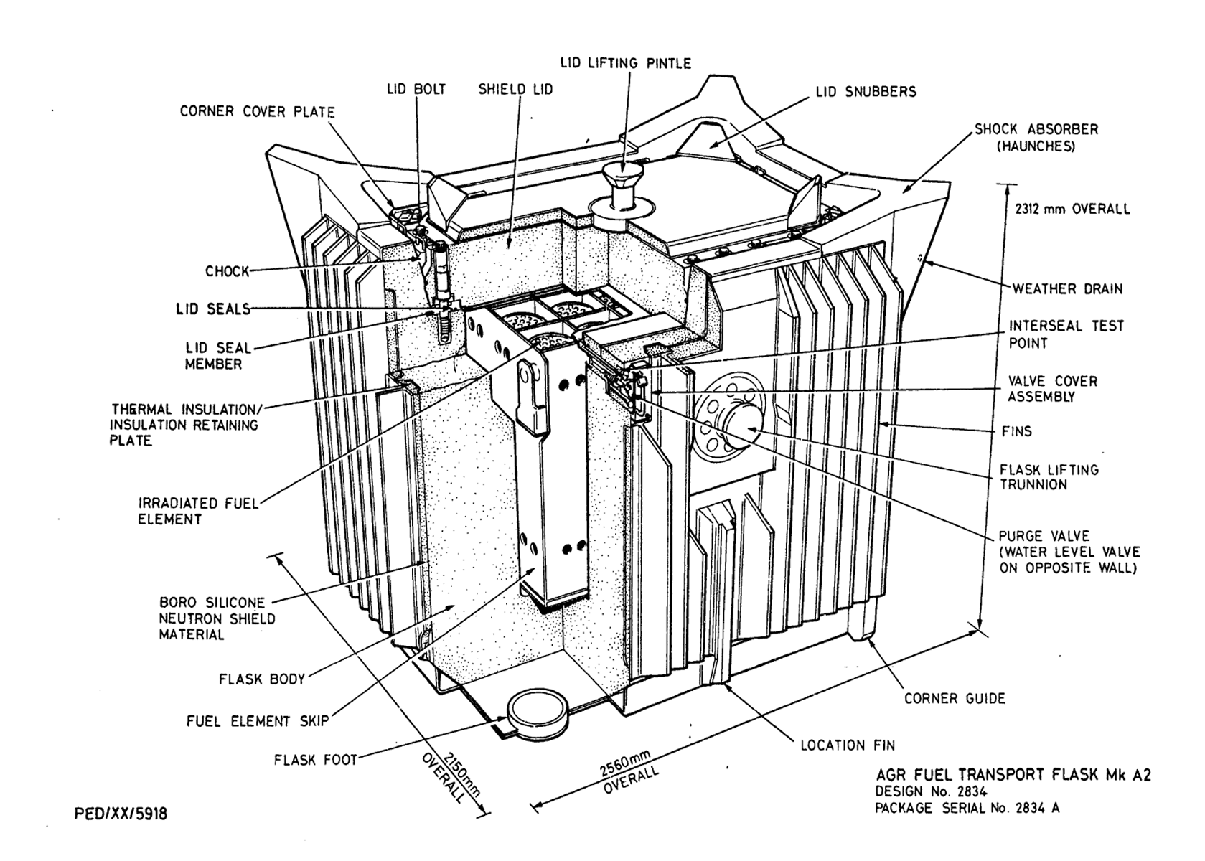
Figure 1: Mk A2 AGR Flask (Design No. 2834), A Variant Configuration

Regulatory history
- The last renewal of the GB/2834 package design approval was completed in 2022 (‘A’, ‘B’, ‘D’ & ‘E’ variants) (ref. [3]) and 2024 (‘C’ variant) (ref. [7]). Based on our assessment, we granted package design and shipment approval for the ‘A’, ‘B’, ‘C’, ‘D’ and ‘E’ package variants for transport by road and rail in the United Kingdom (UK).
- There is an extensive regulatory history associated with the Mk A2 Irradiated Fuel Flask (Design No. 2834). This includes a number of Category A to C modifications that have an impact on the Mk A2 packages, or specific flasks, flask lids, or flask furniture.
- The records identified below are limited to those with direct relevance to this modification:
- PR-01211 – Category A modification N0251 (Phase 1): sought endorsement of the ‘C’ variant for use by road and rail and an extension of the maintenance periodicity from four to five years. Phase 1 was limited to the maintenance extension – November 2023.
- PR-01479 – Category A modification N0251 (Phase 2): addressed the remaining scope, including approvals for the ‘C’, ‘D’ and ‘E’ package variants – September 2024.
- PR-01937 – Category B modification N0287: alignment of Package Design Safety Report (PDSR) and Package Operation and Maintenance Manual (POMM) – July 2025.
- PR-01204 – Category A modification N0248: permitted the transport of spent fuel from Hinkley Point B (HPB) to Sellafield – November 2025.
- PR-01212 – Category B modification N0221: for damaged fuel from Dungeness B – June 2026.

Purpose and Scope of Modification
- The purpose of Modification N0270 is to update the Mk A2 AGR flask safety case to support the transport of AGR fuel irradiated in reactor cores with GWL of up to 45%. The modification includes revisions to the Package Design Safety Report (PDSR) (ref. [2]), a new shielding assessment for the Mk A2 AGR flask (ref. [8]) and updated activity release assessments (ref. [9]) reflecting revised radiological inventory assumptions resulting from increased GWL predictions across the AGR fleet.
- The modification does not alter the physical design, manufacture or operation of the flask, nor does it change the approved package contents in terms of fuel elements, fuel pins or water inventory. Rather, it updates the underpinning safety analyses and supporting evidence used to demonstrate compliance with the applicable transport regulations and statutory dose rate limits.
- Although no physical changes are proposed to the package design, the modification revises key safety case analyses that underpin approved package performance and therefore requires CA approval in line with ONR guidance.
- As the proposal introduces changes to the package safety case through revisions to the PDSR (ref. [2]) and associated supporting assessments (ref. [8] [9]), the applicant has classified Modification N0270 as a Category A modification. This classification is consistent with the licensee's arrangements for the control of modifications and ONR guidance on the categorisation of modifications requiring approval by the Competent Authority (ref. [10]).

Assessment and inspection work carried out by ONR in consideration of this request

Regulatory permissioning strategy
- In accordance with the approved regulatory permissioning strategy, we have carried out a targeted and proportionate assessment of the applicant’s proposed modification against the existing approved baseline. As the change relates solely to the authorised contents and does not alter the package design, the assessment scope was limited to criticality and radiation shielding. Mechanical Engineering and Human Factors specialists confirmed that assessments within their disciplines were not required for this application (ref. [11] [12]).
- Accordingly, ONR undertook a targeted assessment by a Criticality and Shielding Specialist Inspector (ref. [13]). The agreed assessment scope, endorsed by the Head of Profession, was to confirm that transport of AGR fuel irradiated in a core with up to 45% GWL in the Mk A2 AGR flask remains compliant with the requirements of ADR and RID, as implemented in UK legislation.
- The Transport Competent Authority (TCA) has committed to undertake an inspection of the applicant’s management system under ONR permissioning ID PR-01936. In the context of this modification (PR-01695), it is considered that additional inspection activity would not provide additional regulatory confidence, given the limited scope of the modification and the absence of any changes to the physical package design or its operational use.
- The permissioning of this modification is therefore appropriately supported through targeted assessment of the applicant’s safety case, without the need for supplementary inspection.

Criticality & Radiation Shielding assessment
- Our assessor undertook a targeted assessment of the applicant's proposal to increase the bounding GWL assumed in the Mk A2 AGR flask safety case from 30% to 45%. The assessment focused on those aspects of the safety case affected by increased GWL and did not revisit areas that had been comprehensively assessed during the 2022 package approval renewal.

Graphite weight loss
- GWL is an expected consequence of long-term reactor operation and affects the characteristics of irradiated fuel. The applicant demonstrated that a bounding assumption of 45% GWL is required to cover conditions that may arise during the remaining operational lifetime of the AGR fleet. Our assessor reviewed the applicant's assessment of the effect of increased GWL on fuel radiation sources and confirmed that, while neutron radiation levels increase as GWL increases, the impact on gamma radiation remains limited.

Shielding assessment
- The applicant's updated shielding assessment, including revised radiation source terms representing fuel irradiated in reactors with up to 45% GWL was reviewed by our assessor. The assessment identified an increase in neutron source strength of approximately 50-60% relative to the original zero GWL assumptions. Notwithstanding this increase, the package continues to satisfy all applicable statutory dose rate limits. The limiting routine transport dose rate was calculated as 1.17 mSv/h at the package surface, compared to the applicable limit of 2 mSv/h. For accident conditions of transport, the limiting dose rate at 1 m above the flask lid was calculated as 8.66 mSv/h, compared to the applicable limit of 10 mSv/h. Our assessor was therefore satisfied that adequate safety margins remain and that continued compliance with the transport regulations has been demonstrated.

Criticality assessment
- Our assessor assessed whether the proposed increase in GWL affected the package criticality safety case. The existing criticality assessment is based on fresh fuel under all conditions of transport and is therefore not materially affected by changes in irradiated fuel composition resulting from increased GWL. The assessment also considered the neutron multiplication factors used to support the shielding assessment. The updated safety case adopts a maximum keff of 0.947 in place of a previous highly conservative value of 0.956 derived from an extreme fault scenario involving fuel pin failures, graphite sleeve rearrangement and optimum differential voidage (ODV). Our assessor agreed that the revised assumption remains conservative and more representative of credible package conditions. Our assessor therefore concluded that the criticality safety case remains valid and that the proposed increase in GWL does not adversely affect the safety margins associated with criticality control.
- The package criticality safety case remains unchanged, with fresh fuel continuing to represent the bounding case. The modification concerns only the neutron enhancement factor used in the accident conditions of transport shielding assessment, replacing a value derived from an extremely pessimistic and non-credible configuration with one considered more representative of credible package conditions.

Conclusion
- Our assessor concluded that the applicant had provided an adequate safety justification demonstrating that AGR fuel irradiated in reactors with up to 45% GWL can continue to be transported safely in the Mk A2 AGR flask. The assessment found that the package remains compliant with the relevant transport regulations and radiation protection requirements, and no shortfalls were identified that would prevent approval of the modification. Our assessor recommends from a criticality safety and radiation shielding perspective that Mk A2 AGR flask Modification N0270 is approved by the GB transport competent authority.

Matters arising from ONR’s work
- There are no matters arising from our assessment of this modification.

Conclusions
- Based on the assessment undertaken, I am satisfied that the updated safety case demonstrates continued compliance with the applicable requirements of ADR and RID, as implemented in UK legislation. The proposed increase in GWL from 30% to 45% does not adversely affect the package's ability to meet relevant criticality safety and radiation shielding requirements.

Recommendations
- I recommend that ONR’s Head of Regulation for the GB Transport Competent Authority:
- accepts this PAR to confirm support for the ONR technical and regulatory arguments that justify granting competent authority approval of the requested Modification N0270; and
- grants approval of Modification N0270 by signing the competent authority approval section of the applicant’s modification sheet, Modification Number N0270 (ref. [5]).

References

[1] | EDF Energy Nuclear Generation Limited, “Mk A2 Irradiated Fuel Transport Flask, Modification number N270 Issue 1, E/REP/BRDB/0007/AGR/03; WIReD: ONRW-2019369590-24923,” June 2025.
[2] | EDF Energy Nuclear Generation, “Package Design Safety Report for the MK A2 AGR Flask Design No. 2834, Revision 16 pre approval for ONR, E/REP/BRDB/0007/AGR/03; WIReD: ONRW-2019369590-28657,” May 2026.
[3] | ONR, “Assessment of Application for Renewal of Mk A2 AGR Transport Flask (Design No. 2834) Package Design and Shipment Approval; ONR-TD-PAR-22-002, Revision 0; CM9: 2022/39499,” August 2022.
[4] | ONR, “Regulatory query - RQ-02633 - Initial RQ's from the project initiation meeting,” March 2026.
[5] | EDF Energy Nuclear Generation Limited, “Modification sheet - Mk A2 Irradiated Fuel Transport Flask, Modification number N270 Issue 1; WIReD: ONRW-2019369590-24923,” 2025.
[6] | INA, “Update to the radiological inventory of the fuel elements to be transported as a result of Graphite Weight Loss in the core, issue no. 1, SRD/PROC/NSB/014; WIReD: ONRW-2019369590-24924,” October 2025.
[7] | ONR, “PR-01211 Mk A2 AGR Transport Flask (Design No. 2834) - Assessment of Modification N0251 to Extend the Flask Major Maintenance Period, Issue 1; WIReD: ONRW-2019369590-4698,” November 2023.
[8] | Cavendish Nuclear, “Mk A2 AGR Flask - MCBEND Calculations to Support the Transport of Unbottled Intact Fuel Elements, Bottled Intact Fuel Elements and AGR Fuel Arisings Considering the Effect of up to 45% Reactor Graphite Weight Loss", 81073-RPT-00001 Issue B,” WIReD: ONRW-2019369590-24928, October 2024.
[9] | EDF Energy Nuclear Generation Limited, “A2 Flask Safety Case - Assessment of Activity Release from the Flask for a Range of Fuel Types and Core Graphite Weight Loss", E/EAN/BRDB/0216/AGR/25 Revision 000; WIReD Ref: ONRW-2019369590-24927,” June 2025.
[10] | ONR, “Guidance for Applications for UK Competent Authority Approval, Issue 4; TRA-PER-GD-014,” October 2023.
[11] | ONR, “Transport Permissioning Pre-Job Brief Form; WIReD: ONRW-2019369590-26832,” February 2026.
[12] | ONR, “HF - PJB - Cat A Mod N0270 - Increased graphite weight loss safety case adjustments email; WIReD: ONRW-2019369590-26836,” February 2026.
[13] | ONR, “AR-01880 - Criticality & Shielding Assessment of Mk A2 AGR Flask Modification N0270, GB/2834; WIReD: ONRW-2126615823-13088,” July 2026.

