ONR Project assessment report
PR-02368 Mk A2 AGR Transport Flask (Design No. 2834) - Assessment of Modification N0288


ONR Project assessment report
Project name: PR-02368 Mk A2 AGR Transport Flask (Design No. 2834)
Report title: Assessment of Modification N0288

Dutyholder/Applicant: EDF Energy Nuclear Generation Limited
Authored by:
Report issue no.: 1
Publication date: July 2026
Document ID: ONRW-2019369590-29974

Circulation list (latest issue)
Organisation | Recipient | Date report sent
 |  | 24/07/26
 |  | 24/07/26

© Office for Nuclear Regulation, 2026
For published documents, the electronic copy on the ONR website remains the most current publicly available version and copying or printing renders this document uncontrolled. If you wish to reuse this information visit www.onr.org.uk/copyright for details.

Executive summary
The applicant, EDF Energy Nuclear Generation Limited, has applied to the Office for Nuclear Regulation, as the Great Britain Transport Competent Authority for the transport of radioactive material (Class 7 dangerous goods), for approval of Modification N0288 to the Mk A2 Advanced Gas-cooled Reactor transport flask (Design No. 2384) package design.
Modification N0288 applies to the five variants of the Mk A2 Advanced Gas-cooled Reactor transport flask:
- GB/2834A/B(M)F
- GB/2834B/B(M)F
- GB/2834C/B(M)F
- GB/2834D/B(M)
- GB/2834E/B(M)

The effect of approving this modification will be to allow a change to the GB/2384 package design, increasing the tolerance from 6H to 7H on the flask lid insert threads.
The basis of our regulatory decision is documented in this Project Assessment Report. We have undertaken a proportionate and targeted assessment, focusing on the differences in claims, arguments and evidence between the approved package and this modification.
It is concluded that the modification provides an adequate justification for increasing the flask lid insert thread tolerance.
I therefore recommend that ONR’s Head of Regulation for the GB Transport Competent Authority:
- accepts this Project Assessment Report to confirm support for the ONR technical and regulatory arguments that justify granting Competent Authority approval of the requested Modification N0288; and,
- grants approval of Modification N0288 by signing the Competent Authority approval section of EDF Energy Nuclear Generation Limited’s “Modification Sheet” for Modification N0288.

Table 1: List of abbreviations.
Term/Acronym | Description
ADR | Agreement concerning the International Carriage of Dangerous Goods by Road
AGR | Advanced Gas-cooled Reactor
CoA | Certificate of approval
DA | Design Authority
DMG | Delivery Management Group
EDF | EDF Energy Nuclear Generation Limited
GB | Great Britain
IAEA | The International Atomic Energy Agency
INA | Independent Nuclear Assurance
ONR | Office for Nuclear Regulation
OTIF | Intergovernmental Organisation for International Carriage by Rail
PAR | Project Assessment Report
PDSR | Package Design Safety Report
PJB | Pre-Job Brief
POMM | Package Operations and Maintenance Manual
RID | Regulation concerning the International Carriage of Dangerous Goods by Rail
SSR | (IAEA) Specific Safety Requirements
TCA | Transport Competent Authority
UNECE | United Nations Economic Commission for Europe
WIReD | Well-Informed Regulatory Decisions (ONR)

Table of contents
Executive summary 3
1. Permission requested 7
2. Background 7
2.1. EDF Application 7
2.2. Overview of Package Design 8
2.3. Regulatory History 8
2.4. Purpose and Scope of Modification 9
3. Assessment and inspection work carried out by ONR in consideration of this request 9
3.1. Transport Permissioning Instruction and Guidance 9
3.2. Regulations 9
3.3. Regulatory Permissioning Strategy 10
3.4. Mechanical Assessment 10
4. Matters arising from ONR’s work 11
5. Conclusions 11
6. Recommendations 11
References 13

Permission requested
- EDF Energy Nuclear Generation Limited, hereafter referred to as EDF, has applied to the Office for Nuclear Regulation (ONR), as the Great Britain (GB) Transport Competent Authority (TCA) for the transport of radioactive material (Class 7 dangerous goods), for approval of Modification N0288 to the Mk A2 Advanced Gas Reactor (AGR) transport flask, Design No. 2384 [1].
- Modification N0288 applies to all five variants of the Mk A2 AGR transport flask, with the following Certificate of Approval of package design and shipment for the carriage of radioactive material (CoA):
- GB/2384A/B(M)F (Rev. 14) [2]
- GB/2384B/B(M)F (Rev. 14) [3]
- GB/2384C/B(M)F (Rev. 13) [4]
- GB/2384C/D(M) (Rev. 14) [5]
- GB/2384C/E(M) (Rev. 6) [6]
These five variants of the CoA are extant at the time of this PAR, and expire on 30 September 2027.
- The effect of ONR approving this modification will be to allow EDF to transport Mk A2 AGR flasks with flask lid thread inserts that have a tolerance of 7H, where the as-designed tolerance was 6H. This has operational implications for EDF as it reduces the maintenance burden involved in restoring the flask lid thread inserts to design intent when they do not meet the 6H tolerance but can meet the 7H tolerance.
- This Project Assessment Report (PAR) presents the basis of our regulatory decision regarding Modification N0288. This modification has been assigned permissioning ID PR-02368 in ONR’s Well-Informed Regulatory Decisions (WIReD) system.

Background

EDF Application
- EDF Application for Modification N0288 was supported by several documents including:
- The “Modification Sheet” for Modification N0288 signed by EDF’s Mk A2 AGR transport flask Design Authority (DA) and EDF’s Independent Nuclear Assurance (INA) function [7].
- The INA Approval Certificate for Modification N0288 [8].

Overview of Package Design
- The GB/2384 package design is commonly known as the Mk A2 AGR transport flask and has been in operation since the 1990s. It has principally been used for the shipment of AGR fuel from the applicant’s AGR power stations to Sellafield for storage and reprocessing, as well as transport of fuel assembly tie-bars and other non-fissile components.
- The package design comprises a forged carbon steel flask body with attached external cooling fins, a flask lid assembly, and an internal stainless-steel skip (of two different designs) carrying the radioactive contents.
- Reference [4] is the extant Package Design Safety Report (PDSR) for the GB/2834 package design. This PDSR covers variants “A” to “E” of the GB/2834 package design, and Modification N0288 applies to all five variants:
- “A” – unbottled AGR fuel elements in a 15-compartment skip;
- “B” – bottled AGR fuel elements in an 8-compartment skip;
- “C” – loose AGR fuel pins in slotted cans or whole/part pins, pellets and powders in debris capsules within slotted cans in an 8-compartment skip;
- “D” – discharged flask; and
- “E” – non-fissile fuel components e.g. irradiated tie-bars.
- Figure 1 provides an illustration of the GB/2834A package design. The flask body and flask lid design are universal for all variants.

Regulatory History
- A review of regulatory history relevant to this modification was undertaken to inform the Pre-Job Brief (PJB) for this project. The following key points were identified:
- Modification N0288 does not require the five variants of the extant CoA to be updated; and
- No historic Regulatory Issues (RIs) or incidents are relevant to this transport permission.

Purpose and Scope of Modification
- The purpose of this modification is to allow for some wear in the flask lid thread inserts, reducing the requirement to change the lid bolt inserts and associated maintenance/out of service time. The applicant has determined that this will not detrimentally affect the function of the bolts in securing the flask lid to the flask.
- The regulatory permissioning strategy for Modification N0288 was agreed with the TCA Permissioning Delivery Management Group (DMG) Lead.

Assessment and inspection work carried out by ONR in consideration of this request

Transport Permissioning Instruction and Guidance
- I have used ONR Instruction ONR-TCA-IN-001 “Transport Permissioning” [10] and ONR Guidance Document ONR-TCA-GD-001 during this permission [11].

Regulations
- Relevant international and UK regulations governing the transport of radioactive materials by road and rail cited in this PAR are:
- International Atomic Energy Agency (IAEA) Specific Safety Requirements (SSR)-6 (Rev. 1) “Regulations for the Safe Transport of Radioactive Material. 2018 Edition” [12]
- United Nations Economic Commission for Europe (UNECE) “European Agreement concerning the International Carriage of Dangerous Goods by Road (ADR) 2025 Edition” [13]
- Intergovernmental Organisation for International Carriage by Rail (OTIF) “Regulation concerning the International Carriage of Dangerous Goods by Rail (RID) 2025 Edition” [14]
- Energy Act 2013 [15]
- The Carriage of Dangerous Goods and Use of Transportable Pressure Equipment Regulations 2009 (CDG09) [16].

Regulatory Permissioning Strategy
- In accordance with the approved regulatory permissioning strategy, we have carried out targeted and proportionate assessments of the applicant’s proposed modification focusing on:
- Mechanical Engineering.
- The PJB [13] confirmed, and justifies for this project, that there was no requirement for assessment by:
- Criticality,
- Radiation and Shielding, or
- Human Factors.
- The PJB also confirmed, and justifies for this project, that there was no requirement for an inspection to support permissioning of this modification.
- We previously assessed the safety case requirements aspects of the package design as part of the approval for the renewal of the existing transport and shipment certificates for the GB/2384 package in 2022 (‘A’, ‘B’, ‘D’ and ‘E’ variants) and 2024 (‘C’ variant). The assessment relating to modification N0288 targeted the differences from the existing approval to account for the impact of the modification on the lid bolting arrangement and its containment function to meet the requirements of SSR-6 [12] for a Type B(M) package.

Mechanical Assessment
- Our mechanical engineering assessment for modification N0288 was reported in a technical assessment report [18].
- The change in flask lid insert thread tolerance is a deviation from the as designed Mk A2 AGR flask (package design no. 2384). The mechanical engineering assessor confirmed that, although the tolerance has been increased, the change in tolerance is consistent with established standards for metric threaded fasteners. The assessor determined that the applicant’s analysis of the bolted joint with its revised tolerance, and the resulting impact on through-life operation and maintenance, demonstrates that the change in tolerance does not detrimentally affect the performance of the bolted joint or flask containment and does not invalidate the existing demonstration of package design no. 2384 against the NCT and ACT requirements of SSR-6 [12].
- Our mechanical engineering assessor recommended that Modification N0288 should be approved from a mechanical engineering perspective.

Matters arising from ONR’s work
- There are no matters arising from our assessment.

Conclusions
- Based on the work carried out by ONR, I am satisfied that the change in flask lid thread tolerance identified by modification N0288 is safe and compliant for transport of the Mk A2 AGR flask by road and rail.

Recommendations
- I recommend that ONR’s Head of Regulation for the GB Transport Competent Authority:
- accepts this PAR to confirm support for the ONR technical and regulatory arguments that justify granting Competent Authority approval of the requested Modification N0288; and,
- grants approval of Modification N0288 by signing the Competent Authority approval section of EDF Energy Nuclear Generation Limited’s “Modification Sheet” for Modification N0288 [3].

Figure 1 Illustration of the GB/2834/A Package Design (A-E variants share the same flask and flask lid).
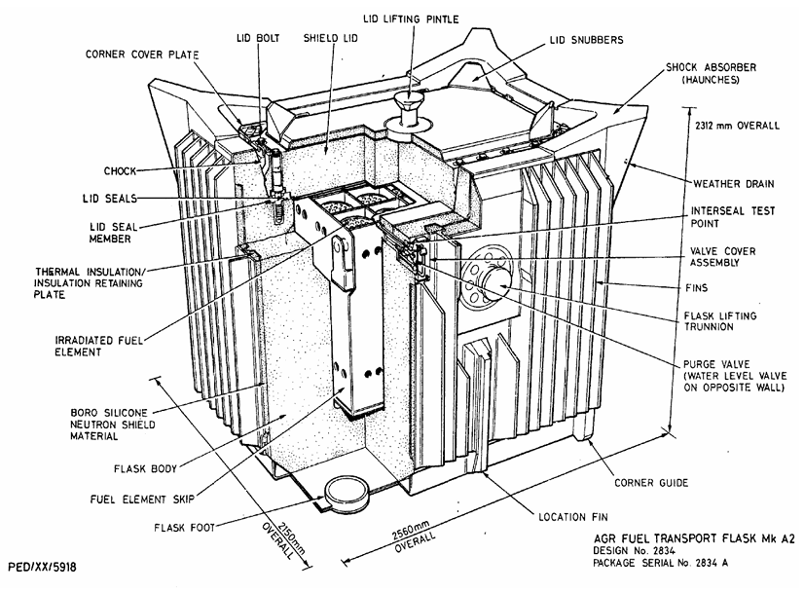

References

[1] | EDF, "e-mail with EDF Unique Number NSLGEN32938, EDF A2 Flask modification No288," 3 March 2026 (ONRW-2019369590-27101).
[2] | ONR, Certificate of Approval of Package Design and Shipment for the Carriage of Radioactive Material GB/2384A/B(M)F (Rev. 14), September 2024 (ONRW-157424439-386).
[3] | ONR, Certificate of Approval of Package Design and Shipment for the Carriage of Radioactive Material GB/2384B/B(M)F (Rev. 14), September 2024 (ONRW-157424439-387).
[4] | ONR, "Certificate of Approval of Package Design and Shipment for the Carriage of Radioactive Material GB/2384C/B(M)F (Rev. 14)," September 2024 (ONRw-157424439-388).
[5] | ONR, Certificate of Approval of Package Design and Shipment for the Carriage of Radioactive Material GB/2384D/B(M) (Rev. 14), September 2024 (ONRW-157424439-389).
[6] | ONR, Certificate of Approval of Package Design and Shipment for the Carriage of Radioactive Material GB/2384E/B(M) (Rev. 6), September 2024 (ONRW-157424439-391).
[7] | EDF, "Modification Number N0288 Issue 1," 26 February 2026 (ONRW-2019369590-27090).
[8] | EDF, "INA Approval Certificate for Modification Number N0288 Issue No. 01, Flask lid bolt inserts - increase tolerance to 7H," 26 February 2026 (ONRW-2019369590-27091).
[9] | EDF, "Report E/REP/BRDB/0007/AGR/03 Revision 015, Package Design Safety Report For the Mk A2 AGR Flask Design No. 2834," July 2025 (ONRW-2019369590-22164).
[10] | ONR, Instruction ONR-TCA-IN-001 Issue No. 1, Transport Permissioning, January 2025. (CM9 2022/47683).
[11] | ONR, Guidance Document ONR-TCA-GD-001 Issue No. 1, Transport Permissioning, January 2025. (CM9 2018/386305).
[12] | IAEA, "Specific Safety Requirements No. SSR-6 (Rev. 1), Regulations for the Safe Transport of Radioactive Material. 2018 Edition," June 2018.
[13] | UNECE, European Agreement Concerning the International Carriage of Dangerous Goods by Road (ADR), 2025 Edition.
[14] | OTIF, Regulation concerning the International Carriage of Dangerous Goods by Rail (RID), 2025 Edition.
[15] | UK Parliament, "Energy Act 2013, 2013 Chapter 32," London, 2013.
[16] | UK Parliament, "The Carriage of Dangerous Goods and Use of Transportable Pressure Equipment Regulations 2009, SI 2009 No. 1348," London, 2009.
[17] | ONR, "Pre-Job Brief Mod N0288," 04 June 2026 (ONRW-2019369590-29095).
[18] | ONR, "Assessment Report AR-01965. Mechanical Engineering Assessment. GB/2834 - Mk A2 AGR Transport Flask - Modification N0288 - Flask lid bolt tolerance," 10 July 2026 (ONRW-2126615823-13079).
[19] | ONR, "Assessment Report AR-01799, Radiation Protection - Shielding/Dose Rate Assessment. GB/2834 - Mk A2 AGR Transport Flask - Modification N0221 - Transport of Damged Fuel from Dungeness B," 1 April 2026 (ONRW-2126615823-12256).

