ONR Project Assessment Report
Hinkley Point C: LC 19(4) Consent - installation of the unit 1 reactor pressure vessel


ONR Project Assessment Report
Project Name: Hinkley Point C
Report Title: LC 19(4) Consent - installation of the unit 1 reactor pressure vessel

Duty holder/ Applicant: NNB GenCo (HPC) Ltd
Report Issue No.: 1
Publication Date: October 2026
Document ID: ONRW-2019369590-16991

© Office for Nuclear Regulation, 2025
For published documents, the electronic copy on the ONR website remains the most current publicly available version and copying or printing renders this document uncontrolled. If you wish to reuse this information visit www.onr.org.uk/copyright for details.

Executive summary
Title
ONR assessment of a request by NNB GenCo (HPC) Ltd (the licensee) for consent under licence condition 19(4) to commence the installation of the reactor pressure vessel into the unit 1 reactor building on the Hinkley Point C nuclear licensed site.
Permission requested
NNB Generation Company (HPC) Limited (NNB GenCo) is constructing a twin reactor European pressurised (water) reactor™ (EPR) nuclear power station at Hinkley Point C (HPC) in Somerset. NNB GenCo is the holder of a nuclear site licence for HPC, first granted by ONR in November 2012. In July 2023 ONR issued a specification under licence condition (LC) 19(4) of the HPC nuclear site licence requiring the licensee to seek ONR’s consent before commencing the installation of the reactor pressure vessel (RPV) into the unit 1 reactor building. This begins with the transport of the RPV from its dedicated store on site, and that activity is constrained by the licensee’s hold point 2.2.11.
NNB GenCo has recently requested ONR’s consent under LC 19(4) to commence the installation of the RPV.
Assessment and inspection work carried out by ONR in consideration of this request
This PAR summarises ONR’s assessment in relation to the following key areas:
- Evidence that the structural integrity of the RPV is adequate to allow the safe operation of the power station for its design lifetime;
- Evidence for the readiness of the HPC site and relevant personnel to safely undertake the process of installing the RPV; and
- The robustness of the licensee’s processes for determining its own readiness for the commencement of installation of the RPV.
Conclusions
Structural integrity of the RPV
NNB GenCo’s decision to allow the release of the RPV from the manufacturer Framatome St Marcel in November 2022 was supported by a flexible permissioning (Enhanced Implementation Management and Control; EIM&C) decision by ONR. This focused on the available evidence supporting claims on the structural integrity of the vessel. In allowing the RPV to be moved from the factory, the licensee raised a number of recommendations, or open points, to be addressed at a later stage. An update on the status of these open points is given in the licensee’s latest documentation to support installation of the RPV. ONR’s specialist structural integrity inspectors have assessed the evidence provided against each open point. Their assessment report notes that whilst a few open points remain to be closed, those aspects which specifically impact the installation of RPV have been addressed, and appropriate justifications are in place for those which remain open.
Based on the areas sampled, the ONR structural integrity inspector is content that residual risks associated with the installation of the RPV have been reduced so far as is reasonably practicable from a structural integrity perspective. The report went on to recommend that ONR gives its permission for the installation of the RPV into HPC unit 1.
Site readiness
A report from ONR’s nominated site inspector for HPC addressed several matters pertaining to the readiness of the site and its staff to undertake the physical task of conveying the RPV from its on-site store and installing it safely onto the already-installed RPV support ring in the unit 1 reactor pit. These matters covered:
- Incorporation of relevant learning from previous EPR installations and from relevant previous complex lifts on site;
- Readiness of the HPC Reactor Building (unit 1; HR) to receive the RPV;
- Control of work activities through lifting and installation activities;
- Governance and oversight, including quality;
- Asset care and maintenance post installation activity; and
- Routine ONR oversight of the licensee against relevant statutory provisions.
Having examined each of these matters through on-site inspections and discussions, the site inspector concluded that there were no areas related to site compliance that would preclude ONR giving permission for NNB Genco to install the RPV.
In addition, the Risk Assessment and Method Statements (RAMS) for each part of the journey of the RPV from the on-site store to its installation in the reactor building have been examined by ONR and are considered to adequately identify the health and safety risks to site personnel and their mitigation.
Nuclear security
ONR’s HPC nuclear security lead is satisfied that NNB GenCo’s security arrangements are adequate for the start of installation of the RPV.
Other ONR considerations
This PAR explicitly notes ONR’s position on several other matters which it considers relevant to its decision on the licensee’s readiness to proceed beyond hold point 2.2.11. These are:
- Closure or satisfactory position with all GDA Assessment Findings relevant to hold point 2.2.11;
- Closure or adequate progress with all relevant regulatory issues; and
- Confirmation that there are no open NNB GenCo commitments relevant to the hold point.
This PAR concludes that there are no concerns regarding any of these matters that prevent ONR from giving its consent to NNB GenCo to commence the installation of the RPV.
NNB GenCo’s process for release of the Hold Point
The outcome of the licensee’s hold point release process was a hold point review document (HPRD) with a residual action plan which was subject to review by the licensee’s standing hold point panel. The HPRD, the internal nuclear regulator’s concurrence report and the licensee’s case for release of the hold point were considered by the Nuclear Safety Committee in September 2024, which was content that the hold point could be released.
ONR has examined NNB GenCo’s application of its hold point release process for the release of hold point 2.2.11 and considers this to have been carried out in an appropriately rigorous manner, and that its decision to lift the hold point is supported by the evidence cited in the HPRD.
Recommendation
ONR issue licence instrument 529 granting consent to NNB Genco to commence installation of the unit 1 RPV at Hinkley Point C.

List of abbreviations
Term/Acronym | Description
ALARP | As low as reasonably practicable
CDM | Construction (Design & Management) Regulations 2015
CFSI | Counterfeit, fraudulent or suspect items
CNS | Civil nuclear security (ONR)
EdF | Électricité de France
EIM&C | Enhanced implementation, management and control
EPR | European pressurised (water) reactor™
GDA | Generic design assessment
GDAF | Generic design assessment finding
HIC | High integrity component
HK | HPC Fuel Building (unit 1)
HOW2 | (Office for Nuclear Regulation) business management system
HPC | Hinkley Point C
HP | Hold point
HPP | Hold point panel
HPRD | Hold point review document
HR | HPC Reactor Building (unit 1)
HTS | Hatch transfer system
I&C | Instrumentation and control
INR | Internal nuclear regulator (NNB GenCo)
JSW | Japan Steel Works
LC | Licence condition
LI | Licence instrument
MED | Management expectations document
MEWP | Mobile elevating work platform
OLS | Outside lifting system
ONR | Office for Nuclear Regulation
NCR | Non-conformance report
NSC | Nuclear safety committee
NSSS | Nuclear steam supply system
NNB GenCo | NNB Generation Company (HPC) Limited
OP | Open point
PAR | Project assessment report
RAMS | Risk assessment and method statement
RAP | Residual action plan
RGP | Relevant good practice
RCS | Reactor coolant system
RPV | Reactor pressure vessel
SED | Summary evidence document
SIAR | Structural integrity assessment report
SPMT | Self-propelled modular transporter
TLD | Temporary lifting device
WIReD | ONR business process management system

Table of contents
Executive summary 3
2.1. The reactor pressure vessel 9
2.1.1. Description 9
2.1.2. Classification 9
2.2. Installation of the RPV 10
3.1. Structural integrity of the RPV 11
3.1.1. Background 11
3.1.2. Open points following release of the RPV from Framatome 12
3.1.3. Assessment of applicable GDAFs 13
3.1.4. Conformity for pressure equipment 13
3.1.5. Regulatory issues 13
3.1.6. Regulatory commitments 14
3.1.7. Conclusions on structural integrity 14
3.2. Site readiness 15
3.2.1. Installation procedure 15
3.2.2. Site inspector’s report on site readiness 15
3.2.3. Risk assessments and method statements (RAMS) 19
3.3. Security 19
3.4. NNB GenCo internal governance 19
3.4.1. Hold Point Panel 19
3.4.2. Internal nuclear regulator 21
3.4.3. Nuclear Safety Committee 21
3.4.4. Conclusions on internal governance 22
Appendix 1 25
Appendix 2 26

- Permission requested
- ONR has specified under licence condition (LC) 19 that the licensee, NNB GenCo (HPC) Ltd (NNB GenCo), requires ONR’s consent before it begins the process of installing the reactor pressure vessel (RPV) into Unit 1 reactor building in the plant under construction at the Hinkley Point C (HPC) nuclear licensed site [1]. NNB GenCo has recently requested ONR’s consent under LC 19(4) to commence the installation of the RPV [2]. The licensee’s request is accompanied by several supporting documents [3].
- This project assessment report (PAR) documents ONR's view on granting a consent under LC 19(4) to allow the licensee to proceed with the RPV installation.
- Background

The reactor pressure vessel

Description
- The RPV is the main component of the reactor coolant system (RCS). The RCS configuration is a conventional four-loop design. The RPV is located at the centre of the reactor building and contains the core with fuel assemblies. The reactor coolant flows through the hot leg pipes to the steam generators and returns to the RPV via the cold leg pipes by the reactor coolant pumps. The pressurizer is connected to one hot leg via the surge line and to two cold legs by the spray lines (see the illustration in appendix 1).
- The vessel is around thirteen meters in length and weighs almost 500 tonnes. It is made of low-alloy steel with the complete internal surface covered by stainless steel cladding for corrosion resistance. The RPV has four inlet nozzles and four outlet nozzles located in a horizontal plane above the top of the core. It provides a critical role in the safety and integrity of the pressurized water reactor by providing a key barrier to the release of radioactivity into the reactor building containment.

Classification
- Mechanical components for HPC are assigned a component classification depending on the way their failure is considered within the design basis. There are three types of component classification:
- Type 1 – Component failure is explicitly considered within the design basis using a conservative approach and assumptions;
- Type 2 – Component failure is not explicitly addressed within the design basis, but the consequences may be shown to be tolerable if some relaxation to the usual level of conservatism is allowed in the component safety analysis; and
- Type 3 – High integrity components (HIC) whose failure is not addressed within the design basis and for which the consequences of failure cannot be shown to be tolerable. For these components, the structural integrity safety case relies on a multi-legged approach with onerous beyond-design-code requirements on materials and manufacturing, inspection and analysis. The RPV is a HIC of the HPC primary circuit, and its quality of construction is therefore of major significance. This is considered in section 3.1 of this PAR.

Installation of the RPV
- Under its arrangements for compliance with LC 19 (‘Construction or installation of new plant’), NNB GenCo has divided the HPC construction and commissioning phases into stages separated by hold points. In line with its ‘Strategy for regulating Hinkley Point C to the start of commercial operation’ [4], ONR will make use of primary or derived powers to permit the commencement of identified stages of the construction of HPC; the installation of the unit 1 RPV is one of those identified stages.
- The installation of the RPV in the reactor building is constrained by NNB GenCo hold point hold point 2.2.11. The activity consists of the movement of the RPV from its on-site store into the reactor building via the equipment hatch and then using temporary lifting devices (TLDs) attached to the polar crane to lift the vessel onto a previously installed supporting ring. The main risks involved are not of direct nuclear safety significance – primarily they concern:
- Safety of personnel during lifting and manoeuvring the large and heavy vessel;
- Potential for damage to the RPV itself through collisions or dropping; and
- Potential for damage to nuclear safety-related structures or other installed equipment and components.
- On the basis of these risks alone, it is unlikely that ONR would seek to apply licence instrument permissioning to the activity. However, ONR’s permissioning assessment of the release of the RPV from the factory in France, identified a number of points which ONR would expect to be addressed in order for it to be in a position to make a decision on consenting to the installation of the RPV [5].
- Those points included:
- Some key activities in support of HIC claims had yet to be performed. Regulatory confidence is required that the risk of not being able to substantiate the safety case claims is low;
- Regulatory confidence is required that relevant regulatory issues are closed, or adequate progress has been made such that any residual risk is low;
- Regulatory confidence is required that earlier quality shortfalls at the RPV manufacturer, Framatome St Marcel, have not impacted the claims in the safety case; and
- Due to irregularities in Japan Steel Works (JSW) manufacturing records for some forgings produced for nuclear use, ONR will need to assess the output of NNB GenCo’s, and its own, investigations to establish if there is a potential threat to the integrity of the RPV.
- In addition, the use of a licence instrument to permission the RPV installation, and the production of this PAR which will be published, provides an opportunity for ONR to set out in the public domain the basis for its confidence in the quality of the RPV. Making such information available to the public and stakeholders on such a vital safety-related component was an important factor in the decision to formally permission this activity.
- On the basis of these considerations, the proposal for the use of primary powers licence instrument permissioning was endorsed by the March 2023 EPR subdivision board [6].

- ONR’s consideration of this request

Structural integrity of the RPV

Background
- A structural integrity assessment report was produced to support the EIM&C permission for the release of the unit 1 RPV from the Framatome St Marcel factory [7]. That report contained a comprehensive assessment of ONR’s regulatory activities up to the ex-works. The EIM&C permission was also supported by an assessment report that considered NNB GenCo's activities to address irregularities relating to forgings at JSW.
- To inform ONR’s judgement on granting consent for the installation of the RPV, a further structural integrity assessment report (SIAR) has been produced [8] which builds on the ex-works assessments, focusing on the open points arising from these assessments and relevant knowledge gained since ex-works. The areas of focus include:
- Open points from NNB GenCo RPV ex-works decision;
- Assessment of applicable generic design assessment findings (GDAFs);
- Status of applicable regulatory issues (RIs);
- The outcomes from relevant ONR inspections;
- Fracture mechanics assessment of the vessel;
- The RPV summary evidence document (SED) used by NNB GenCo to support lifting of hold point 2.2.11;
- Progress of independent tests to address the JSW irregularities; and
- Tensile properties of the RPV ‘safe ends’.
- The purpose of the licensee’s SED is to:
- Provide evidence to substantiate the claim that relevant HIC requirements have been met, or that the demonstration associated to these requirements is sufficiently mature to support the release of the hold point;
- Provide links to further sources of information, such as the HIC requirements document;
- Highlight any gaps in available evidence and provide a statement of risk to the safety case claims for the release of the hold point;
- Identify any further work required to meet all HIC safety case requirements and to mitigate any risks; and
- Summarise any open RIs or GDAFs which could increase the risk of releasing the hold point.
- ONR’s structural integrity assessment has focused on those matters that pertain to the RPV body as this is the subject of the constrained activity. However, the assessment also included a review of the SED [9] for the separate, unit 1 RPV closure head and considers whether there are any open issues that impinge on the integrity of the RPV body. Any other open issues associated with the closure head will be addressed in due course through routine regulatory engagement.
- As noted above, the ONR assessments reported in the SIAR are based upon the safety case for installing the RPV as presented in the licensee’s SED and other supporting documentation submitted by the licensee. The extensive material considered in the SIAR is listed in the references section of the SIAR. Findings from the key areas of focus in the SIAR are briefly summarised below.

Open points following release of the RPV from Framatome
- Following the release of the RPV from the manufacturer Framatome St Marcel, the licensee raised 20 open points (OP). An update on the status of these OPs is given in the latest revision of the SED. ONR’s structural integrity specialist inspectors have assessed this and the SIAR provides a judgement on each OP.
- The SIAR provides commentary on each of the OPs and concludes that the licensee had adequately addressed the majority of these. Six OPs have ongoing work unrelated to the decision to install the RPV and therefore remain open. In general, the residual work will provide additional confirmation of the RPV integrity, and will be completed before the start of hot functional testing (HFT) during the station commissioning phase. The ONR structural integrity inspector was satisfied with the licensee’s decision to leave these OPs open. Progress towards closure prior to HFT will be monitored through routine regulatory oversight.

Assessment of applicable GDAFs
- The SIAR lists 64 GDAFs which were targeted for closure by the time of RPV installation. The bulk of these fall under the structural integrity topic area, reflecting the importance attached by ONR at the conclusion of its GDA work to the final quality of the as-installed RPV.
- The SIAR notes that although many of the structural integrity assessment findings raised at GDA were assigned a completion milestone of ‘Install RPV’, which appeared to be correct at the time, ONR has since agreed to a milestone deferral for 15 of these GDAFs due to their associated activities being scheduled to take place after ‘Install RPV’. With these agreed exceptions, the SIAR reports on each relevant GDAF and notes that these have all been closed to ONR’s satisfaction.

Conformity for pressure equipment
- The SIAR notes that during RPV installation, Lloyds Register Quality Assurance & Apave (LRQAA) will be undertaking assurance activities for the RPV as well as the associated pipework. The licensee has also appointed LRQAA as Competent Person Organisation as required by the Pressure Safety System Regulations 2000 post-installation, and LRQAA has begun reviewing the documentation supporting the installation, which includes inter alia handling and cleanliness procedures, inspection and test plans. LRQAA has also undertaken site inductions in readiness for attending inspection activities on site and supports installation for the nuclear steam supply system scopes.
- The authors of the SIAR stated that they were content that the licensee’s conformity process to support the installation has been effective in demonstrating compliance with the relevant legal requirements.

Regulatory issues
- The SIAR [8] reported on nine RIs relevant to the structural integrity aspects of the RPV, that had been raised by ONR between 2018 and 2024. All of these were reported as fully closed apart from one, RI 11306, relating to the tensile properties of the ‘safe ends’. An additional action has been raised within this issue to ensure that the tensile properties are adequately substantiated. Based on the good progress being made by the licensee to address the issue, the report expresses confidence that the issue will be satisfactorily closed, and that it does not need to be closed prior to RPV installation.
- The SIAR reports that during the assessment process a shortfall had been identified in relation to the cumulative structural integrity risk for the RPV ‘safe ends’, and RI 12191 (Level 4) has been raised to address this. The shortfall was judged to be minor and the report comments that the issue does not require closure prior to RPV installation.
- Additionally, as project inspector I have reviewed all open RIs relating to HPC, and I am satisfied that there are no other open RIs that have significance for ONR’s decision on whether to grant a consent for the installation of the RPV.

Regulatory commitments
- During the early stages of the HPC project, NNB GenCo made a number of commitments to ONR in relation to actions it would take at some future date or project milestone. Many of these commitments were made before the licence was granted and were formally recorded in a log [10] by NNB GenCo to ensure they were not overlooked and could be tracked to conclusion.
- In relation to the installation of the RPV, NNB GenCo identified seven relevant commitments [11], that were mostly raised before the licence was granted in 2012:
      - CMT-HPC-000018 – Perform fracture toughness testing on parts submitted to irradiation;
      - CMT-HPC-000019 – Perform fracture toughness testing on parts not submitted to irradiation;
      - CMT-HPC-000020 – Low testing temperature and setting lower bound limits on fracture toughness;
      - CMT-HPC-000021 – Justification of the adequacy of the fracture toughness and fracture toughness testing of the as-built forgings;
      - CMT-HPC-000022 – Provide chemical composition evidence of the forgings;
      - CMT-HPC-000023 – Undertake inspection qualification; and
      - CMT-HPC-000038 – Independent review of RSE-M Appendix 5.4 for the HPC safety case.
- The licensee proposed [11] that each of these commitments had been closed through submissions that had already been provided to ONR. The SIAR considered the licensee proposals and concurred that the commitments could be considered closed.
- Additionally, as project inspector I have reviewed the rest of the open commitments in the commitments log [10] and I am content that there are no other open commitments that are pertinent to the installation of the RPV.

Conclusions on structural integrity
- Based on the areas sampled, the structural integrity inspector was content that the licensee is compliant with LC19 from a structural integrity perspective. The inspector was further content that risks associated with the installation of the RPV have been reduced so far as is reasonably practicable from a structural integrity perspective. The report went on to recommend that ONR gives its permission for the installation of the RPV into HPC unit 1.

Site readiness

Installation procedure
- It should be noted that all the installation activities are being undertaken by the Tier 1 contractor Framatome, along with its lifting systems sub-contractor Mammoet. The approach and all lifting systems are the same as used at Flamanville 3.
- The starting point of this activity is the RPV stored in horizontal position in the RPV storage building on the HPC site. The activity constrained by the hold point is the RPV leaving the storage building. Before transport to the HR building, in the storage building a peel-off protective coating is removed from all accessible areas of the RPV, and protective strips are positioned to protect dissimilar metal welds.
- The RPV is then transferred on a self-propelled modular transporter (SPMT) from the storage building to the lifting area in front of the HK (fuel) building. The RPV is lifted directly from the SPMT, in front of HK building, into HR using the following routing:
      - Lifting the RPV outside HK building to a temporary extension of the 19.50m floor;
      - Introducing the RPV into HK; and
      - Transfer through HK to HR, on 19.50m floor.
- The outside lifting and horizontal transfer of the RPV on 19.50m floor requires the use of a temporary Outside Lifting System (OLS – a large gantry crane), which will lift the RPV (still horizontal) onto the Hatch Transfer System (HTS). The HTS is a Teflon skid-rail system where the RPV jacks itself forward, allowing it to be moved across from HK into HR. This is illustrated in the diagrams in Appendix 2.
- Once introduced in HR, the RPV is lifted from the HTS using the two TLDs mounted on the polar crane girders. The RPV is first moved from its horizontal position on the HTS to a vertical position. The rear lifting tool is removed, as well as the remaining part of peel-off coating.
- The RPV is moved down in the reactor pit onto the RPV support ring, and the protective RPV closure plate is removed as well as the front lifting tool. The final status of the RPV introduction is the RPV positioned on the RPV support ring in the reactor pit, with appropriate levelling shims in place.

Site inspector’s report on site readiness
- Through discussions with the ONR nominated HPC site inspector, it was established that the inspector would provide a report addressing a number of matters pertaining to the readiness of the site and its staff to undertake the physical task of conveying the RPV from its on-site store and installing it safely onto the already-installed RPV support ring in the unit 1 reactor pit [12]. These matters covered:
- Incorporation of relevant learning from previous EPR installations and from relevant previous complex lifts on site;
- Readiness of the HR building to receive the RPV;
- Control of work activities through lifting and installation activities;
- Governance and oversight, including quality;
- Asset care and maintenance post-installation activity; and
- Continuing ONR oversight, including a focus on compliance with licence conditions pertinent to the presence of a major HIC component.
- The findings in the report from the site inspector are summarised below.

Incorporation of relevant learning from previous EPR installations and from relevant previous complex lifts on site
- The installation method adopted for HPC replicates the method used for installation of the RPV at other EPR stations (Taishan, Flamanville and Olkiluoto). Operational experience from those sites has been taken into consideration in planning for the RPV installation at HPC. Additionally, there is significant experience of undertaking complex lifts at the HPC site (including all reactor building liner sections, the unit 1 polar crane and unit 1 dome). This provides significant confidence in the level of control that will be exercised over RPV lifting activities.

Readiness of the HR building to receive the RPV
(i) Civil engineering considerations
- The main issue relevant to RPV installation relates to problems encountered in installing the RPV support ring. These led to the cutting of rebar to accommodate the ring and to changes to second stage concrete specifications. A significant number of Field Change Requests (FCRs) and non-conformance reports (NCRs) were raised, and ONR inspectors engaged over a period of months to understand what had happened and whether the NNB response was appropriate, including looking at how the NCRs were categorised. This concluded with an inspection on Design Management (IR-53098 on WIReD), which had a section on this topic. As a result of that inspection, ONR inspectors agreed the matter had been adequately dealt with.
- More recently ONR inspectors undertook an inspection on Interim States Management (IR-53072 on WIReD), which included consideration of the temporary works that will be used to externally lift the RPV onto a bridge structure so that it can be moved into the HR, where it can be picked up by the TLDs attached to the polar crane. ONR inspector interest in this structure was in gaining confidence that this had been adequately designed to reflect its importance and that the loads that it imposed on any permanent works had been adequately considered. The IR reports that the ONR specialist inspector did not have any significant concerns based on the discussions held at site.
(ii) Polar crane readiness
- As part of our considerations of the adequacy of NNB GenCo’s preparedness for the start of early commissioning activities, ONR conducted an inspection of the implementation of NNB GenCo’s commissioning arrangements for the polar crane on 9-10 July 2024 (IR-52694). This concluded that implementation of NNB GenCo’s arrangements for LC21 (commissioning) and LC28 (examination, inspection, maintenance and testing) met relevant good practice. The management of commissioning activities and health and safety risks during commissioning met expectations. NNB GenCo’s surveillance of the commissioning activities was also observed to be adequate. In addition, the inspection concluded that relevant good practice was met in relation to the Provision and Use of Work Equipment Regulations 1998, particularly maintenance activities, emergency stops and lighting, and Work at Height Regulations 2005 regarding safe access/egress, prevention of overreaching and prevention of falling objects.

Control of work activities through lifting and installation activities
- Control of work activities has been a particular focus of site inspection activities. There are several existing regulatory issues related to this, with one issue specifically focused on NNB GenCo CDM 2015 Principal Contractor arrangements to monitor lifting operations at HPC (RI 10549 on WIReD). The dutyholder has made significant progress in addressing the shortfalls identified in this regulatory issue and given the additional oversight and governance that will be applied to this specific lift I consider that this regulatory issue does not present any impediment to release of the hold point.
- The HR building into which the RPV is to be installed is now subject to additional controls to limit numbers and prevent unnecessary access. A new induction course was introduced in January 2024 along with additional access controls to reflect the changing nature of hazard and risk presented within the building. Turnstile access has been introduced and a limit on building occupancy of 220 persons at any one time introduced to comply with fire risk assessments. The induction provides a focus on foreign material exclusion (FME), cleanliness (emphasising the shift toward a factory environment as opposed to construction environment as more equipment is installed), fire awareness and additional controls that have been introduced including prohibition on charging of batteries and replacing MEWP lithium batteries with a gel-based alternative. A new contract has been established with a company called Wilson James who will specifically cover general building areas in terms of cleanliness and compliance with fire risk assessment requirements (e.g. signage). Subsequent inspections and walkdowns within the building have demonstrated that additional controls are commensurate with the expectations for installation of high integrity components.

Governance and oversight, including quality
- In relation to generic installation and fabrication assurance oversight, there is a routine schedule of Level 4 technical engagements covering both installation and fabrication assurance and quality. In these engagements, ONR have sampled the control of exceptions, readiness for future activities, the mitigation of known risks and NNB GenCo's response to emergent issues e.g. CFSI and/or quality events. These interactions have generally provided confidence in NNB GenCo's approach.
- Release of the RPV hold point will be subject to robust governance processes within NNB GenCo. The robustness of these hold point processes were a key part of the previous ONR permissioning activities prior to installation of the unit dome lift. Additionally, a recent intervention focused on safety leadership on the site was rated green (IR 53064 on WIReD). The inspection found a clear flow through the Client (NNB GenCo) setting of standards and expectations to the Principal Contractor who then set standards that are cascaded onto contractors. Compliance with these standards is monitored through cascaded audit schedules (Client, Principal Contractor, and individual contractors).

Asset care and maintenance post installation activity
- An inspection focused on the adequacy of the implementation of NNB GenCo’s arrangements for the preservation and maintenance of systems, structures and components following shipment from the factory, after construction and/or installation was undertaken in August 2023 (IR-52640 on WIReD). This included preservation and maintenance of equipment stored on site or pending installation, and preservation and maintenance of systems, structures and components at site following their construction and/or installation. For the sample taken, the arrangements for care and maintenance of plant at HPC were judged to be adequate. This is in terms of plant awaiting installation, being installed and following installation. Minor observations were made that have continued to be followed up as part of normal business. Asset care and maintenance has been a routine agenda item at the main site facing meeting and in the site inspector’s opinion the arrangements and implementation of them are sufficient to provide confidence in asset care and maintenance of the RPV post installation in unit 1 HR building.

Continuing ONR oversight, including compliance with licence conditions
- There is a significant regulatory footprint on the HPC site through both formal inspection and targeted Level 4 technical meetings. Whilst the outcomes of these inspections are not a key input to the conclusions reached, they provide an additional level of confidence in terms of oversight of RPV installation activities.
- Overall NNB GenCo has maintained appropriate standards of non-construction specific licence condition compliance and I have not identified any significant issues which would preclude granting of the consent to installation of the RPV. Since April 2023 there have been a total of 57 ONR inspections, with 49 rated at green and 10 rated at amber. Those rated at amber are either not relevant to RPV installation or adequate progress has been made in addressing identified shortfalls as discussed, in relation to regulatory issues associated with control of work activities.

Site inspector’s conclusion on site readiness
- The site inspector concluded that there were no areas related to site compliance that would preclude ONR issuing an agreement for NNB GenCo to install the RPV in unit 1 HR building at the Hinkley Point C licenced site.

Risk assessments and method statements (RAMS)
- During discussions with the licensee it was established that the polar crane lifting mechanism will not be used in the RPV installation. For handling heavy components during construction (steam generators, pressurizer and RPV) two TLDs run along the crane girders and only the bodily rotation of the crane is used for the RPV installation. The Risk Assessment and Method Statement (RAMS) for this activity had been produced by the primary circuit installation contractor, Framatome, and reviewed and accepted by NNB GenCo.
- The Tier 2 contractor Mammoet is responsible for the movement of the RPV from the on-site store and lifting it up and into the reactor building. Mommoet has produced two RAMS covering the separate transport and lifting operations, which had also been subject to review and acceptance by NNB GenCo.
- I have reviewed all of these RAMS [13] and I consider that they have adequately identified the risks to on-site personnel during the transport, lifting and installation phases, and have set out suitable mitigations to reduce those risks to an acceptable level.

Security
In the licensee’s management expectations document for the release of the hold point (see next section) the requirement on security is stated as: ‘Adequate security arrangements are in place to protect the RPV during on-site transportation, storage, installation and post installation.’
- ONR’s HPC security lead noted [14] that the security of nuclear significant systems, structures and components, such as the RPV, is routinely discussed with HPC security staff. The security lead further noted that having examined the evidence listed in the ‘RPV Building and Transportation Security Plan’, he was content with the licensee’s arrangements and considered them satisfactory and proportionate.

NNB GenCo internal governance

Hold Point Panel
- The release of each primary and secondary hold point identified by the licensee is subject to its Define, Manage, and Release Key Hold Points procedure [15]. That process requires the production of a management expectations document (MED) setting out those actions which need to be completed to allow the hold point to be released.
- A MED is an integral part of the Hold Point Management Document which consists of the MED, a Hold Point Review Document (HPRD) and a Residual Action Plan (RAP). The HPRD sets out the evidence that NNB GenCo considers necessary to close each of the actions and this is submitted to the Hold Point Panel (HPP) for review. If satisfied, the HPP will recommend the release of the hold point. Any outstanding actions that cannot be completed before that stage will be included in the RAP. The actions in RAP must be closed before the start of the constrained activity. Closure of the RAP requires the signatures of the HPP Chair, the Head of Internal Nuclear Regulation, and the Hold Point Manager.
- The MED for the RPV installation hold point was considered at the HPP on April 12 2023 [16]. The MED was presented for consideration and advice to the June 2023 Nuclear Safety Committee [17]. As a result, some revisions were made and the HPP Chair shared the endorsement of Version 3.0 of the MED with the HPC Direction Team in early October 2023.
- The MED identified eleven broad themes, with 26 sub-themes (or ‘expectations’) which are required to be completed before the hold point is released [18]. Only some of these expectations are of interest to ONR in coming to a decision on permissioning the activity. These are listed below with the key risks NNB GenCo has identified and which they are intended to address.
MED theme | Risks addressed
- Organisation structure to support the processes | Risk of damage to components if handled incorrectly. Latent risk to safety if components installed incorrectly.
E. Nuclear safety and safety case | 1. The overarching safety case is appropriately mature to support RPV installation.  2. Relevant nuclear safety requirements (including structural integrity) are appropriately satisfied to support RPV installation.  3. Installation started without sufficient evidence that JSW findings do not impact HPC RPV.
G. Security arrangements | Due to a lack of adequate security arrangements in place, this may allow an adversarial threat actor to exploit vulnerabilities within this scope/package, which may negatively impact safety, quality, schedule, cost, and reputation of the project.
J. Design (of the polar crane, temporary lifting devices etc.) | Damage to the RPV or other equipment during lifting.
K. Construction | 1. Damage to the RPV or other equipment during lifting.  2. Damage to the RPV before installation if adequate care and maintenance are not effectively implemented.  3. Damage to the HK/HR permanent works caused by imposed loads from temporary works being outside of design parameters.
L. Emergency arrangements | RPV installation impacting normal emergency arrangements.
- The suite of expectations is sub-divided into a total of 26 manageable actions, each fulfilled through a pack of evidence to be presented for endorsement at a meeting (or meetings) of the HPP. In this case the evidence packs were presented to two HPP meetings, on 11 July 2024 and 29 August 2024. A member of the ONR structural integrity assessment team observed the second meeting.
- I have reviewed the minutes of the HPPs held on 11 July [19] and 29 August [20] which indicate that the panel undertook a thorough consideration of the status of each MED expectation. Feedback from the ONR observer at the 29 August meeting was that [21] the HPP agreed that the hold point could be lifted subject to the RAP items being closed. The observer considered that the meeting was well managed, structured, and that there was an effective challenge.
- Alongside the application letter [2], NNB GenCo set out 12 RAP items that remained open as of the date of application. These were scheduled for closure over the four weeks leading up to the date targeted for the start of the constrained activity. Subject to the agreement of its Head of the New Reactors Directorate, ONR will issue the licence instrument giving LC 19 consent around one week prior to that date. NNB GenCo has undertaken to provide updates as each RAP item is closed so that the decision on when to issue the licence instrument can be made [22].

Internal nuclear regulator
- As part of its internal governance, NNB GenCo’s internal nuclear regulator (INR) undertook a concurrence review of the project’s readiness to release the hold point and proceed with the constrained activity [23]. This identified three actions which INR required to be completed prior to the start of the constrained activity and these were added to the RAP. The concurrence report concluded that, subject to satisfactory resolution of those actions, INR was content with the readiness of the project to proceed through the RPV installation hold point.

Nuclear Safety Committee
- Both the HPRD and the INR concurrence findings were put to the 25 September 2024 Nuclear Safety Committee (NSC) for consideration and advice. An ONR observer at that meeting also noted [24] that:
- There was a 90-minute session on the hold point;
- It was a well-managed and effective meeting;
- This was the end of a series of engagements with the NSC on the topic and previous NSC comments had been addressed to the satisfaction of members;
- There was a diverse range of questions and suggestions raised by members based upon experience; and
- All members supported lifting of the hold point.
- The minutes of the meeting [25] confirmed the ONR observations.

Conclusions on internal governance
- On the basis of the above, I am satisfied that NNB GenCo has properly applied its hold point management process to the release of the RPV installation hold point 2.1.11 and has subjected this decision to the appropriate level of internal governance.

- Conclusions
- Based on the work carried out by ONR, I am satisfied that a consent can be granted to permit the installation of the RPV into the HPC unit 1 reactor building.

- Recommendations
- On the basis of the request submitted by the licensee and the conclusions of this PAR, I recommend that the Head of ONR’s New Reactors Directorate signs licence instrument number 529 granting LC 19(4) consent to NNB Genco to commence installation of the unit 1 RPV at Hinkley Point C.
- References

[1] | ONR, Licence Instrument 525, specification under LC19(4), July 2023, 2023/48927.
[2] | NNB GenCo, ONR-HPC-21861Y, Request for Consent to install the RPV, October 2024, CM9 2024/45460.
[3] | NNB GenCo, request for Consent to install the RPV. Supporting documents. October 2024. CM9 2024/45462.
[4] | ONR, Strategy for regulating Hinkley Point C to commenrcial operation, Issue 3, June 2024, CM9 2024/25152.
[5] | ONR, ONR-NR-DR-22-002, Permissioning Decision Record: HPC Unit 1 Reactor Pressure Vessel Shipment, CM9 2022/46143.
[6] | ONR, EPR SDB meeting minutes March 2023, CM9 2023/18579.
[7] | ONR, Structural integrity assessment for shipment from works of the Unit 1 RPV body & head, November 2022, CM9 2022/54955.
[8] | ONR, AR-01249, Structural Integrity Report for RPV installation, September 2024, ONRW-2126615823-4464.
[9] | NNB GenCo, Summary Evidence Document - Unit 1 RPV Body and Head: Revision 4, CM9: 2024/32727.
[10] | NNB GenCo, NNB-209-LOG-000026, HPC Commitments Log, CM9 2016/408133.
[11] | NNB GenCo, Closure of HPC commitments relating to RPV installation, Sept 2024. CM9 2024/38380.
[12] | ONR, HPC RPV Installation Permission - Site Inspector perspective, July 2024. CM9 2024/33731.
[13] | NNB GenCo, Risk assessment and method statements (RAMS) for activities involved in installation of the RPV, CM9 2024/50388.
[14] | ONR. RPV Installation - comments from Security lead, Sep 2024, CM9 2024/38922.
[15] | NNB GenCo, Define, Manage, and Release Key Hold-Points procedure, version 7.0, CM9 2021/61063.
[16] | NNB GenCo, Minutes of HPP 151 held on 12 April 2023, CM9 2024/15242.
[17] | NNB GenCo, Minutes of Nuclear Safety Committee 076 held on 28 June 2023, CM9 2023/38625.
[18] | NNB GenCo, Hold Point Management Document (HPMD) for HP2.2.11 Installation of RPV, Version 5.0, ONRW-2019369590-10586.
[19] | NNB GenCo, Minutes of Hold Point Panel July 2024, CM9 2024/41906; Panel comments table CM2024/41907.
[20] | NNB GenCo, Minutes of Hold Point Panel, August 29 2024, CM9 2024/41908; Panel comments table CM9 2024/41909.
[21] | ONR, Contact Record: observation of August 2024 HPP. CM9 2024/42425.
[22] | NNB GenCo. Confirming closure of RAP items. CM9 2024/45914.
[23] | NNB GenCo, INR concurrence report on HP 2.2.11, CM9 2024/40225.
[24] | ONR, Comments from observation of 25th September 2024 HPC Nuclear safety Committee. CM9 2024/0041346.
[25] | NNB GenCo, Nuclear Safety Committee, September 25th 2024 minutes, CM9 2024/43720.

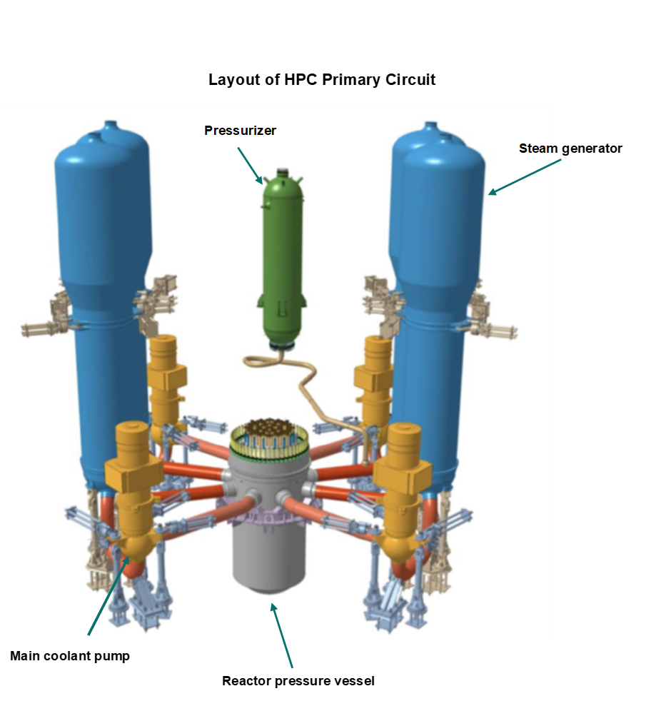
Appendix 1

Appendix 2
Introduction of the RPV – figures and illustrations
Figure A1 – routing scenario for RPV outside HK
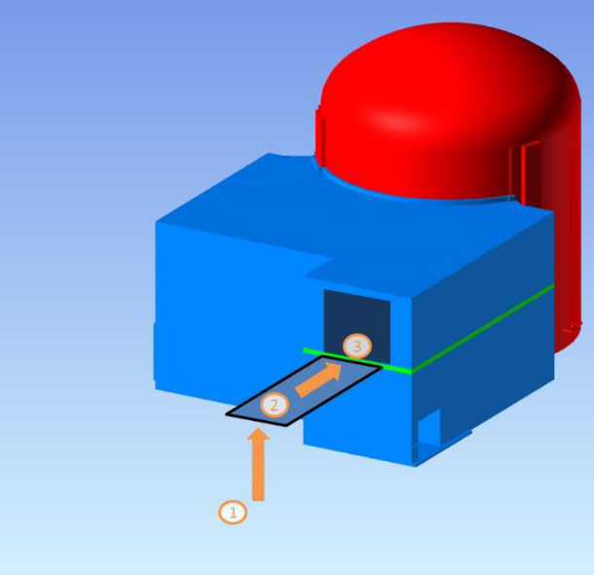
HR HR

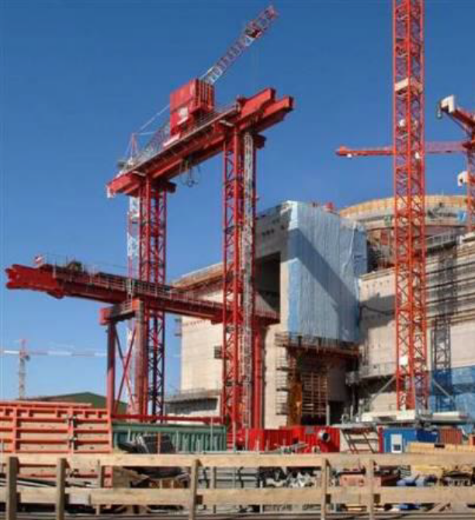
HK HR
Figure A2 – HTS and OLS on another EPR project (view from outside HK building)
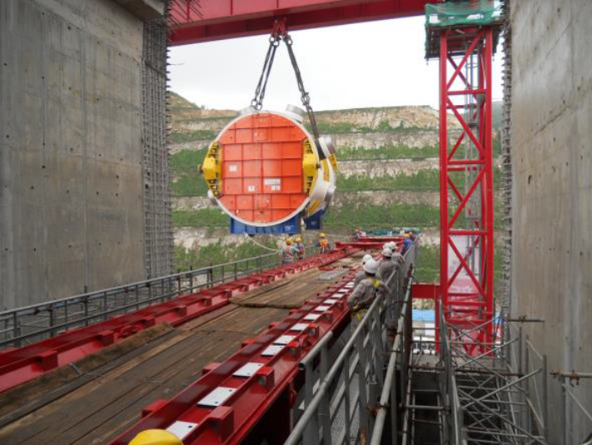
Figure A3 – HTS and OLS during RPV introduction on other EPR project (view from inside HK building)

Figure A4/A5 – TLD installation on the polar crane

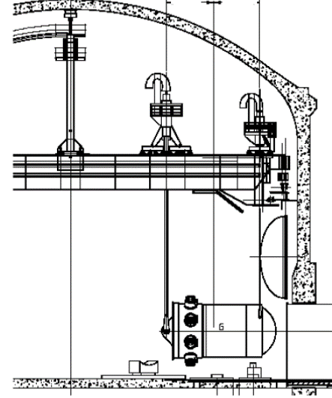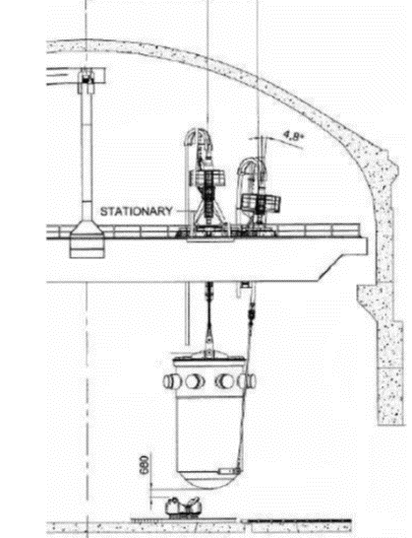

The permissioning utilised the ONR EIM&C ‘flexible permissioning’ approach.
‘Safe ends’ are welded to the RPV nozzles at the manufacturing plant to avoid welding two dissimilar materials during the erection on site.
In the on-site store, the RPV penetrations are all covered to ensure FME is maintained. The covers will remain in place until the vessel is in the reactor building

