ONR Project assessment report
PR-01212 Mk A2 AGR Transport Flask (Design No. 2834) - Assessment of Modification N0221


ONR Project assessment report
Project name: PR-01212 Mk A2 AGR Transport Flask (Design No. 2834)
Report title: Assessment of Modification N0221

Dutyholder/Applicant: EDF Energy Nuclear Generation Limited
Authored by:
Report issue no.: 1
Publication date: June 2026
Document ID: ONRW-2019369590-28726

Circulation list (latest issue)
Organisation | Recipient | Date report sent

© Office for Nuclear Regulation, 2026
For published documents, the electronic copy on the ONR website remains the most current publicly available version and copying or printing renders this document uncontrolled. If you wish to reuse this information visit www.onr.org.uk/copyright for details.

Executive summary
The applicant, EDF Energy Nuclear Generation Limited, has applied to the Office for Nuclear Regulation, as the Great Britain transport Competent Authority for the transport of radioactive material (Class 7 dangerous goods), for approval of Modification N0221 to the Mk A2 Advanced Gas-cooled Reactor transport flask (Design No. 2384) package design.
Modification N0221 applies only to the “C” variant of the Mk A2 Advanced Gas-cooled Reactor transport flask, GB/2384C.
The effect of approving this modification will be to allow the applicant to transport a single one-off shipment of mechanically damaged Advanced Gas-cooled Reactor fuel from Dungeness B to Sellafield in a GB/2384 package.
The basis of our regulatory decision is documented in this Project Assessment Report. We have undertaken a proportionate and targeted assessment, focusing on the differences in claims, arguments and evidence between the approved package and this modification.
It is concluded that the modification provides an adequate justification for the specific one-off shipment from Dungeness B to Sellafield.
I therefore recommend that ONR’s Head of Regulation for the GB Transport Competent Authority:
- accepts this Project Assessment Report to confirm support for the ONR technical and regulatory arguments that justify granting Competent Authority approval of the requested Modification N0221; and,
- grants approval of Modification N0221 by signing the Competent Authority approval section of EDF Energy Nuclear Generation Limited’s “Modification Sheet” for Modification N0221.

Table 1: List of abbreviations.
Term/Acronym | Description
ADR | Agreement concerning the International Carriage of Dangerous Goods by Road
AGR | Advanced Gas-cooled Reactor
CoA | Certificate of approval of package design and shipment for the carriage of radioactive material
DA | Design Authority
DMG | Delivery Management Group
DNB | Dungeness B
EDF | EDF Energy Nuclear Generation Limited
GB | Great Britain
IAEA | The International Atomic Energy Agency
INA | Independent Nuclear Assurance
ONR | Office for Nuclear Regulation
OTIF | Intergovernmental Organisation for International Carriage by Rail
PAR | Project Assessment Report
PDSR | Package Design Safety Report
PJB | Pre-Job Brief
POMM | Package Operations and Maintenance Manual
RI | Regulatory Issue
RID | Regulation concerning the International Carriage of Dangerous Goods by Rail
RQ | Regulatory Query
SSR | (IAEA) Specific Safety Requirements
TCA | Transport Competent Authority
UNECE | United Nations Economic Commission for Europe
WIReD | Well-Informed Regulatory Decisions (ONR)

Table of contents
Executive summary 3
1. Permission requested 6
2. Background 6
2.1. EDF Application 6
2.2. Overview of Package Design 6
2.3. Regulatory History 7
2.4. Purpose and Scope of Modification 7
3. Assessment and inspection work carried out by ONR in consideration of this request 8
3.1. Transport Permissioning Instruction and Guidance 8
3.2. Regulations 8
3.3. Regulatory Permissioning Strategy 8
3.4. Criticality Assessment 9
3.5. Radiation Shielding Assessment 9
4. Matters arising from ONR’s work 10
5. Conclusions 10
6. Recommendations 10
References 12

Permission requested
- EDF Energy Nuclear Generation Limited, hereafter referred to as EDF, has applied to the Office for Nuclear Regulation (ONR), as the Great Britain (GB) Transport Competent Authority (TCA) for the transport of radioactive material (Class 7 dangerous goods), for approval of Modification N0221 to the Mk A2 Advanced Gas Reactor (AGR) transport flask, Design No. 2384 [1].
- Modification N0221 applies only to the “C” variant (“Other AGR Fuel Arisings”) of the Mk A2 AGR transport flask, with Certificate of Approval of package design and shipment for the carriage of radioactive material (CoA) GB/2384C/B(M)F (Rev. 13) extant at the time of publication of this PAR.
- The effect of ONR approving this modification will be to allow EDF to transport a single one-off shipment comprising three unbottled mechanically damaged AGR fuel elements and one bottle containing non-fissile core components from Dungeness B (DNB) to Sellafield in a GB/2384C package.
- This Project Assessment Report (PAR) presents the basis of our regulatory decision regarding Modification N0221. This modification has been assigned permissioning ID PR-01212 in ONR’s Well-Informed Regulatory Decisions (WIReD) system.

Background

EDF Application
- EDF Application for Modification N0221 was supported by several documents including:
- The “Modification Sheet” for Modification N0221 signed by EDF’s Mk A2 AGR transport flask Design Authority (DA) and EDF’s Independent Nuclear Assurance (INA) function [2].
- The INA Approval Certificate for Modification N0221 [3].

Overview of Package Design
- The GB/2384 package design is commonly known as the Mk A2 AGR transport flask and has been in operation since the 1990s. It has principally been used for the shipment of AGR fuel from the applicant’s AGR power stations to Sellafield for storage and reprocessing, as well as transport of fuel assembly tie-bars and other non-fissile components.
- The package design comprises a forged carbon steel flask body with attached external cooling fins, a flask lid assembly, and an internal stainless-steel skip (of two different designs) carrying the radioactive contents.
- Reference [4] is the extant Package Design Safety Report (PDSR) for the GB/2834 package design. This PDSR covers variants “A” to “E” of the GB/2834 package design. Modification N0221 is limited to the “C” variant only, that is intended for:
- loose AGR fuel pins in slotted cans or whole/part pins, pellets and powders in debris capsules within slotted cans in an 8-compartment skip.
- Figure 1 provides an illustration of the GB/2834C package design.

Regulatory History
- A review of regulatory history relevant to this modification was undertaken to inform the Pre-Job Brief (PJB) for this project. The following key points were identified:
- For the GB/2834C package design, CoA GB/2834C/B(M)F (Rev.13) is in place [5]. This CoA, which was granted as part of Category A modification N0251 - Phase 2 associated with ONR permissioning ID PR-01479, covers shipment by road and rail in GB and is valid until 30 September 2027.
- Modification N0221 does not require this CoA to be updated.
- No historic Regulatory Issues (RIs) or incidents are relevant to this transport permission.

Purpose and Scope of Modification
- The purpose of this modification is to permit the movement of a single A2 flask for a one-off shipment from DNB to the Sellafield site. The modification will amend the authorised contents for this one-off consignment to:
- Three modified fuel fleet element bottle liners, with each bottle liner containing a fuel element fitted with a sword grab but missing the graphite sleeve.
- Fuel element bottle J85 containing DNB top spacer (serial no. 2301/06786) and intermediate spacer (serial no. 2281/06733); stainless steel and graphite items.
- The regulatory permissioning strategy for Modification N0221 was agreed with the TCA Permissioning Delivery Management Group (DMG) Lead.

Assessment and inspection work carried out by ONR in consideration of this request

Transport Permissioning Instruction and Guidance
- I have used ONR Instruction ONR-TCA-IN-001 “Transport Permissioning” [6] and ONR Guidance Document ONR-TCA-GD-001 during this permission [7].

Regulations
- Relevant international and UK regulations governing the transport of radioactive materials by road and rail cited in this PAR are:
- International Atomic Energy Agency (IAEA) Specific Safety Requirements (SSR)-6 (Rev. 1) “Regulations for the Safe Transport of Radioactive Material. 2018 Edition” [8].
- United Nations Economic Commission for Europe (UNECE) “European Agreement concerning the International Carriage of Dangerous Goods by Road (ADR) 2025 Edition” [9].
- Intergovernmental Organisation for International Carriage by Rail (OTIF) “Regulation concerning the International Carriage of Dangerous Goods by Rail (RID) 2025 Edition” [10].
- Energy Act 2013 [11].
- The Carriage of Dangerous Goods and Use of Transportable Pressure Equipment Regulations 2009 (CDG09) [12].

Regulatory Permissioning Strategy
- In accordance with the approved regulatory permissioning strategy, we have carried out targeted and proportionate assessments of the applicant’s proposed modification focusing on:
- Criticality, and
- Radiation Shielding.
- The PJB [13] confirmed, and justifies for this project, that there was no requirement for assessment by:
- Human Factors, or
- Mechanical Engineering.
- The PJB also confirmed, and justifies for this project, that there was no requirement for an inspection to support permissioning of this modification.
- We previously assessed the safety case requirements aspects of the package design as part of the approval for the renewal of the existing transport and shipment certificates for the GB/2384 package in 2022. The assessment relating to modification N0221 targeted the differences from the existing approval to account for:
- Requirement 673(a) of IAEA SSR-6 (Rev. 1) which requires fissile material to be transported to maintain subcriticality during routine, normal and accident conditions of transport.
- As modification N0221 applies to a single one-off shipment it does not impact the scope or conclusions of our earlier assessment.

Criticality Assessment
- Our criticality assessment for modification N0221 was reported in a technical assessment note [14].
- The damaged fuel elements are not intact fuel elements as defined in the PDSR [4], and do not conform to existing approvals. The criticality assessor confirmed that the proposed package contents, in their as-loaded configuration for this one-off shipment, remain bounded by the extant criticality assessment for the “C” variant of the GB/2384 package.
- Our criticality assessor recommended that Modification N0221 should be approved from a criticality perspective.

Radiation and Shielding Assessment
- Our radiation and shielding assessment for modification N0221 was reported in a technical assessment note [15].
- Our radiation and shielding assessor reviewed the applicant’s new shielding analysis for this modification to the “C” variant of the package. This confirmed that the principal source assumptions and calculation model were consistent with that used at the last renewal in 2022.
- Our assessor identified that the shielding analysis for normal conditions of transport did not comply with the regulations and raised Regulatory Query (RQ)-02417. This RQ was closed based on the evidence the applicant provided in their response that amended the model for normal conditions of transport and demonstrated compliance.
- Inconsistencies regarding non-fissile steel authorized contents under the “C” certificate in the PDSR, Package Operations and Maintenance Manual (POMM) and CoA were identified. This discrepancy was raised in RQ-02418 but is not safety significant. This RQ was closed based on the PDSR evidence the applicant provided in their response.
- Our radiation shielding assessor recommended that Modification N0221 should be approved from a radiation shielding perspective.

Matters arising from ONR’s work
- There are no matters arising from our assessment.

Conclusions
- Based on the work carried out by ONR, I am satisfied that the single one-off shipment of AGR fuel identified by Modification N0221 is safe and compliant to transport from DNB to the Sellafield site.

Recommendations
- I recommend that ONR’s Head of Regulation for the GB Transport Competent Authority:
- accepts this PAR to confirm support for the ONR technical and regulatory arguments that justify granting Competent Authority approval of the requested Modification N0221; and,
- grants approval of Modification N0221 by signing the Competent Authority approval section of EDF Energy Nuclear Generation Limited’s “Modification Sheet” for Modification N0221 [3].

Figure 1 Illustration of the GB/2834C Package Design
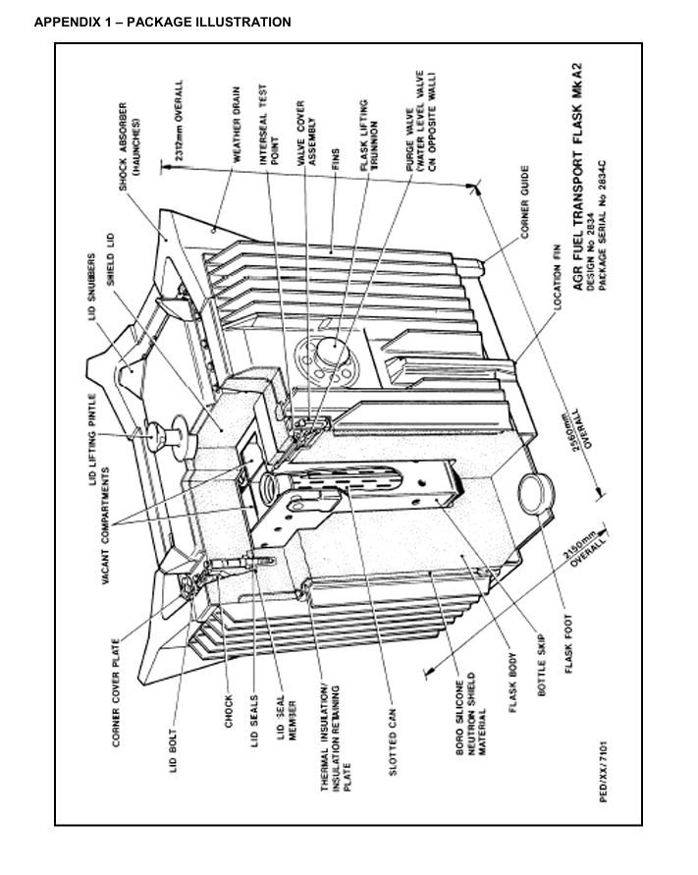

References

[1] | EDF, "e-mail with EDF Unique Number NSLGEN32912, EDF A2 Flask modification No221," 26 June 2025 (ONRW-2019369590-21906).
[2] | EDF, "Modification Number N0221 Issue 1," 24 June 2025 (ONRW-2019369590-21908).
[3] | EDF, "INA Approval Certificate for Modification Number N0221 Issue No. 01, Dungeness B - Damged Fuel Transport," 24 June 2025 (ONRW-2019369590-21907).
[4] | EDF, "Report E/REP/BRDB/0007/AGR/03 Revision 015, Package Design Safety Report For the Mk A2 AGR Flask Design No. 2834," July 2025 (ONRW-2019369590-22164).
[5] | ONR, "Certificate of Approval of Package Design and Shipment for the Carriage of Radioactive Material GB/2384C/B(M)F (Rev. 13)," September 2024 (ONRw-157424439-388).
[6] | ONR, Instruction ONR-TCA-IN-001 Issue No. 1, Transport Permissioning, January 2025. (CM9 2022/47683).
[7] | ONR, Guidance Document ONR-TCA-GD-001 Issue No. 1, Transport Permissioning, January 2025. (CM9 2018/386305).
[8] | IAEA, "Specific Safety Requirements No. SSR-6 (Rev. 1), Regulations for the Safe Transport of Radioactive Material. 2018 Edition," June 2018.
[9] | UNECE, European Agreement Concerning the International Carriage of Dangerous Goods by Road (ADR), 2025 Edition.
[10] | OTIF, Regulation concerning the International Carriage of Dangerous Goods by Rail (RID), 2025 Edition.
[11] | UK Parliament, "Energy Act 2013, 2013 Chapter 32," London, 2013.
[12] | UK Parliament, "The Carriage of Dangerous Goods and Use of Transportable Pressure Equipment Regulations 2009, SI 2009 No. 1348," London, 2009.
[13] | ONR, "Pre-Job Brief GB2384C Mod N0221," 29 Janaury 2026 (ONRW-2019369590-26462).
[14] | ONR, "Assessment Report AR-01801. Radiation Protection - Criticality Assessment. GB/2834 - Mk A2 AGR Transport Flask - Modification N0221 - Transport of Damged Fuel from Dungeness B," 30 September 2025 (ONRW-2126615823-8809).
[15] | ONR, "Assessment Report AR-01799, Radiation Protection - Shielding/Dose Rate Assessment. GB/2834 - Mk A2 AGR Transport Flask - Modification N0221 - Transport of Damged Fuel from Dungeness B," 1 April 2026 (ONRW-2126615823-12256).

