ONR site report
EDF – Heysham Power Stations
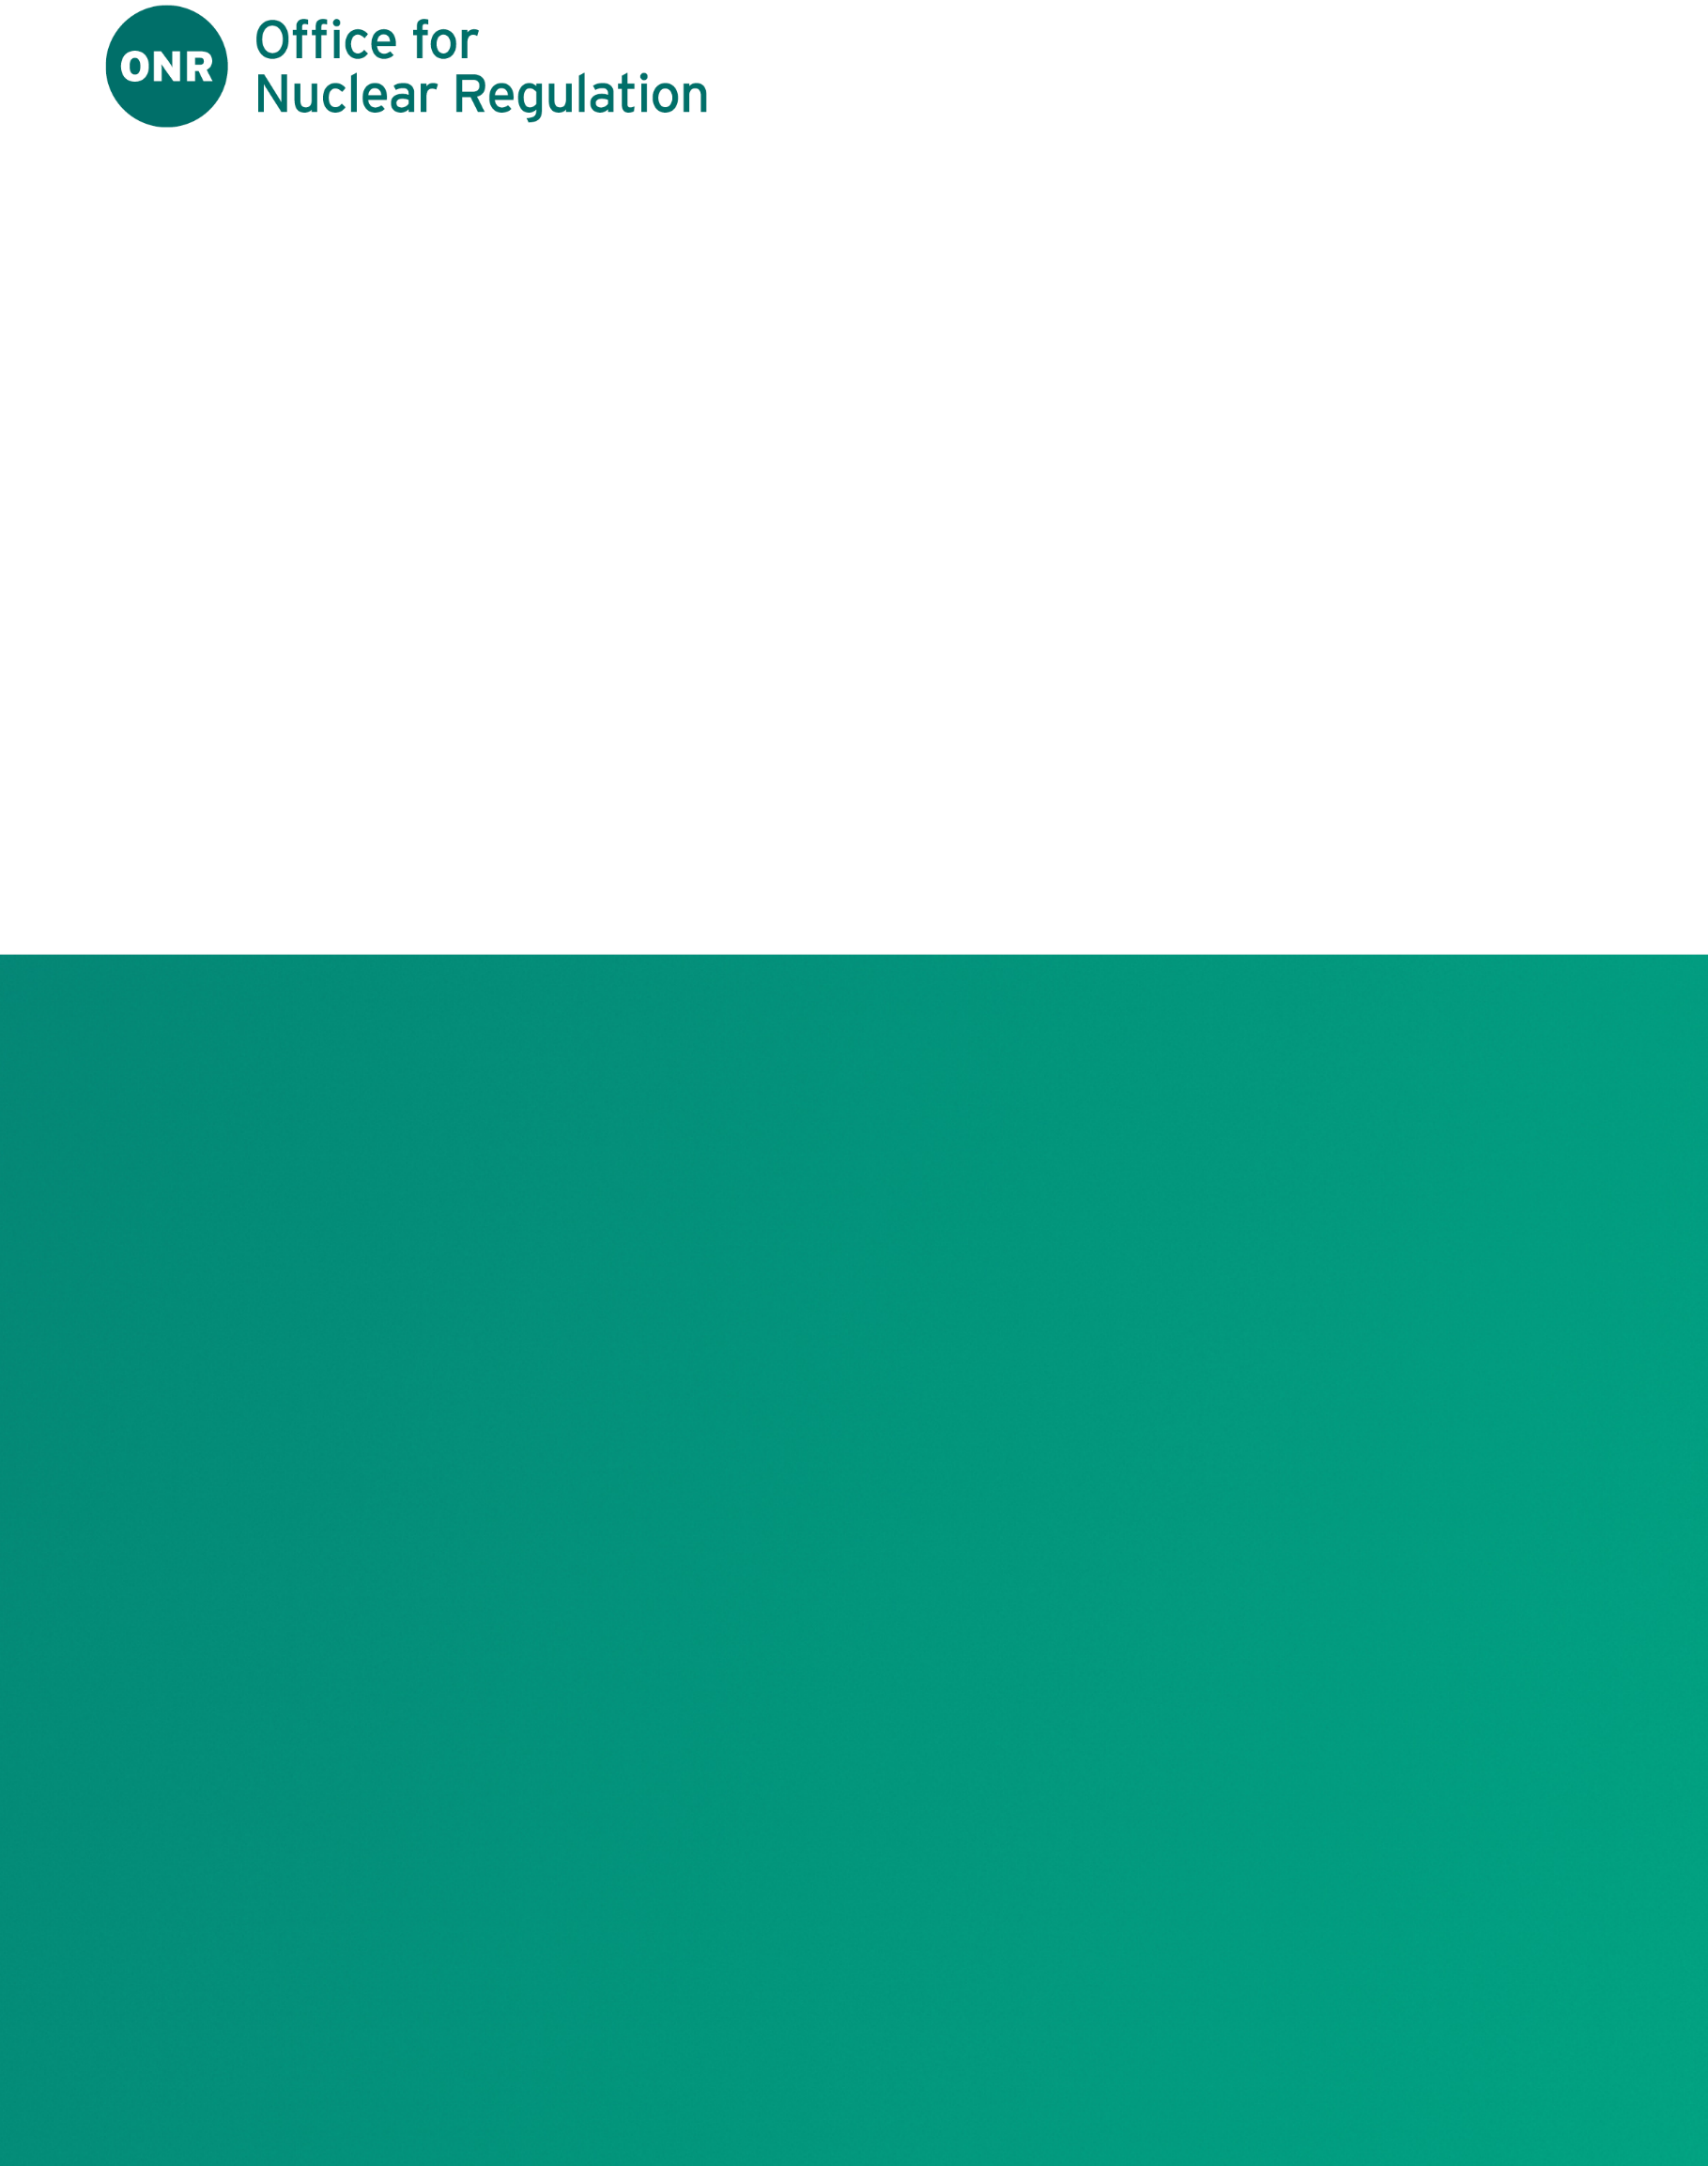

ONR site report
EDF - Heysham Power Stations
Report for period: 1 July – 30 September 2026

Authored by: Nominated Site inspector
Approved by: Head of Regulation (Operating Reactors)
Issue: 1
Published: October 2026
Record reference: OPFD-2136780860-65312

Foreword
This report is issued as part of our commitment to make information about inspection and regulatory activities relating to the above site available to the public. Reports are distributed to members for the Heysham Local Community Liaison Committee (LCLC) and are also available on our website: www.onr.org.uk/publications/regulatory-reports/site-specific-reports/llcssg-reports.
Our site inspectors usually attend Heysham LCLC meetings where these reports are presented and will respond to any questions raised there. Any person wishing to inquire about matters covered by this report should contact us via email at contact@onr.gov.uk.
Contents
1. Inspections 4
2. Routine matters 5
3. Non-routine matters 7
4. Regulatory activity 8
5. News from ONR 9
6. Contacts 9
References 10

Inspections

Date(s) of inspection
Our site inspector made inspections on the following dates during the report period 1 July to 30 September 2026:
Heysham 1
19-20 August
20-21 September
23-24 September
Heysham 2
29 July
22 September
28 September
29 September

.

Routine matters

Inspections
Inspections are undertaken as part of the process for monitoring compliance with:
- The conditions attached by ONR to the nuclear site licence granted under the Nuclear Installations Act 1965 (NIA65) (as amended);
- The Energy Act 2013;
- The Health and Safety at Work etc Act 1974 (HSWA74); and
- Regulations made under HSWA74, for example, the Ionising Radiations Regulations 2017 (IRR17) and the Management of Health and Safety at Work Regulations 1999 (MHSWR99).
The inspections entail monitoring the licensee’s actions on the site in relation to incidents, operations, maintenance, projects, modifications, safety case changes and any other matters that may affect safety. The licensee is required to make and implement adequate arrangements under the conditions attached to the licence in order to ensure legal compliance. Inspections seek to judge both the adequacy of these arrangements and their implementation.
In this period, routine inspections of Heysham covered the following:
Heysham 1
- A themed inspection to review the adequacy of the implementation of arrangements at site for working under a permit and what work can be carried out under other instructions. The following were sampled in relation to Licence Conditions (LC) 12 (DAPs and SQEPs), 26 (Control and supervision of operations) and parts of the Management of health and safety at work regulations pertaining to HSG 253 - The safe isolation of plant and equipment and HSG 250 - Guidance on permit to work systems: One work package, work area walk down and associated isolations, Setting to work, Permit to work processes and production, Training and SQEP arrangements. This inspection was rated green (no formal action).

- An unannounced out of hours inspection during refuelling outage. The aim of this inspection was to target items that are not normally available to inspect during normal working hours inspections. This inspection considered different ways at HY1 for setting to work out of normal hours including implementation of recent process improvements. The area sampled was isolations. Isolations are mainly applied out of hours to allow work to be carried out during the normal working day. This out of hours unannounced inspection was undertaken between the hours of 8pm and 1am. I sampled four isolations, three electrical and one mechanical. This inspection consisted of plant walkdowns, discussions with staff and sampling of work. From the evidence sampled, LC26 Control and Supervision of Operations this inspection was rated green (no formal action).

- A themed inspection on Supply Chain, Spares and Quality Control. The purpose of this inspection was to sample evidence of the adequacy of EDF Nuclear Generation Limited's (NGL's) Supply Chain Management arrangements for work conducted at Heysham 1 to inform a regulatory judgement regarding the licensee’s compliance with Licence Condition (LC) 17 (Management systems), LC28 (Examination, inspection, maintenance and testing) and associated relevant good practice. Specifically, this inspection looked to seek assurance that Heysham 1’s supply chain management arrangements, adequately controlled risks from poor quality items in line with relevant good practice and regulatory expectations. From the evidence sampled, LC17 and LC28 were rated green (no formal action).

Heysham 2
- An inspection related to Computer Based Systems Important to Safety (CBSIS). The aim of this inspection was to confirm the application of the Standards, Procedures and Arrangements (SPAs) that appear in the station's nuclear site security plan as they relate to CBSIS and that those SPAs are appropriate. This inspection was rated green (no formal action).

- As part of Heysham 2 Reactor 8 (R8) Statutory Outage inspections were undertaken to determine whether suitable arrangements were in place to carry out examination, inspection, maintenance, and testing (LC28). The findings of these inspections contributed to the ONR’s regulatory decision to Consent the restart of R8 to normal operating service in accordance with LC30 – periodic shutdown. ONR inspections are ongoing throughout the statutory outage, to date the following inspections were rated green (no formal action).
  - Electrical Engineering Inspection
  - IRR 17 Radiological Protection inspection.

- An inspection was undertaken that focussed on Risk Assessment. This inspection targeted Heysham 2 work processes for assessing industrial safety risks during the planning of tasks. The inspection was held over two days. The scope consisted of discussions with personnel and review of documentation. ONR identified shortfalls within the work management process which had the potential to result in staff carrying out tasks without awareness of the control measures used to protect their health and safety. The inspection was rated amber (seek improvement) and a level 3 regulatory issue raised to track and bring about improvement in the Heysham 2 arrangements, ensuring employees are adequately informed of the potential risks associated with tasks they undertake.

- A Readiness Inspection of the Leak Termination System (LTS) modification at Heysham 2 was undertaken. This modification, a "boiler leak termination system" was an identified improvement during the latest safety case periodic review and will reduce station boiler leak risks by approximately one third.
Overall, evidence of good construction and installation practices were observed. No significant control and instrumentation issues were identified that would prevent ONR from supporting the release of the associated hold point for the project.
Based on our sample of the modifications being undertaken, an inspection rating of green (no further action) was assigned for LC21 ‘Commissioning’, LC22 ‘Modification or experiment on existing plant’ and LC28 ‘Examination, inspection, maintenance and testing’ and the hold point released.
Security inspections across both sites are undertaken periodically by ONR and have been judged to be in line with ourexpectations with any issues managed through our normal processes.
Members of the public who would like further information on our inspection activities during the reporting period can view site inspection records on our website: www.onr.org.uk/publications/regulatory-reports/site-specific-reports/inspection-records.
Should you have any queries regarding our inspection activities, please email contact@onr.gov.uk.

Other work
In this period, other routine matters at Heysham stations covered the following:
- Regulatory issue progress (both sites).
- Routine event follow-ups including any conventional health and safety events (both sites).
- Periodic meetings with site safety representatives (both sites).
- Daily plant status, refuelling preparations and progress (both sites)
- Oversight of graphite inspection data (both sites).
- Oversight and attandance at site governance meetings (both sites).
- Plant walkdowns (both sites).
- Planning for annual level 1 emergency demonstration exercise (both sites).
- Planning for reactor statutory outages (both sites).
- Attendance at site stakeholder group (both sites).

Non-routine matters
Licensees are required to have arrangements to respond to non-routine matters and events. Our inspectors judge the adequacy of the licensee’s response, including actions taken to implement any necessary improvements.
Matters and events of note during the period were:
Heysham 1
- Following a defect identified on a spray line, Reactor 2 was manually tripped to enact a repair. The repair of the defect required the Main Condenser to be out of service, making a reactor shutdown necessary to complete the work safely. A controlled unit shutdown was carried out and shut down cooling established on the station dump condenser. An Equipment Reliability Investigation (EFI) is ongoing.
- Reporting of Injuries, Diseases and Dangerous Occurrence Regulations (RIDDOR) – Injury. A person using a type of torque wrench injured their hand leading to them being unable to undertake their normal duties for >7days, resulting in a RIDDOR report. They were treated on site then had further treatment in hospital. The site investigated and acted appropriately.
- RIDDOR- Dangerous Occurrence- Reactor 1 reduction in vessel pressure. On 17 September, a site incident was declared. Reactor 1 was in its inspection and refuelling outage (shutdown), with the reactor vessel at 0.23 bar. CO₂ alarms initiated in the reactor basement and reactor pressure was seen to be decreasing on R1. An indoor muster to ensure personnel safety and plant isolations was carried out. All personnel were accounted for and within 8 minutes the CO₂ leak had been isolated and follow up investigations subsequently undertaken to confirm the leak had stopped. The reactor gas was radiologically contaminated and clean up was carried out. No personnel received exposures. Investigations by both Heysham 1 and ONR are ongoing.
During this quarter, one safety case anomaly was identified. The site entered the safety case anomalies process, and this was dealt with in accordance with the licensee's arrangements, which are deemed to be adequate, however we are maintaining oversight.
Heysham 2
- RIDDOR - Dangerous Occurrence - An anomaly post testing of the safety relief valves (SRV) on reactor 7 following the planned graphite inspection outage was observed. There is a requirement to test the startup vessel (SUV) SRVs). The test methodology allows determination of the SRVs set point without exceeding system normal operating pressures. Plant activities were completed, shortly afterward a pressure control valve became unresponsive, potentially causing a pressure spike causing at least one SRV to lift with one remaining in the lifted position for some time. On initial investigation, significant quantities of steam were present in the area around the SRVs. The SRV was then removed from service. Subsequent investigation identified that the outlet exhaust flange joint of a valve had been compromised, a repair was undertaken successfully. No personnel were in the area or injured during this incident. An investigation by Heysham 2 is ongoing.
- A maintenance schedule (MS) test anomaly for reactor 7 gas circulator plant was observed. Due to the plant being out of service whilst the unit was tripped, these tests could not be completed and were therefore added to an engineering change "plant unavailable master maintenance schedule suspension" which requires test completion prior to going to ‘at power’ status. The reactor was subsequently taken to ‘at power’ status without these MS tests having taken place. Upon discovering this condition, the two affected plant items were declared unavailable and maintenance schedule tests were subsequently successfully completed. An investigation by Heysham 2 is ongoing.

Regulatory activity
We may issue formal documents to ensure compliance with regulatory requirements. Under nuclear site licence conditions, we issue regulatory documents, which either permit an activity or require some form of action to be taken. These are usually collectively termed licence instruments but can take other forms. In addition, inspectors may take a range of enforcement actions, to include issuing an enforcement notice.
No licence instruments, enforcement notices or enforcement letters were issued during this period for Heysham 1 and 2.
Reports detailing the above regulatory decisions can be found on our website: www.onr.org.uk/publications/regulatory-reports/site-specific-reports/project-assessment-reports.

News from ONR
For the latest updates and information on our work, please subscribe to our regular email newsletter, ONR News, at www.onr.org.uk/news/newsletter.

Contacts
Office for Nuclear Regulation
Redgrave Court
Merton Road
Bootle
Merseyside
L20 7HS
Website: www.onr.org.uk
Email: contact@onr.gov.uk
This document is issued by ONR. For further information about us, or to report inconsistencies or inaccuracies in this publication, please email contact@onr.gov.uk.
If you wish to reuse this information, please visit www.onr.org.uk/access-to-information/copyright blocked::blocked::BLOCKED::http://www.hse.gov.uk/copyrightfor details.
For published documents, the electronic copy on our website remains the most current publicly available version and copying or printing renders this document uncontrolled.

