ONR, Environment Agency and NRW - Joint regulatory operational policy
Leveraging international regulators’ assessments




Purpose and background
The Office for Nuclear Regulation (ONR), the Environment Agency and Natural Resources Wales (NRW) (‘the nuclear regulators’) are working together to make sure that any new nuclear installations built in Great Britain (GB) meet the standards for safety, security, safeguards, environmental protection and waste management.
This operational policy explains how the nuclear regulators will take advantage of information arising from the assessment of reactor designs by nuclear regulators in other countries to support our own regulatory assessments and judgements. Our aim is to provide clarity in how we set out to maintain robust standards and independence when leveraging assessments by other regulators internationally, accelerating regulatory decision-making and reducing unnecessary duplication.
The Government has issued a clear steer that radical change is needed to realise a new generation of nuclear power, [1] [2] [3] [4] and has highlighted that increased international engagement and streamlined regulation, while maintaining independence and robust safety and security standards, is key to achieving this ambition. Learning from recent Generic Design Assessments (GDAs) [5] assessing US reactor technologies has highlighted opportunities to achieve this acceleration, particularly where regulators in other countries have already undertaken assessments and reached judgements on reactor designs. As international co-operation expands, the nuclear regulators will make greater use of other regulators’ assessments where this is appropriate and safe, while ensuring that such evidence informs and strengthens our own independent regulatory judgements.
This operational policy outlines our principles governing the use of international regulatory reviews and sets out how we will incorporate these into our own assessments to inform our judgements. We will look to leverage other regulators’ judgements wherever possible to inform our regulatory decisions, but we see the biggest advantages of this being in the regulatory assessment of new reactor technologies, where multiple regulators have reviewed the same design. We will continue to work with other regulators internationally, to identify opportunities for deeper collaboration, such as joint assessments, and enhanced recognition of each other’s judgements.
Our regulatory guidance is benchmarked against international good practice, including the International Atomic Energy Agency (IAEA) Safety, Security, and Environment Standards, and Western European Nuclear Regulators Association (WENRA) Safety Reference Levels. We therefore expect there to be significant opportunities to leverage the judgements of other regulators as it is likely our expectations will share a common foundation.
This operational policy is consistent with the objectives of the IAEA Nuclear Harmonisation and Standardisation Initiative (NHSI) and we will be informed by the outputs from the regulatory track. Similarly we will take lessons learned from applying this framework and use them to inform future work of NHSI [6]. We will also inform and be informed by Nuclear Energy Agency (NEA) activities including joint projects and working groups.

What is different?
Our published guidance for the Generic Design Assessment (GDA) of new Nuclear Power Plants [7] sets out how we seek to take advantage of reviews undertaken by nuclear regulators in other countries. However, the current GDA, Licensing, Permissioning, and Permitting process places the responsibility on the Requesting Party (RP), licensee, or permit holder to provide evidence and to demonstrate how material produced for another regulator meets UK expectations. Under this revised approach, when assessing safety, security, safeguards, and environment cases submitted by the RP/licensee/permit holder, the nuclear regulators will take a more proactive role by engaging directly with international regulators to understand and gain confidence in the applicability of their regulatory reviews and the underpinning evidence used. This has the potential to reduce the extent for UK specific documentation to be produced where pre-existing documentation is robust and demonstrably applicable to a generic or site-specific case.
Two important implications follow from this change:

Produce once, use many times
Where a regulatory review relates to generic aspects of a design, it is likely that it will be applicable to several countries. In such cases this should reduce the need for UK specific generic safety, security, safeguards or environment demonstrations for these aspects, where the existing documentation has achieved regulatory acceptance in an established and robust regulatory regime, thus reducing unnecessary duplication.

Legal duties remain unchanged
Where we leverage other regulators’ assessments to support our own decision making, this does not remove or diminish a dutyholder’s legal responsibilities. A site-specific safety, security, safeguards and environmental protection case will always be required for any facility built in Great Britain, which must demonstrate that risks have been reduced so far as is reasonably practicable and best available techniques have been used to protect people and the environment and reduce exposures to ionising radiation to as low as reasonably achievable in accordance with UK legal requirements.

Principles for leveraging other regulators Assessments

Principle 1 – Regulatory sovereignty
We will retain independence by making our own regulatory judgements and decisions. The UK is required under international law, notably the Convention on Nuclear Safety and the Joint Convention on the Safety of Spent Fuel Management and on the Safety of Radioactive Waste Management [8] [9], to maintain an independent nuclear regulator. Each sovereign state has the same obligations and has implemented its own regulatory regime based on its legal system and societal risk tolerance. This responsibility is delivered through UK legislation, including the Health and Safety at Work Act 1974, the Energy Act 2013, the Nuclear Installations Act 1965 and The Environmental Permitting (England and Wales) Regulations 2016. The nuclear regulators must therefore make their own regulatory judgements and cannot simply adopt another regulator’s decision or judgement.
However, we may draw on the work of other regulators where it helps inform our assessments. International regulatory reviews can be used as evidence, in whole or in part, where we judge them against UK legal requirements. They inform and support our decision making, but they do not replace it.

Principle 2 – Benchmarking
Benchmarking establishes the foundation for understanding the extent to which other regulators’ judgements can inform our own. It underpins the tests described later in this policy, and the level of confidence we can take from another regulator’s work.
The purpose of benchmarking other regulators’ frameworks, judgements, and approaches is to understand similarities and differences between respective regimes. This understanding allows us to assess how judgements were reached, how applicable they are in a UK context, and what level of additional evidence or justification may be required.
Benchmarking will be carried out through comparison of overarching regulatory frameworks (for example decision making processes and governance), through comparison of regulatory codes, standards and expectations at a topic specific level, and other codes and standards which inform regulatory expectations such as IAEA safety, security, and environment standards, and WENRA safety reference levels.

Principle 3 – Confidence and Accountability
We need to have confidence in the regulators carrying out the assessments that we will make use of. This includes confidence in the applicability of the regulators work as well as its accountability for that work. This will enable us to accept accountability for relying on it. While benchmarking focuses on standards and processes, securing confidence will be an ongoing process taking account of interactions and learning. We gain confidence where we can verify independent and impartial decisions from a competent and capable organisation undertaken through a fair and transparent process.
Our considerations on confidence in other regulators will also include:
- participation in intergovernmental organisations, such as IAEA and NEA, in developing international standards
- evidence from independent peer reviews, such as IAEA Integrated Regulatory Review Service missions
- formal bi/multi-lateral agreements, such as memoranda of understanding, memoranda of co-operation, and information exchange agreements
- effective working relationships with others
We will verify that the evidence, methods, and standards applied are suitable and sufficient to support our own regulatory decisions. This includes reviewing available evidence, considering the level of challenge and scrutiny applied, and applying an appropriate level of due diligence based on the risk significance and novelty of the topic.

Principle 4 – Transparency
We will be open about when and how we use the work of other regulators. Any international regulatory judgements used to support our conclusions will be clearly recorded in the assessment records. We will only use international regulators’ work where this is available to the RP, applicant or licensee/permit holder. We will explain what evidence was relied upon, how we judged it to be acceptable, and its relevance to support the case being made. We will share our judgements in line with our publication schemes [10] [11] [12].

Principle 5 – Information Security
Information shared between regulators will be handled in line with each country’s security, export control, confidentiality, and data‑sharing requirements. This will be in accordance with information sharing agreements between regulators and technology vendors/developers or duty holders including acknowledgment of our obligation to disclose information in certain circumstances under Freedom of Information (FOI) and Environmental Information Regulations (EIR) requests.
We will ensure that any shared documents, discussions or assessments comply with information‑handling agreements and protect sensitive data.
We will only use information when it can be shared and managed securely, and we will respect any restrictions placed on information received in confidence.

How we will do it
Assessments carried out using these principles will follow the nuclear regulators’ normal regulatory processes. We will begin by developing an understanding of the RP or licensee/permit holder’s case.
The responsibility for demonstrating compliance with UK legal requirements always sits with the RP or licensee/permit holder. We will require them to demonstrate that the proposal meets UK legal requirements. This may be through a case developed specifically for the UK, a case prepared for another national regulator where it can be shown to meet UK requirements, or a combination of the two.
Using this information, we will develop our assessment strategy and identify which aspects of the case require more detailed sampling, in line with our standard processes [13] [14]. We will then consider the availability and applicability of relevant international regulatory judgements used as evidence, either through published material or through agreements with other regulators.
Where potentially relevant international assessments are identified, we will apply a series of tests to determine the extent to which we can use the information to support our own judgements. We will typically consider the extent of the regulatory information available, regulatory equivalence, and significance of what we are assessing to form an overall judgement of the risk level associated with using those judgements, however this depends on the context of the regulatory decision and additional tests or considerations may be necessary. This risk judgement will determine the level of due diligence required before the available information can be used to support our own assessment.
Example regulatory information, equivalence, and significance tests, how they will be used, and relevant case studies describing how similar tests have been used in the past are described in the following sections.

Regulatory information test
We consider what regulatory information is available to support our assessment of the RP or licensee/permit holder’s case. In general, the more detailed and accessible the information, the more confidence we may take from it, and the less additional assessment we may need to carry out ourselves. This of course depends on the quality and relevance of the information available.
The information for this test may include full regulatory assessment reports, technical analysis, and judgements available to us through bilateral agreements, or information published openly by other regulators.
Where information is heavily redacted or limited to high level summaries, it is likely to provide only limited assurance. In these cases, there will be little reduction in the amount of assessment we need to undertake.
Where full assessment reports are available, and we have an established working relationship with the other regulator that allows discussion of its assessment (for example through memoranda of understanding or information exchange agreements), this can provide significant assurance and enable greater efficiencies in our own assessment effort, thereby avoiding unnecessary duplication.
The extent to which a pre-existing assessment can contribute to our judgement depends on both the quality of the information available and the specific context of the assessment. This will be agreed upon as part of assessment planning.

Regulatory equivalence test
For the regulatory equivalence test we consider how closely the regulatory framework, standards, and assessment approach used by the other regulator align with our own.
This includes understanding how the other regulator reached its judgement, in line with Principles 2 and 3, as well as the level of regulatory scrutiny applied. Where these are broadly equivalent to our own approach, it is likely we can more readily use another regulator’s assessments to inform our own.
We will also consider the evidence, methods, and standards on which the judgement is based. Understanding where these differ from UK expectations helps us identify where additional justification may be needed. Different standards may introduce unnecessary complexity or cost, or may not fully meet UK legal requirements. Even where expectations differ, parts of the assessment may still be relevant and can reduce the scope of our own detailed assessments.
Organisational culture is also considered. Different regulators place different emphasis on behaviours such as challenge, transparency, compliance, and the balance between upfront assessment with subsequent assurance by inspection. Understanding these differences helps us apply appropriate level of scrutiny and due diligence. Closer alignment of regulatory approaches will reduce the level of additional assurance required.

Assessment significance
For the assessment significance test we consider the importance to safety, security, safeguards, or the environment of the claims being made, including the potential consequences of failure, its probability / frequency, level and type of uncertainties, and the level of novelty involved.
The more significant the safety, security, safeguards, or environment hazard and risk is, the greater the regulatory scrutiny required because the consequences of failure and/or the likelihood of the event occurring is greater. Novel technologies or unfamiliar approaches increase uncertainty which in turn impact confidence in risk estimates. This approach is in line with ONR’s Risk-Informed and Targeted Engagements (RITE) policy [15].

Due diligence levels
The outcomes of the evidence, regulatory equivalence, and assessment significance tests are considered together alongside any other relevant factors to form an overall risk-informed judgement on the extent to which another regulator’s work can be leveraged.
Where assessment information and regulatory equivalence differ from our regulatory expectations and/or the regulatory significance is deemed to be high, the risk with leveraging international assessments is higher and more extensive due diligence and independent assessment will be required. Where stronger alignment is observed and the regulatory significance is lower, the risk with leveraging international assessments is lower and a more confirmatory approach may be appropriate. Figure 1 illustrates how the risk of leveraging international judgements informs the extent of due diligence to be undertaken. The extent of due diligence to be applied in any particular case will be determined according to our governance processes.

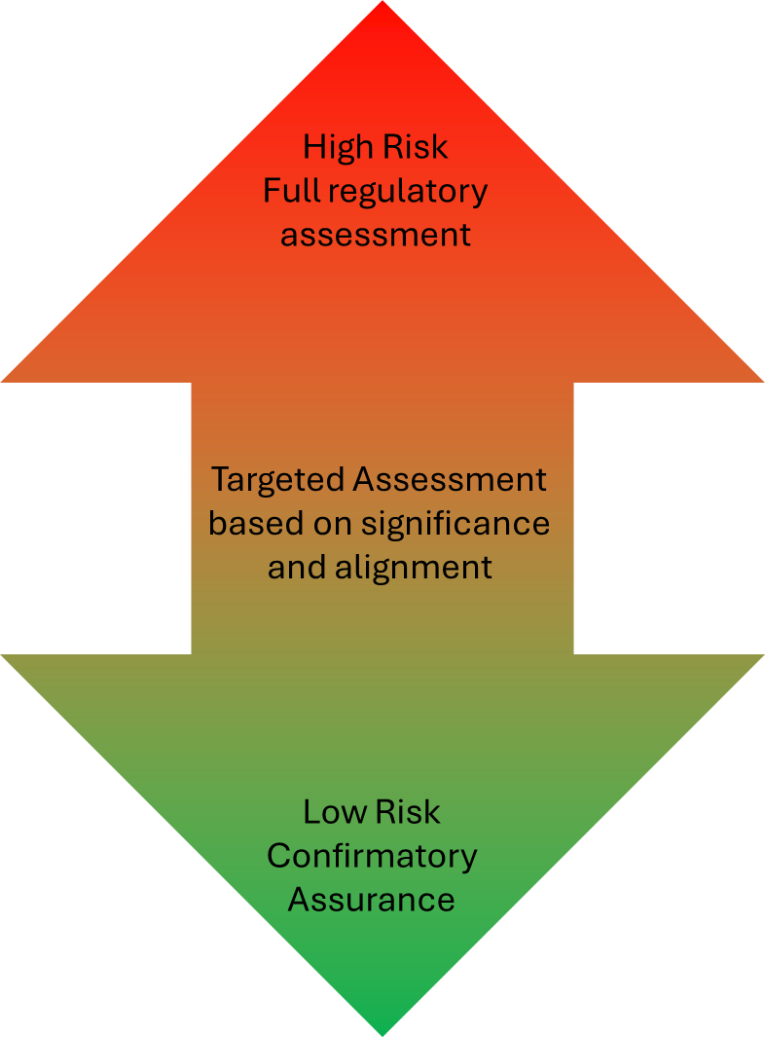
Figure 1 - Risk-informed due diligence

In practice, where the risk is judged to be high, there may be limited benefit from leveraging international judgements. Also, if inconsistencies or concerns are identified during our assessment, this may represent a change in risk and the scope and depth of our sampling should be increased in line with our normal regulatory processes.
As a minimum, where we are leveraging other regulators’ work we will always undertake a review to consider the technical accuracy, regulatory scrutiny applied, and applicability to a UK context.
In line with Principle 4, where international regulatory judgements are used to support our conclusions, this will be clearly recorded in the assessment record, including the evidence used, the due diligence undertaken, the applicability in a UK context, and any limitations or areas of divergence. This will demonstrate our compliance with the UK’s obligations under relevant international law.

Case studies
The following case studies show how ONR has applied the principles and tests set out in this policy in practice. Although they pre-date the publication of this policy, they demonstrate how we have used international regulatory judgements to inform our own assessments. In each case, we considered the available regulatory information, the degree of regulatory equivalence, and the significance of the topics being assessed. These factors were used to form a judgement, which then informed the level of due diligence and assessment required. Together, the case studies illustrate how the principles and tests in this policy can be applied in a proportionate and transparent way.

Fundamental design assessment of the Holtec SMR-300 fuel and control rod assemblies
As part of the GDA Step 2 Fundamental Design Assessment for the Holtec SMR-300 [16] [17], ONR considered the proposed fuel and control rod assemblies. These are standard designs manufactured by Framatome and are in service in multiple reactors worldwide. They have therefore already been subject to regulatory assessment in other countries. This existing work was relevant to and could inform our own assessment.

Regulatory information test
The fuel and control rod assemblies are well understood and supported by extensive international evidence, including detailed regulatory assessment reports and operational experience from operating reactors. This provided a high level of confidence in the regulatory information base available to support our assessment.

Regulatory equivalence test
The assemblies have previously been assessed by the United States Nuclear Regulatory Commission (US NRC), with whom ONR has an existing regulatory relationship and familiarity with its approach to nuclear regulation [18]. The designs are based on IAEA standards and guidance. ONR benchmarks its standards against IAEA standards and actively contributes to their development and to IAEA Integrated Regulatory Review Service missions [19]. This gave confidence that the regulatory approaches and standards underpinning the international assessments were broadly equivalent to those applied in the UK.

Assessment significance test
Fuel integrity and the ability to shut down the reactor are fundamental to nuclear safety and therefore of high importance. However, the novelty associated with these components is low, as they are established designs with a long history of use. At this stage of GDA (a judgement of fundamental adequacy in the design – Step 2 statement), the objective was to assess the fundamental aspects of the design in order to determine whether it was potentially capable of being safely constructed and operated in Great Britain, rather than to undertake a full detailed assessment which is undertaken subsequently (a Step 3 of GDA or site-specific design assessment).

Due diligence applied
Taking these factors together, we judged that the risk associated with leveraging the international assessments was low. We therefore applied confirmatory due diligence, focusing on verifying that the fuel and control rod assemblies were being used within their proven safety limits in the context of the Holtec SMR-300 core design. The international regulatory assessments informed, but did not replace, ONR’s own regulatory judgement on the fundamental adequacy of the design, nor ONR’s future detailed assessments on the design and its deployment in Great Britain.

Fundamental design assessment of the GE Vernova BWRX-300 Diaphragm Plate Steel Composite Reactor Building
As part of the GDA Step 2 Fundamental Design Assessment for the BWRX-300 [20] [21], ONR considered the proposed use of Diaphragm Plate – Steel Composite (DP SC) modular construction for the reactor containment building. This is a novel approach for the UK. In April 2025, the Canadian Nuclear Safety Commission (CNSC) issued a construction licence for a BWRX-300 reactor at the Darlington site in Ontario [22]. The assessments supporting that decision were therefore relevant to and could inform our own assessment.

Regulatory information test
We reviewed information supporting the CNSC’s judgement, who jointly assessed this aspect with the US NRC [23]. We reviewed both publicly available material and information shared through our Memorandum of Cooperation [24] on advanced reactor and small modular reactor technologies. This included detailed technical assessment work that was directly relevant to the issues being considered and can support our assessment.

Regulatory equivalence test
ONR has existing relationships with both the CNSC and US NRC on collaboration of SMR design assessment. This provides us with on-going practical experience and confidence that their regulatory processes and decision making are robust and are broadly comparable to those expected in the UK. We reviewed the standards used in their respective assessments and noted that they are well established international design codes which we consider to represent relevant good practice in the UK.

Assessment significance test
The reactor building is a key safety and security structure, forming one of the main barriers to the release of radioactive material under fault conditions. The design uses construction techniques which are novel for reactor buildings in the UK, although it draws on experience from similar technologies deployed on other nuclear projects, including designs previously assessed by ONR. Overall, we judged the safety significance to be high and the novelty to be moderate.

Due diligence applied
Taking these factors together, ONR concluded that there were aspects of the international assessments from which we could take confidence, alongside areas requiring further consideration. We therefore undertook more extensive due diligence than the confirmatory checks illustrated in the previous example. The more extensive checks involved targeted and complementary sampling to confirm the international findings and to address topics which had not been considered by the other regulators at the time of our assessment. We held technical workshops with both regulators. Leveraging the existing international assessments reduced unnecessary duplication and shortened the time needed to complete our assessment, while ONR retained responsibility for the final regulatory judgement.

List of acronyms / initialisms
Table 1 - List of cited acronyms / initialisms.
Acronym / initialism | Description
CNSC | Canadian Nuclear Safety Commission
DP SC | Diaphragm Plate – Steel Composite
EIR | Environmental Information Regulations
FOI | Freedom of Information Act
GE | General Electric
GB | Great Britain
GDA | Generic Design Assessment
IAEA | International Atomic Energy Agency
IRRS | Integrated Regulatory Review Service
NEA | Nuclear Energy Agency
NHSI | Nuclear Harmonisation and Standardisation and Initiative
NRW | Natural Resources Wales
ONR | Office for Nuclear Regulation
RP | Requesting Party
RITE | Risk-Informed and Targeted Engagements
SMR | Small Modular Reactor
UK | United Kingdom
US NRC | United States Nuclear Regulatory Commission
WENRA | Western European Nuclear Regulators Association

References

[1] | https://www.gov.uk/government/publications/prime-ministers-strategic-steer-to-the-nuclear-sector.
[2] | https://assets.publishing.service.gov.uk/media/692080f75c394e481336ab89/nuclear-regulatory-review-2025.pdf.
[3] | https://www.gov.uk/government/news/golden-age-of-nuclear-delivers-uk-us-deal-on-energy-security.
[4] | https://www.gov.uk/government/publications/building-our-nuclear-nation-government-response-to-the-nuclear-regulatory-review-2025/building-our-nuclear-nation-government-response-to-the-nuclear-regulatory-review-2025-accessible-webpage.
[5] | https://www.onr.org.uk/generic-design-assessment.
[6] | https://nucleus.iaea.org/sites/smr/SitePages/Nuclear-Harmonization-and-Standardization-Initiative.aspx.
[7] | https://www.onr.org.uk/media/iexmextu/onr-gda-gd-006.docx.
[8] | https://www.iaea.org/topics/nuclear-safety-conventions/convention-nuclear-safety.
[9] | https://www.iaea.org/topics/nuclear-safety-conventions/joint-convention-safety-spent-fuel-management-and-safety-radioactive-waste.
[10] | https://www.onr.org.uk/access-to-information/publication-scheme.
[11] | https://naturalresources.wales/about-us/contact-us/publication-scheme/?lang=en.
[12] | https://www.gov.uk/government/organisations/environment-agency/about/publication-scheme.
[13] | https://www.onr.org.uk/publications/regulatory-guidance/regulatory-assessment-and-permissioning/assessment.
[14] | https://www.onr.org.uk/generic-design-assessment/guidance-on-assessment-of-new-nuclear-power-stations.
[15] | https://www.onr.org.uk/publications/regulatory-reports/regulatory-policy/onr-rd-pol-002-risk-informed-and-targeted-engagements-rite-policy.
[16] | https://www.onr.org.uk/media/4clhuezj/holtec-smr-300-step-2-summary-report-for-publication.docx.
[17] | https://www.onr.org.uk/media/yx5dbcfb/holtec-smr-300-step-2-fuel-and-core-assessment-report-for-publication.docx.
[18] | https://www.onr.org.uk/news/all-news/2025/09/nuclear-regulators-renew-transatlantic-agreement.
[19] | https://www.iaea.org/sites/default/files/24/11/22-00616e_ns_tech_bro_irrs_final.pdf.
[20] | https://www.onr.org.uk/media/taufoxsv/bwrx-300-gda-step-2-summary-report.pdf.
[21] | https://www.onr.org.uk/media/paehnckk/bwrx-300-gda-step-2-assessment-report-civil-engineering.pdf.
[22] | https://www.canada.ca/en/nuclear-safety-commission/news/2025/04/commission-authorizes-ontario-power-generation-inc-to-construct-1-bwrx-300-reactor-at-the-darlington-new-nuclear-project-site.html.
[23] | https://www.nrc.gov/docs/ML2310/ML23100A032.pdf.
[24] | https://www.onr.org.uk/news/all-news/2024/03/onr-signs-memorandum-of-cooperation-with-nrc-and-cnsc.

