ONR Technical Inspection Guide (TIG)
LC29 – Duty to carry out tests, inspections and examinations



Introduction
- Technical Inspection Guides (TIG) support inspectors undertaking compliance inspections to make regulatory judgements in relation to the adequacy of compliance and in providing regulatory advice on specific Licence Conditions (LCs) to licensees. The purpose of this guidance is to facilitate a consistent approach to LC29.

Licence Condition 29 – Duty to carry out tests, inspections and examinations
29(1) The licensee shall carry out such tests, inspections and examinations in connection with any plant (in addition to any carried out under LC28 above) as ONR may, after consultation with the licensee, specify.
29 (2) The licensee shall furnish the results of any tests, inspections and examinations carried out in accordance with paragraph 1 of this condition to ONR as soon as practicable.

Purpose of Licence Condition 29
- LC29 allows ONR to formally require a licensee to carry out additional tests, inspections, or examinations beyond those in LC28, and to provide the results. Issuing such a specification follows ONR’s enforcement procedures and requires consultation with the licensee.
- LC29 only obliges the licensee to comply with any specification issued; it does not require them to create or implement arrangements, so routine inspection is unnecessary unless ensuring compliance with a specific ONR specification.
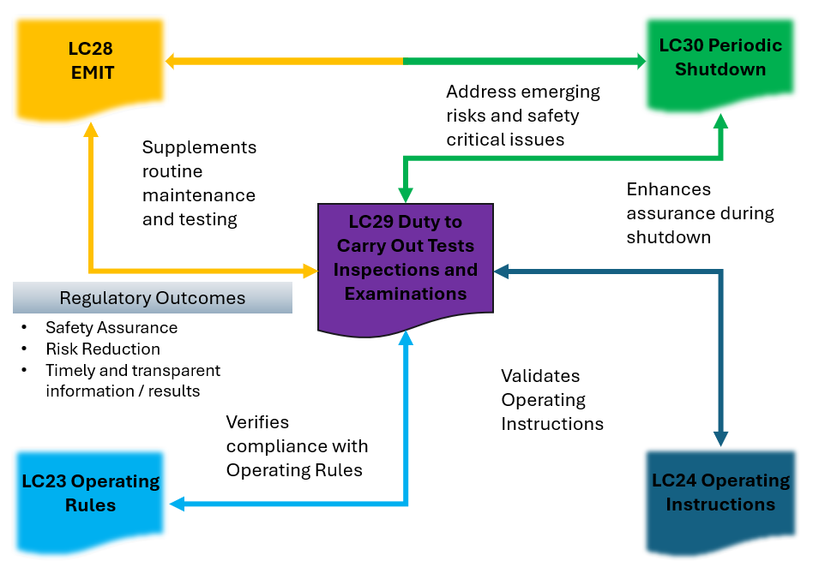
Figure 1 - Illustration of interactions with other relevant LCs.

References
There are no sources in the current document.

Document control information
Authored by – Nuclear Safety Inspector
Approved by – Head of Profession – Operational Inspection
Issue: 6.1
Published: April 26
Next scheduled review: January 31
Document reference: NS-INSP-GD-029
Record reference: ONRHH-822789359-20603

Revision commentary
Issue | Description of update(s)
6 | Updated template
6.1 | Minor update – document simplified/duplication removed, no major change to outcomes or intent.

