ONR Framework Document
Framework for the assignment of regulatory attention levels



Contents
1. Introduction 3
2. Derivation of attention levels 6
3. Governance of regulatory attention levels 12
4. Implications of enhanced attention levels 14
Appendix A – Regulatory attention level timeline 15
Appendix B – Nuclear security attributes 16
Appendix C – Nuclear safeguards attributes 18
Appendix D – Transport attributes 19
Appendix E – Nuclear site health and safety attributes 20
Appendix F – Nuclear safety attributes 21
References 24
Document control information 25

Introduction
- Assigning regulatory attention levels (RAL) is an important aspect of how ONR targets its attention and supports transparency of our regulatory activities with those we regulate.
- This document sets out a structured framework enabling inspectors to consistently determine our future regulatory attention for a dutyholder based upon their current performance and knowledge of the dutyholder activities in year.
- The RAL outputs and associated governance support ONR’s demonstration of aligning to the Regulators Code [1] and with key ONR policies of Risk Informed and Targeted Engagements (RITE) [2] and the Enforcement Policy Statement (EPS) [3] (refer to Figure 1).
- The output of the RAL is also an input to the annual Chief Nuclear Inspectors (CNI) report.

Purpose
- The purpose of this framework is to:
- Provide the process for recording a structured view of ONR’s overall assessment of dutyholder performance against a defined criterion.
- Support targeted regulatory effort based on risk and intelligence.
- Provide enhanced visibility, auditability and transparency of our regulatory decisions.
Regulators Code
Statutory duties to enable those that we regulate, both to comply with the law and to be able to grow. We base our regulatory activities on risk. Ensure that our approach to our regulatory activities is transparent.

Enforcement Policy Statement
In allocating resources ONR should have regard to the enforcement principles, the objectives published in its Corporate Plan, and the need to maintain an appropriate balance between enforcement and other activities, including inspection.
Our enforcement principles: proportionality in applying the law and securing compliance; consistency of approach; targeting of enforcement action; transparency about how the regulator operates and what those regulated may expect; and accountability for the regulator’s actions.
Risk Informed and Targeted Engagements Policy
We focus on those activities giving rise to the most serious risks, or where the related hazards or vulnerabilities are least well controlled, or where we decide that ongoing compliance with relevant legislation needs to be established. 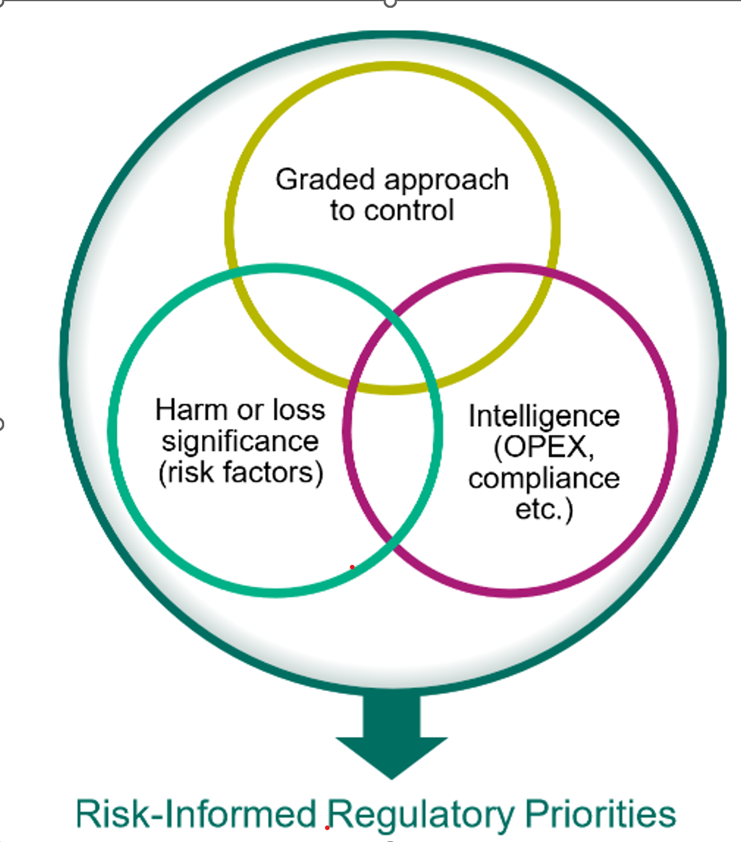

Figure 1 - How assigning RAL aligns with ONR policy and the Regulators Code.
Annually assigning RAL and applying governance to the outputs
Supports how we demonstrate alignment to ONR policies and the Regulators Code. Along with our planning and ‘golden thread’ with the ONR Strategy, Corporate Plan and directorates priorities.

Scope and applicability
- Assigning dutyholder attention levels is not required in all instances, for directorates there is a level of discretion which can be applied.
- In general, ONR expects that in each financial year and aligned to this guidance, purpose lead inspectors, Heads of Regulation (HoR) and Directors of Regulation (DoR) should plan to be involved in:
- Completing RAL assessments for ONR’s safety, security and safeguards regulatory purposes, where applicable, at all GB Nuclear Licenced Sites.
- Recording, endorsing and consolidating the RAL results across a sub-Directorate.
- Presenting for moderation the RAL results as part of Directorate governance arrangements.
- It is for the discretion of the HoR and DoR to apply this RAL process to the following as they deem appropriate, and inspectors should check with directorates on what is expected:
- Safety and/or security for specific facilities within a licensed site, licensee corporate bodies, other linked organisations and/or nuclear construction site.
- Safety at defence authorised sites.
- Security for non-licensed site and Class A/B transport carrier NISR 2003 dutyholders.
- CDG Class 7 Transport, considering whether thematic, sector or individual dutyholders, is most appropriate.
- Any other dutyholder.

Derivation of attention levels
- The timeline for completing the attention levels annually is detailed in Appendix A. The commencement of this process will be driven by the DoR.
- It is usually the Nominated Site Inspector (NSI) and the purpose specific leads for the site who draft the regulatory attention levels. There are no set rules, but involvement from specialist inspectors who have been involved in the regulation of the site during the year is recommended for their perspectives and input, as well as additional intelligence of any specialism specific themes.
- The overall regulatory attention levels assigned for ONR purposes to each dutyholder combines judgements across a range of attributes.
Inspectors should utilise WIReD and associated dashboards as the basis for the data and knowledge management for most processes (for example, inspections, incidents) to inform the indicators.
- Attention ratings against each individual indicator should assist inspectors in their judgement of an overall attention level for a dutyholder for ONR purposes. The narrative against each indicator should be succinct and evidence, not opinion based.
- ONR is a sampling organisation, and it may be the case that no intelligence or evidence has been collected for a specific attribute. In such cases, it is acceptable to state that no evidence has been collected and ascribe a routine level of regulatory attention.
- It is for individual directorates to apply their regulatory judgements on the extent to which individual indicators inform the overall attention levels assigned and to consider what is proportionate to record for those sites which are in routine regulatory attention.
- Indicators that are rated higher than routine may usefully inform inspectors where additional regulatory focus may be targeted, as part of their intervention planning, even if the overall attention level is designated as ‘Routine’.
- Purpose specific templates [4] [5] [6] [7] [8] and a combined safety purposes [9] are available on HOW2 Hub, which have guidance associated with the indicators included in them. There is an ‘any other dutyholder’ template, which can be used for licensee corporate bodies if appropriate [10].
- The attributes are tailored for each regulatory purpose. Refer to Appendices B – F for more detail on these.
- The following broad definitions apply to the three regulatory attention levels that may be assigned (Table 1 to Table 3).
Table 1 - Regulatory attention level 3
3 | Level 3 – Routine regulatory attention
3 | Nuclear safety purpose - ONR has undertaken routine planned inspection and nuclear safety permissioning activities and nuclear risks associated with the dutyholder’s activities are well managed in accordance with an adequate and up-to-date safety case. There is not a repeated history of formal enforcement activity.
3 | Nuclear site health and safety purpose – Dutyholders demonstrate visible and proactive safety leadership, understand the organisation’s nuclear site health and safety performance and maintain attention on the significant health and safety risks. There is not a repeated history of formal enforcement.
 | Nuclear security purpose - ONR has undertaken routine planned compliance inspections and related regulatory engagement and nuclear risks associated with the dutyholder’s activities are well managed in accordance with an adequate and up-to-date security plan. There is not a repeated history of formal enforcement activity.
 | Nuclear safeguards purpose - ONR has undertaken routine planned compliance inspections and assessments of dutyholder Basic Technical Characteristics (BTCs) and Accountancy and Control Plans (ACPs). Nuclear material accountancy reporting is adequate and submitted in a timely manner and dutyholder activities are managed in accordance with an adequate and up to date ACP. Where required, the dutyholder has facilitated IAEA activities in support of the UK meeting its international safeguards obligations. There is not a repeated history of formal enforcement activity.
 | Transport purpose - ONR has undertaken routine planned compliance inspection, transport permissioning activities and reviewed other forms of regulatory intelligence and the dutyholder’s activities are well managed in accordance with relevant legislation for the transport of radioactive material (Class 7 dangerous goods). There is not a repeated history of formal enforcement activity.

Table 2 - Regulatory attention level 2
2 | Level 2 – Enhanced regulatory attention
2 | Nuclear safety purpose - Enhanced regulatory attention describes a higher level of regulatory activity paid to the dutyholder. This may be influenced by:  - An increasing level of risk or hazard profile in the licensee’s undertakings  - Recent formal enforcement activity, particularly of repeated nature,  - Challenging and complex assessment issues that require enhanced specialist inspector attention  - Emergent or long-standing safety issues and/or the risk associated with the facilities in question.
2 | Nuclear site health and safety purpose – Enhanced regulatory attention describes a higher level of regulatory activity. This may be influenced by:  - Inadequate nuclear site health and safety leadership – reactive in nature (responding to the regulator’s gaze, rather than proactively managing health and safety, and over-reliance on ‘lagging indicators to judge health and safety performance).  - Inadequate arrangements for risk profiling resulting in failure to prioritise significant health and safety risks or respond to a changing risk profile.  - Declining health and safety performance in key risk areas and/or failure to achieve sustained compliance resulting in repeated formal enforcement action.  - Repeated failure to deliver against agreed programmes of improvement in key risk areas.  - Serious shortfalls in assurance/monitoring of nuclear site safety performance.
Nuclear security purpose - Enhanced regulatory attention describes a higher level of regulatory activity paid to the dutyholder. This may be influenced by:
- An increasing level of risk or hazard profile in the licensee’s undertakings
- Recent formal enforcement activity, particularly of repeated nature,
- Challenging and complex assessment issues that require enhanced specialist inspector attention.
- Emergent or long-standing security issues and/or the risk associated with the facilities in question.
Nuclear safeguards purpose - Enhanced regulatory attention describes a higher level of regulatory activity paid to the dutyholder. This may be influenced by:
- An increasing level of safeguards significance in the dutyholders undertakings
- Evidence of issues in facilitation of the IAEAs safeguards activities which may impact on the UKs ability to meet its international safeguards obligations
- Recent formal enforcement activity, particularly of a repeated nature (including issues with nuclear material accountancy reporting)
- Emergent or long-standing safeguards issues and/or the safeguards significance associated with the facilities in question
 | Transport purpose - Evidence of significant instances of non-compliance or other issues demanding ONR attention or enforcement to oversee effective resolution.

Table 3 - Regulatory attention level 1
1 | Level 1 – Significantly enhanced regulatory attention
1 | Nuclear safety purpose - Significantly enhanced attention is based upon the factors above at Level 2 but may also be influenced by:  - Changes in our regulatory strategy to achieve hazard and risk reduction across sites over a shorter period of time.  - Sustained failure to address long-standing safety issues and/or the risk associated with the facilities in question despite current or previous enhanced regulatory attention.
1 | Nuclear site health and safety purpose – Significantly enhanced attention is based upon the factors at level 2 but may also be influenced by:  - Sustained failure to respond to enhanced regulatory attention status.  - Repeated failure of leadership to address nuclear site health and safety poor performance.  - Significant failures in the health and safety management systems, giving rise to repeated serious/high potential events/ROSPIs.
Nuclear security purpose - Significantly enhanced attention is based upon the factors above at Level 2 but may also be influenced by:
- Changes in our regulatory strategy to achieve hazard and risk reduction across sites over a shorter period of time.
- Sustained failure to address long-standing security issues and/or the risk associated with the facilities in question despite current or previous enhanced regulatory attention.
- Increasing and repeated non-compliances over the period.
Nuclear safeguards purpose - Significantly enhanced attention is based upon the factors above at level 2 but may also be influenced by:
- Changes to our regulatory strategy to achieve safeguards improvements required over a short time period.
- Sustained failure to address longstanding safeguards issues despite current or previous enhanced regulatory attention.
- Failure to submit timely and adequate nuclear material accountancy reports.
- Failures in facilitation of IAEA safeguards activities which means the UK is unable to meet its international safeguards obligations.
Transport purpose - Evidence of serious instances of non-compliance or other issues, which demand ONR attention or enforcement to oversee effective resolution.
- Sustained failure to address long-standing transport issues despite current or previous enhanced regulatory attention.
- Increasing and repeated non-compliances over the period.

Governance of regulatory attention levels
- Refer to the RAL timeline at Appendix A for prompts. This process commences in October (with the purpose to align with the ONR planning round) and completes at the end of March.
- Sub-directorates will take the proposed RAL’s through governance, confirming:
  - the correct template has been used.
  - regulatory attention levels have been assigned for licensed sites and other specific dutyholders as appropriate to the sub-directorate.
  - evidence based reviews are presented against attributes.
  - consistent approach adopted to assigning RALs for indicators and the initial overall RAL.
  - brief justification for the initial overall RAL is presented. Any regulatory approach (RAL 2 or 1) demonstrates the application of RITE [2].
  - Approval of those assessments.
  - inspectors can indicate to the dutyholder the proposed RAL, noting that additional governance is taking place at which stage you can share the final assessment and details.
- Directorate moderation by the DoR should be completed in relation to those assessments which are at overall level 2 ‘enhanced’ or 1 ‘significantly enhanced’ and any sample that the DoR requests. Confirming:
  - consistent judgements are being made across the directorate.
  - adequate evidence is in place for the RAL being proposed.
  - that the proposed regulatory approach is appropriate, in that it is risk informed and targeted, and will result in a return to a routine RAL over an acceptable timeframe.
  - if RAL is the same as the previous year, content that progress is being made. If it is not being made confirm that the regulatory approach is still appropriate.
  - whether an increase or decrease in overall regulatory attention level is anticipated within the next reporting year and record this.
  - approval of assessments which are at overall level 1 ‘significantly enhanced’ and 2 ‘enhanced’ RAL
  - Output is confirmation of the directorate moderation on the RAL template and a list of regulatory attention levels across the directorate for sites and purposes that apply.
- Regulatory Leadership Team (RLT) review of the compiled list of RALs from directorates. Confirming:
  - consistent judgements are being made across regulatory directorates.
  - that DoR will provide feedback to directorates and confirm the governance process has been finalised and dutyholders can be informed of this.
  - the outcome of this moderation will inform the attention levels specified in the CNI’s annual report published, and that the consolidated and finalised list of RALs is shared with the Communications team.

Implications of enhanced attention levels
- The assignment of ‘enhanced’ attention levels may result in additional regulatory resource allocated to a site to support an enhanced inspection programme or undertake additional specialist assessment. It may also result in a refocus of our regulatory approach resulting in a reduction of regulatory resource.
- Sub-directorates, to support securing a return to routine attention by the dutyholder, may consider the following tactics to inform the regulatory approach:
  - Structured Improvement Plans developed by the dutyholder and overseen by ONR.
  - Level 1 and 2 regulatory issues where relevant to manage and track progress. This also provides oversight of progress with dutyholder plans at DoR and Deputy CNI (DCNI) level.
  - Changes we may need to make to ONR existing inspection plans and management of regulatory issues to prevent distractions from return to routine for the dutyholder.
  - Changes we need to make to the existing Regulatory Interface Meeting (RIM) structure to support regular progress, assurance and oversight. Identify any expectations for the inclusion of the dutyholder internal assurance function, safety representatives or committees, to provide assurance of the improvement plan progress.
  - Communicating the output of the RALs, it is useful to capture in writing but also consider the options of face-to-face communication and a workshop approach to help dutyholders understand the attributes and the conclusion.
  - Notwithstanding the enabling approach we adopt, in cases of non-compliance we apply our formal powers of enforcement proportionately and in line with our Enforcement Policy Statement [3] and the Enforcement Management Model (EMM) [11].
  - If ONR consider that the attention level has changed in year either as a part of the dutyholder progress being or not being made, then the sub-directorate may wish to review the RAL status additional to the RAL timeline in Appendix A, if this is the case escalate the intention through to directorate governance.

Appendix A – Regulatory attention level timeline

Appendix B – Nuclear security attributes
The overall RAL considers the combined judgements across Security Delivery, Security Operations and Security Strategic Enablers (refer to Table 4).

The attributes relating to strategy and operations are drawn from the Security Assessment Principles (SyAPs). Security delivery can be considered more to be a measure of compliance and closing compliance gaps. In all cases, the attributes correlate with ONR's nuclear security performance indicator framework (Figure 2) but with greater regulatory emphasis - as represented by the close relationship to SyAPs.

The template for recording the security RAL [5] has further detail on each of the attribute indicators to support inspectors in completing the RAL for a dutyholder.

Table 4 – Security performance attributes: Overall regulatory attention for security purposes
Security Delivery | Security Operations | Security Strategic Enablers
Dutyholder Compliance record | Physical Protection Systems | Leadership and Management for Security
Number and significance of security regulatory issues and timeliness of resolution | Cyber Security and Information Assurance | Organisational Culture
Enforcement action taken or under consideration | Workforce Trustworthiness | Management of Human Performance
Number and significance of Nuclear Security incidents on the site | Policing and Guarding | Nuclear Supply Chain Management
Delivery of agreed nuclear security improvements | Emergency Preparedness and Response | Reliability, Resilience and Sustainability

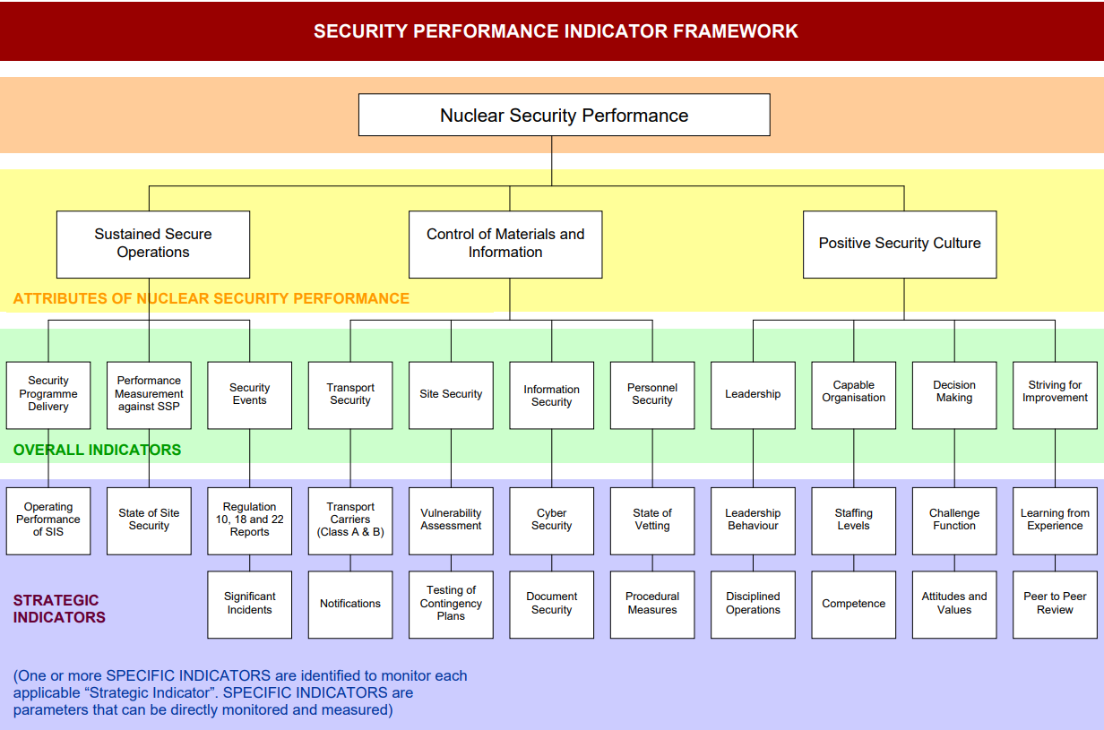
Figure 2 - Security performance indicator framework.

Appendix C – Nuclear safeguards attributes
The overall RALs assigned for safeguards combines assessment across four performance attributes, capturing ONR’s safeguards related purpose.

These indicators correlate with the statutory safeguards requirements and ONRs Nuclear Material Accountancy, Control and Safeguards (ONMACS) fundamental safeguards expectations (FSE) [12].

Evidence to support attributes and indicators should make use of the routine statutory reporting as well as site-based interventions and interactions.

The four attributes, with recommended supporting indicators are summarised in Table 5. The template for recording the safeguards RAL [4] has further detail on each of the attribute indicators to support inspectors in completing the RAL for a dutyholder.

Table 5 - Safeguards performance attributes: Overall regulatory attention for safeguards purposes.
Safeguards delivery | Strategic enablers | NMAC system | Nuclear Material Accountancy
Operator programme of activities  Nuclear safeguards incidents and follow-up  Regulatory issues and operator response  Formal enforcement action  Observations and issues received in formal letters from the IAEA  Delivery of information required by NSR19  Delivery of other required statutory information (NCAs, APs etc) | Leadership and culture  Organisational capability  Internal assurance and challenge | Nuclear material control  Reliability, resilience and maintenance  Nuclear material accountancy system changes  NMAC documentation and implementation | Records and data processing  NMA reports  Material balance performance

Appendix D – Transport attributes
The overall RALs assigned for transport is a product of dutyholder's regulatory performance with regards to general compliance with The Carriage of Dangerous Goods and Use of Transportable Pressure Equipment Regulations 2009 (as amended) (which invokes the Agreement concerning the International Carriage of Dangerous Goods by Road (ADR) and the Regulations concerning the International Carriage of Dangerous Goods by Rail (RID) into GB legislation) and the Ionising Radiation Regulations 2017 (IRR17).

The three attributes, with recommended supporting indicators are summarised in Table 6. The template for recording the transport RAL [6] has further detail to support inspectors in completing the RAL for a dutyholder.

Evidence to support attributes and indicators should make use of dutyholder compliance inspection history and any interactions such as incident reports, whistleblower concerns etc.

Table 6 - Transport performance attributes: Overall regulatory attention for transport purposes.
Safety Performance | Control of Hazards and Risks | Safety Leadership and Culture
Dutyholder compliance record | Level of hazard and risk posed by the dutyholder’s undertakings | Leadership
Number and significance of regulatory issues and timeliness of resolution | Package Design Safety Report (PDSR) adequacy and currency | Capable Organisation
Enforcement action taken or under consideration | Radiation Risk Assessment (RRA) adequacy | Decision making
Number and significance of notifiable incidents | Emergency preparedness and response capability | Learning

Appendix E – Nuclear site health and safety attributes
Nuclear site health and safety (NS H&S) is a product of dutyholder's regulatory performance with regards to general compliance with relevant statutory provisions and associated guidance, including:
- The Management of Health and Safety at Work Regulations 1999, Managing for Health and Safety (HSG65), Leading Health and Safety at Work (INDG417).
- The Construction (Design and Management) Regulations 2015, Managing Health and Safety in Construction (L153)
- The Control of Major Accident Hazards Regulations 2015, The Control of Major Accident Hazards Regulations – Guidance on the Regulations (L111)
The three attributes, with recommended supporting indicators, are summarised in Table 7. The template for recording the NS H&S RAL [8] has further detail on each of the attribute indicators to support inspectors in completing the RAL.
Evidence to support attributes and indicators should make use of dutyholder compliance inspection history and any interactions such as incident reports, whistleblower concerns etc.
Table 7 - NS H&S performance attributes: Overall regulatory attention for NS H&S purposes.
Safety Performance | Control of Hazards and Risks | Safety Leadership and Culture
Dutyholder compliance record | Level of hazard and risk posed by dutyholders undertaking. | Leadership for NS H&S
Number and significance of Industrial Safety incidents and RIDDOR reportable events | Maturity of nuclear site safety risk profiling and prioritisation. | Nuclear Site Health and Safety Culture
Number and significance of regulatory issues and timeliness of resolution | Effectiveness of arrangements for risk assessment | Capable Organisation
Enforcement action taken or under consideration | Adequacy of risk control measures | Learning
Delivery of Industrial and Fire Safety Improvements |  | Internal Assurance and Challenge

Appendix F – Nuclear safety attributes
The overall RALs assigned for nuclear safety combines assessment across three performance attributes.
These indicators correlate with ONR’s Nuclear Safety Performance Indicator framework but with greater regulatory emphasis. ONR, in consultation with the Safety Directors Forum (SDF), has tailored the safety performance indicator framework [13], which was originally designed with nuclear power plant operations in mind and broadened the application to the wider nuclear industry (Figure 3).
‘Safety Performance’ is a product of dutyholder compliance record, incidents on the site and delivery against agreed or required safety enhancements. This aligns closely to the ‘sustained excellence of operations’ attribute in the nuclear safety performance indicator framework. Dutyholders maintain a wide variety of metric-based indicators to measure safety performance. For attention level assessment, inspector judgement is required considering their interactions with and tacit knowledge of the site and its performance in-year. This may consider the dutyholder’s own performance indicators.
The ‘Control of Hazard and Risk’ attribute is a product of the level of hazard and risk posed by the licensee’s undertakings and the adequacy with which the licensee demonstrates that risks are controlled so far as is reasonably practicable in accordance with an adequate and live safety case. As part of this consideration, the licensee’s onsite emergency preparedness and response capability should be considered in terms of their capability to manage and respond to fault progression within and beyond the design basis. The adequacy of conventional health and safety risk profiling should also be considered.
ONRs Technical Inspection Guide (TIG) on ‘Organisational Culture Guide for Inspectors’ [14] advocates the use of cultural warning flags as a way of routinely gathering insights from interventions on site. The LMfS SAPs are the basis for the attention level assessment 'Positive Safety Culture' attribute, and the health of the warning flags can be used as further indicators to highlight a deteriorating organisational culture and to inform the regulatory attention level assessment.
The outcome from this assessment can be used to inform the 'safety leadership and culture' indicator to reflect those areas that have emerged during engagements with dutyholders.
The three attributes, with recommended supporting indicators are summarised in Table 8. The template for recording the nuclear safety RAL [7] has further detail on each of the attribute indicators to support inspectors in completing the RAL.

Table 8 - Nuclear safety performance attributes: Overall regulatory attention for nuclear safety purposes.
Safety Performance | Control of Hazards and Risks | Safety Leadership and Culture
Licensee Compliance record | Level of Hazard and Risk posed by the dutyholder’s undertakings | Leadership
Number and significance of regulatory issues and timeliness of resolution | Nuclear safety case adequacy and currency | Capable Organisation
Enforcement action taken or under consideration | Emergency preparedness and response capability | Decision making
Number and significance of Nuclear Safety incidents on the site | Management of Radioactive Waste | Learning
Delivery of agreed Nuclear Safety Enhancements | Timely Decommissioning to reduce risk | Internal Assurance and Challenge
Plant status (control of modifications and maintenance) | Transport

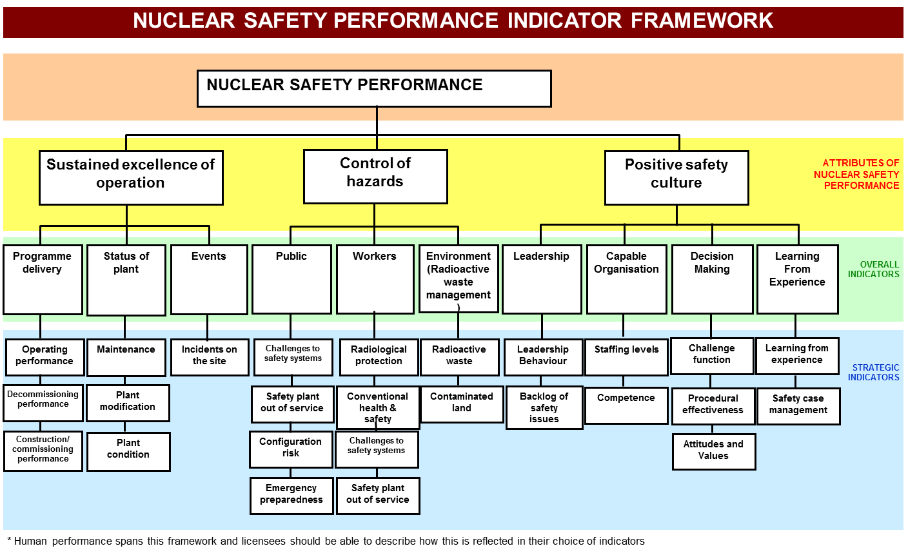
Figure 3 - Nuclear safety performance indicator framework.

References

[1] | HM Government, “Regulators' Code,” 2014. [Online]. Available: https://assets.publishing.service.gov.uk/media/5f4e14e2e90e071c745ff2df/14-705-regulators-code.pdf.
[2] | ONR, “ONR-RD-POL-002 - Risk-Informed and Targeted Engagements”.
[3] | ONR, “ONR-ENF-POL-001 - Enforcement Policy Statement”.
[4] | ONR, “ONR-DOC-TEMP-452 - Recording nuclear safeguards purpose attention levels (RALs) assessment for licensed sites”.
[5] | ONR, “ONR-DOC-TEMP-449 - Security purpose dutyholder attention levels assessment template”.
[6] | ONR, “ONR-DOC-TEMP-451 - Recording attention levels for transport template”.
[7] | ONR, “ONR-DOC-TEMP-447 - Recording nuclear safety purpose attention levels (RALs) assessment for licensed sites”.
[8] | ONR, “ONR-DOC-TEMP-448 - Recording nuclear site health and safety purpose attention levels (RALs) assessment for licensed sites”.
[9] | ONR, “ONR-DOC-TEMP-450 - Recording combined safety (nuclear safety and nuclear site health and safety (NS H&S)) attention levels assessment for licensed sites”.
[10] | ONR, “ONR-DOC-TEMP-453 - Recording attention levels for other dutyholders (including licensee corporate bodies) template”.
[11] | ONR, “ONR-ENF-GD-006 - Enforcement Management Model (EMM)”.
[12] | ONR, “ONR-CNSS-MAN-001 - ONR Nuclear Material Accountancy Control and Safeguards Assessment Principles”.
[13] | IAEA, “TECDOC-1141 - Operational Safety Performance Indicators for Nuclear Power Plants,” 2000. [Online]. Available: https://www.iaea.org/publications/5945/operational-safety-performance-indicators-for-nuclear-power-plants.
[14] | ONR, “NS-INSP-GD-070 - Organisational Culture Guide for Inspectors”.

Document control information
Authored by – Head of Function for Site Inspection
Approved by – Deputy Director Capability and Standards
Issue: 4
Published: August 2026
Next scheduled review: August 2030
Document reference: ONR-RD-FW-002

Revision commentary
Issue | Description of update(s)
4 | Major review (on the basis content has substantially changed from the previous issue) to:  - Clarify the alignment with ONR policies e.g. RITE.  - Include a process flow for completing the RAL and associated governance.  - Clarify when a RAL is required and discretionary areas.  - Update and remove the RAL tables from the guidance and include as templates on HOW2 Hub.  - Incorporate feedback from Regulatory Directorate on the use and areas where it can be improved e.g. NS H&S, management of radioactive waste.  - Document changed from a guide to a framework document to bring it inline with ONR management system hierarchy. Document reference updated from ONR-GEN-GD-013 to reflect the change.

Safety purposes covering nuclear safety, nuclear site health and safety (including conventional health and fire life safety), storage and use of nuclear matter and arrangements for the decommissioning of relevant nuclear installations.
For relevant licensed sites as not deemed proportionate for qualifying nuclear facilities with limited operations (QNFLO) dutyholders.
There are a combined safety template or separate templates for nuclear site health and safety and nuclear safety depending on which best suits your needs as a sub-directorate.

