ONR Project Assessment Report
Generic Design Assessment of the Rolls-Royce SMR – Step 1 summary

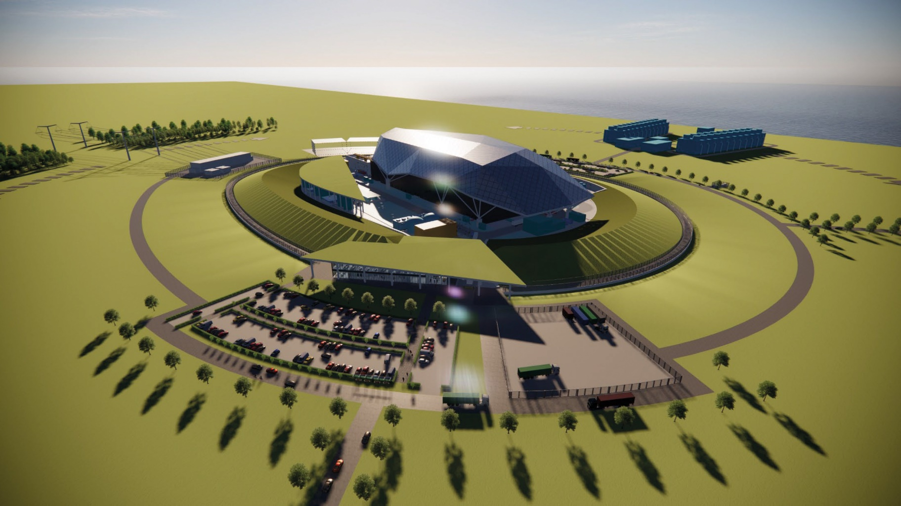

ONR Project Assessment Report
Project Name: Generic Design Assessment of the Rolls-Royce SMR
Report title: Step 1 summary

Dutyholder/Applicant: Rolls-Royce SMR Limited

Authored by: [REDACTED], Principal Inspector, ONR
ONR Report Ref. No.: ONRW-2019369590-1908
Report Issue No.: 0
Publication Date: April-23

Table 1: Circulation (latest issue)
Organisation | Recipient | Date Report Sent
ONR | [REDACTED], Director of Regulation  [REDACTED], Delivery Lead  [REDACTED], Delivery Management Group Lead  [REDACTED], Delivery Management Group Lead  [REDACTED], Delivery Management Group Lead  [REDACTED], Programme Manager | 03/04/23
Environment Agency | [REDACTED], Specialist, Nuclear Regulation Group North | 03/04/23
Natural Resources Wales | [REDACTED], Senior Specialist Advisor, Evidence, Policy and Permitting | 03/04/23
Dutyholder/ applicant | [REDACTED], Safety and Regulatory Affairs Director  [REDACTED], Head of Regulatory Affairs  Regulatory Interface Office | 03/04/23

© Office for Nuclear Regulation, 2023
For published documents, the electronic copy on the ONR website remains the most current publicly available version and copying or printing renders this document uncontrolled. If you wish to reuse this information visit www.onr.org.uk/copyright for details.
All images © Rolls-Royce SMR Ltd, used with permission.

Executive summary
In April 2022, the Office for Nuclear Regulation (ONR), together with the Environment Agency and Natural Resource Wales, began Step 1 of the Generic Design Assessment (GDA) of the Rolls-Royce SMR design. During the last 12 months, we have undertaken activities to initiate and establish the project and to prepare for technical assessment in later steps. These activities are defined within our GDA guidance document, Guidance to Requesting Parties.

This report has been produced:
- To document the completion of and outcomes from Step 1;
- To summarise the activities undertaken by both Rolls-Royce SMR Limited and ONR during the step;
- To summarise ONR’s judgements, particularly regarding whether the objectives for Step 1 have been met; and
- To document the basis for the decision on whether to proceed to Step 2, or not.
Rolls-Royce SMR Limited is the Requesting Party (RP) for the GDA. It is a recently formed company created to design and build the Rolls-Royce SMR (although design work started within Rolls-Royce plc in 2015). Its design is a 470 MWe pressurised water reactor which uses well-established technology in operation all over the world. Innovation comes in the form of its modular approach to construction which would see many components built in factory conditions and assembled on site. The design is being developed during the GDA and in parallel with the RP’s safety, security, safeguards (and environmental) cases (referred to as the ‘E3S’ case). Our assessment will be the first time that the design has been subject to regulatory scrutiny.

We have undertaken activities which have allowed us to fulfil the objectives for Step 1. These are for ONR and the RP to agree:
- The GDA scope;
- The documentary basis for the generic safety and security cases that will be submitted for assessment throughout GDA;
- The gaps that have been identified by the RP in meeting regulatory expectations and the resolution plans for how these may be resolved;
- The RP’s arrangements necessary to undertake the GDA; and
- The schedule and associated programme for subsequent steps.

During Step 1 we have undertaken more than 200 engagements and assessed more than 40 submissions. The information submitted met all the requirements from our guidance and demonstrated a good understanding of UK practice and regulatory expectations. We take confidence from these submissions that the RP has a clear view of what is needed to progress through the GDA and how it will justify its design.
Rolls-Royce SMR Limited has confirmed that it intends to complete a 3 step GDA with the objective of receiving a Design Acceptance Confirmation (DAC), if judged acceptable by ONR. The overall duration for GDA is expected to be 53 months, completing in August 2026. Step 2 is expected to take 16 months. Progression from Step 2 to 3 is subject to the RP securing additional funding during Step 2.
We have agreed a defined GDA scope with the RP. This is consistent with previous GDAs and Rolls-Royce SMR Limited’s stated objective of receiving a DAC. The GDA scope defines the generic plant and layout and includes all systems, structures and components that are identified as being important to safety, security and safeguards, all modes of operation, and all stages of the plant lifecycle. Where aspects are declared as being of reduced or out of scope, we are content that these are justified and appropriate. Overall, we are satisfied that the agreed GDA scope will allow for a meaningful assessment of the generic design.
We have assessed the arrangements that the RP has developed to undertake the GDA, which included specific interventions by our Management of Safety and Quality Assurance (MSQA) specialists. The RP has developed considerably in this regard during Step 1 including an overarching management system which it is subjecting to external audits. The integration of GDA specific arrangements into its wider business and engineering arrangements is a particular strength. Overall, we are content that sufficient progress has been made during Step 1, and plans for further development and implementation during Step 2 are sufficient.
Rolls-Royce SMR Limited are using a combined systems engineering and safety analysis approach, where the design and justifications inform and reinforce each other. The RP is using digital tools to benefit its work. This integrated approach, aided by modern practices and tools, is a strength in the RP’s plans.
The Environment, Safety, Security and Safeguards cases are being developed holistically as an E3S case, based on documented strategies and using a hierarchical Claim, Argument and Evidence (CAE) approach. The scope is intended to align with relevant international guidance and covers all the technical topics we consider. We are satisfied that the proposed E3S approach is logical, suitably structured and will give the RP means to control the development of its design. We recognise the early production of clear strategies and the holistic approach to be good practices adopted by the RP.
We have agreed a submission schedule with the RP, which includes the submission of more than 500 documents during Step 2. We are content that this aligns with our assessment plans, the agreed GDA scope and the RP’s declared schedule for GDA. The RP has stated it has sufficient resource to deliver the submissions identified for Step 2 to the agreed schedule. Given the outstanding need to secure funding beyond Step 2 activities, the schedule for submissions for Step 3 has not been agreed at this time.
In line with our guidance, the RP undertook a self-assessment and review of its own readiness to proceed to Step 2. The RP also undertook a review of its organisational capacity and capability and a gap analysis of its planned submissions to support Step 2, as part of its wider E3S case, against regulatory expectations. We judge that the process undertaken by the RP was reasonable, proportionate and sufficiently robust for this step of GDA. The overall conclusion of the RP’s readiness review is that it considers itself ready to begin Step 2, subject to completion of some improvement actions.
The actions identified by the RP include improvements in its organisation, arrangements, and capacity and capability. We are content that the self-identified actions accurately reflect the outcomes from the RP’s readiness review and are consistent with our work during the step. We will review progress and hold the RP to account on the delivery of these during Step 2.
We have used the knowledge gained during Step 1 to inform our detailed planning within the 21 assessment plans we have developed for Step 2.
We undertook a review of our own readiness to proceed to Step 2. We conclude that, based on the agreed GDA scope and submission schedule, the assessment will remain meaningful during Step 2 and warrants the continued deployment of regulatory resource. The outcome from our readiness review was that we consider we are ready to proceed to Step 2 of GDA for the Rolls-Royce SMR.
In summary:
- The RP has completed all the requirements for Step 1 from our guidance;
- Interactions with the RP throughout Step 1 have been professional and constructive, and we have confidence that this will continue;
- The RP has made good progress in developing its organisation and arrangements to support GDA, with clear evidence of improvements;
- The agreements necessary to undertake the GDA are in place, or have developed sufficiently for this point in the project with clear plans for further development;
- The RP has demonstrated a good understanding of our regulatory expectations and has confidence that these can be met by its design and E3S case;
- We have improved our understanding of the generic Rolls-Royce SMR design and E3S case, and have used this to inform our planning for further assessment activities; and
- We, and the RP, are ready to proceed to Step 2 of the GDA.
Based on our work during Step 1, we recommend that ONR should proceed to Step 2 of the GDA for the generic Rolls-Royce SMR design.

List of abbreviations
ALARP As low As Reasonably Practicable
ASME American Society of Mechanical Engineers
BAT Best Available Technique
BEIS (the department of) Business, Energy and Industrial Strategy
C&I Control and Instrumentation
CAE Claim, Argument and Evidence
CDF Core Damage Frequency
CDR Critical Definition Review
CRDM Control Rod Drive Mechanism
DAC Design Acceptance Confirmation
DR Design Reference
DRx Definition Review, with x being a sequential number
DRP Design Reference Point
E3S Environment, Safety, Security and Safeguards
EBI Emergency Boron Injection
ECCS Emergency Core Cooling System
EMP Engineering Management Plan
FCD Final Concept Definition
GB Great Britain
GDA Generic Design Assessment
GSE Generic Site Envelope
GSR Generic Security Report
HPIS High Pressure Injection System
IAEA The International Atomic Energy Agency
IMS Integrated Management System
ISO International Organization for Standardization
IVR In-Vessel Retention
LOCA Loss of Coolant Accident
LLI Long Lead Item
LUHS Local Ultimate Heatsink System
MDSL Master Document Submission List
MRI Master Records Index
MSQA Management for Safety and Quality Assurance
NISR Nuclear Industries Security Regulations
NPP Nuclear Power Plant
NRW Natural Resources Wales
ONR Office for Nuclear Regulation
OPEX Operational Experience
PCC Passive Containment Cooling
PCD Preliminary Concept Definition
PCSR Pre-construction Safety Report
PDHR Passive Decay Heat Removal
PSA Probabilistic Safety Analysis
PSR Preliminary Safety Report
PSyR Preliminary Security Report
PWR Pressurised Water Reactor
RCS Reactor Coolant System
RGP Relevant Good Practice
RI Regulatory Issue
RO Regulatory Observation
RP Requesting Party
RPV Reactor Pressure Vessel
RVCIS Reactor Vessel Cavity Injection System
RQ Regulatory Query
SAP Safety Assessment Principle(s)
SbD Secure by Design
SG Steam Generator
SMR Small Modular Reactor
SNI Sensitive Nuclear Information
SSC Structure, System and Component
TAG Technical Assessment Guide (ONR)
UK United Kingdom
WENRA Western European Nuclear Regulators Association

Contents

1. Purpose 10
2. Background 11
3. Work carried out by ONR in consideration of this request 27
4. Matters arising from ONRs work 30
5. Conclusions 51
6. Recommendations 53
References 54

Tables
Table 1: Step 1 requirements from Guidance to Requesting Parties
Figures
Figure 1: Rolls-Royce SMR layout
Figure 2: Reactor island plan view
Figure 3: Cross-section of reactor island base isolation system
Figure 4: Containment vessel schematic
Figure 5: Reactor Coolant System (RCS) layout
Figure 6: Passive Decay Heat Removal (PDHR) system schematic
Figure 7: Emergency Core Cooling System (ECCS) schematic
Figure 8: Reactor Vessel Cavity Injection System (RVCIS) schematic
Figure 9: Claim, Argument Evidence (CAE) structure within the E3S hierarchy
Figure 10: Integrated Management System (IMS) hierarchy
Figure 11: Rolls-Royce SMR Limited definition review gates and engineering milestones

Purpose
- Following a request from the Department of Business, Energy and Industrial Strategy (BEIS), in April 2022, the Office for Nuclear Regulation (ONR), the Environment Agency and Natural Resources Wales (NRW) began Step 1 of the Generic Design Assessment (GDA) for Rolls-Royce SMR Limited's reactor design.
- During the last 12 months we have undertaken those activities identified for Step 1 within our GDA guidance document, Guidance to Requesting Parties (ref. [1]). These are mainly associated with initiation of the project and preparation for technical assessment in later steps.
- This report has been produced:
To document the completion of and outcomes from Step 1;
To summarise the activities undertaken by both Rolls-Royce SMR Limited and ONR during the step;
To summarise ONR’s judgements, in particular regarding whether the objectives for Step 1 have been met; and
To document the basis for the decision on whether to proceed to Step 2, or not.

Background

Generic Design Assessment
- ONR is the UK’s independent nuclear regulator, with the legal authority to regulate nuclear safety, civil nuclear security and safeguards, and conventional health and safety at the 35 licensed nuclear sites in Great Britain (GB). We also regulate the transport of civil nuclear and radioactive materials by road, rail and inland waterways. ONR’s mission is to protect society by securing safe nuclear operations.
- The environment protection aspects of the generic design are assessed and reported separately (ref. [2]) by the environment agencies (the Environment Agency and NRW) whom we work with closely during GDA. There is separate guidance which provides an overview of the processes followed by the regulators and how those processes are integrated (ref. [3]). The Environment Agency has also published separate guidance on the process it follows (ref. [4]).
- The GDA process was developed in response to the government's 2006 Energy Review; in particular lessons learnt from experience with new Nuclear Power Plants (NPPs) indicated that the use of a standardised design, where the design and safety case are well developed much earlier in the project, would facilitate a reduction in the time for regulatory assessment as well as minimise any potential regulatory uncertainty for a future site licensee wishing to build such a design. Although GDA is not a mandatory process, because of its inherent benefits it is expected that it will usually be requested for new NPPs intended for construction in GB.
- The objective for GDA is to provide confidence that the proposed design is capable of being constructed, operated and decommissioned in accordance with the standards of safety, security, safeguards and environmental protection required in GB. For the Requesting Party (RP), the organisation(s) who requested the GDA, this offers a reduction in uncertainty and project risk regarding the design and safety, security, safeguards and environmental cases so as to be an enabler to future licensing, permitting, construction and regulatory activities.
- To fulfil this objective, GDA progresses in steps, with the regulatory assessments becoming increasingly detailed. The assessment considers the majority of ONR’s purposes, using inspectors from the full range of technical topics (for example, fault studies, civil engineering or chemistry), as defined in Guidance to Requesting Parties (ref. [1]).

- The GDA process has three steps, noting that earlier GDAs had four steps; a change that resulted from lessons learnt and efficiency improvements implemented in 2019. The overall intent is that:
Step 1 is the initiation step where matters such as the scope and timescales are agreed, and ONR’s knowledge of the design and the RP’s safety, security and safeguards cases increases. Further details on Step 1 are provided in Section 2.2.;
Step 2 is the fundamental assessment of the generic design and safety, security and safeguards cases, to identify any potential ‘showstoppers’ that may preclude deployment of the design; and
Step 3 is the detailed assessment of the generic safety, security and safeguards cases on a sampling basis.
- The Rolls-Royce SMR Limited design is the seventh design to begin a GDA. The first round of GDA started in 2007 when ONR and the Environment Agency began assessment of four designs, although two of these first-round designs were withdrawn by the RP part-way through the assessment process. The remaining two designs, the EDF and AREVA UK EPR™ and the Westinghouse AP1000® designs, subsequently completed GDA in 2012 and 2017 respectively (noting the latter included a pause of several years). In 2013, the Hitachi-GE UK ABWR entered the GDA process, and this was completed in 2017. Also in 2017, the CGN/EDF/GNI UK HPR1000 started a GDA which was completed in 2022. Full details of completed GDA projects are available on the joint regulators’ website (ref. [5]).

Objectives for Step 1
- Step 1 is the project initiation part of the design assessment process. This involves the RP establishing its project management and technical teams, its arrangements for undertaking a GDA and preparing and submitting submissions during Step 1 and for the commencement of Step 2. It also involves discussions with the RP to ensure a full understanding of the requirements and processes that will be applied.
- Therefore, the objectives for Step 1 are for ONR and the RP to agree:
The GDA scope;
The documentary basis for the generic safety and security cases that will be submitted for assessment throughout GDA;
The gaps that have been identified by the RP in meeting regulatory expectations and the resolution plans for how these may be resolved;
The RP’s arrangements necessary to undertake the GDA; and
The schedule and associated programme for subsequent steps.
- Appendix 2 of Guidance to Requesting Parties (ref. [1]) provides further details of what the RP is required to do and what ONR will do during Step 1. Where we have made a judgement against a requirement placed on the RP from this appendix, these are specifically cited in this report.
- A number of the requirements on the RP are to submit information to ONR. These cover matters which are necessary for undertaking GDA (such as project management controls, cost recovery and demonstration of adequate resources) along with matters of a more technical or regulatory nature. They are targeted at ensuring that both the RP and ONR are prepared for the more detailed assessments to be undertaken in later steps.
- During Step 1 our assessment of the RP’s submissions has been limited. The purpose of our assessment was to form a judgement on whether the requirements in Appendix 2 of Guidance to Requesting Parties (ref. [1]) have been met and to provide us with confidence going forwards with the GDA. While the submissions were often technical we did not fully consider the detailed adequacy of the content, nor how it has been applied to the generic Rolls-Royce SMR design or safety, security and safeguards cases, which will be the focus for later steps. We did provide feedback to the RP and highlight any obvious omissions or gaps in meeting regulatory expectations.

Requesting Party
- For the purposes of the GDA, Rolls-Royce SMR Limited is the RP, and therefore the point of contact for the regulators.
- Rolls-Royce SMR Limited is a recently formed company which was formally established on 5 November 2021. It was created as an independent company to draw upon the many decades of experience of nuclear design and engineering in the parent body to deliver the generic Rolls-Royce SMR design. It is backed by the UK government, international investors, and Constellation who are the largest US nuclear operator. The majority shareholding remains with Rolls-Royce plc.
- Rolls-Royce SMR Limited is the designer, responsible for undertaking all aspects of the design, analysis and engineering and production of the safety, security, safeguards and environmental submissions which justify the design.
- Further details of the RP’s capacity, capability and organisation to support GDA are given in Section 4.5.

Rolls-Royce SMR design

Design status
- The generic Rolls-Royce SMR design is being developed as a complete NPP solution based on what the RP claims is an optimised and enhanced use of proven technologies. The RP has stated that the design adopts innovations where these are claimed to add value, focused on providing cost and build assurance while maintaining safety, security, safeguards and environmental standards. It claims this is achieved by using modularised build techniques and off-site manufacturing under factory conditions, both of which are not new approaches but have never been applied to this extent in the nuclear industry.
- Rolls-Royce SMR Limited is the first RP to enter GDA with a design that is not built or under construction worldwide. This means that there is no “reference design” for the purposes of GDA, and the generic design will continue to be developed in parallel with our regulatory assessments. Our assessment of the Rolls-Royce SMR will also be the first time that the design has been considered by regulatory bodies.
- While this represents an opportunity to ensure the design meets UK expectations from the outset, this does emphasise the need to have confidence in the RP’s controls and processes regarding design activities. Our work during Step 1 did start to examine these aspects; see Section 4.

- Development of the design began in the autumn of 2015 when the main foundations for the design were chosen, including the choice to use existing Pressurised Water Reactor (PWR) technology with modular and factory construction techniques. The RP developed a set of key design objectives for the project, based upon functional and commercial needs, including a number related to safety, security or environmental performance which have subsequently been used to inform decision making and further evolution of the design.
- The RP has stated that it is using a combined systems engineering and safety assessment approach for its design activities. This is underpinned by a governance framework for the design to ensure that the solution is optimised to meet all key requirements for safety, security and safeguards. For example, this includes safety requirements that support demonstration that risks are acceptable and reduced to As Low As Reasonably Practicable (ALARP), and equivalents for security and safeguards. Further details of the RP’s design processes and design maturity are given in Section 4.3.

Design overview
- The Rolls-Royce SMR design has been developed by the RP based upon well-established PWR technology, in use all over the world, but the modular approach adopted in the design will see the majority of the power station built in factory conditions and assembled on site. In addition to commercial drivers, the RP claims that this approach will have benefits due to the more controlled environment for manufacture and commissioning.
- The generic Rolls-Royce SMR design is a three loop PWR with a target electrical power output of 470 MWe (from a thermal power of 1,358 MWth) and a design life of 60 years for non-replaceable components.

Layout
- The generic site layout is shown in Figure 1, noting that this diagram excludes the architectural shell which covers the reactor, turbine and cooling water islands, and the earth berm which surrounds the plant. The total site footprint has been optimised to approximately 49,000m².

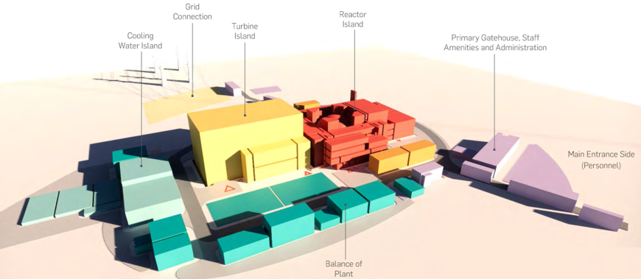

Figure 1: Rolls-Royce SMR layout (ref. [6])
- The design layout features a number of areas or ‘islands’ and includes:
The reactor island includes the Structures, Systems and Components (SSCs) that form the reactor, transfer and storage of new and used fuel, and any associated nuclear auxiliary systems. The purpose of the reactor island is to use the heat from a controlled nuclear fission reaction to generate steam, which is then passed to the Turbine Island.
The turbine island provides the link between the reactor island where steam is generated, and the electrical connections where generated electricity is provided to the power grid. The main equipment in the turbine island is the steam turbine and generator arrangement, where the mechanical energy of steam is converted into electrical energy.
The cooling water island provides the primary means of removing heat from the power station, passing it to the ultimate heat sink. This includes the various cooling water systems needed for operating the plant.
The balance of plant provides a range of ancillary functions to enable the other systems across the power station to achieve their functions, such as the supply of demineralised water and chemicals. This includes the water supply, disposal, treatment system, auxiliary systems, storage systems and ancillary systems.
- A range of electrical and Control and Instrumentation (C&I) systems span the design including systems relating to grid connection and intra-site electrical distribution, including emergency power supplies. It also includes nuclear and non-nuclear C&I systems, covering control, monitoring and protection functions.
- The generic design for GDA utilises cooling towers at a coastal site to provide the main heat sink for the plant during normal operations.
Structures
- The main nuclear significant structures are associated with the reactor island. These include the containment building, fuel and control building, radioactive waste building, access building and auxiliary building. A plan view through the reactor island is shown in Figure 2.

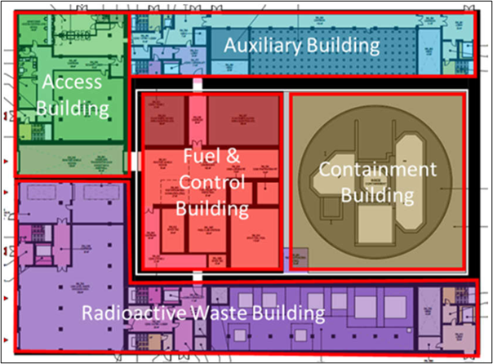
Figure 2: Reactor island plan view (ref. [6])
- A hazard shield, consisting of a reinforced concrete wall and roof, is included in the Rolls-Royce SMR design to provide protection against a radioactive release due to external hazards. The bounding case for the hazard shield is based on an aircraft impact hazard, aiming to ensure confinement of fuel, prevention of criticality, protection of reactor shutdown and cooling systems and protection of monitoring systems. The hazard shield covers the containment building and the fuel and control building to ensure all class 1 SSCs needed for these functions are protected (indicated by the thicker black outline in Figure 2).

- The generic Rolls-Royce SMR design also includes aseismic bearings for a base isolation system within the reactor island. The main benefit of this system is that it is claimed to allow the superstructure to be standardised, along with the equipment in the power station, regardless of site-specific seismicity. The base isolation system is comprised of three main components: the raft foundation, the concrete pedestals and aseismic bearings and the basemat. This is shown in Figure 3. The arrangement allows for the decoupling between the ground and the superstructure, with a gap (labelled as moat) around the perimeter to allow for horizontal displacements. This is claimed to protect the supported structure from the damaging effects of horizontal earthquake shaking in a seismic event. The base isolation applies to both the containment and fuel and control buildings, which house the class 1 and 2 SSCs needed for post-earthquake functionality.

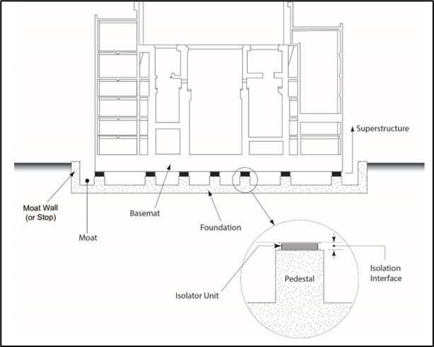

Figure 3: Cross-section of reactor island base isolation system (ref. [6])

- The containment building holds a containment vessel that encloses the reactor, providing confinement of radiation sources and preventing release to the environment in accident conditions. The containment vessel is a large steel pressure vessel, designed and substantiated to American Society of Mechanical Engineers (ASME) III specifications, which contains the components of the Reactor Coolant System (RCS). The vessel is cylindrical and includes a top and bottom dome. The bottom dome is embedded into concrete and supported upon the aseismic bearing. The vessel is approximately 32 m in diameter, 37 m in height with an internal free air volume of around 18,000 m³. The containment vessel is shown in Figure 4.

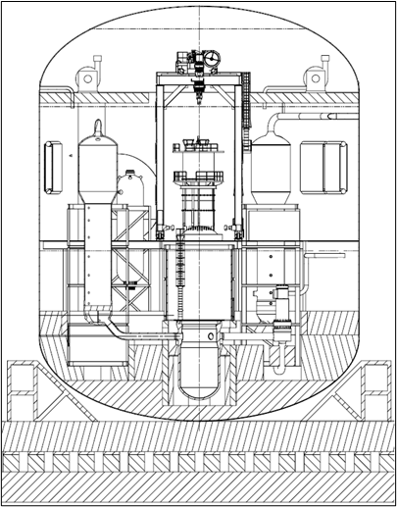

Figure 4: Containment vessel schematic (ref. [6])

Reactor
- The RCS is shown in Figure 5. The RCS is in a three-loop close-coupled configuration, arranged to facilitate natural circulation when pumped flow is unavailable.
- Each loop consists of primary pipes going into and out of the Reactor Pressure Vessel (RPV) (referred to as cold and hot leg respectively), one seal-less reactor coolant pump in the cold leg, and one vertical u-tube Steam Generator (SG). One of the loops contains the pressuriser connected to the hot leg, whose function is to maintain high pressure within the primary reactor circuit and avoid boiling of the coolant. The operational pressure of the primary circuit is 15.5 MPa abs.

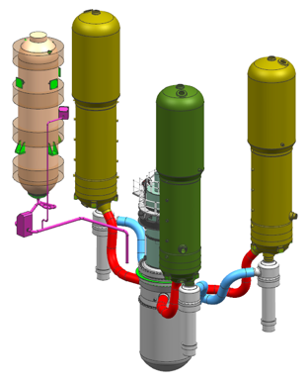

Figure 5: Reactor Coolant System (RCS) layout (ref. [6])

- At the centre of the RCS is the Reactor Pressure Vessel (RPV). The RPV is a cylindrical steel vessel designed to withstand the high temperatures, pressures and radiation of the reactor. The RPV houses the reactor core, in-core instrumentation and the reactor internals. The reactor core is made up of 121 fuel assemblies and 113 control rod assemblies. Each fuel assembly is arranged in a 17x17 array of fuel rods consisting of a metallic zirconium alloy cladding housing the nuclear fuel, which is in the form of small ceramic pellets, which contain up to 4.95% enriched uranium dioxide fuel. The hemispherical upper head of the RPV is removable to allow refuelling of the reactor every 18 months.
- Water is used as the primary coolant, to extract the heat from the reactor, and as a moderator to maintain the nuclear reaction in the core. Hot water from the core outlet passes into the SGs, where it flows through thousands of heat exchange tubes which transfer the heat to the secondary coolant on the outside of the tubes, which is allowed to boil and produce steam. It is this steam produced in the secondary side of the SGs that drives a turbine that ultimately, via a generator, produces electricity. The primary coolant leaving the SGs, which is now at lower temperature, is then pumped back into the reactor via the cold legs. The flowrate of the primary coolant is such that the flow through each loop takes only a few seconds.
- Unlike other commercial PWRs, the generic Rolls-Royce SMR design is designed to operate without soluble boron during normal operations. Rolls-Royce SMR Limited claim that, in addition to simplification of the design, this provides safety benefits including full shutdown margin delivered by the control rods and elimination of boron dilution faults.

Safety systems
- A range of safety measures are present in the Rolls-Royce SMR design to provide cooling, control criticality and contain radioactivity under fault conditions. Reflecting the RP’s design philosophy which prioritises use of passive safety features, active components and supporting electrical supply are claimed not to be significantly risk important. As such, hazards which render active systems unavailable such as complete loss of electrical supplies (station blackout) are claimed to present very low risk. Similarly, failures of operator actions in delivery of safety functions are identified as not significantly important. As a result, a period of 72 hours is predicted before offsite support is required.
- The Rolls-Royce SMR employs both active and passive decay heat removal systems. Condenser decay heat removal utilises the SGs and the normal duty steam condenser to cool the RCS. Passive Decay Heat Removal (PDHR) is a dedicated safety system that utilises the SGs and the Local Ultimate Heatsink System (LUHS) to cool the RCS. In the PDHR system decay heat is transferred to the LUHS water tanks via dedicated submerged heat exchangers. Boiling of the LUHS water to atmosphere provides the ultimate heat sink via passive means which rely on natural circulation. This is shown in Figure 6.

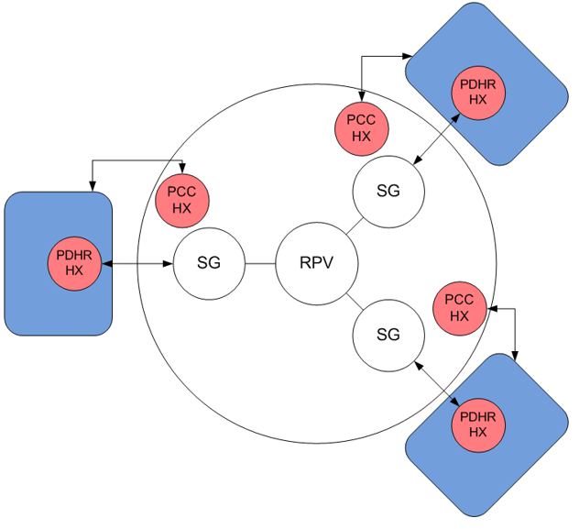

Figure 6: Passive Decay Heat Removal (PDHR) system schematic (ref. [6])
- In circumstances where the SGs are unavailable for decay heat removal, for example in Loss of Coolant Accidents (LOCA), the Emergency Core Cooling System (ECCS) provides a passive, redundant, diverse and segregated protective safety measure. This system provides core cooling in a sequence which involves blowdown of the RCS to the containment through dedicated relief valves, water injection from three accumulator tanks, gravity injection from the refuelling pool and auxiliary LOCA pool and passive circulation from water accumulated within the containment sumps. This is shown in Figure 7.

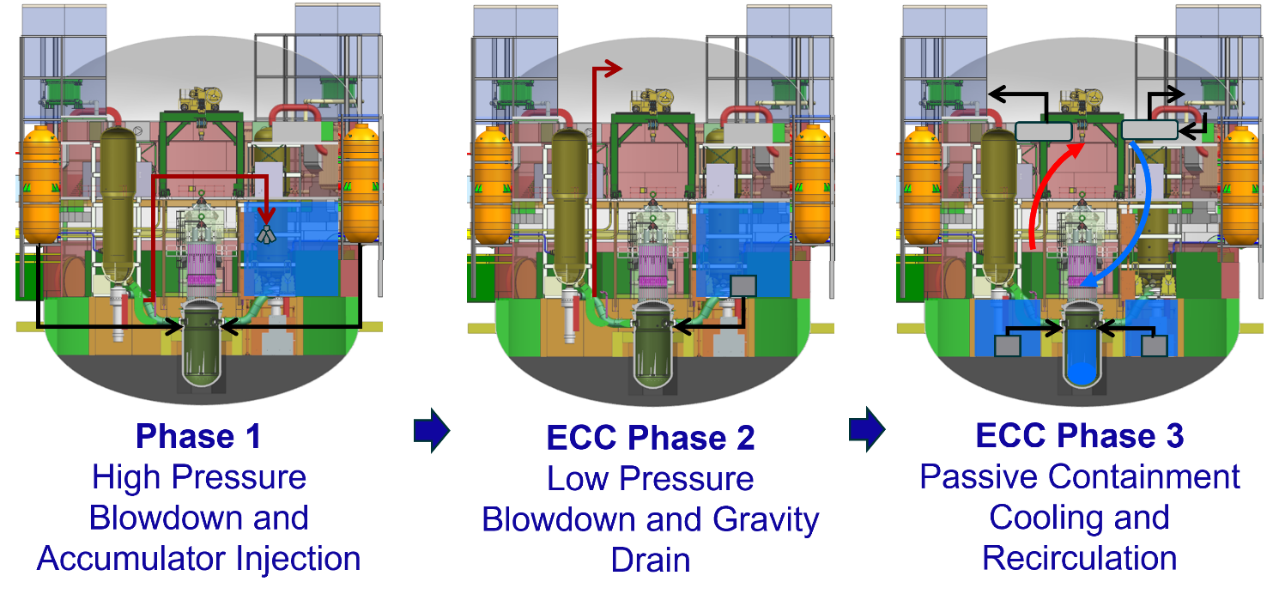

Figure 7: Emergency Core Cooling System (ECCS) schematic (ref. [6])
- Additional protection is available from the High Pressure Injection System (HPIS) for smaller leaks, which uses pumped flow to introduce water into the RCS.
- Shutdown of the reactor in faults can be achieved using both the scram function and Emergency Boron Injection (EBI) system. The scram function isolates power to the Control Rod Drive Mechanisms (CRDM), causing the control rods to be rapidly inserted. The alternative shutdown function is provided by the EBI system which delivers boron solution to the RCS. The EBI system operates at low pressure and is therefore dependent on the HPIS pumps. These systems are triggered from independent and diverse control and instrumentation systems.
- As described previously, a steel containment is provided to mitigate the release of fission products to the environment in the unlikely event of core damage. The containment also incorporates features to minimise and mitigate postulated severe accident phenomena. These include passive hydrogen re-combiners to prevent hydrogen explosions and containment vessel overpressure protection via filtered containment venting. The design also includes a Reactor Vessel Cavity Injection System (RVCIS) which has been designed to achieve In-Vessel Retention (IVR) of molten core material in a severe accident. This is achieved by externally cooling the RPV lower head by gravity flooding the reactor cavity pit with water, and allowing this to boil, condense and return to the pit. Steam released into the containment throughout the transient is cooled by the LUHS Passive Containment Cooling (PCC) system heat exchangers. This is shown in Figure 8.

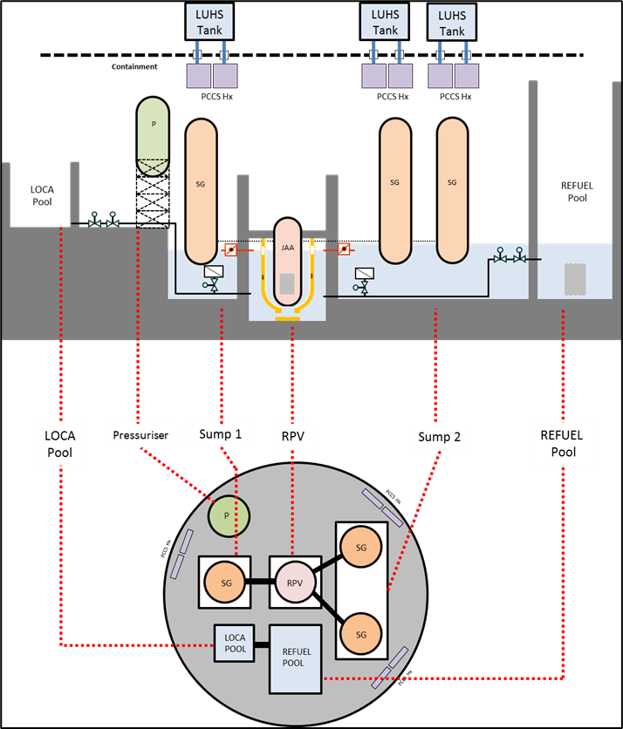

Figure 8: Reactor Vessel Cavity Injection System (RCVIS) schematic (ref. [6])
- The RP claims that the behaviour of the plant during abnormal operating conditions has been analysed and assessed using industry validated codes to demonstrate sufficient margin against plant damage for all postulated faults. A Probabilistic Safety Analysis (PSA) indicates an overall Core Damage Frequency (CDF) of <10⁻⁷ per year of power operation. PSA results identify that the Rolls-Royce SMR presents a balanced design with no single initiating event making a disproportionate CDF contribution.

ONR’s Familiarity with the technology used in the Rolls-Royce SMR design
- ONR has extensive experience assessing and regulating PWR designs and is therefore familiar with the technologies presented. Our assessment moving forwards, while considering all aspects of the design, will pay attention to areas of novelty, have high significance or that are unique to the Rolls-Royce SMR, and how their effectiveness is demonstrated by the RP.

Safety, security and safeguards cases
- The RP has submitted information on its strategy and intentions regarding the development of the safety, security and safeguards cases. This was submitted to ONR during Step 1, and our views on this are detailed further in Section 4.3, but some of the key points are summarised below.

Approach
- Rolls-Royce SMR Limited has chosen to develop its cases in a holistic manner, as an Environment, Safety, Security and Safeguards (E3S) case. The overall objective for the E3S case is to demonstrate that the design will ‘protect people and the environment from harm’.
- This means that, although the case made for each of the E3S purposes (i.e. environment, safety, security and safeguards) will inevitably be different at the top level, it will draw upon common evidence outputs (as well as other non-common outputs) to substantiate each of the purposes. This is claimed to offer benefits in terms of clarity, integration and understanding impacts from any changes to the case.
- The combined systems engineering and safety assessment approach used by Rolls-Royce SMR Limited means that E3S aspects are key inputs to its definition review process which govern its design activities (see Section 4.3.1). Specific guidance exists regarding ALARP, Best Available Techniques (BAT) and Secure by Design (SbD) as inputs to the process. The E3S team also work to support the engineers in the design activities, outside the formal engineering milestones process. These activities are aimed at producing an integrated design and E3S case.

Structure, scope and contents
- The E3S case is being developed using a three tier hierarchy and incorporating a Claim, Argument and Evidence (CAE) structure with the highest-level claims being derived from the RP’s own E3S principles. The highest level of the three tiers is the RP’s summary report, or head document, with the lower tiers providing more detailed arguments and evidence. This is illustrated in Figure 9.

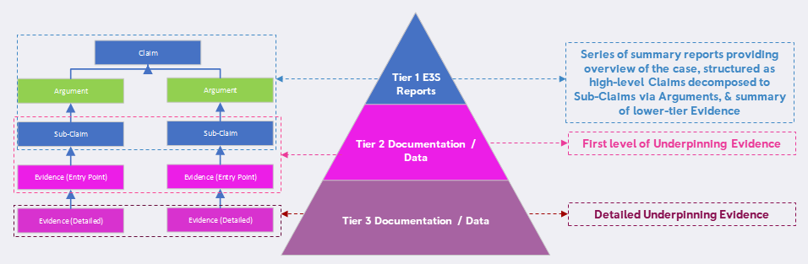

Figure 9: Claim, Argument Evidence (CAE) structure within the E3S hierarchy (ref. [6])
- The structure of the E3S case largely aligns with the International Atomic Energy Agency (IAEA) guidance for safety cases, SSG-61 (ref. [7]), supplemented to include UK specific expectations and expanded to include the other E3S purposes. This leads to about 30 chapters. All of ONR’s technical topics, as defined in Guidance to Requesting Parties (ref. [1]), are within the scope of the E3S case, albeit a number do not have specific individual chapters but are distributed throughout.
- One artifact of the RP’s engineering process is the derivation and management of requirements which define what the design must deliver. The E3S requirements, comprising both safety functional (or equivalent for security, safeguards and environment) and non-functional requirements, are a sub-set of the requirements generated, and derive from the underpinning E3S analysis (or evidence). The requirements, and their substantiation, will therefore be a prominent feature of the E3S case and provide a ‘golden thread’ to the engineering substantiation.
- Rolls-Royce SMR Limited is deploying a number of digital tools to aid the production and control of the E3S case. These include the use of a requirements management platform (IBM DOORS) and an assurance case tool (Adelard’s Assurance and Safety Case Environment (ASCE)). Neither of these replace the case authors, but the RP expects that these tools will help to improve traceability, visibility, configuration management and collaboration, and will lead to a simplification or reduction of documentation.

Work carried out by ONR in consideration of this request
- Guidance to requesting parties (ref. [1]) details the activities that both ONR and the RP are expected to undertake. This provided the framework for ONR’s work during Step 1.
- To ensure that ONR’s activities were coordinated and delivered, we produced a delivery strategy (ref. [8]) which outlines roles and responsibilities, key activities and assurance arrangements for the project. It also served as the assessment plan for Step 1. It is intended that this strategy will provide the overarching framework for ONR’s regulatory assessments during this GDA, including how we will coordinate assessments across each of our technical topics. It will be kept live and updated as the GDA progresses.

Assessment of submissions
- Appendix 2 of Guidance to Requesting Parties (ref. [1]) sets requirements on the RP for information to be submitted during Step 1. The requirements are summarised in Table 1 of this report along with reference to where they are documented in this report, as appropriate.
- In response to those requirements the RP submitted more than 40 documents to ONR.
- As described in Section 2.2, ONR assessed the submissions made by the RP to form a judgement on whether the requirements had been met during Step 1. Details of ONR’s assessment of these submission is in Section 4.

Interactions with the requesting party
- During Step 1 we held more than 200 meetings with the RP, at the project and individual technical topic level. This also included a number of workshops and briefings provided by the RP to improve our understanding of the design and its arrangements and processes. We also started the Management for Safety and Quality Assurance (MSQA) assessment activities, which included a number of specific targeted interventions to look at the RPs arrangements and capability to support the GDA.
- Overall, the purpose of these engagements was:
- To seek assurance on the adequacy of the RP’s arrangements to undertake the GDA;
- To develop our understanding of the generic Rolls-Royce SMR design;
- To understand the developing E3S case;
To discuss submissions made during Step 1;
To agree the GDA scope; and
To plan our assessments in each technical topic area for Step 2, including development of a schedule of submissions required from the RP.
- The outcomes from these interactions are discussed in Section 4.
- We found the RP to be professional, responsive and open throughout our interactions. We have confidence that this constructive working relationship will continue throughout GDA.
- During Step 1 the RP also requested ONR to provide advice and feedback on a number of ‘early engagement’ themes. These were specific, multi-disciplinary themes considered by the RP to be important to the success of its design. The RP requested early advice on whether they were progressing these themes in a manner consistent with regulatory expectations. We recognised the risk this posed and ensured we maintained our independence from the RP’s design decisions. These also provided an opportunity for ONR to increase our understanding and to identify potential areas of interest for Step 2. The themes were:
Civil structures and seismic – discussion centred on the integration between seismically isolated and non-isolated areas of plant, and the use of low damping rubber bearings (aseismic bearings).
Modularisation and layout – the RP outlined its approach to modular construction and the compact layout of its design. Further work is needed to identify if the approach to modularisation and layout presents any unique safety, security or safeguards challenges.
Control and Instrumentation design – the allocation of category A and B reactor C&I protection functions to a class 2 reactor protection system and a class 1 hardwired diverse protection system, the consideration of 3 vs 4 divisions for C&I reactor protection functions, and cyber security for C&I systems were each discussed.
Use of a modified chemistry regime for reactivity control – the implications for the choice of operating the primary coolant without soluble boron for reactivity control was discussed.
Structural Integrity classifications – the potential use of an additional classification of very high reliability based on secondary consequences was presented by the RP.
- These discussions have been factored into our Step 2 planning activities.

Step 2 assessment plans and submissions schedule
- The main deliverable produced from each of ONR’s technical topics is our assessment plan for Step 2. These outline the areas we intend to focus on to make a judgement on the fundamental adequacy of the design and E3S case, and the suitability of the methodologies, approaches, codes, standards and philosophies which form the building blocks for these. As part of these we have explicitly considered how our targetted assessment activities support the delivery strategy (ref. [8]) and the objectives for Step 2, such that we will produce a holistic, joined up assessment of the overall design and E3S case.
- To inform these plans, we agreed with the RP a submission schedule which defines all of the documents we expect to receive throughout Step 2 (ref. [9]). This meets requirement [1.19] from Guidance to Requesting Parties (ref. [1]). This schedule will be maintained as live by the RP throughout GDA.

Gap analysis
- A specific requirement during Step 1 is for the RP to undertake a gap analysis of its safety, security and safeguards cases, and the submissions it plans to support Step 2, against regulatory expectations and propose how any gaps would be resolved. The RP undertook such a review and we agreed plans for how any self-identified gaps would be resolved. The details of the review is provided in Section 4.6.

Readiness reviews
- As required by Guidance to Requesting Parties (ref. [1]) we undertook a readiness review to determine if the RP should proceed to Step 2. This included a review of our own readiness, but also considered the evidence provided by the RP of its readiness to proceed. The details of these reviews are provided in Section 4.6.

Joint working with the Environment Agency and Natural Resources Wales
- As a joint project, we have worked collaboratively with both the Environment Agency and NRW during Step 1, as appropriate. This included joint meetings on matters of regulatory interest to each regulator, particularly for MSQA and aspects of radioactive waste management. We expect this joint working to continue and deepen for the remainder of the GDA.
- The Environment Agency assessment of the environmental aspects of the generic Rolls-Royce SMR design are reported separately (ref. [2]).

Matters arising from ONR’s work
- The matters arising from the work carried out by ONR are summarised as follows.

RP’s arrangements for undertaking GDA
- Undertaking a GDA represents a significant undertaking for both the RP and the regulators. One of ONR’s priorities during Step 1 is to determine that the working arrangements needed to facilitate the GDA are developed, agreed and embedded. These aspects are specified in Appendix 2 of Guidance to Requesting Parties (ref. [1]), as they are important enabling activities for conducting the technical assessments in later steps of GDA.
- For this reason, we initiated our work under the MSQA topic during Step 1. This involved a series of targeted interventions combined with assessment of a sample of key documents from the RP. The objectives were to assess the adequacy and deployment of the RP’s Integrated Management System (IMS), and to provide confidence that the RP has the controls and arrangements in place to deliver the GDA. The following summary is consistent with ONR’s MSQA assessment (ref. [10]).

Integrated management system
- During Step 1 the RP has developed and implemented an IMS which provides the governance framework, policies, manuals, and processes for its undertakings, including those necessary for GDA. This is described in the IMS manual (ref. [11]). The IMS itself consists of a hierarchical document structure, as shown in Figure 10. This approach is similar to other industry peers. Several aspects covered by the IMS were sampled during Step 1, and were found to align with expectations from Guidance to Requesting Parties (ref. [1]) and ONR’s GDA technical guidance (ref. [12]).

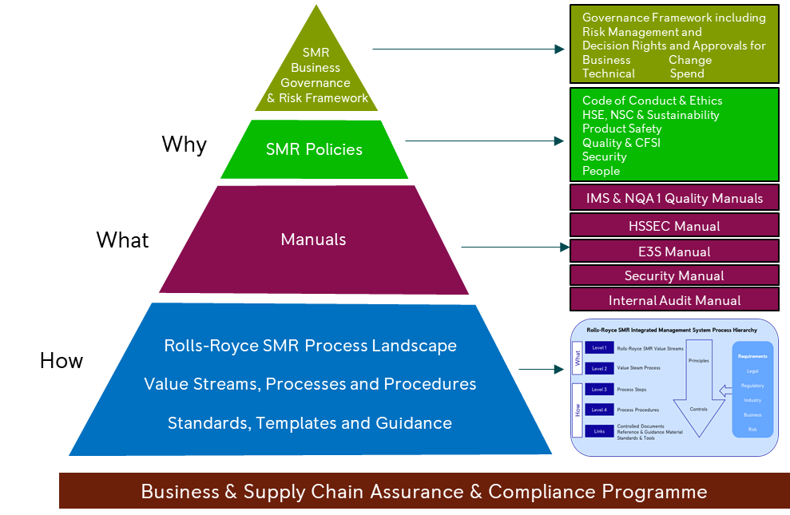

Figure 10: Integrated Management System (IMS) hierarchy (ref. [13])
- The IMS is being developed to comply with several relevant management system standards from the International Organization for Standardization (ISO), the American Society of Mechanical Engineers (ASME) and the IAEA. The RP has submitted its IMS to an accredited certification body for compliance to ISO 9001: 2015. It is the RP’s intention to seek certification to other ISO standards over the coming years.
- The development of the IMS, and the overall arrangements described therein align with relevant standards. While it has been developed during Step 1 and continues to evolve, it is sufficiently mature to provide a foundation for the GDA activities, and the defined architecture will facilitate further development, improvement and implementation during later steps of the GDA.

Interface arrangements
- An interface document (ref. [14]) has been agreed with the RP during Step 1, which details the working level interfaces. This includes the agreed system for transmission and tracking of submissions, correspondence, meetings, and regulatory questions. These arrangements have been successfully implemented during Step 1, considered as part of the readiness review for entry to Step 2, and are judged adequate. Any amendments to these will be part of normal business for the remainder of the GDA.
- We judge that this information is sufficient to meet requirement [1.1] from Guidance to Requesting Parties (ref. [1]).

Master document submission list
- During GDA the RP will make numerous submissions to ONR. Given the longevity of the project, and the ongoing development of the design and E3S case, the RP needs to have arrangements to keep track of the documents submitted, any subsequent changes to these documents, and any documents withdrawn. This also includes responses to regulatory questions and their incorporation in E3S documents. Key to these arrangements is a Master Document Submission List (MDSL), which is a live document that allows ONR to understand and reference the latest versions of the GDA submissions. The MDSL will be a key reference from any subsequent GDA output provided (GDA statement or Design Acceptance Confirmation (DAC)). During Step 1 we worked with the RP to establish its arrangements to control and manage the MDSL.
- The MDSL (ref. [15]) is a version-controlled spreadsheet, generated from data within the Rolls-Royce SMR Limited document management system. The first version was submitted to ONR during Step 1, with updates supplied monthly. It is produced and controlled in accordance with the RP’s process for regulatory correspondence (ref. [16]). The scope and contents of the MDSL are consistent with ONR’s expectations. Maintenance of the MDSL will be an important activity for the remainder of GDA, particularly during later steps when the number of submissions increases significantly and will therefore continue to be reviewed.

Regulatory questions
- Guidance to requesting parties (ref. [1]) defines a hierarchy for regulatory questions that may be asked of the RP during GDA, which includes Regulatory Queries (RQ), Regulatory Observations (RO) and Regulatory Issues (RI). During Step 1 we sought confidence that the RP had arrangements in place to receive, process, respond and control these questions.
- The RP has documented arrangements for managing RQs (ref. [17]) and RO/RIs (ref. [18]). These are consistent with the agreed interface arrangements (ref. [14]). These include the responsibilities for checking and approving the responses. They include a range of metrics to monitor performance. During Step 2, when an increase in both the number and significance of regulatory questions is expected, we will monitor the ongoing implementation of these arrangements.
- During Step 1, ONR raised three RQs. These have all been responded to in accordance with the interface arrangements and the RP’s procedures, demonstrating the adequacy of these arrangements.

Design reference
- Given the evolving nature of the design during the GDA the RP needs to have suitable arrangements to document and control the design against which ONR is assessing; in simple terms the generic safety, security and safeguards cases must align with the generic design. The RP is therefore required to submit a Design Reference (DR) which lists all the documents that define the design of the NPP. In accordance with Guidance to Requesting Parties (ref. [1]), during Step 1, we have sought to agree the DR arrangements to be applied for the GDA.
- The RP has indicated that it will document its DR within a specific report which will be submitted and updated periodically. This will be focused on the documents that define the generic design and will be based on the relevant Master Records Index (MRI) (ref. [19]) produced as part of its engineering Definition Review process. This integrates the DR into the RP’s engineering process, which is beneficial given the structured approach to the design employed. The response to RQ-RRSMR-0002 (ref. [20]) indicates the expected content of the DR report, noting that the content will mature alongside the design. It is expected to include a range of design, layout, engineering and analysis information which collectively defines the generic design. The first DR report will be submitted to ONR during Step 2. We are content that this approach is sufficient for this point in GDA, recognising that the detailed arrangements and their implementation will be assessed during Step 2.
- ONR expect the DR to be ‘frozen’ at a specific date known as the Design Reference Point (DRP), with the first DRP set during Step 2. The RP has confirmed its intention to set the first DRP in Step 2. Further updates to the DRP will be set dependent upon several factors including design maturity and the number and impact of any identified changes. This aligns to both the RP’s intended E3S development schedule, and the GDA programme. This approach meets ONR expectations and is adequate.
- Any subsequent changes to the DR itself, which the RP request to be brought within the GDA scope, will need to be agreed by the regulators. This is one part of change control discussed below.

Change control
- We expect the RP to put arrangements in place to control changes to the generic design or E3S case. There are good business reasons for the RP to do this, but from a GDA perspective the regulators’ expectations are to ensure we have clarity over what is assessed and what any regulatory judgements and GDA output are given against.

- The configuration management plan (ref. [21]) and engineering change management policy (ref. [22]) provide valuable information on the RP’s intentions for the change control arrangements to be applied during GDA, for when the DRP has been set. As presented, these documents are considered reasonable as an overview of the intent. However, in our judgement, they are focused on the engineering (design) aspects, not E3S changes, do not consider interactions with the DR and are policy, rather than process.
- In response to RQ-RRSMR-0003 (ref. [23]) the RP confirmed that it is developing holistic change control arrangements which will cover changes to design, E3S and the DR. The intention is for these arrangements to be developed and implemented by 31 March 2023, allowing for a period of use before the first DRP is set. The response confirmed that the RP understands the need to have robust arrangements to categorise the impact of any change, ensure appropriate governance, and interface with the regulators at the appropriate time and with suitable documentation. The arrangements will be incorporated into the IMS. These intentions align with ONR’s expectations.
- The MSQA assessment (ref. [10]) also identified that the RP has work to complete to confirm it has a robustly configured design prior to the DRP. This may require additional work not ordinarily factored into the RP’s engineering processes. This matter will continue to be monitored through the MSQA topic.
- We therefore judge that the RP has demonstrated an understanding of the expectations for the change control arrangements needed for undertaking GDA and has a schedule to develop these further, in time for the first DRP. At the time of writing this report we are continuing to engage with the RP on the details of its arrangements, and this will continue into their implementation and use in later steps.

Capturing requirements, assumptions and commitments
- During GDA, and indeed outside of its GDA activities, the RP will identify requirements, assumptions and commitments. These could come via development of the design or E3S case. The ‘recipient’ of these could be the RP, or a future licensee. It is important that the RP has arrangements in place to record and control these, such that they can be fulfilled by the design, E3S case or by the future licensee. In Step 1 we sought an overview of these arrangements, recognising that they were linked to other aspects that were still being developed. The RP shared a briefing on its approach during Step 1, and this matter was discussed during the MSQA interventions.

- The RP has set out the purpose of its requirements management process in the Engineering Management Plan (EMP) (ref. [24]), including the use of a requirements management platform which the RP will use to manage design requirements. Roles and responsibilities relating to management of such requirements are also detailed. It is the intention of Rolls-Royce SMR Limited that this will cover safety, security and safeguards related requirements. This is more mature for the engineering aspects, but the RP itself notes that the methodology for the management of E3S case requirements is still being defined.
- The RP’s project operating instruction (ref. [25]) defines how assumptions and commitments generated in the E3S case, which are intended for the licensee, are identified and captured. A specific log, referenced from the E3S case will be generated as the repository for these. Assumptions and commitments arising from the generic design will use the engineering design process.
- We have not made a judgement on the adequacy of the RP’s arrangements at this time given the limited assessment undertaken in Step 1. However, we take confidence from the early consideration given to this by the RP and note that the intentions meet our expectations. The assessment of these arrangements and their implementation will therefore be an area of focus throughout Step 2.

MSQA intervention
- In addition to assessing the RP’s arrangements for undertaking GDA, our MSQA intervention also considered related aspects regarding the RP’s quality function and organisation, competency, intelligent customer capability, operational experience (OPEX) and knowledge management. These aspects are much broader than the arrangements for GDA, but are important enablers for the RP to be successful.
- In general, we were content that the RP is making good progress with all of these aspects. There remains work to do, but the development is consistent with our expectations for this step of GDA and we note several areas of good practice being developed.
- We expect to continue to monitor the development and implementation of the arrangements for achieving sufficient intelligent customer capability for the organisation as normal business. Similarly, the application of processes to effectively use OPEX in the E3S case and design will be an important area of focus for Step 2.

Summary
- During Step 1 the RP has demonstrated a good understanding of the arrangements needed to undertake the GDA. It has developed many processes and guidance documents, under an overarching IMS, with many already implemented. We consider it a positive that the RP has integrated any GDA specifics into its wider business and engineering arrangements.
- Overall, we are content that sufficient progress has been made during Step 1, and plans for further development and implementation during Step 2 are acceptable.
- We judge that this information, in combination with other information in Section 4 of this report, is sufficient to meet requirement [1.1], [1.21], [1.22], [1.23], [1.24] and [1.27] from Guidance to Requesting Parties (ref. [1]).

Agreement of the GDA scope
- A fundamental objective of Step 1 of GDA was to agree the GDA scope between the RP and the regulators (ref. [1]). The GDA scope defines the boundaries of the GDA, and therefore influences both the submissions produced by the RP and the assessment undertaken by ONR. We have therefore engaged with the RP to discuss and agree the GDA scope and the associated schedules throughout Step 1.
- Based upon these engagements, the RP has documented the agreed GDA scope (ref. [26]). This report documents the physical and functional scope of the power station that is proposed for consideration in the GDA.
- Rolls-Royce SMR Limited has indicated that it intends to complete a three step GDA, with the objective of receiving a DAC from ONR. The current schedule is for a 16 month Step 2, followed by a 25 month Step 3. This corresponds to a total duration of GDA of 53 months from April 2022 to August 2026. Progression from Step 2 to 3 is subject to the RP securing additional funding during Step 2. The GDA scope therefore matches this objective.
- In summary, the GDA scope (ref. [26]) confirms:
The key parameters of the design, which are as summarised in Section 2 of this report;
The generic design is for a single unit site, that is deployed at a coastal location, with an indirect cooling system utilising forced draft cooling towers cooled by sea water;
The generic design is located within a site environment bounded by the defined Generic Site Envelope (GSE) (ref. [27]). The GSE is discussed further in Section 4.4;
The GDA scope includes, as a minimum, all SSCs that are identified as being important to safety, security and safeguards. A list is documented within the GDA scope report (ref. [26]);
All modes of operation are considered, from power operation through shutdown and refuelling; and
All stages of the plant lifecycle will be considered, although the level of detail will vary as appropriate for a GDA.
- As would be expected, a number of exclusions are declared from the GDA scope. Some of these relate to aspects which are the responsibility of a future licensee and therefore cannot reasonably be considered within a GDA. However, there are several which are specific to the Rolls-Royce SMR design:
The site factory, which is a temporary structure that provides an environmental shelter to the Rolls-Royce SMR assembly area during construction;
The design, construction, and operation of the various factories which will build and supply the modules and components for the design;
Aspects of modular transport and modular construction on site;
Final fuel storage (assumed to be an off-site geological disposal facility);
Specific commissioning tests (although general principles around the commissioning will be included in the scope);
The arrangements for the procurement of Long Lead Items (LLIs) will not be covered in the scope of GDA. However, the safety justifications for LLIs will form part of the safety case and are therefore included in the scope of GDA; and
Specific arrangements for responding in the event of a radiological or conventional emergency (although facilitation of emergency response and design requirements to enable future licensees to comply with regulations will be included).
- We are content that the agreed GDA scope is sufficient to undertake a meaningful assessment of the generic Rolls-Royce SMR design. It is consistent with previous GDAs that have achieved a DAC. Further refinements or changes to the agreed GDA scope can be agreed as normal business for the remainder of the GDA.
- We judge that this information is sufficient to meet requirement [1.2] and [1.3] from Guidance to Requesting Parties (ref. [1]).

Status of the design and safety, security and safeguards cases

Design
- Upon entry to GDA, Rolls-Royce SMR Limited were working towards the Preliminary Concept Definition (PCD) engineering milestone (DR1), which was subsequently achieved in July 2022. This level of design represents a single baseline design for the complete NPP. Optioneering and design optimisations remain on-going.
- The RP’s engineering governance arrangements use a gated review process, using Definition Review (DRx, with x being a sequential number) points against which the design maturity of any SSC may be planned, assessed and reported. In total there are nine Definition Review points, with some of these corresponding to declared engineering milestones. Each gate is essentially an internal multidisciplinary audit of the design's maturity and compliance to relevant processes. This approach is developed from BS EN61160:2005 Design Review.
- The next major engineering milestone to be reached will be Final Concept Definition (FCD) which aligns with the completion of a number of prioritised DR3 gates. This is currently targeted to be met during 2023, after the planned start of Step 2 of GDA. Rolls-Royce SMR Limited is aiming for the design to reach Critical Definition Review (CDR) (DR5) around the start of Step 3. The main difference between these milestones is the increasing maturity of individual SSCs, and the underpinning justifications and substantiations. As the design matures the level of optioneering and decision making is expected to reduce, with the RP expecting to have made all significant design choices by DR3. This is shown in Figure 11.

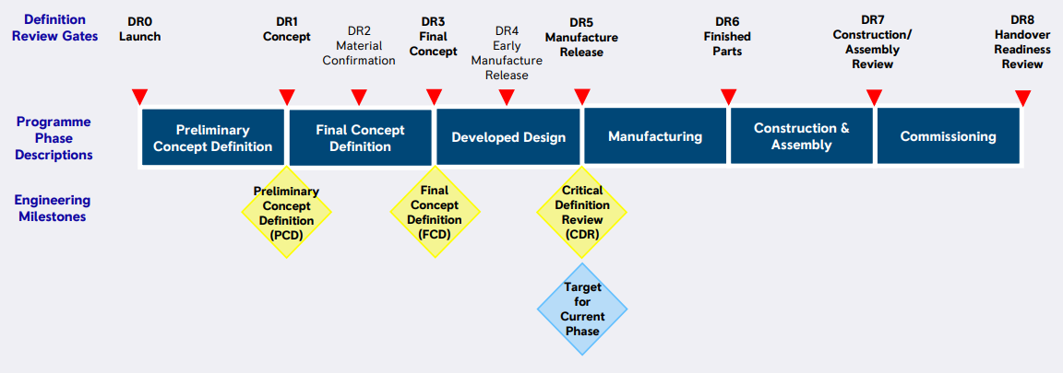

Figure 11: Rolls-Royce SMR Limited definition review gates and engineering milestones (ref. [22])
- The MRI (ref. [19]) provides an index of all the documents which form the design basis and its justification. The MRI for PCD lists more than 350 documents that include design, engineering, analysis and justification.

- Development of the design will be controlled and managed in accordance with the arrangements as described within the EMP (ref. [24]). This describes the organisation, governance and methods used by Rolls-Royce SMR Limited to develop its design. There are four main aspects which the RP will use collectively to ensure compliance with UK legislation, regulation, codes and standards:
Requirements Management – covering identification, capture, verification and traceability of their delivery in design.
Design Process – as defined within IMS covering development of a solution that complies with the requirements of codes, standards and legislation.
Optioneering Process – which explicitly addresses the consideration of ALARP, BAT and SbD.
Design Governance – which confirms the identification and consideration of relevant legislation, regulation, codes and standards.
- We are content that the RP has a documented, structured approach to design development built upon its previous experience and relevant good practices. The on-going implementation of these arrangements by the RP will be an important area of focus for ONR during Step 2. We expect the interactions between the design and E3S case as they each develop will be an important area of attention for ONR.

E3S case
- As part of the submissions made to ONR during Step 1, the RP provided a Preliminary Safety Report (PSR) (ref. [6]) and Preliminary Security Report (PSyR) (ref. [28]). There is no equivalent safeguards submission. These documents were produced prior to the start of GDA and hence use an earlier version of the design and associated documents, but were updated to better reflect the PCD engineering milestone before submission. These documents are the highest level, Tier 1, overview of the safety and security cases.
- The E3S case summarised in the PSR and PSyR will evolve alongside the maturity of the design, such that future submissions will be developed in a staged approach. The next revision is expected to support Step 2 of GDA and will be based upon the PCD design plus work done up to that point towards FCD.
- Future revisions of the E3S case will evolve to include a generic Pre-Construction Safety Report (PCSR), derived from the PSR, a Generic Security Report (GSR), derived from the PSyR, and safeguards related information.

- This approach is documented within the E3S case development strategy (ref. [29]), which provides the high-level framework for development of the E3S case in terms of its overall structure and content and how it is integrated into the design development programme. Some features within the strategy are still to be fully detailed, such as the integration of safeguards. A similar GSR strategy exists (ref. [30]), which further expands upon the E3S strategy with reference to the security specific aspects.
- The intent described in these strategies meets our expectations, and we judge it to be positive that the RP has developed detailed strategies at this early stage of the project and prior to the first versions of the PCSR and GSR. We will assess the implementation of these during Step 2.
- We judge that this information is sufficient to meet requirement [1.18] from Guidance to Requesting Parties (ref. [1]).

Information submitted during Step 1
- Guidance to requesting parties (ref. [1]) contains several requirements for the RP to submit information to ONR. This information is essential to enable us to gain familiarity with the RP’s design and safety, security and safeguards cases and approach, and for the RP to demonstrate an understanding of the regulatory expectations for GDA.
- This section summarises the information that has been submitted during Step 1 against each of those specific requirements. Note that the intention for such submissions was to inform subsequent assessments in Step 2 and to build confidence in the RP’s ability to meet regulatory expectations. Therefore, although the technical content of these submissions has been reviewed to gain a view on maturity, relevance and consistency with our expectations, no regulatory assessment has been made on their application to the Rolls-Royce SMR design and E3S case.

Design familiarisation
- During Step 1 ONR has undertaken several design familiarisation activities to prepare for and aid the planning of the technical assessments in Step 2.
- To facilitate this the RP submitted a design overview report (ref. [31]), the PSR (ref. [6]) and the PSyR (ref. [28]) and held a number of meetings to brief the regulators on the generic design. Collectively these increased ONR’s understanding of the design and provided useful information regarding the design, functions, justifications, and approaches likely to be adopted in future E3S submissions. They formed the basis of the initial technical discussions between ONR and the RP during Step 1, towards agreement of the GDA scope and production of ONR’s assessment plans for Step 2.
- We judge that this information is sufficient to meet requirement [1.8] from Guidance to Requesting Parties (ref. [1]).

Fundamental design philosophy
- To aid in the Step 1 activities, ONR requested information on the design philosophy employed for the generic Rolls-Royce SMR, such that we could understand the main design features, main safety and security claims including identification of hazards, control measures and protection systems. Collectively the design overview report (ref. [31]), PSR (ref. [6]) and PSyR (ref. [28]) provide this information. We recognise that both the design and E3S case are maturing, but these were sufficient to develop ONR’s understanding during Step 1.
- We judge that this information is sufficient to meet requirement [1.10] from Guidance to Requesting Parties (ref. [1]).

Demonstration of ALARP
- The PSR (ref. [6]) provides an overview of the approach being adopted by Rolls-Royce SMR Limited to demonstrate that risks are ALARP (as well as BAT and SbD). In summary, the RP claims that the design is being developed with optioneering and supporting analysis, starting from compliance with Relevant Good Practice (RGP), sound engineering, and then justifying whether anything further could reasonably be done to reduce risks. This is aligned to the design decision process defined in the EMP (ref. [24]), which requires all design decisions to be traceable. This includes details of the alternative options that were considered, the decision-making method used, the evaluations, the criteria considered, and the approver. A graded approach is inherent in this process, dependant on the significance.
- Design decision making is covered by process C3.2.2-2 conduct design optioneering (ref. [32]), which is part of the IMS. The output is recorded in a decision record template (ref. [33]) and recorded within the RP’s DOORS system.
- In principle we are content that this approach is aligned with ONR’s expectations for an overall demonstration that the level of risk is ALARP. The consideration of ALARP as an integral part of the RP’s decision-making arrangements is advantageous. These processes demonstrate a commitment to a logical and auditable optioneering process in support of a demonstration that risks are ALARP. The application of these arrangements, and whether the decisions do indeed lead to risks that are ALARP, will be integral to ONR’s assessments for the remainder of the GDA.
- We judge that this information is sufficient to meet requirement [1.11] from Guidance to Requesting Parties (ref. [1]).

Compliance with NISR
- The Nuclear Industry Security Regulations (NISR) 2003 (as amended) (ref. [34]) places requirements on dutyholders regarding physical security measures for facilities, cyber security, nuclear material and the security of Sensitive Nuclear Information (SNI). During GDA, the expectation is for the RP to demonstrate that its generic design can meet such requirements, focused on how the generic security information developed during GDA could be used to inform a site specific security plan. This matter is explicitly noted within the PSyR (ref. [28]), and it is the RP’s stated intention to address relevant matters during GDA.
- We judge that this information is sufficient to meet requirement [1.12] from Guidance to Requesting Parties (ref. [1]).

Regulatory framework and principles
- The PSR (ref. [6]) summarises the nuclear safety case for the generic design. It describes the design philosophy, the safety principles and how they are/will be applied, a summary of the design, the claims made, and assessment undertaken to date by the RP. It therefore touches on many areas of the regulatory framework and principles including how these have been considered. This includes matters such as defence in depth, numerical targets, hierarchy of controls, common cause failure, segregation, redundancy and diversity, amongst others. Ultimately, it is how these have been included and delivered by the design and E3S case that will be examined during the GDA.
- We are content that the PSR provides an adequate overview of the main design features and safety claims for Step 1, consistent with the time it was produced. It demonstrates a good understanding of UK practice and regulatory expectations for safety cases and should provide a good foundation for the future development of the PCSR.
- Similarly, the PSyR (ref. [28]) provides a high-level overview of the basis on which the nuclear security arrangements for the Rolls-Royce SMR will be developed, including how the requirements of the UK regulatory regime for nuclear security and RGP will inform this. This includes application of key expectations of relevance to security such as use of a secure by design approach, application of defence in depth and a graded approach. We are content that, sufficient for Step 1, this demonstrates the RP’s understanding of the regulatory framework and principles.
- Corresponding information relevant to the safeguards approach was not provided. However, we are content that this is a programme matter that will be resolved during later steps. Based on our interactions, we are confident that the RP has a sufficient understanding of these matters.

- The RP submitted its methodology for the categorisation of functions and classifications of SSCs (ref. [35]) during Step 1. This is consistent with the summary provided in the PSR (ref. [6]), The method describes the structured approach for deriving classifications such that appropriate engineering quality can be applied in the design. In addition, it describes the intent and approaches adopted in the overall plant design, which involves minimising highly classified SSCs where practicable, and assigning high classifications to simple and reliable SSCs that deliver protection functionality against a wide array of faults. The method is based upon international guidance, lessons learnt and the RP’s previous experience.
- The philosophy described in the methodology is consistent with other approaches used for GDA. We welcome the consideration of ONR’s SAPs (ref. [36]), TAG (ref. [37]) and IAEA SSG-30 (ref. [38]) and we are content that these should provide a sound basis for use in the safety case. However, the method is intended to also cover security, safeguards and environment but there is little detail on how this relates to purposes other than safety. We judge that having a single process for all purposes is ambitious and there may need to be some adaption to ensure that appropriate outcomes are delivered for all functions. Similarly, there are several matters related to the application of the method where we expect to need to seek further clarity. These will be part of the assessment of the application of this method to the design during the remainder of the GDA.
- We judge that this information is sufficient to meet requirement [1.13] from Guidance to Requesting Parties (ref. [1]).

E3S design principles
- The RP submitted its environmental, safety, security and safeguards principles (ref. [39]) that will be used to inform the Rolls-Royce SMR design. The principles present a distillation of international practices for plant and site design. The approach uses a hierarchical decomposition to a set of design principles that cover distinct thematic areas and leads to mandatory (shall) and advisory (should) principles. These cover a broad range of topics, from design through engineering and operational aspects across the full plant lifecycle.
- As the backbone for the E3S case, the CAE structure is currently being developed by the RP. This includes mapping the principles against the developing CAE structure to determine those principles that will be specified as design requirements. The aim of this exercise is to demonstrate that all principles will be addressed by claims and suitably supported by evidence. Given the approach adopted by Rolls-Royce SMR Limited this is an important pre-requisite to development of its E3S case.
- The PSR (ref. [6]) and PSyR (ref. [28]) both describe a range of principles that have influenced the design in terms of safety measures, SSCs and layout. These differ in wording, but not intent from the principles report. This is mainly an artifact of timing and demonstrates that such principles have already informed the design.
- We judge that the document clearly sets out the principles that will be applied to the design. The principles appear consistent with good practice guidance, such as that published by IAEA and the Western European Nuclear Regulators Associateion (WENRA), and refer to relevant ONR guidance. Their integration in the development of the E3S case is commended. Application of the principles, both in terms of the design and E3S case, will form future areas of assessment during Step 2.
- We judge that this information is sufficient to meet requirement [1.15] from Guidance to Requesting Parties (ref. [1]).

Site characteristics
- The RP submitted its GSE (ref. [27]) which bounds the site characteristics within which the generic Rolls-Royce SMR is capable of being built and operated.
- We are content that the scope and coverage of the GSE is reasonable, that it is suitably representative of a generic GB site, and is consistent with previous GDAs. During Step 2 we will assess the adequacy of the values proposed by the RP, noting that we have identified that further work will be required to justify some aspects including conservatisms, beyond design-basis hazards and grid connections. We note such aspects are normal business and will be refined as the design matures.
- We judge that this information is sufficient to meet requirement [1.16] from Guidance to Requesting Parties (ref. [1]).

Codes and standards
- The EMP (ref. [24]) presents the RP’s policy for the selection of codes and standards for the Rolls-Royce SMR design, utilising good practice and addressing lessons learnt. The Rolls-Royce Small Modular Reactor Codes and Standards report (ref. [40]) presents a summary of outputs from this policy for mechanical, electrical C&I, civil and structural design. In addition, it defines a set of principles against which codes and standards are chosen. The RP recognise that this is a snapshot of a point in time, and that further refinement will be necessary as the design matures, in particular at the FCD engineering milestone. Codes and standards are being identified within the requirement set for each SSC.
- The codes and standards cited by the RP are familiar to ONR, as the generic Rolls-Royce SMR has a UK origin. At a high level the content is reasonable, and we take confidence in the systematic approach adopted to identification and use of relevant design inputs. However, while further development is acknowledged, several notable absences were observed. We will follow up this matter, alongside implementation of these codes and standards into the design during assessment in Step 2.
- We judge that this information is sufficient to meet requirement [1.17] from Guidance to Requesting Parties (ref. [1]).

Gap analysis
- Guidance to requesting parties (ref. [1]) requires the RP to undertake a gap analysis of the submissions planned to support Step 2 against regulatory expectations and to propose how any identified gaps would be resolved. This requirement was included based on lesson learnt from previous GDAs with non-UK based organisations. In those instances, gaps commonly existed due to lack of familiarity and experience with UK regulatory expectations, such as ALARP, and when the generic designs or safety, security or safeguards cases were not developed with these in mind.
- The RP’s gap analysis report (ref. [41]) provides a narrative of its review. As the Rolls-Royce SMR is being developed by an organisation familiar with current UK requirements and expectations, the gap analysis was simpler. It considers the RP’s planned Step 2 submissions (as part of its wider E3S case) against regulatory requirements and expectations and the RP’s own E3S principles. A range of other inputs, including key learning from previous GDAs and regulatory interactions throughout Step 1 were factored into the review. The evaluation was undertaken with inputs from safety and regulatory affairs, engineering and E3S case personnel.
- As an activity and output to respond to requirement [1.20] from Guidance to Requesting Parties (ref. [1]) to undertake such a review, the submission is considered adequate. The RP has undertaken a systematic review, considering a reasonable range of inputs and has identified a number of gaps and plans for how they can be resolved.
- The identified gaps are mainly associated with capacity and capability of the RP’s organisation to deliver the design and E3S case on GDA timescales. There is therefore considerable overlap with the actions that arise from the RP’s review of its readiness to proceed to Step 2. Whilst our guidance (ref, [1]) expects resolution plans to be prepared for these gaps, we agreed that combining these with the readiness review actions is a pragmatic approach. These actions are discussed further in Section 4.6.1, as part of the RP’s readiness review.

ONR’s Step 2 assessment plans
- A total of 21 assessment plans have been produced by ONR for Step 2. These cover each of the technical topics that will assess the RP’s submissions, in addition to a project assessment plan that covers matters that need coordination and assessment at a strategic level. All the plans are consistent with our delivery strategy (ref. [8]).

- Our assessment plans have been informed by:
The agreed GDA scope;
Our understanding of the generic design and E3S case; and
Discussions with the RP to understand the scope and maturity of submissions planned for Step 2.
- The submissions we need to undertake our assessments during Step 2 have formed the basis of the RP’s submission schedule (ref. [9]). In total the RP is currently planning to submit more than 500 individual documents during Step 2, but this number will increase due to regulatory questions and interactions.

Readiness reviews

Rolls-Royce SMR Limited
- In accordance with requirement [1.30] of Guidance to Requesting Parties (ref. [1]), Rolls-Royce SMR Limited undertook a self-assessment and review of its readiness to proceed to Step 2 of the GDA. The evidence presented to ONR to support the outcomes of this review is spread across three documents: the readiness review report (ref. [42]), the gap analysis report (ref. [41]) and the organisational capability report (ref. [43]). Each of these is described individually below.
- There is overlap between these three documents, especially regarding the identified improvement actions needed as part of proceeding to Step 2. Therefore we also summarise the overall outcomes from the RP’s readiness review below, alongside our views on it.

Readiness review report
- The readiness review report (ref. [42]) documents the internal review undertaken by the RP. This was undertaken in early 2023, in advance of the planned entry to Step 2, to allow time for review by the regulators.
- The approach taken by the RP was to identify a series of expectations and success criteria against which to judge the project. Evidence was collated by the RP against each criteria and judged by its regulatory affairs team. Where gaps in readiness were identified, these were ranked in terms of significance and action plans developed to resolve them. This was also independently assured through the activities of Rolls-Royce SMR Limited’s internal nuclear assurance function. We judge that the process undertaken by the RP was reasonable, proportionate and sufficiently robust for this step of GDA.

- The four high level expectations defined by the RP were against project maturity, arrangements to undertake GDA, status of the design and E3S case, and organisational capacity and capability. A number of more detailed expectations sit below each of these. The overall conclusion of the RP’s readiness review is that it considers itself ready to begin Step 2, subject to completion of several improvement actions. The review also confirmed that the RP considered it had met all of the relevant requirements in Appendix 2 of Guidance to Requesting Parties (ref. [1]), as Table 1.
- In our assessment of the RP’s readiness review we also sought further information in various areas relating to information management, design maturity and organisational arrangements amongst others. The responses provide by the RP were satisfactory. The information supplied by the RP confirmed that requirements [1.4] to [1.7], [1.28] and [1.29] from Guidance to Requesting Parties (ref. [1]) had been satisfied.
- Overall, we are content that the information provided is sufficient to satisfy requirement [1.30] from Guidance to Requesting Parties, for the RP to undertake its own readiness review, albeit it also relies on the gap analysis and organisational capability report outputs.

Gap analysis report
- The RP’s gap analysis report (ref. [41]) identifies gaps that cover aspects relating to change control, DRP, intelligent customer arrangements, knowledge management and the impacts of design maturity on several safety analysis technical topics.
- The first four of these aspects are consistent with the findings from ONR’s activities during Step 1, as discussed in Sections 4.1 and 4.4. The resolution for each of these gaps is captured in the actions described below. We are content with the on-going activities to resolve these and will hold the RP to account for delivery of these during Step 2 as part of normal business.
- The remaining gaps, covering the impacts of design maturity on safety analysis technical topics, are considered further as part of the RP’s organisational capability review, in particular how these may be resolved.

Organisational capability report
- The Rolls-Royce SMR Organisational capability report (ref. [43]) describes the results of audits and internal reviews (pertinent to organisational capability) that compare the capability within Rolls-Royce SMR Limited with that considered necessary to mature the generic design, develop the E3S case and support GDA Step 2. The report also touches upon wider considerations pertinent to the capability of the RP, such as organisational structures, competency assessments and succession planning. The review is compared against the RP’s extant baseline programme for Step 2, which includes the agreed GDA scope and submission schedule.
- A number of improvement actions are identified by the RP. Again, these are described below.

Readiness review outcomes
- The RP’s overall conclusion from its readiness review, when considering all three reports holistically, is that it is ready to proceed to Step 2 of GDA and has satisfactorily completed all the requirements for Step 1.
- In total the RP identified 57 individual actions across the three reports that contribute to its readiness review. However, when rationalised, the number of actions is lower as:
There is overlap between the actions described in each of the reports;
Several have subsequently been completed, or sufficiently progressed to be considered resolved for the purpose of Step 1; and
Some are not considered necessary to proceed to Step 2, but are improvements recognised by the RP that it intends to implement.
- Therefore, the RP identified 49 individual improvement actions as the outcome from its readiness review process (ref. [44]). We are content that the self-identified actions accurately reflect the outcomes from the RP’s readiness review.
- Seven of these are considered pre-requisites for entry to Step 2 by the RP, with the remainder representing enablers needed at appropriate points during Step 2. The RP subsequently confirmed that it has resolved the seven actions needed for entry to Step 2.
- The actions are recorded in the RP’s action tracker, which we judge to offer a suitable means to manage these outcomes. We will review progress and hold the RP to account on delivery of these as appropriate.

- It is notable that a large proportion of the actions relate to the gaps identified (ref. [41]) associated with the impacts of design maturity on the safety analysis technical topics. The root cause is difficulty in aligning design maturity, progress with the underlying analysis needed to substantiate the design, and submissions which provide for a meaningful regulatory assessment during Step 2. In practice this is a programme risk that requires iterations of the design process, and ultimately time and suitable resource to deliver it. This has therefore manifested itself in several broad aspects relating to:
Capacity and capability in the RP to deliver these technical topics, including intelligent customer and effective leadership aspects;
The ability of the analysis to influence the design and E3S case development, risk informed decision making and support ALARP justifications; and
The scope of analysis and design maturity expected for the remainder of GDA and the programme to produce this in timescales compatible with the regulators undertaking a meaningful assessment.
- The organisational capability report (ref. [43]) identifies that to resolve the first of these, it will be necessary to supplement its resources for PSA, severe accidents, internal hazards and external hazards. In addition, it will strengthen its E3S case and engineering interface teams. This will be through a mixture of direct recruitment and technical support, as well as changes to processes and organisation. We consider these actions to be credible to address the identified gaps.
- A combined response to the second and third points will be provided in strategy documents that will be submitted early in Step 2 for PSA, severe accidents, and internal hazards. These are captured within the delivery schedule (ref. [9]). We consider it important that these documents address the difficulties and provide realistic solutions. We judge these plans credible and will assess the detailed responses upon receipt in addition to continuing to engage with the RP on these gaps in the interim.
- We will monitor the impact of these improvements on the above points as normal business during Step 2.
- We consider it significant and positive that the RP has recognised that these are gaps that need to be resolved and has declared plans with specific credible actions to do so.
- On this basis we are content that these gaps do not preclude progression to Step 2. However, they do represent risks that will need to be managed for the remainder of the GDA. We expect that they will also need to be revisited by the RP as part of any readiness review for progression to Step 3 of the GDA.

ONR
- In line with the requirements of Guidance to Requesting Parties (ref. [1]), ONR undertook a review of our own readiness to progress to Step 2 (ref. [45]). In addition to considering the outcomes from the RP’s readiness review, we also confirmed that we:
Agree that the RP has met requirements [1.1] to [1.30] of Guidance to Requesting Parties, as Table 1, as described in this report;
Agree that the RP has resolved the seven improvements actions it identified as prerequisites for Step 2;
Have completed all of the requirements against us as defined in Appendix 2 of Guidance to Requesting Parties, namely [1.31] to [1.40];
Have implemented suitable project management and arrangements to undertake the GDA;
Have secured sufficient internal resources to undertake the activities identified in our assessment plans for Step 2
Have taken account of the outcome of the Environment Agency’s own readiness review; and
Consider that, based on the agreed GDA scope (ref. [26]) and submission schedule (ref. [9]), the assessment will remain meaningful during Step 2, and warrants the continued deployment of regulatory resource.
- The outcome from our readiness review was that we consider we are ready to proceed to Step 2 of GDA for the Rolls-Royce SMR.

Conclusions
- This report is ONR’s first report summarising our assessment of the generic Rolls-Royce SMR, produced at the end of Step 1 of the GDA. In this step we have initiated the project and developed our understanding of the generic design, E3S case and RP. We have agreed the GDA scope and schedule, and a submission schedule for Step 2. This has allowed us to plan for our fundamental assessment to begin in Step 2 and to develop detailed assessment plans for each of our technical topics.
- Based on the work carried out by ONR, we are satisfied that:
The RP has completed all the requirements for Step 1 from our guidance;
Interactions with the RP throughout Step 1 have been professional and constructive, and we have confidence that this will continue;
The RP has made good progress in developing its organisation and arrangements to support GDA, with clear evidence of improvements;
The agreements necessary to undertake the GDA are in place, or have developed sufficiently for this point in the project with clear plans for further development;
The RP has demonstrated a good understanding of our regulatory expectations and has confidence that these can be met by its design and E3S case;
We have improved our understanding of the generic Rolls-Royce SMR design and E3S case, and have used this to inform our planning for further assessment activities; and
We, and the RP, are ready to proceed to Step 2 of the GDA.
- Moving forward, there is a considerable amount of work to be undertaken by the RP, both to mature the generic design and develop the justifications for the E3S case. In addition to undertaking the work to support our assessments during Step 2, the RP will need to prepare for Step 3. This will require significant efforts by the RP.
- A vital element of delivery of Step 2 in line with the indicative timescales relies on the timely production of high quality E3S submissions. This may challenge the RP, and it will need to exercise a high level of control to ensure that the quality of submissions is not undermined by delivery at pace.

- We will continue to rigorously assess the RP’s submissions in line with our assessment plans and will address any potential matters of concern should they arise. We will continue to assess the effectiveness of the RP’s arrangements to deliver an adequate, holistic safety, security and safeguards case for its generic design. We have planned our assessments across the 20 technical topics we will assess to ensure we deliver a holistic fundamental assessment of the generic Rolls-Royce SMR design during Step 2.

Recommendations
- Based upon the work described in this report, we recommend that:
ONR should proceed to Step 2 of the GDA for the generic Rolls-Royce SMR design.
ONR should maintain regulatory oversight of the 42 remaining readiness review improvement actions identified by the RP.

References

[1] | ONR, New Nuclear Power Plants: Generic Design Assessment Guidance to Requesting Parties, ONR-GDA-GD-006, Revision 0, October 2019. www.onr.org.uk/new-reactors/onr-gda-gd-006.pdf.
[2] | www.gov.uk/guidance/new-nuclear-power-stations-assessing-reactor-designs.
[3] | EA and ONR, A guide to the regulatory process, Revision 0, September 2013. www.onr.org.uk/new-reactors/ngn01.pdf.
[4] | EA, New Nuclear Power Plants: Generic Design Assessment Guidance to Requesting Parties, October 2019. www.gov.uk/government/publications/new-nuclear-power-plants-generic-design-assessment-guidance-for-requesting-parties.
[5] | www.onr.org.uk/new-reactors/index.htm.
[6] | Rolls-Royce SMR Limited, RR SMR Preliminary Safety Report, SMR0001510, Issue 1, August 2022. (Record ref. 2022/51262).
[7] | IAEA, Format and Content of the Safety Analsyis Report for Nuclear Power Plants, Specific Safety Guide No. SSG-61, September 2021. www.iaea.org.
[8] | ONR, Delivery Strategy for the Generic Design Assessment of the Rolls-Royce Small Modular Reactor, ONR-GDA-AP-22-001, Issue No. 1, September 2022. (Record ref. 2022/43611).
[9] | Rolls-Royce SMR Limited, GDA Step 2 Submission Schedule, 2 February 2023. (Record ref. 2023/8546).
[10] | ONR, Step 1 Assessment of Management for Safety and Quality Assurance of the Rolls-Royce Small Modular Reactor, ONR-NR-AR-22-014, Issue 1, December 2022. (Record ref. 2022/72211).
[11] | Rolls-Royce SMR Limited, Integrated Management System Manual, SMR0001351, Issue 1, December 2022. (Record ref. 2023/7137).
[12] | ONR, New Nuclear Power Plants: Generic Design Assessment Technical Guidance, ONR-GDA-GD-007, Revision 0, May 2019. www.onr.org.uk/new-reactors/reports/onr-gda-007.pdf.
[13] | Rolls-Royce SMR Limited, Generic Design Assessment Quality Management Plan, SMR0000963, Issue 2, October 2022. (Record ref. 2022/63726).
[14] | ONR, Generic Design Assessment Interface Arrangements with Rolls-Royce SMR Limited, ONR-GEN-IN-023, Issue 1, July 2022. (Record ref. 2022/40296).
[15] | Rolls-Royce SMR Limited, Master Document Submission Lists and Document List, SMR0001724, Issue 7, February 2023. (Record ref. 2023/8388).
[16] | Rolls-Royce SMR Limited, Project Operating Instruction TITLE: Regulatory Correspondence, SMR0000967, Issue 1, September 2022. (Record ref. 2022/63735).
[17] | Rolls-Royce SMR Limited, Project Operating Instruction TITLE: Manageing Regulatory Queries (RQs), SMR0000964, Issue 1, June 2022. (Record ref. 2022/63728).
[18] | Rolls-Royce SMR Limited, Project Operating Instruction TITLE: Managing Regulatory Observations (ROs) and Regulatory Issues (RIs), SMR0000965, Issue 1, September 2022. (Record ref. 2022/63729).
[19] | Rolls-Royce SMR Limited, Rolls-Royce Small Modular Reactor Master Records Index - Reference Design 5 - In Support of Preliminary Concept Definition, SMR0001204, Issue 1, June 2022. (Record ref. 2022/69359).
[20] | Rolls-Royce SMR Limited, Full response - Design Reference for GDA, RQ-RRSMR-0002, January 2023. (Record ref. 2023/6777).
[21] | Rolls-Royce SMR Limited, Configuration Management Plan for Rolls-Royce SMR, SMR0000521, Issue 1, July 2022. (Record ref. 2022/63699).
[22] | Rolls-Royce SMR Limited, Rolls-Royce SMR Engineering Change Management Policy, SMR0001441, Issue 3, October 2022. (Record ref. 2022/63713).
[23] | Rolls-Royce SMR Limited, Full response - Change Control During GDA, RQ-RRSRM-0003, January 2023. (Record ref. 2023/2556).
[24] | Rolls-Royce SMR Limited, Engineering Management Plan for Rolls-Royce SMR, SMR0000520, Issue 3, October 2022. (Record ref. 2022/63722).
[25] | Rolls-Royce SMR Limited, Project Operating Instruction TITLE: Identifying, recording, and tracking GDA and Licensing Assumptions and Commitments, SMR0002119, Issue 1, September 2022. (Record ref. 2022/63738).
[26] | Rolls-Royce SMR Limited, Rolls-Royce SMR Generic Design Assessment Scope, SMR0002183, Issue 2, January 2023. (Record ref. 2023/7807).
[27] | Rolls-Royce SMR Limited, RR SMR UK Generic Site Envelope, SMR0001535, Issue 1, August 2022. (Record ref. 2022/51248).
[28] | Rolls-Royce SMR Limited, Rolls-Royce Small Modular Reactor (RR SMR) - Preliminary Security Report (PSyR), SMR0001610, Issue 1, August 2022. (Record ref. 2022/51267).
[29] | Rolls-Royce SMR LImited, E3S Case Development Strategy, SMR0000627, Issue 1, August 2022. (Record ref. 2022/51241).
[30] | Rolls-Royce SMR Limited, Strategy for the Delivery of a Generic Security Report (GSR) for the RR SMR (during GDA), SMR0001611, Issue 1, August 2022. (Record ref. 2022/51268).
[31] | Rolls-Royce SMR Limited, RR SMR Design Overview Report, SMR0000594, Issue 1, June 2022. (Record ref. 2022/37064).
[32] | Rolls-Royce SMR Limited, IMS Process - (C3.2.2-2) Conduct design optioneering. Last edited 5 May 2022. (Record ref. 2022/51250).
[33] | Rolls-Royce SMR Limited, Decision Record Tempate, TS-DD-02, Issue 2. (Record ref. 2022/51261).
[34] | H.M. Government, Nuclear Industry Security Regulations (NISR) 2003 (as amended). www.legislation.gov.uk/uksi/2003/403/contents/made.
[35] | Rolls-Royce SMR Limited, UK SMR Environment, Safety, Security and Safeguards Categorisation and Classification Method, EDNS01000887611_002, Revision 2, August 2021. (Record ref. 2022/51247).
[36] | ONR, Safety Assessment Principles for Nuclear Facilities (SAPs), 2014 Edition, Revision 1, January 2020. www.onr.org.uk/saps/saps2014.pdf.
[37] | ONR, Categorisation of Safety Functions and Classification of Structures and Components, NS-TAST-GD-094, Issue 2, July 2019. www.onr.org.uk/operational/tech_asst_guides/index.htm.
[38] | IAEA, Safety Classification of Structures, Systems and Components in Nuclaer Power Plants, Specific Safety Guide No. SSG-30, May 2014. www.iaea.org.
[39] | Rolls-Royce SMR Limited, Rolls-Royce SMR Environment, Safety, Security and Safeguards Design Principles, SMR0001603, Issue 1, August 2022. (Record ref. 2022/51243).
[40] | Rolls-Royce SMR Limited, Rolls-Royce Small Modular Reactor Codes and Standards, SMR0003023, Issue 1, October 2022. (Record ref. 2022/63754).
[41] | Rolls-Royce SMR Limited, Step 2 Gap Analysis, SMR0003629, Issue 1, January 2023. (Record ref. 2023/7987).
[42] | Rolls-Royce SMR Limited, GDA Step 2 Readiness Review, SMR0004327, Issue 1, February 2023. (Record ref. 2023/8386).
[43] | Rolls-Royce SMR Limited, Rolls-Royce SMR Organisation Capability, SMR0004127, Issue 1, February 2023. (Record ref. 2023/12721).
[44] | Rolls-Royce SMR Limited, GDA Step 2 Readiness Combined Actions, SMR0004913, Issue 1, March 2023. (Record ref. 2023/15590).
[45] | ONR, Extraordinary RRM - Minutes, 22 March 2023. (Record ref. 2023/15880).
[46] | Rolls-Royce SMR Limited, Master Document Submission Lists and Document List, SMR0001724, Issue 7, February 2023. (Record ref. 2023/8388).

Table 1
Step 1 requirements from Guidance to Requesting Parties (ref. [1])
 | Requirement on the RP during Step 1 | Section
[1.1] | Agree with ONR interface arrangements to be applied throughout GDA | 4.1.2
[1.2] | Agree with ONR the GDA scope, to ensure that the assessment is meaningful | 4.2
[1.3] | Agree with ONR the overall GDA timescales and associated schedule, including subsequent steps | 4.2
[1.4] | Put arrangements in place to ensure that ONR will have full access to any commercially confidential information necessary for it to complete its assessments at each step; this must also include relevant commercial information which is the property of third parties. ONR expects this information to be made available in ONR’s offices | 4.6.1
[1.5] | Put arrangements in place for handling and protecting security marked documentation, including identifying any SNI. ONR expects the RP’s document classification scheme to be compatible with the Government Security Classifications | 4.6.1
[1.6] | Obtain all necessary personnel security clearances for all staff who will be supporting GDA | 4.6.1
[1.7] | Obtain all necessary export licenses to ensure that information can be transferred to and from the UK, and other relevant countries where information transfer is necessary as part of GDA | 4.6.1
[1.8] | Submit to ONR design familiarisation information. This should include sufficient information to provide ONR with an overall understanding of the safety and security of the proposed design, in line with the agreed scope for GDA. This should also include information on the current status of the design and the identification of any aspects where development is still required, alongside an indication of what this may entail and likely timescales. The RP should identify any distinguishing features of the design | 4.4.1
[1.9] | Submit to ONR information on assessments performed by other regulators on the proposed design, including the current status of any reviews, any findings and any changes made or proposed as a result, including a judgement on their significance | 2.4.1
[1.10] | Submit to ONR a description of the fundamental design philosophy and identification of the main safety and security claims including identification of hazards, control measures and protection systems | 4.4.2
[1.11] | Submit to ONR a description of the process being adopted by the RP to demonstrate compliance with the legal duty to ensure that the risks to human health arising from the operation of a power station based on the proposed design are reduced to ALARP | 4.4.3
[1.12] | Submit to ONR a description of the process being adopted by the RP to demonstrate compliance with the requirements of the Nuclear Industries Security Regulations (NISR) | 4.4.4
[1.13] | Submit to ONR evidence of the RP’s understanding of the nuclear regulatory framework and regulatory principles and how these have been (or will be) considered as part of the design and generic safety and security cases for the proposed design. This should include matters such as:  - the approach to categorisation of safety functions and classification of structures, systems and components  - the development of a schedule of faults (including internal events and internal and external hazards), including protection and mitigation measures and the links this has to the associated engineering  - an understanding of the approach adopted to defence in depth and the hierarchy of controls, including consideration of matters such as common cause failure, segregation, redundancy and diversity | 4.4.5
[1.14] | Submit to ONR information about the reference design (or designs) on which the generic safety and security cases are based, if appropriate | 2.4.1
[1.15] | Submit to ONR the RP’s own design, security and safety principles adopted in the proposed design | 4.4.6
[1.16] | Submit to ONR a definition of the site characteristics to be used as the basis for the safety analysis (the 'generic site envelope') | 4.4.7
[1.17] | Submit to ONR a description of the codes and standards which have been used as part of the proposed design, including the identification of any non-conformances | 4.4.8
[1.18] | Put arrangements in place for development of the safety and security cases. Agree with ONR the approach for structuring the generic safety and security cases and their format, including the intentions for using existing information throughout GDA. This should include details of existing safety and security case information and its availability. Where existing information is to be used the scope, background and regulatory basis of this information should be specified | 4.3
[1.19] | Agree with ONR a schedule of generic safety and security case information which will be submitted to ONR ahead of, and during Step 2. Submit to ONR any information agreed for submission during Step 1 | 3.3  4.4
[1.20] | Undertake a gap analysis of the submissions identified to support Step 2 against regulatory expectations. Where gaps are identified the RP should agree with ONR a resolution plan which identifies what those gaps are, how they may be resolved and the timescales for doing so. | 4.4.9  4.6.1
[1.21] | Agree with ONR the scope and contents (template) of the Master Document Submission List (MDSL) and any required arrangements for handling it, including provision of routine updates. Submit to ONR the MDSL in accordance with the RP’s arrangements and any updates necessary throughout the step | 4.1.3
[1.22] | Agree with ONR the scope and contents of the Design Reference (DR) and any required arrangements for handling it, including routine updates, and the intent for the Design Reference Point (DRP) | 4.1.5  4.1.6
[1.23] | Put arrangements in place for capturing commitments, assumptions and requirements identified in the generic safety and security cases | 4.1.7
[1.24] | Submit to ONR responses to any questions raised by ONR during its assessment (RQs, ROs and RIs) | 4.1.4
[1.25] | Obtain sufficient resources to support completion of GDA. This should include technical, regulatory, front office, interface and management resources, as necessary, and may include third-party support. The RP should submit to ONR information regarding its intentions for evolution of its GDA resources and a demonstration of the on-going sufficiency of resources to be applied through the step | 4.6.1
[1.26] | Put arrangements in place to facilitate meetings between ONR and relevant RP’s personnel to share information and discuss technical matters | 3.2  4.1.2
[1.27] | Submit to ONR a demonstration of the adequacy of the RP’s arrangements, including:  - project management arrangements and quality management system  - the DR change control process to be applied during GDA, including the RP’s decision making arrangements for safety and security related matters  - arrangements and timescales for responding to ONR assessment  - arrangements for ensuring that the designers, and generic safety and security case authors and approvers are suitably qualified and experienced persons  - the generic safety and security case developer's quality control, including peer review arrangements | 4.1  4.4.9
[1.28] | Put arrangements in place to facilitate a public comment process which should run for the duration of GDA. This should include:  - Host a public website containing information on the proposed design and generic safety and security cases, and including the means to submit comments  - Agree with ONR what information will be published on the RP’s website (following removal of commercial and security related information) to allow comments to be made by the public during GDA, including updates when a significant change is made to the information submitted to ONR  - Agree with ONR the process and timescales to be adopted for responding to public comments | 4.6.1
[1.29] | Agree with ONR any extended or revised cost recovery agreements. This should cover the remainder of all subsequent steps | 4.6.1
[1.30] | Undertake a review of its readiness to begin Step 2 and submit to ONR evidence to support the outcomes | 4.6.1

