ONR Instruction
Decision Review and Appeals Process

ONR Instruction
Decision Review and Appeals Process
Authored by – Nuclear Safety Inspector
Approved by – Chief Nuclear Inspector
Process Owner – Head of Regulatory Intelligence

Publication Date: Jan-2023
Next Major Review Date: Jan-2026
Issue No.: 4.1
Doc. Ref. No.: ONR-PER-IN-006
Record Ref. No.: 2022/37722

Table 1: Revision commentary
Issue No. | Description of Update(s)
4 | New template.  Updated to reflect organisational changes and to improve clarity of the process.  Change of approver from Chief Executive to Chief Nuclear Inspector.  Delegations added.  References replaced with hyperlinks.
4.1 | Minor editorial updates.

Introduction
The Office for Nuclear Regulation (ONR) is committed to providing efficient, effective, professional, and demonstrably objective regulation. As part of this commitment, ONR accepts that challenges to its decision making may occur.
This appeals process exists to manage such challenges in a visible and transparent manner, consistent with ONR’s organisational values.

Purpose
This document describes ONR’s ‘Decision Review and Appeals Process’. It can be used by an appellant (as defined in Appendix A) to appeal a regulatory decision that affects them on the basis that the decision making process was flawed and/or did not meet the UK Regulators’ Code requirements.
This is an impartial process. Individuals from ONR considering the appeal will have had no role in making the decision being challenged. This process meets the expectations of the UK Regulators’ Code and International Atomic Energy Agency guidance.

Scope and Applicability
This process relates to appeals of ONR’s regulatory decisions only. Reasons for an appeal are:
- ONR has not followed its process(es) in making a regulatory decision.
- ONR has not followed the requirements of the UK Regulators’ Code in making a regulatory decision
ONR’s decisions come in a variety of forms. For the purposes of this process, an ONR decision that may be subject to appeal includes:
- Decisions concerning the granting or otherwise of a nuclear site licence.
- Decisions relating to the use of powers contained within the licence conditions (directions, approvals, specifications, consents, notifications and agreements).
- Decisions in relation to whether an investigation should proceed, as well as the investigation process up to the point at which a decision in relation to prosecution is made.
- Decisions in relation to the Ionising Radiation Regulations 2017.
- Approval of security plans required under the Nuclear Industries Security Regulations 2003.
- Approval of package designs for class 7 material under the Carriage of Dangerous Goods Regulations 2019.
- Non-compliance with Sections 1 to 6 of the UK Regulators’ Code
An appeal via this process cannot be based upon:
- Advice provided by ONR to dutyholders, other regulators or wider government.
- The award of a Design Acceptance Conformation as part of a Generic Design Assessment.
- ONR responses to consultations (including where ONR is a statutory consultee).
- Decisions made by others (for example, Ministers or other regulators) to which ONR has contributed advice.
- Decisions concerning the issue of improvement or prohibition notices, which have existing appeals systems in place through employment tribunal.
- Decisions relating to investigations for which the approval officer has taken a prosecution decision, as this would be non-compliant with the Crown Prosecution Service’s Code for Crown Prosecutors. Any appeal would need to be performed as a formal judicial review of the decision or via the Victim’s Right of Review Scheme operated by the Crown Prosecution Service.
An appeal via this process does not preclude appellants from subsequently pursuing other means of resolution outside of ONR (sub-section 2.1.2).

Decision Review and Appeals

Requirements
Figure 1 presents the Decision Review and Appeals process. It has two stages:
- Informal, preliminary discussions between the appellant and ONR (sub-section 2.1.1).
- Formal application of the appeals process (sub-section 2.1.2).
Application of this process will be facilitated by the Head of Regulatory Intelligence and Oversight.
The Chief Nuclear Inspector and/or the Executive Director of Regulation (EDR) may, if appropriate, suspend the regulatory decision being appealed at any time during application of this process. Such action can be taken should the process associated with the regulatory decision not be in accordance with ONR’s procedures or is found to have not followed the regulators’ code. This decision shall be communicated to the appellant and, if necessary, the Chief Nuclear Inspector.
Should a review, either uphold or partially uphold an appeal then the shortfalls will be addressed and rectified by ONR. This will include the identification of organisational learning and implementation of corrective actions. Outcomes will be communicated in a visible and transparent manner to the appellant and ONR inspectors. The issue will then be considered resolved.
An appeal may not, necessarily, result in a different regulatory decision being made by ONR. Rectifying a flaw in the application of the decision-making process may not mean a different outcome is obtained when the decision is revisited.

Informal Application of the Process: Preliminary Discussions
Appellants wishing to appeal an ONR regulatory decision will be encouraged to participate in informal, preliminary discussions before entering the formal review process (sub-section 2.1.2). The intention of any informal, preliminary discussions is to reach a timely and practical solution to issues raised. Interactions at this stage will follow standard ONR administrative procedures and any additional information or changes to the ONR’s position will be recorded in a contact record (Section 3).
To ensure best use of resources and timely resolution of disputes, appellants will be encouraged to meet with an independent Director of Regulation (Figure 1, Step 1), who shall be impartial with respect to the regulatory decision being challenged.
The Head of Regulatory Intelligence and Oversight will identify the independent Director or Regulation. The purpose of this meeting shall be for ONR to hear the appellant’s objections, and for the appellant to provide further evidence in support of their appeal should they wish to do so. The Director of Regulation may discuss the appellant’s concerns with the inspector(s) responsible for making the decision being appealed to check that the decision-making process was adequately implemented. The independent Director of Regulation should communicate the findings of their review including learning and any corrective actions to the appellant, Chief Nuclear Inspector and EDR.
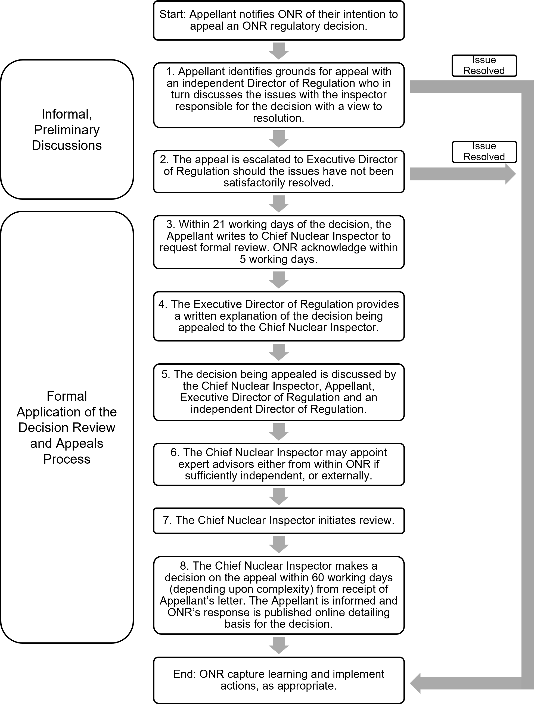
Figure 1 – Decision review and appeals process flow diagram
The appellant may escalate their appeal to the EDR (Step 2) should they consider the matter to not have been resolved. This is still considered informal application of the appeals process. The purpose of the EDR’s review is to consider the grounds for appeal through discussion with the appellant and arrive at a decision whether to uphold, partially uphold, or reject the appeal. The engagement between the EDR and appellant shall be recorded in a contact record. The EDR shall inform the appellant of the outcome of their review.
Should the appeal not be upheld then the EDR should inform the appellant of the formal Decision Review and Appeals process.
In cases where the decision being challenged was made by either the EDR and/or Chief Nuclear Inspector, then the review at this stage (Figure 1, Step 2) shall be conducted by a second, independent Director of Regulation sponsored by the Chair of the ONR Board. This is to maintain impartiality. The Chair of the ONR Board will support the independent Director of Regulation as senior sponsor. The Chair will act in this capacity in any situation where the appeal reviewer is junior to the original decision maker (Appendix B). The independent Director of Regulation shall decide if the appeal is eligible for acceptance and, should this be the case, consider whether it should be upheld, partially upheld, or rejected. The outcome of the appeal will be reported to the appellant, relevant ONR inspectors and the Chair of the ONR Board.
Should the grounds for the appeal be accepted, and the original decision need to be reviewed, the outcome will be documented via a contact record. Should the appeal not be upheld, the appellant shall be informed of the formal Decision Review and Appeals process.
Regardless of the outcome of the informal, preliminary discussions, there will likely be learning that can be implemented by ONR. This may, for example, result in the need to amend our processes and procedures. Any remedial actions shall be implemented and managed through ONR’s existing governance arrangements.

Formal Application of the Process: Decision Review and Appeal
Where use of the informal approach (sub-section 2.1.1) is unsuccessful in resolving the matter, the appellant may appeal in writing to the ONR Chief Nuclear Inspector to request a formal review of the process applied to the regulatory decision.
The appeal in writing should clearly describe the basis for the appeal and provide evidence supporting the appellant’s case. In cases where the decision being appealed was made by the Chief Nuclear Inspector responsibilities will be delegated to others who are impartial (see below and Appendix B) with the Chair of the ONR Board acting as senior sponsor of the reviewer.
The appellant shall submit a request for review within 21 working days, beginning the day after which the decision being challenged was made (Figure 1, Step 3).
ONR may consider requests to extend this time. For example, if the appellant is engaged in informal, preliminary discussions. Appellants should not assume that an extension will be granted in every case, particularly if the circumstances do not justify an extension.
The Chief Nuclear Inspector should confirm receipt of the appellant’s request for formal review in writing, within five working days (Step 3).
On receipt of the appellant’s letter requesting a review, the EDR should write an explanation of the regulatory decision to the Chief Nuclear Inspector (Step 4).
The EDR should provide information relevant to the regulatory decision being challenged and previous discussions with the appellant (e.g., contact records relating to preliminary discussions). The EDR may also request further information or written clarification of any points from the appellant, as necessary. In cases where the decision being appealed was made by the Chief Nuclear Inspector, this step will be communicated to the Chair of the ONR Board.
The Chief Nuclear Inspector should discuss the appeal directly with the appellant, the EDR, an impartial Director of Regulation, and the ONR inspector(s) accountable for the decision (Stage 5). This meeting will be recorded in a contact record that will be shared with the appellant.
Prior to starting the decision review, the Chief Nuclear Inspector may appoint expert advisers to provide impartial advice in reviewing the process elements associated with the regulatory decision (Step 6). The expert advisors may be appointed from within ONR, if impartial of the regulatory decision being challenged, or from appropriate external organisations.
In reviewing the decision (Step 7), the Chief Nuclear Inspector should focus on the process by which the original decision was made, including both the technical and non-technical approaches taken. While the focus will be on the application of ONR process, other relevant factors may be taken into account in arriving at the decision. The Chief Nuclear Inspector shall decide if ONR has made a valid decision through the correct application of ONR’s processes or, in the case of the Regulators’ Code, whether a non-compliance has occurred. The Chief Nuclear Inspector should make this judgement by taking into account all evidence presented by the appellant, the Inspector(s) and advice from appointed experts.
The Chief Nuclear Inspector should normally conduct the review and communicate their final decision to the appellant within 60 working days of receipt of the written appeal. There may be instances when the review takes longer due to the complexity of the decision or availability of relevant personal and/or expert advice. In such cases, the appellant should be notified, and a date provided confirming when the decision shall be communicated.
As a result of the review the Chief Nuclear Inspector should either:
- Reject the appeal.
- Partially uphold the appeal on the grounds of process or other relevant factors.
- Uphold the appeal.
The Chief Nuclear Inspector may not change regulatory decisions providing ONR has correctly applied its processes in making the decision and followed the requirements of the Regulators’ Code. If the process by which the decision was made is found to be deficient then the Chief Nuclear Inspector may suspend the decision, depending on the significance of the shortfall.
The Chief Nuclear Inspector shall communicate the outcome of their review in writing to the appellant (Step 8), and other relevant stakeholders. This letter should provide the detailed basis of the decision. For visibility and transparency purposes, the outcome of the review should be published on the ONR website (Section 4).
Once this letter is issued to the appellant there is no recourse for further appeal within ONR.
Should any other party wish to appeal an ONR decision, or should the appellant be dissatisfied with the outcome having completed the Decision Review and Appeals process the following options remain available:
- Raise the matter in writing with their local Member of Parlaiment, asking them to raise the concern with the relevent minister.
- A request can be made to the Parliamentary and Health Service Ombudsman to review the appeal via their Member of Parliament.
- Pursue an appeal through formal judicial review via the appropriate legal channels.
The Chief Nuclear Inspector, as part of regular reporting, should communicate the outcome of any reviews to the ONR Board for awareness and to identify any immediate remedial actions that are required.
In cases where the decision being challenged was made by the Chief Nuclear Inspector then the formal application of this process (Figure 1, Steps 3 to 8) shall be conducted by the EDR, sponsored by the Chair of the ONR Board. The EDR will provide the Chair of the ONR Board with updates related to the review. The process otherwise remains the same, unless stated. In the unlikely event that the decision being challenged had involved both the Chief Nuclear Inspector and EDR, then this role would be delegated to an impartial and independent Director of Regulation, sponsored by the Chair of the ONR Board. For unforeseen scenarios where multiple individuals were involved in making the decision being appealed then the Head of Regulatory Intelligence and Oversight will perform a review to identify the most impartial and suitably qualified and experienced individuals within the organisation to undertake the formal application of this process, or from external organisations.
Regardless of the outcome of the Decision Review and Appeals process there is likely to be learning identified by ONR. Remedial actions shall be implemented and managed through ONR’s existing governance arrangements.

Roles and Responsibilities
Roles and responsibilities related with this process are presented in Appendix A.

Delegations
In some instances, individual roles identified by this instruction may be unavailable.
For example, due to absence from work or having been involved in the decision being appealed. In these cases, ONR may delegate the responsibilities to another suitably qualified and experienced individual. This will be managed by the Head of Regulatory Intelligence and Oversight. The appointee should be independent of the decision being challenged to ensure impartiality, but can be from within ONR or, if appropriate, an external organisation. Some delegations are identified in sub-sections 2.1.1 and 2.1.2 and Appendix B.
During the informal, preliminary discussions any delegation shall be communicated to the appellant and recorded in a contact record. During formal application of this process ONR should write to the appellant explaining the reasons for delegation.

Records
The following records are produced as a result of this activity:
- Contact records – to record discussions with the appellant, and only during the informal, preliminary discussions to communicate any changes to the regulatory decision being appealed.
- Letters – to acknowledge receipt of the appeal and to record the outcomes of any decisions made by ONR during the formal application of the appeals process.
Records will be shared with the appellant, and where appropriate, published to the ONR website following appropriate redactions (Section 4).
All records listed above are retained in accordance with the retention times described in the ONR Business Classification Scheme and Disposal Schedule Manual.

Openness and Transparency
In accordance with ONR’s organisational values, the letter from the Chief Nuclear Inspector to the appellant detailing the outcome (with reasons) of the appeal will be published with redactions, as appropriate. The letter should identify any organisational learning and required remedial actions.
All publications will be subject to any relevant restrictions concerning security, data protection, disclosure of information provisions in the Health and Safety at Work etc Act 1974, the Energy Act 2013, and any other relevant legislation.

Cost Recovery
ONR will only recover costs that arise from a review when an appeal fails. ONR has powers to charge for the majority of its regulatory functions, primarily through provisions of the Nuclear Installations Act 1965, the Health and Safety and Nuclear (Fees) Regulations 2021; the Nuclear Industries Security (Fees) Regulations 2005 and the Nuclear Safeguards (Fees) Regulations 2021. These fees will be applied where relevant to the costs of decision reviews. Costs will be recovered in line with ONR’s standard charging model and will include the costs associated with any appointed expert advisers.
Where the appeal is upheld by ONR, the cost of ONR having to remake the regulatory decision will not be charged to the appellant.

Appendix A – Roles and Responsibilities
Appellant
The appellant is the body challenging the regulatory decision made by ONR.
The appellant may have been affected by the regulatory decision. An appellant can be:
- A dutyholder regulated by the ONR under its purposes.
- A prospective licensee participating in the site licensing process.
Under this process, the appellant’s responsibilities include:
- Informing ONR of their intent to appeal the regulatory decision within the specified timescales.
- Ensuring their appeal meets the requirements for entry into this process
(sub-section 1.2).
- Participating in informal, preliminary discussions and formal application of this process by attending meetings with relevant ONR stakeholders and providing information and evidence to support their objections, when requested.
- Requesting a formal review by the Chief Nuclear Inspector in writing, if appropriate.
- Responding to ONR queries, and requests for information and evidence in a timely manner.
Expert Advisors
Expert advisors are appointed to provide impartial advice in reviewing the process elements associated with the regulatory decision. The expert advisors may be appointed from within ONR, if impartial of the regulatory decision being challenged, or from appropriate external organisations. The responsibilities of an expert advisor include:
- Provision of impartial, expert advice to the Chief Nuclear Inspector and/or others participating in the appeals process.
- Identification and communication of learning and corrective actions to ONR.
Head of Regulatory Intelligence and Oversight
The Head of Regulatory Intelligence and Oversight is the lead of ONR’s intelligence and oversight function. They are the Decision Review and Appeals process owner. The Head of the Regulatory Intelligence and Oversight function is responsible for managing the application of this process and facilitating its use.
Independent Director of Regulation
The independent Director of Regulation is the lead of one of ONR’s regulatory divisions. They will not have been involved with the making of the regulatory decision being appealed to ensure impartiality.
Responsibilities include:
- Meeting with the appellant to discuss their objections regarding the regulatory decision being appealed.
- Impartial review of the appellant’s objections and evidence.
- Issue of a contact record that captures the key points of the discussion with the appellant.
- Informing the EDR of whether they were able to resolve the appellant’s objections.
- Identifying any lessons and remedial actions, and ensure these are adequately implemented and managed by ONR.
- Participating in other steps of the process as required.
In situations where the impartiality of the Chief Nuclear Inspector and EDR is compromised, an independent Director of Regulation may be called upon to perform their responsibilities. The Chair of the ONR Board will act as senior sponsor in such circumstances.
Inspector
The inspector is an individual appointed by the ONR under Part 1 of Schedule 8 of the Energy Act 2013 and/or Section 19(1) of the Health and Safety at Work etc. Act 1974. They are the individual accountable for the regulatory decision being challenged by the appellant.
Responsibilities include:
- Attendance at meetings with relevant stakeholders on request.
- Providing information relevant to the regulatory decision being appealed on request.
Executive Director of Regulation (EDR)
The EDR is an Executive ONR Board member, and responsible for the day-to-day leadership of ONRs regulation of the UK Nuclear Industry.

Responsibilities include:
- Impartially consider the grounds for appeal through discussion with the appellant during the informal, preliminary discussions and decide whether to uphold, partially uphold, or reject the appeal.
- Identifying any lessons and remedial actions, and ensure these are adequately implemented and managed by ONR.
- Informing the appellant of the outcome of their review.
- Alerting the appellant to the formal Decision Review and Appeals process should their appeal not be upheld.
- Write to the Chief Nuclear Inspector providing an explanation of the regulatory decision being challenged and a summary of engagements with the appellant on entry into the formal application of the decision review and appeals process.
- Attending and supporting meetings during the formal application of this process with other stakeholders including the appellant.
In cases where the decision being appealed was made by the Chief Nuclear Inspector, then the EDR will undertake those duties of the Chief Nuclear Inspector during the formal application of this process (sub-sections 2.1.2). The Chair of the ONR Board will act as senior sponsor in such circumstances.
Chief Nuclear Inspector
The Chief Nuclear Inspector is an Executive ONR Board member and has overall accountabilty as the Regulatory Head of ONR, they provide independent authoritative expert advice on nuclear safety, security and safeguards to the Board, ministers and parliament. The Chief Nuclear Inspector is also the Chief Executive of ONR.
Responsibilities include:
- Confirming receipt of the appellant’s formal request to review the regulatory decision within five working days.
- Organisation of and chairing of meetings with relevant stakeholders to discuss the objections to the regulatory decision.
- Keeping the ONR board informed of the decision review and appeal.
- Identifying and appointing expert advisors to support the formal review.
- Conducting a review of the regulatory decision being challenged by the appellant.
- Making an impartial and informed decision whether to uphold, partially uphold or reject the appellant’s appeal.
- Informing the appellant of the decision within 60 working days of starting the review, and if necessary, alert the appellant of other avenues with which to appeal the decision.
- Notifying the appellant if the decision will take longer than 60 working days, and provide a date when the decision will be communicated.
- Facilitating the publication of the decision to the ONR website.
- Identifying any lessons and remedial actions, and ensure these are adequately implemented and managed by ONR.
Chair of the ONR Board
The Chair is a non-executive member of the ONR board. The Board's role is to provide leadership, set strategy, agree the overarching policy framework within which ONR operates as a regulator, agree and monitor resources and performance and ensure good governance. The Chair’s responsibilities are described in the framework document.
With respect to this process the Chair of the ONR Board will act as senior sponsor in cases where the reviewer is junior to the original decision maker. For example, the Chair would support the reviewer for decisions that were made by the Chief Nuclear Inspector or where the EDR is not impartial. The Chair is responsible for:
- Supporting and communicating directly with the EDR or independent Director of Regulation including via progress meetings.
- Ensuring the impartiality of the EDR or independent Director of Regulation is maintained and that no undue influence is applied to their decision making.

Appendix B – Summary of Delegations
Stage | Decision made by Director of Regulation or another Inspector | Decision made by the Executive Director of Regulation (EDR) | Decision made by Chief Nuclear Inspector
Informal, preliminary discussions | Use process | Step 2: replace EDR with a second, independent Director of Regulation sponsored by Chair of Board.  Note: The Chief Nuclear Inspector should not undertake this step to maintain impartiality should the appeal progress to the formal stage. | Step 2: replace EDR with a second, independent Director of Regulation sponsored by Chair of Board.  Note: The EDR should not undertake this step to maintain impartiality should the appeal progress to the formal stage.
Formal application of process | Use process | Use process – EDR excluded from review. | EDR sponsored by Chair of Board – the Chief Nuclear Inspector excluded from review.  If EDR is not impartial, then use an independent Director of Regulation sponsored by Chair of Board – the Chief Nuclear Inspector and EDR excluded from review.

Impartiality of the EDR will be maintained during any informal, preliminary discussions, by delegating the EDR’s responsibilities to an independent Director of Regulation. The EDR will also not have been involved in making the decision being challenged.

