ONR Procedure
Production of Alerts, Advice Notes and Inspector Awareness Briefs

ONR Procedure
Production of Alerts, Advice Notes and Inspector Awareness Briefs
Process Owner: Technical Division Director

Authored by: Nuclear Safety Inspector
Reviewed by: Principal Nuclear Safety Inspector
Principal Nuclear Safety Inspector
Approved by: Head of Regulatory Intelligence & Oversight

Issue No.: 2
Publication Date: January 2024
Next Major Review Date: January 2027
Doc. Ref. No.: ONR-OPEX-GD-005
Record Ref. No.: 2019/309744

Revision commentary
Issue No. | Description of Update(s)
0 | Original version
1 | Updated template. Regulatory Intelligence and Oversight’s role clarified. Minor revisions to process.
2 | Inspector Awareness Briefs added with associated revisions to process. RIO DDS check sheet added. Minor updates, editorial and quality checks.

Contents
1. Introduction 4
1.1. Purpose 4
1.2. Scope and Applicability 4
1.3. Definitions 6
2. Responsibilities 6
3. Process 7
3.1. General guidance 7
3.2. Alerts 7
3.3. Advice Notes 8
3.4. Inspector Awareness Briefs 9
References 11
Appendix A – Roles and Responsibilities 12
Appendix B – RIO DDS Check Sheet 15

Introduction
Alerts, Advice Notes and Inspector Awareness Briefs are ONR documents for sharing of learning with stakeholders. This aligns with IAEA relevant good practice [1], which expects regulatory bodies to make arrangements for analysis to be undertaken to identify lessons to be learned from operating experience and regulatory experience. These arrangements should disseminate lessons learned for use by the regulatory body, stakeholders and other relevant authorities. The way ONR does this is described in this document.

Purpose
This document presents ONR’s procedure for producing Alerts, Advice Notes and Inspector Awareness Briefs, which share learning with external and internal stakeholders.

Scope and Applicability
The scope of learning covered by Alerts, Advice Notes and Inspector Awareness Briefs is broad. It includes matters relevant to ONR’s purposes and the effectiveness with which we deliver our mission. Learning applicable to ONR and/or our stakeholders could result from:
- Incidents notified by a dutyholder.
- Learning from ONR’s activities.
- Other national and international regulatory bodies and their activities.
- International nuclear power plant operating experience.
- Learning identified from outside the nuclear sector.
- Examples of good practice.
Alerts are external documents to communicate a considered regulatory position:
- Notify our dutyholders of a specific significant concern that could result in a serious injury or a threat to public safety.
- Inform dutyholders and other stakeholders of a signficiant risk; where appropriate, dutyholders should review the adequacy of their arrangements in light of the operational experience, and make any necessary enhancements.
- Share learning from national and international regulatory activities that is relevant to our dutyholders' operations.
Advice Notes are internal ONR documents to share learning and advice across ONR’s regulatory teams:
- Share operational and regulatory experience.
- Support knowledge management by reinforcing learning from historical incidents.
- Share good practices.
- Raise awareness of the common causes of regulatory failure and success.
- Contribute to and support our learning culture.
Inspector Awareness Briefs are internal ONR documents, but may be shared externally to:
- Rapidly disseminate details of operational experience to raise awareness of consequentialincidents, significant near misses or topics of concern that are relevant to our dutyholders.
- Provide information to operational inspectors, so that they can decide if further targeted interaction with dutyholder(s) is warranted.
- Provide a factual account of reported incidents to prompt inspectors to consider where other similar activities or risks may be present. They do not include a regulatory position.

Definitions
Table 1 – Table of Definitions
Term/Acronym | Description
DDS | Divisional Delivery Support
DL | Delivery Lead
Head | Head of a [Regulatory] Function in ONR
IAEA | International Atomic Energy Agency
PL | Professional Lead
RIO | Regulatory Intelligence and Oversight
RLT | Regulatory Leadership Team
SLT | Senior Leadership Team
TD | Technical Director

Responsibilities
Responsibilities associated with this process are defined in Appendix A.

Process

General guidance
The need for an Alert, Advice Note and/or Inspector Awareness Brief will typically be determined by ONR’s sub-divisions, specialisms or functions. The relevant Delivery Lead (DL), Professional Lead (PL) or Head of Function is the Sponsor and will oversee its development. The production of an Alert, Advice Note and/or Inspector Awareness Brief should be driven by the identification of learning relevant to our regulatory activities and/or our stakeholders.
An Author(s) should be assigned by the Sponsor. The Author is responsible for producing the Alert, Advice Note and/or Inspector Awareness Brief in consultation with relevant stakeholders, such as specialist inspectors.
The Head of Regulatory Intelligence and Oversight (RIO) should be informed when an Alert, Advice Note and/or Inspector Awareness Brief is being developed. RIO is the owner of this process and will facilitate its application. This includes supporting the Author with document production and ensuring consistency.
Any decisions about security or legal implications will need to be considered and advice taken as required (e.g., due to on-going investigations). This should be explicitly considered where external sharing is expected.
Figure 1 presents the process for producing Alert, Advice Note and/or Inspector Awareness Brief. Specific guidance for Alerts is provided in §3.2, Advice Notes in §3.3, and Inspector Awareness Briefs in §3.4.
Feedback relating to use of this process from the Sponsor and Author(s) should be forwarded to RIO. Feedback will be used by RIO to enhance this process and ensure the timely issue of high-quality learning relevant to ONR’s activities.

Alerts
Alerts are externally facing documents that inform dutyholders and other relevant stakeholder of matters of major concern that pose a risk to health, safety and / or security. Alerts communicate a considered regulatory position (cf. Inspector Awareness Briefs in §3.4). For example, an Alert may be issued as a pre-emptive measure following identification of an industry-wide trend, or on completion of an ONR investigation.
Alerts will often require immediate dutyholder attention. They should be produced and issued in a timely manner. The Sponsor is responsible for securing the resources needed to produce the Alert, and ensuring its production is prioritised.

ONR may choose to issue an Alert, ahead of undertaking related regulatory activities depending on the significance of the concern(s). Dutyholders may be expected to undertake actions in response to the Alert, if appropriate. Any actions should be explicitly included along with timeframes for implementation.
In addition to informing RIO that an Alert is to be issued, ONR’s Communications Team must also be notified. The Sponsor should agree with the assigned Communications Business Partner:
- the distribution list of external stakeholders; and,
- expected date of release.
Alerts will receive rigorous governance and oversight as they notify dutyholders and stakeholders of matters of concern that pose a risk to health and safety. Alerts will be approved for external publication by the Technical Director (TD) or their delegate. Quality checks that should be undertaken prior to publication are included in Appendix A.
Once approved for publication the Sponsor should arrange issue of the Alert to the agreed distribution list. The means of communicating the Alert is to be decided by the Sponsor and TD (or delegate). For example, the Alert may be appended to an ONR letter, or e-mailed to dutyholders. Publication to the ONR website should be considered.
A copy of the ONR Alert template is available via HOW2 [2]. This template can, with agreement from RIO, be tailored by the Author to best suit the information.
It is good practice to develop an Alert and an Advice Note, in parallel, on the same incident/lessons learned. This raises awareness of the concerns amongst our regulatory teams and provides related advice and guidance to our inspectors. Production of the Alert should be prioritised; the Advice Note can be produced in-parallel or to follow shortly afterwards.

Advice Notes
Advice Notes are internal documents that share learning and advice across ONR regulatory teams. The identification and development of Advice Notes should primarily be led by sub-divisions and specialisms based on learning from their regulatory activities.
Timescales for Advice Note publication should be agreed between the Sponsor, Author and RIO. If supporting an Alert, the aim should be to publish the Advice Note in conjunction with the Alert or shortly after.
The Sponsor and Author should consider whether an Advice Note has a validity period, and if so, appropriate caveats should be included.
RIO will provide advice and guidance to the Author to ensure consistency of Advice Note production. The Advice Note can be shared with an assigned Communications Business Partner for review, if considered appropriate.
The Sponsor is responsible for approving the Advice Note (refer to Appendix A).
Once an Advice Note is approved it should be submitted to the Organisational Learning Function e-mail account for publication. The RIO team will:
- Publish the approved Advice Note to Nucelus.
- RIO Divisional Delivery Support (DDS) will circulate the Advice Note to relevant stakeholders including the ONR training team, and DLs/PLs for further cascading to their teams.
- As appropriate, work with the Author and Communications Business Partner to advertise the Advice Note on the intranet news centre and staff briefing.
A copy of the ONR Advice Note template is available via HOW2 [3]. This template can, with agreement from RIO, be tailored by the Author to best suit the information.

Inspector Awareness Briefs
Inspector Awareness Briefs share operational experience internally. Where appropriate, they may be published externally. The purpose is to quickly raise awareness of consequential incidents, significant near misses and topics of concern. They provide a factual account of reported incidents to prompt inspectors to consider where other similar activities or risks may be present at facilities or activities they regulate. They do not include a regulatory position.
Inspector Awareness Briefs should be prepared promptly by the Author so that operational experience is disseminated in a timely manner. A copy of the Inspector Awareness Brief template is available via HOW2 [4]. The template headings can be adapted to suit the subject. All Inspector Awareness Briefs must include a section titled ‘Points for ONR inspectors to consider including within dutyholder interactions’.
The Sponsor is responsible for approving the Inspector Awareness Brief for internal publication (Appendix A). The approved Inspector Awareness Brief should be submitted to the Organisational Learning Function for publication by RIO to Nucleus and dissemination (refer to §3.3 for details).
RIO will, in consultation with the Author, Sponsor and Communications Business Partner, consider whether the Inspector Awareness Brief is appropriate for external issue. Consideration should be given to incident significance, applicability to the wider industry and identification of trends. It may be possible to consolidate learning from several incidents into a single Inspector Awareness Brief.

The TD, or delegate, will approve Inspector Awareness Briefs considered suitable for external issue. A suitable quality check should be provided by the Communications Business Partner (Appendix A). The Author should take account of any advice provided by the Communications Business Partner, and if necessary, revise the Inspector Awareness Brief prior to external issue.
The approved Inspector Awareness Brief will be distributed to dutyholders by email. A distribution list will be agreed by the Sponsor and Communications Business Partner. RIO DDS will distribute the Inspector Awareness Brief.
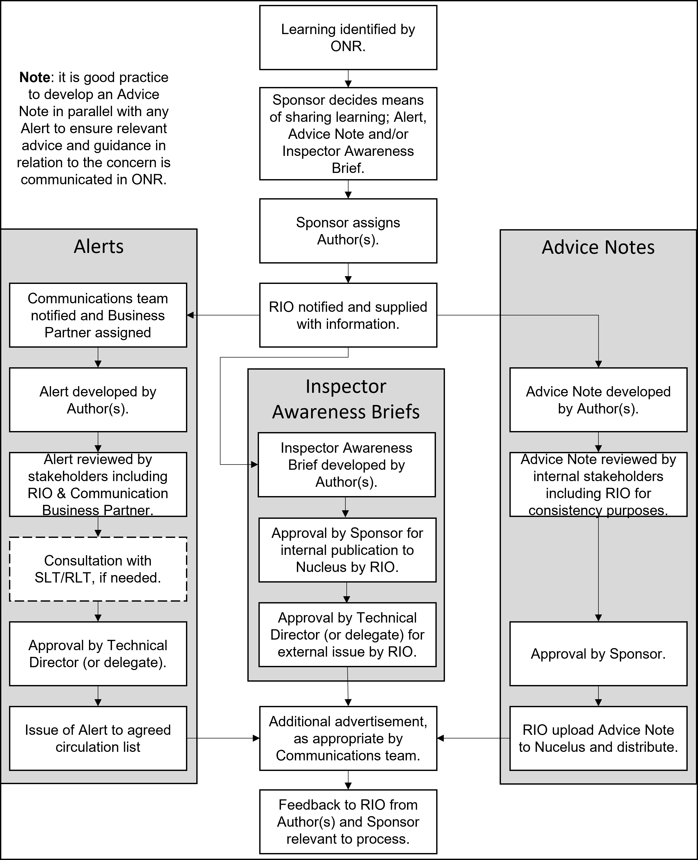
Figure 1 – Process for production of Alerts and/or Advice Notes

References

[1] | IAEA, Governmental, Legal and Regulatory Framework for Safety. Safety Standards Series No. General Safety Requirements (GSR) Part 1 (Rev. 1), 2016.
[2] | ONR, “ONR-DOC-TEMP-378 - ONR Alert Template”.
[3] | ONR, “ONR-DOC-TEMP-377 - ONR Advice Note Template”.
[4] | ONR, ONR-DOC-TEMP-NNN - ONR Inspector Awareness Brief (IAB) Template.
[5] | Health and Safety Executive, “Safety Alerts and Notices: Guidance,” [Online]. Available: https://www.hse.gov.uk/safetybulletins/index.htm. [Accessed 03 July 2023].

Appendix A – Roles and Responsibilities

Author
The Author(s) will be assigned by the Sponsor, and is responsible for:
- Drafting the Alert, Advice Note and/or Inspector Awareness Brief ensuring that:
  - the content is factually correct;
  - information sources are referenced;
  - written clearly and in plain english;
  - adheres with the ONR style guide; and
  - information is accessible.
- Liaising with RIO in relation to the process, and agreeing any changes to the standard templates.
- Liaising with the assigned Communications Business Partner, as appropriate.
- Consulting with relevant stakeholders with respect to the content of the Alert, Advice Note or Inspector Awareness Brief. For example, specialist inspectors from other specialisms.
- Sharing the draft Alert, Advice Note and/or Inspector Awareness Brief with reviewers and approvers.
- Implementing feedback on the Alert, Advice Note and/or Inspector Awareness Brief from reviewers and approvers.
- Provision of feedback and learning to RIO in relation to the use of this process.

Approver
Approvers will be:
- The TD, or delegate, for Alerts.
- The Sponsor for Advice Notes and internal issue of Inspector Awareness Briefs.
- The TD, or delegate, for external issue of Inspector Awareness Briefs.

Communications Business Partner
The Communications Business Partner(s) is responsible for:
- Reviewing Alerts and Inspector Awareness Briefs (and where appropriate, Advice Notes):
  - ensuring they meet the ONR style guide and are written in plain English; and
  - providing advice to the Author and Sponsor recognising the documents will be shared with dutyholders.
- Agreeing the Alert or Inspector Awareness Brief distribution list with the Sponsor.
- Where appropriate, advertise the release of an Alert, Advice Note and/or Inspector Awareness Brief including via the Nucleus News Centre and/or Staff Brief.
- Noting any substantive feedback received on Alerts and/or Inspector Awareness Briefs from dutyholders and providing this feedback to the Sponsor and RIO.

Regulatory Intelligence and Oversight
RIO is the owner of this procedure. The Head of RIO will assign a member(s) of the team to be responsible for:
- Maintaining this procedure.
- Supporting the Sponsor and Author(s) in applying this process.
- Ensuring Alerts, Advice Notes and/or Inspector Awareness Briefs are developed in accordance with this process.
- Helping to co-ordinate interactions between various internal stakeholders.
- Uploading approved Advice Notes and/or Inspector Awareness Briefs to the RIO Nucleus page.
- RIO DDS circulate approved Advice Notes and/or Inspector Awareness Briefs to internal stakeholders.
- Facilitating the external circulation of approved Alerts and Inspector Awareness Briefs to agreed distribution lists. RIO DDS should maintain a dutyholder email distribution list for circulating Alerts and Inspector Awareness Briefs.
- Maintaining the RIO Nucleus page for Alerts, Advice Notes and Inspector Awareness Briefs.
- Recording feedback in relation to this process and implementing enhancements.

Sponsor
- The Sponsor (DL/PL/Head of) will usually be the individual that identifies the need for an Alert, Advice Note and/or Inspector Awareness Brief. Occasionally, the Sponsor may be requested to oversee the development of Alert, Advice Note and/or Inspector Awareness Brief. The Sponsor is responsible for:
- Identifying learning suitable for inclusion in an Alert, Advice Note and/or Inspector Awareness Brief.
- Assigning an Author(s).
- Overseeing the development.
- Approving Advice Notes and/or Inspector Awareness Briefs (see Approver).
For Alerts and/or Inspector Awareness Briefs, the Sponsor has the following additional responsibilities:
- Agreeing a distribution list with the assigned Communications Business Partner.
- Ensuring issue of the Alert or Inspector Awareness Brief, once approved, to the agreed distribution list.
For Alerts, the Sponsor must:
- Review the draft Alert and endorse it for submission to the TD (or delegate) for approval.
- Agree the means of communicating the Alert with the TD (or delegate) and assigned Communications Business Partner, as appropriate.

Technical Director (or Delegate)
The TD has the following responsibilities in relation to Alerts:
- Approving Alerts (refer to Approver).
- If unavailable, delegating their approval function to a suitable senior inspector.
- Deciding whether additional assurance should be sought from RLT/SLT on draft Alerts prior to publication, noting rigorous governance and oversight of Alerts is encouraged.
- Agreeing the means of communicating the Alert with the Sponsor.

Appendix B – RIO DDS Check Sheet
RIO DDS are responsible for completing the following actions as part of this process:
Table 2 - RIO DDS Check Sheet
Step | Description | Complete
1 | When informed an Alert, Advice Note or Inspector Awareness Brief is to be produced, share the guidance document (ONR-OPEX-GD-005) and template with the Sponsor and Author.
2 | On receipt of the approved Alert, Advice Note or Inspector Awareness Brief upload the document to the relevant Organisational Learning Function folder on CM9.  If the Sponsor/Author has already uploaded the document to CM9 then add the document as “alternatively within” or similar to the relevant Organisational Learning Function folder.
3 | Add administrative information to the Alert, Advice Note or Inspector Awareness Brief, if necessary. This includes the CM9 document number, CM9 folder number etc.
4 | Upload the Alert, Advice Note or Inspector Awareness Brief to the Organisational Learning Function intranet page.  Documents should be uploaded as a protected Word document for accessibility purposes.
5 | Circulate the Alert, Advice Note or Inspector Awareness Brief to ONR PLs/DLs for cascade to their teams. A standard e-mail should be used describing what PLs/DLs are expected to do including cascading to their teams, considering the relevance of the learning, garnering feedback from their teams, and considering the learning in the context of their intervention strategy etc.
6 | External distribution of Alert or Inspector Awareness Brief, if appropriate – refer to 6a and 6b below for details.
6a | For Alerts only, issue the Alert to the agreed external distribution list by the means agreed by the Sponsor and TD (or their delegate). This may include ONR letter or e-mail to dutyholders.  If appropriate, the Alert should be issued to ONR’s Online Team for publication to the ONR website.
6b | For Inspector Awareness Briefs only, if approved by the TD (or their delegate) for external issue, circulate the Inspector Awareness Brief to the agreed external distribution list by e-mail. Prior to issue the shaded boxes marked “to be removed prior to external circulation” should be removed, and a new file generated with 'for external distribution' in the title. This version should be circulated.
7 | If appropriate, liaise with the Technical Division Communications Business Partner to advertise the internal publication of the Alert, Advice Note or Inspector Awareness Brief in the next available Staff Brief and/or on the News Centre.
8 | Provide any feedback received via the Organisational Learning e-mail account on the Alert, Advice Note or Inspector Awareness Brief to the Sponsor, Author and member of RIO responsible for this process.

‘Learning’ is used in this document to include lessons learned, operational experience, intelligence and information relevant to activities on nuclear licensed sites.
It should be noted that the UK Health and Safety Executive also operates with similar arrangements for safety alerts and notices [5].
This includes interventions, intelligence gathering, investigations, use of the enforcement management model or engagement with stakeholders.

