ONR Technical Assessment Guide
General Guidance for Mechanical Engineering Specialism Group

ONR Technical Assessment Guide (TAG)
General Guidance for Mechanical Engineering Specialism Group

Authored by: Mechanical Engineering Inspector
Approved by: Mechanical Engineering, Professional Lead
Professional Lead: Professional Lead – Mechanical Engineering

Issue No.: 2
Publication Date: June-2023
Next Major Review Date: June 2028
Doc. Ref.: NS-TAST-GD-102
Record Ref. No.: 2020/139079

Revision commentary
Issue No. | Description of Update(s)
0 | New document issue.
1 | Updated review period.
1.1 | Minor update to remove extant URLs from the document to mitigate potential configuration control issues arising because of changes to third-party web documents.
2 | Update review period.

Contents
1. Introduction 5
2. Purpose and Scope 6
3. Relationship to Licence and other Relevant Legislation 7
4. Relationship to Safety Assessment Principles, WENRA Reference Levels, and IAEA Safety Standards and Guides 8
5. Advice to Inspectors 9
References 10
Glossary and Abbreviations 11
Appendices 12
Appendix 1: Compliance Schedule 13
Appendix 2: Quality Assured Bolting in Safety Critical Applications 14
Appendix 3: Guide to Inspection of Mechanical Engineering Workshops and Maintenance Facilities 19

Introduction
- ONR has established its Safety Assessment Principles (SAPs) [1] which apply to the assessment by ONR specialist inspectors of safety cases for nuclear facilities that may be operated by potential licensees, existing licensees, or other duty-holders. The principles presented in the SAPs are supported by a suite of guides to further assist ONR’s inspectors in their technical assessment work in support of making regulatory judgements and decisions. This technical assessment guide (TAG) is one of these guides.
- This TAG supports the mechanical engineering specialism group (MESG) in their technical assessment activities, supporting their regulatory judgements. The TAG functions as a repository for miscellaneous relevant good practice (RGP) not easily assimilated in other ONR mechanical engineering regulatory guidance.
- The TAG is arranged as a collection of focus area appendices developed through time, reflecting appropriate guidance and RGP.

Purpose and Scope
- This TAG contains guidance and RGP to inform ONR inspectors in the development and exercise of their regulatory judgement.
- Valuable information for inspectors is frequently collected within ONR through its activities. However, this information does not always fit into the scope of existing guidance. Consequently, this TAG has been produced to capture such miscellaneous guidance and RGP.
- This TAG is principally collated guidance originating from the MESG. It may however be useful for other specialist ONR inspectors wishing to gain an overview of the topic areas. It identifies guidance and RGP by topic which is conveyed through appendices attached to this TAG. Each appendix outlines the relevant legislation, RGP, good practice guides and internal ONR guidance.
- It is expected that appendices will be added (or potentially removed) over time.

Relationship to Licence and other Relevant Legislation
- ONR was formally established by Part 3 of the Energy Act [2], and a Commencement Order [3] bringing the relevant sections and the organisation into being.
- In particular, the legislation that underpins the legal framework for the nuclear industry includes:
- Health and Safety at Work Act 1974 Employers are responsible for ensuring the safety of their workers and the public;
- Nuclear Installations Act 1965 (NIA) A site cannot have a nuclear plant unless the user has been granted a site licence by ONR (LC). Only a corporate body can hold such a licence. Tese are a set of 36 standard LCs attached to each nuclear site licence [4], covering a whole facility life cycle, including:
  - design
  - construction
  - commissioning
  - operation
  - decommissioning and
  - management oversight and reviews.
- Ionising Radiations Regulations 2017 Provides for protection of workers in all industries from ionising radiations and by the general health and safety regulation which ONR also enforces at nuclear sites;
- the Management of Health and Safety at Work Regulations 1999;
- the Lifting Operations and Lifting Equipment Regulations 1998;
- the Provisions and Use of Work Equipment Regulations 1998; and,
- the Pressure Systems Regulations 2000.
- Such legislation applies to nuclear installations and should be considered by Inspectors in addition to the specific requirements of the LCs.
- Table 2, prior to the appendices, summarises the LCs [4] relevant to each appendix.

Relationship to Safety Assessment Principles, WENRA Reference Levels, and IAEA Safety Standards and Guides
- Inspectors use Safety Assessment Principles (SAPs), together with supporting TAGs, to guide regulatory decision making in the nuclear permissioning process. Underpinning such decisions is the legal requirement on nuclear site licensees to reduce risks so far as is reasonably practicable, and the use of these SAPs should be seen in that context (Safety Assessment Principles - 2014 edition (Revision 1, January 2020) ).
- Table 2 details the SAPs relevant to each appendix. As with the LCs, the various appendices apply to many different SAPs [1]. This is not intended to be a complete list, and other requirements may also influence an inspectors approach.
- WENRA Reference Levels and IAEA Safety Standards Guidance
- This revision of the TAG does not contain references to either the WENRA Reference Levels [3] or any additional IAEA Safety Standards Guidance; and,
- Future revisions of this document may include such referances where applicable, therefore this section has been included for completeness.
- The attached appendices will include reference to additional guidance such as ISO or BS standards where appropriate.

Advice to Inspectors
- This TAG presents advice to inspectors independently within each appendix.
- Inspectors who wish to add additional guidance to this document should consult the process owner on HOW2 for consideration.

References
[1] ONR, “Safety Assessment Principles (SAPs) for Nuclear Facilities - 2014 Edition (Revision 1),” 2020.
[2] Part 3 of the Energy Act
[3] Commencement Order
[4] ONR, “Licence Condition Handbook,” 2017

Glossary and Abbreviations
ALARP As low as reasonably practicable
ASME American Society of Mechanical Engineers
BS British Standard
EIMT Examination, Inspection, Maintenance and Testing
EN European Norm, (European Standards)
FM Foreign Material
FME Foreign Material Exclusion
HSE Health and Safety Executive
IAEA International Atomic Energy Agency
ISO International Standards Organisation
LC License Condition
LFE Learning from Experience
MESG Mechanical Engineering Specialist Group
NEA Nuclear Energy Agency
ONR Office for Nuclear Regulation
OPEX Operational Experience
QA Quality Assurance
RCA Radiologically Controlled Area
RGP Relevant Good Practice
SAP Safety Assessment Principle(s)
SFAIRP So Far As Is Reasonably Practicable
SM Safety Mechanism
SQEP Suitably Qualified and Experienced Person
SSC Structure, System and Component
TAG Technical Assessment Guide(s)
TIG Technical Inspection Guide
UK United Kingdom
UKAS United Kingdom Accreditation Service
WENRA Western European Nuclear Regulators’ Association

Appendices

Contents
- Appendix 1: Complience Schedule
  - Table 1: Appendix Applicable License Conditions
  - Table 2: Appendix Applicable Safety Assessment Priciples
- Appendix 2: Quality Assured bolting in Safety Critical applications
- Appendix 3: Guide to Inspection of Maintenance Facilities

Appendix 1: Compliance Schedule

Table 1: Appendix Applicable Licence Conditions
Licence Condition | Relevant Appendices
 | Appendix 1 | Appendix 2
LC6 – Documents, records, authorities and certificates | ✓
LC15 - Periodic Review | ✓
LC17 - Management Systems | ✓
LC19 - Construction or installation of new plant | ✓
LC20 - Modification to design of plant under construction | ✓
LC21 - Commissioning | ✓
LC22 - Modification or experiment on existing plant | ✓
LC25 – Operational records | ✓ | ✓
LC27 - Safety mechanisms |  | ✓
LC28 - Examination, inspection, maintenance and testing | ✓ | ✓
LC29 - Duty to carry out test, inspections and examinations | ✓

Table 2: Appendix Applicable Safety Assessment Principles
Safety Assessment Principles (SAPs) | Relevant Appendices
 | Appendix 1 | Appendix 2
ECS. 3: Codes and Standards | ✓ | ✓
ECS. 4: Absence of established codes and standards | ✓ | ✓
ECS.5: Use of experience, tests or analysis | ✓
EQU.1: Qualification procedures | ✓
EMC.3: Evidence | ✓ | ✓
EMC.13: Materials | ✓
EMC.20: Records | ✓
MS.4: Learning | ✓ | ✓
ELO.1: Access |  | ✓

Appendix 2: Quality Assured Bolting in Safety Critical Applications

Introduction
- For the purpose of interpretation relating to “fasteners”, BS EN ISO 16426:2002 . [1] lists and BS EN ISO 3269:2001 [2] states these are inclusive of: bolts, screws, studs, nuts, pins, washers, blind rivets and other related fasteners.
- Mechanical Engineering assessment activities have examined the use of fasteners within safety critical structures, systems and components (SSCs) e.g. load-path components or structural fastenings, and whether there was sufficient evidence pertaining quality assurance (QA) arrangements substantiating there utilisation.
- This appendix sets regulatory expectations for such applications. This provides a set of high-level requirements concerning QA measures that should be in place as part of good practice in quality management arrangements for safety critical SSCs. Guidance on how examination, inspection, maintenance, and testing (EIMT) should be used to ensure the integrity of mechanical joints throughout their lifetime including in-service testing is also identified (see In-Service inspection).

Relevant Good Practice

Specifications
- The QA requirements placed on fasteners important to safety should be appropriate to the application and conditions of use (a graded approach). As such, fasteners not critical to safety i.e. fasteners not part of the safety feature, or failure will not degrade delivery of its safety function, the requirements of BS EN ISO 16426:2002 [2] should be applied and managed by the licensee as a minimum.
- BS EN ISO 16426:2002 and ASME B18.18:2011 [3], both state customers must request documentation if required. This is not (normally) supplied as standard. For safety critical fasteners the licensee should ensure appropriate documentation is obtained from the manufacturer / supplier. The licensee should also request that results of compliance tests are provided.
- Bolts should be supplied in individual “lots” (BS EN ISO 16426:2002 [1]) and stored at site in “lots” ensuring no commingling. Suitable documentation, relating to test data / results together with mechanical properties of “lots” shall be held by the licensee for the lifetime of fasteners (as “lots”).
- Where bolts are to be used for safety critical applications, applying the standard BS EN ISO 16426:2002 [1] may not be sufficient, such demands should be specified in the licensee’s technical specification along with suitable reference to standards for testing and QA management. Equally, a plan for auditing of suppliers should be in place where appropriate along with suitable evidence and records of such audits.
- BS EN ISO 16426:2002 [1] provides a minimal level of QA for fasteners. The licensees specification must provide a defined set of performance characteristics for the fastener(s). It is suggested that the licensee undertakes audit(s) of the manufacturer’s QA and technical procedures to assure itself that the manufacturing, testing and QA practices meet its requirements.
- It may also be deemed appropriate (depending on fastener safety significance) to require sample testing during manufacture to ensure consistent quality achievement.
- Fastener “lots” used for non-safety critical applications should not be used for safety critical applications unless sufficient evidence demonstrating design compliance can be provided and held by the licensee.

QA Documentation
- The Licensee shall ensure that where safety critical bolting is identified that documentation required to ensure traceability (mechanical and chemical properties) of supplied fasteners is requested within the technical specification(s) or contract documentation.
- As part of the above, the licensee should identify the need for type testing to be carried out and an appropriate registered body (e.g. UKAS) ensuring quality of deliverables.
- Receipt of such documentation should be recorded within the licensee’s own management system(s) and should confirm the fasteners meet the design requirements.

Pre-operational Considerations
- The licensee should consider their own requirements regarding mechanical properties for safety critical fasteners (e.g. Categorisation and Classification requirements) form part of the load path and failure may result in a radiological incident or compromise nuclear safety.
- Previously, checks on Certificates of Conformity and bolt head stamping have been considered sufficient to guarantee mechanical properties for safety critical bolting. Fastener failures have raised concerns that this is inadequate for some applications and should be questioned on an application-by-application basis. It is not expected that all fasteners are tested, however there should be an expectation that where fasteners ensure safety case compliance, a greater degree of evidence is necessary to support safety case claims.
- Prior to the installation of fasteners in safety critical applications, check(s) to ensure the supplied fasteners meet the minimum design requirements should be undertaken. This should be part of the QA system. Inspection of test reports against design requirements should verify this. Utilisation of the fasteners should not take place if they do not meet design requirements.
- The licensee should have adequate installation processes, ensuring suitable pre-operational checks are undertaken. A confirmation that safety critical bolting has also undergone such checks should be part of this regime.
- The licensee should consider whether a process is required to “track” where safety critical fasteners are installed, so these can be audited back to the source “lot”, test results and manufacturer.

In-service Inspection
- The licensee should normally have an inspection regime confirming that safety critical fasteners continue providing their safety function. This may include checks for signs of corrosion and checks ensuring fasteners have not loosened.
- Regular in-service inspection of fasteners should be part of the licensees planned activities. The licensee’s EIMT schedule(s) may include inspection for:
- surface corrosion on bolts and corrosion of the surrounding parent material(s);
- signs of fatigue e.g. bolts identified as “loose” when previously they should have been tight;
- signs of gapping or “nicks” in threads and equally, checks to determine if bolts have yielded;
- where safety critical bolts are used in structural applications, a suitable methodology for in-service inspection or planned replacement strategy should be provided; and
- Where fasteners have “failed” or have been replaced due to signs of yielding or fatigue, the licensee should have in place a process to identify the cause. This information should be used to determine whether “lots” are failing or whether failures are arbitrary. This LFE data should be where appropriate passed to other plants.

Records Management
- The licensee should be able to provide evidence of an adequate record management system for all safety critical components, in accordance with LC 6 (Documents, records, authorities and certificates), 17 (Management systems) and 25 (Operational records). This includes safety critical fasteners.
- The records should be retrievable and provide an auditable trail from specification through to use on site. Substantiation for not implementing such a requirement in safety related applications would be expected.

Training
- Adequate training is essential to establish, maintain and develop SQEP resource. Appropriate training for those involved in the design, specification, quality assurance, receipt, storage and use of safety significant fasteners should include a focus on safety critical tasks and address the possible consequences of failing to follow procedures.
- Steps to ensure knowledge is captured and shared, with procedures subjected to periodic review should form part of the training arrangements.
- Although mechanical engineering inspectors may not conduct detailed inspection of the training arrangements, the inspector should sample those areas where quality assurance tasks are covered, with a view to identifying where appropriate RGP is referenced.

Existing facilities
- It is recognised that it will not always be reasonably practicably to ally all of the above elements to existing facilities. In all cases, a proportionate approach should be taken to seek confidence that the application of safety critical fasteners has been carried out in a manner that reduces the risk of failure to As Low As Reasonably Practicable (ALARP) levels.
- Inspectors presented with less evidence, may undertake a more detailed discussion with licensees personnel in order to satisfy themselves, or inspectors may require the licensee to provide evidence identifying why they consider their arrangements reduce risks ALARP.

Re-use of Fasteners in Safety Critical Applications
- It is a common practice across many industries that following replacement or maintenance related activities, fasteners are re-used. In the case of safety critical fasteners, the licensee should have sufficient evidence that:
- The same “lot” of fasteners has been tested and the licensee is satisfied that they comply with the design intent;
- A clear set of instructions are employed by operators to inspect the fasteners for signs of corrosion, wear, fatigue or any other life limiting factors;
- A record of inspections, together with procedures for cleaning, lubrication, tightening etc;
- There is a record of the duration for which such fasteners have been in place; and,
- There is an up-to-date record of cyclic loading that such fasteners have undergone (where this is a risk to failure).
- The intent is not to prevent re-using fasteners in applications where this is not necessary, however, proportionate control in regard to the inspection (and testing if necessary) techniques undertaken prior to re-use should be an expectation for these safety critical fasteners.

Additional Information
- Reference BS EN ISO 16426:2002 [1] is not for specialised applications of fasteners. ASME B18.18 – 2011 [3] identifies that a specific Quality Assurance regime should be put in place for fasteners intended for specialised applications – for example safety critical bolting. Within the ASME standard, these are indicated as Category 3 requirements, and utilise documented and verifiable in-process controls. It states that the producer shall have an independently registered quality management system and that final inspection shall be performed to the requirements of ISO/IEC 17025, 2017 [4]. Sample sizes are indicated for all categories of application within the ASME standard and may be useful for determining what would be deemed appropriate.
- For metric fasteners used in structural applications, ASME B18.2.6M – 2012 [5] specifically refers to ASME B18.18 [3] in regard to QA requirements, indicating that this ASME standard covers all key applications.

References

[1] BS EN ISO 16426:2002, Fasteners. Quality Assurance System
[2] BS EN ISO 3269:2001 - Fasteners. Acceptance Inspection
[3] ASME B18.18, Quality Assurance for Fasteners
[4] ISO/IEC 17025:2017 specifies the general requirements for the competence, impartiality, and consistent operation of laboratories
[5] ASME B18.2.6M – 2012, Metric Fasteners for use in Structural Applications

Appendix 3: Guide to Inspection of Mechanical Engineering Workshops and Maintenance Facilities

Introduction

Scope of this Guidance
- Keeping nuclear risks ALARP requires safety related assets to retain the reliability claimed in the facility safety case. Retaining this reliability also helps ensure assets continue to function as designed. Retention of reliability is supported through an appropriate regime of Examination, Inspection, Maintenance and Testing (EIMT), which may include refurbishment or replacement of SSCs.
- ONR identifies asset management as a key strategic factor to delivery of safe and secure management of the UK’s new and existing nuclear infrastructure.
- Guidance on EIMT is often limited to preparing the written arrangements with little information regarding their implementation. The aim of this appendix is to address this gap by presenting examples of RGP for EIMT implementation, helping ensure that the licensee satisfies their obligations under LC 28 to carry out EIMT in accordance with their arrangements.
- The guidance may assist ONR inspectors or others responsible for judging duty holder’s adequacy during EIMT activities in accordance with their written arrangements. The principles in this appendix are relevant to disciplines where implementation of EIMT is of significance.

Statement of the Problem
- Intelligence from ONR inspections indicates that shortfalls can be categorised into one of the following types:
- foreign materials remaining inside critical plant after maintenance activities;
- foreign materials dropped into open plant during maintenance;
- incorrectly specified, damaged, un-traceable or incompatible components used during maintenance activities;
- non serviceable parts inadvertently fitted during maintenance;
- incorrect parts fitted during maintenance;
- poor quality assurance and control arrangements leading to fitting parts that do not meet original design specification;
- incorrect maintenance procedure, or correct procedure incorrectly implemented;
- equipment or tools outside calibration date or inapropriately chosen for intended purpose and
- incorrect plant inspected, tested or maintained.
- ONR’s expectation is that adequate implementation of EIMT is achieved when RGP is established in the following areas:
- Foreign material exclusion;
- Control of spares;
- Housekeeping;
- Appropriate maintenance facilities;
- Suitably Qualified, Experienced and Skilled Persons (SQEP);
- Appropriate written instructions;
- Appropriate work standards and
- Appropriate control and supervision of EIMT activities.

Source Material for this Appendix
- A higher degree of reliability is required in the nuclear, oil and gas, chemical and aviation industries and require enhanced standards and implementation of maintenance arrangements. The consequences of plant failures can be mitigated by having diverse and redundant plant. However, diversity and redundancy should not be relied upon, good EIMT is essential, ensuring plants remain safe and reliable and continue delivering their safety function.

Guide for Inspection of Maintenance Facilities and Maintenance Practice

Organisational Factors
- Maintenance should be planned, allowing sufficient time to complete tasks safely. Managers should ensure staff are not subjected to pressures, resulting in them taking shortcuts. Planning should be supported by an open and transparent process where operatives are able to report concerns to management without recrimination.
- A culture of continuous improvement should exist. For example, management should continually review performance, reinforce and share good practice and improve deficiencies. Maintenance professionals should be capable of reviewing the effectiveness of maintenance programmes and suggesting corrective action if appropriate.

Documentation Requirements
- Maintenance procedures should be current and should specify each task with sufficient detail. The level of detail in the procedures may vary but must be sufficient to ensure appropriate standards and ensure consistency. Maintenance procedures can also assist with knowledge management by capturing sufficient written knowledge and experience form senior technicians for use by those with less experience. Suitable contingency arrangements should be in place to ensure key maintenance documents are available in emergency situations.
- Maintenance documentation should be followed, even experienced technicians should avoid making seemingly innocuous decisions outside the procedures and any deviations should follow the appropriate licensees change procedures. If deviations from procedure are foreseeable due to the nature of the plant, it may be beneficial to nominate authorities who can approve to such deviations. Amended (red penned/lined) documents should be submitted through the official review process. However, this should be rare and used only to drive up standards and levels of consistency.
- Maintenance procedures should be readily available in a clear, organised and structured manner. Colour coding is considered beneficial for distinguishing between similar tasks or for highlighting safety critical tasks. Photographs, drawings and diagrams also help with consistency and understanding.
- On completion of maintenance activities, it is important that the maintenance operative signs relevant paperwork to record that the work has been carried out. A responsible person or multiple persons such as supervisors or managers should verify the work and countersign the records. This paper trail is important to:
- demonstrate that maintenance was suitably completed;
- provide records for input into asset management systems;
- identify any trends in system performance and reliability which can assist with predictive maintenance;
- provide management with a mechanism to supervise maintenance and
- provide a mechanism to gather Operational Experience.
- When exiting a Radiologically Controlled Area (RCA), there is occasionally a requirement to manually copy information onto ‘clean’ paper to control the spread of contamination. To avoid the potential for copying errors, consideration should be given to providing facilities in the RCA for electronically scanning documents. Similarly, portable electronic devices or local display screens can be used to reduce the amount of paper taken into radioactively controlled areas. These electronic devices can subsequently provide greater flexibility for handling, storing and presenting information.

Training
- Suitable training is necessary to establish, maintain and develop SQEP resource. Training programmes for maintainers should include a focus on safety critical tasks and address the possible consequences of failing to follow maintenance procedures. Training programmes should endeavour to capture knowledge from experienced maintainers and experts.
- Arrangements should be in place for staff, at every level to capture the knowledge necessary for those doing the job. For example, having procedures to enable technicians to suggest improvements in maintenance activities not only boosts quality improvements but also encourages ownership of challenges. Successful arrangements require willingness of management to take all suggestions seriously, commit to any necessary investment and be prepared to give reasonable deadlines for a response. Positive and negative responses may be offered although management should justify a negative response in an open and transparent manner.

Maintenance of Safety Mechanisms
- Maintenance standards may not be consistent across all plant categories. Maintenance of Safety Mechanisms (SM’s) or essential systems are likely to require additional organisational considerations. The determination of SM’s is beyond the scope of this appendix and is likely to involve a combination of probabilistic and deterministic assessments. Maintenance schedules should provide sufficient information to ensure the identification of critical tasks, critical durations and critical functional requirements. This can be linked with LC 27 (safety mechanism, devices and circuits) providing the licensee has adequate arrangement under LC27.
- For maintenance of SM’s or essential systems, individuals should not be permitted to work on more than one system at once or to allow several similar components to be dis-assembled in close proximity. This approach improves diversity by avoiding repeated mistakes and avoiding mixing up parts.
- Alternating maintenance schedules can help avoid multiple units being maintained in a similar time frame. This avoids common cause errors, e.g. if several rogue parts are fitted together on multiple units they are likely to fail together whereas an alternating pattern could identify the rogue parts prior to multiple failures. Similarly, consideration should be given to having independent teams of technicians performing maintenance on duplicated plant to avoid duplication of human error or poor practice. Where more than one similar unit needs to be worked on, separate supervisory processes may be necessary to eliminate the risk of information crossover or quality control related issues.
- Safety critical maintenance tasks require a degree of independent validation, either by a third party or a separate team, covering different stages of the maintenance with actual checking of different components or activities. The aim is to confirm each stage is undertaken consistently to the same standards. Persons undertaking functional checks or validation after maintenance operations should be SQEP.

Expected Standards in Maintenance Facilities
- The term ‘maintenance facility’ is applicable to any area where maintenance and repair takes place and should not be limited to permanent maintenance workshops. It is acknowledged that maintaining components outside of a workshop environment is often more difficult to control especially when routine plant operations are still taking place or if the area is outdoors. Good housekeeping, control of tools, control of parts and exclusion of foreign material are all essential regardless of where the work takes place.
- The following sections provide examples of RGP when implementing good standards for maintenance facilities.

Tool Storage
- Photograph 1a below shows a poor example of tool storage. In this all too common example there is a high risk that the technician could leave a hand tool inside a critical plant item because there is no easy way of knowing that the tool is missing. In contrast, photograph 1b indicates good practice with all tools having a designated storage position making it obvious when tools are missing. Regular assessment of the tool stock holding, together with a check of anticipated future requirements, is encouraged. Individual tool identification also aids control. The storage and condition of the tools should reflect the importance of the tasks they perform.

Photograph 1a –Poor Practice for storing tools in a cabinet. | Photograph 1B – Good practice where each tool has designated storage locations.
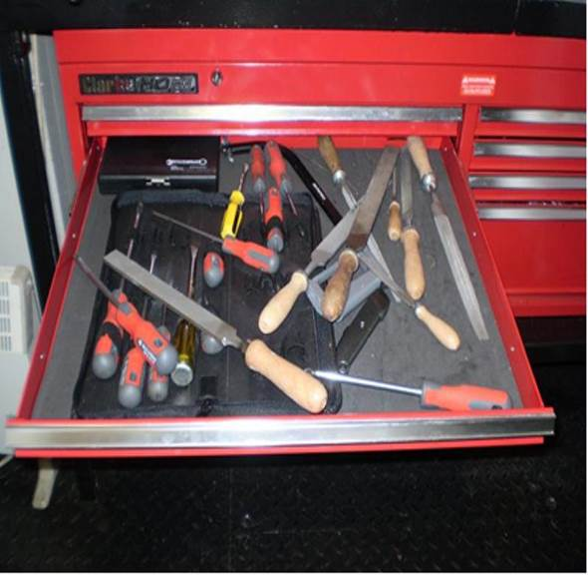 | 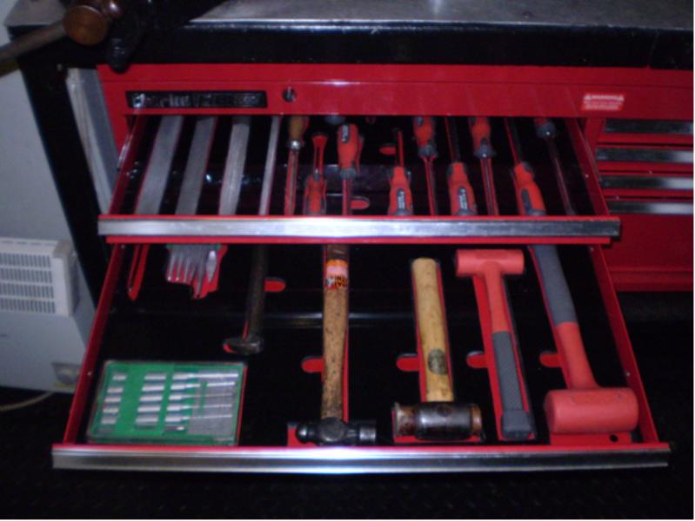

Work Environment
- Even minor deterioration of the building fabric can lead to foreign material ingress. For example, photograph 2a and 2b show examples where there is a risk of paint flakes entering components due to minor deterioration of the building fabric. The condition can also be a sign of water leakage into the room leading to further component degradation. Furthermore, poor quality facilities can present the wrong corporate message leading to a culture of poor workmanship. Photograph 2c shows the same facility after basic repairs bringing it back to the expected standard and demonstration of relevant good practice.

Photograph 2a – Examples of poor building standards leading to foreign material generation.
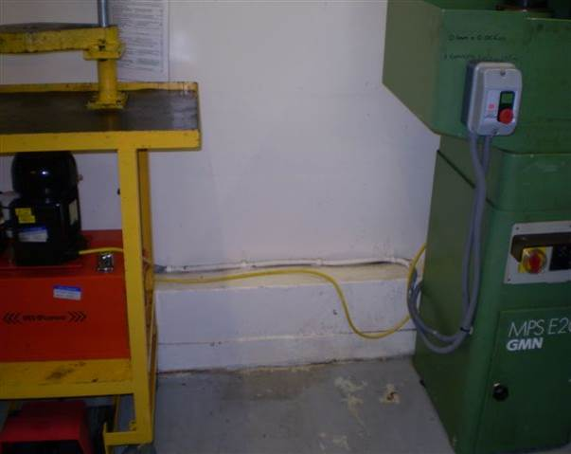
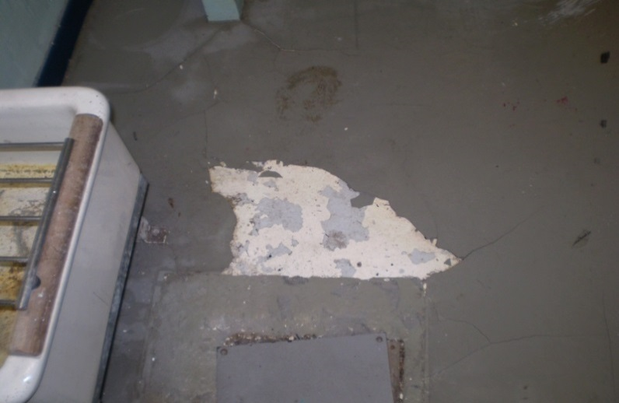

Photograph 2b - Poor building standards leading to foreign material generation.
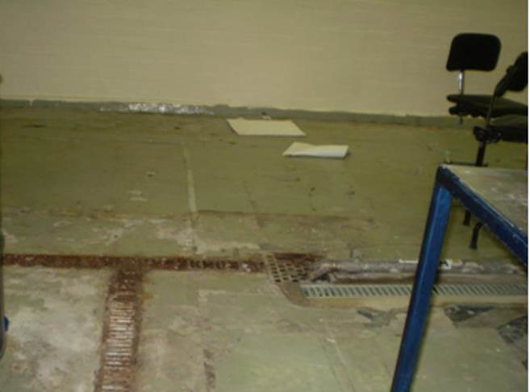

Photograph 2c – Expected workshop standards reducing the risk of foreign material generation and promoting good safety culture.
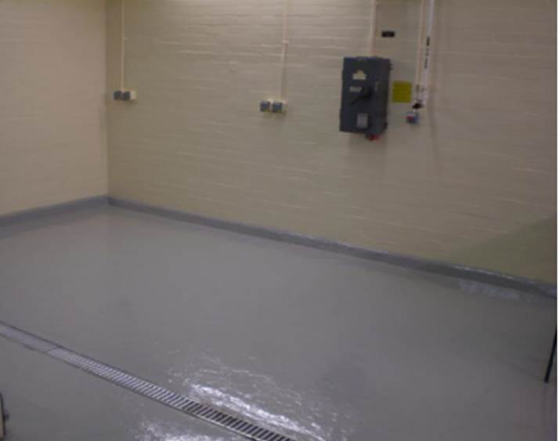

Housekeeping
- Good housekeeping requires that everything has a suitable location including work in progress. Appropriate racks, shelves, cabinets and bespoke storage units avoid an accumulation of redundant items and also make it easier to identify poor housekeeping. Strict parts disposal policies should prevent a culture of hoarding. Photograph 3a, 3b and 3c show examples of poorly thought out storage with little or no control of components presenting a risk that items can become foreign material or to lead to faulty components being fitted. In contrast, photograph 3d and 3e show examples of RGP.

Photograph 3a - Poorly stored items with no traceability and no segregation of different plant items.
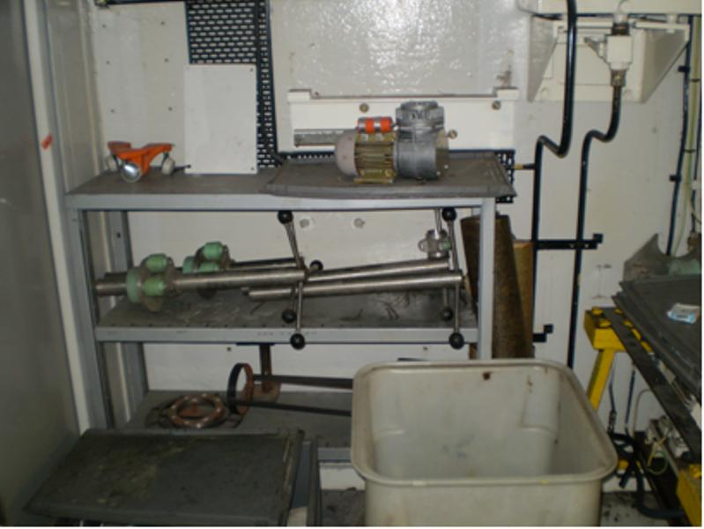

Photograph 3b – Poorly stored items that are not easily retrievable.
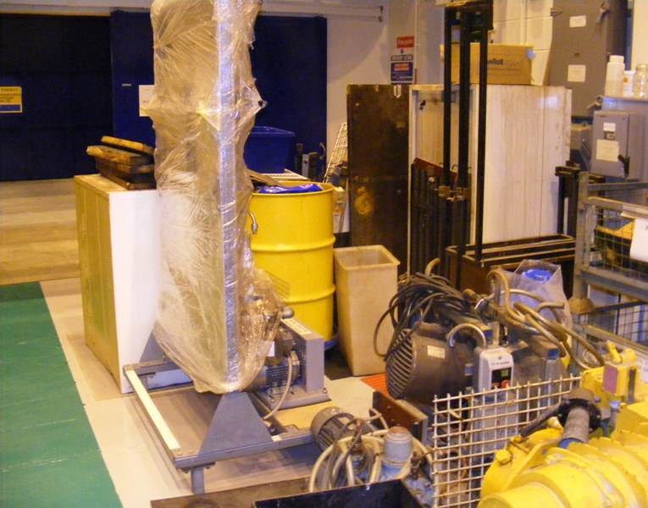

Photograph 3c – Some attempt to store components but with little or no traceability and a mixture of different plant items.
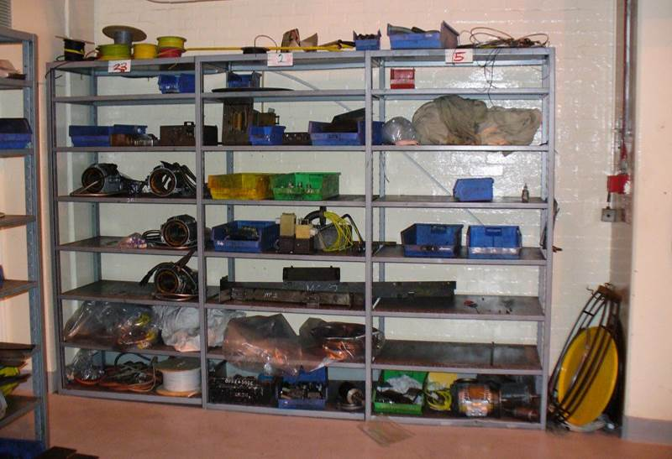
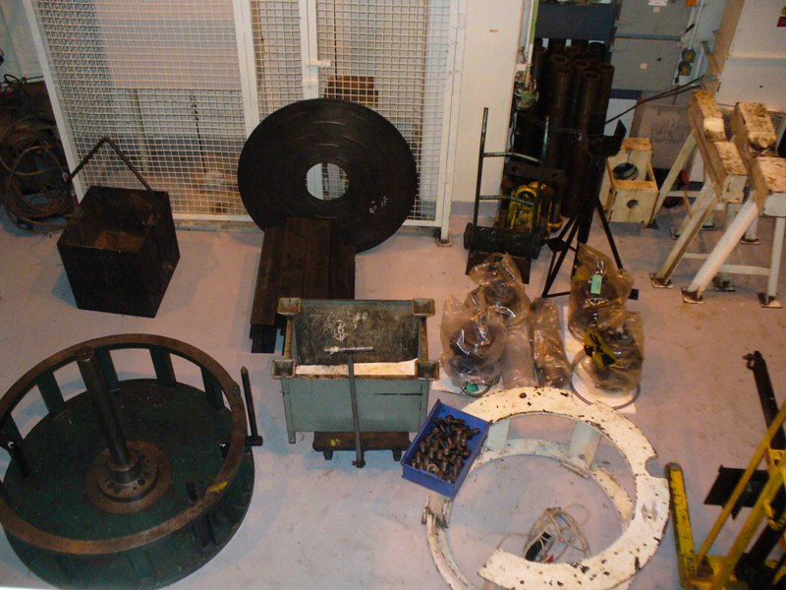

Photograph 3d – Good use of dedicated spares and tool cabinets. | Photograph 3e – Properly designed lay down areas for storage with good access.

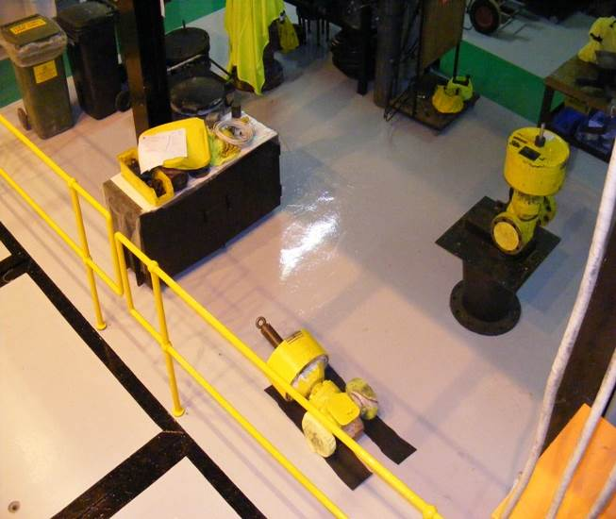
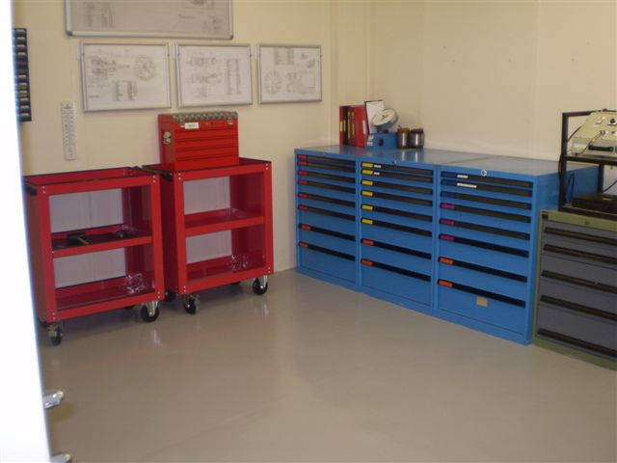

Parts Control
- Stores are vital for control of quality assured spare parts, foreign material exclusion and serve to remove some of the errors that technicians can make if parts are not properly controlled. Duty holders should consider having a main stores and satellite stores to ensure that only essential parts are held at the work face. Furthermore, large stores can assist with removing the need to house large items that can clutter up small workshops.
- All spares and tools in stores should be properly managed making use of shadow boards or tool cabinets to assist with tool control. The use of maintenance specific vending machines, operated via personal identification numbers, facilitates traceability. Vending systems can be programmed to specific jobs such that they will only dispense the correct type and quantity of materials or consumables.
- Dedicated tooling and parts kits offer better control for specific tasks. For example, technicians can be presented with all the tools and parts they need to do a particular task and nothing else. This is particularly useful for spare parts as it enables the removed part to be placed back into the empty position in the parts container making it easy to count parts in and out. It also enables OEM suppliers to provide spares kits which further assist to ensure that the correct parts are fitted. Photograph 4a and 4b shows an example of good practice for dedicated tools and spares kits respectively.
Photograph 4a - Dedicated tool kit. | Photograph 4b – Dedicated Spares Kit.
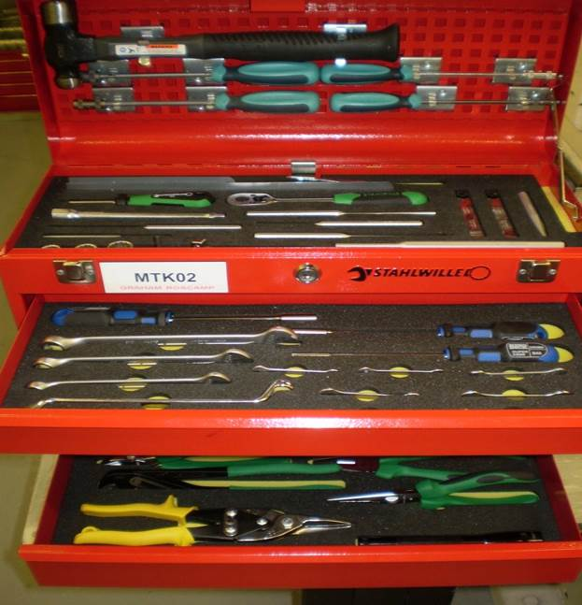 | 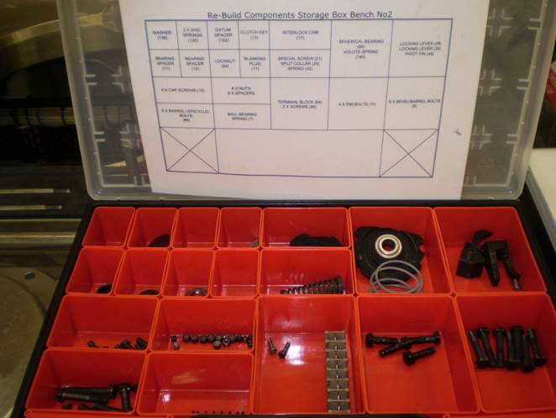
- For general purpose tools, duty holders should decide whether each technician needs their own or whether dedicated tool kits can be held in a central store. Where each technician needs their own tools they should be supplied by the duty holder so that the quality and quantity of tools in the facility can be controlled. Similarly, special purpose tools and those that need calibration should be managed appropriately, deciding whether it is better to hold certain tools centrally (as shown in Photograph 6a &b).

Photograph 6a – Secure area for dedicated tool storage cabinets.
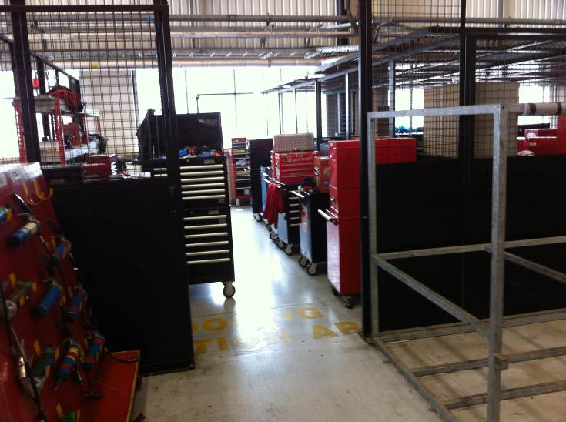

Photograph 6b Good use of storage for specialist tooling.
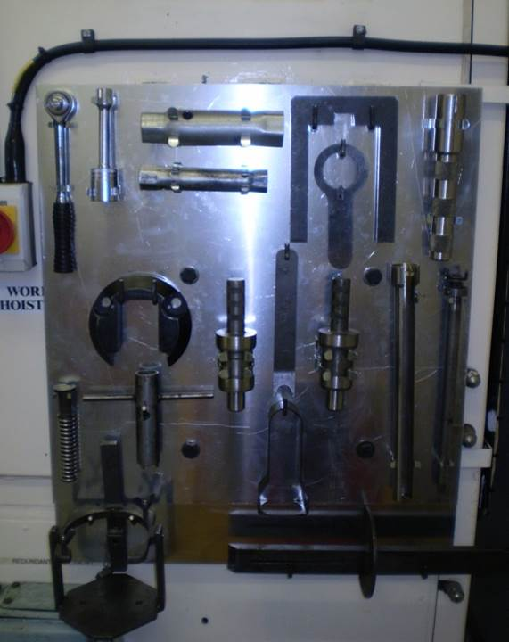
- Component shelf life should be carefully monitored so that perished components or consumables are not inadvertently used and manufacturers may specify specific storage conditions. Quality assurance arrangements for through life management of such components require a heightened level of management attention to ensure suitable controls are in place and effective.
- The storage of used parts or part used consumables should be avoided if possible as they can lead to quality issues and can become a source of foreign material. Parts that can safely be re-used must be adequately labelled and appropriately stored with a traceable history to verify their quality. Bulk storage of new spares should be avoided to assist with foreign material exclusion. Any unwanted removed parts should be discarded through an appropriate waste route. The use of dedicated spares kits with the correct number of parts for a particular task, as mentioned above, helps reduce parts inventory. This is particularly applicable for small items such as fasteners, washers, etc. Effective use of a central stores facility should be adopted providing it is well controlled.
- Larger items of equipment required to undertake certain tasks should be stored with care in a designated ‘set down’ area as shown in photograph 7. This set down area ensures that only those tools necessary for the task are out on the workshop floor.

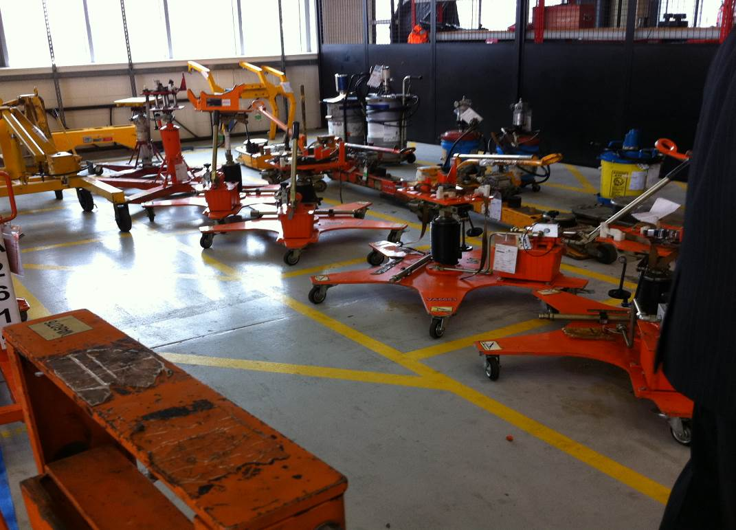
Photograph 7 – Typical example of designated storage area for larger items of maintenance equipment.

- Workshop consumables (nuts, bolts, washers, seals, adhesives, etc.) may be used in routine maintenance tasks which are not safety critical, but are often stored and available in the same facilities used to maintain safety critical equipment. In such cases, management control is necessary to prevent inadvertent deployment to safety critical applications.

Foreign Material - Identification, Assessment and Mitigation
- Whenever maintenance activity involves opening a system or component, Foreign Material Exclusion (FME) becomes a consideration. Foreign Material (FM) includes any rogue material that is not intended to be inside the equipment and is particularly significant where it can threaten reliability. Insufficient covering of open equipment can lead to inadvertent FM entering the item such as metal shavings, rags, grinding dust, etc although inadvertently installing the wrong component or fastener can also be considered as FM.
- The sections above provide examples of good practice for cleanliness and storage to improve FME but handling and transportation of items prior to installation can also improve FME.
- The cleanliness standards expected when undertaking maintenance is commensurate with the safety significance of the equipment being maintained. Good practice includes the deployment of temporary clean surfaces in working areas and covering of dirty workshop surfaces. Such covering can also assist in controlling the potential spread of contamination.
- HSE Guide HSG129 – Health and Safety in Engineering Workshops; provides guidance for small individual workshops. Expectations for the oversight applied by duty holders undertaking maintenance tasks is provided in Nuclear Energy Agency, Nuclear Regulation NEA/CNRA/R [2011]4 – The Nuclear Regulator’s Role in Assessing Licensee Oversight of Vendor and Other Contracted Services.
- FM needs to be minimised and any requirements need to be defined and included in the work package. Consideration should also be given as to whether there is a risk that other systems or plant, voids, ponds or personnel may be affected by the FM. Table 1 sets out some of FME considerations and solutions to be considered.

Table 1 – FME Considerations and Solutions
FME Consideration | FME Possible Solutions
Should the area surrounding the work be in an exclusion zone? If yes, define the work area. | - Warning Signs  - Barriers  - Controlled access  - Access/egress arrangements including those used in emergencies  - Protecting of other areas
Can parts, tools or other items that could be dropped into open systems be retrieved? Consideration should be given to implement the following: | - Appointment of personnel (Guardians) to control and monitor anything taken into or removed from the exclusion area.  - Securing items such as tools, security passes, film badges, dosimeters, spectacles, etc, using lanyards to ensure items are retrievable if dropped.  - Removing non-essential items or materials from the area.  - Ensuring tools are in good condition and do not have loose or missing parts (record missing parts to avoid confusion later).  - Use the correct tool and materials, fail safe tools if required  - Comply with material control as required.  - Account for all tools, equipment & materials prior to system/component closure.
Is there any dirt and debris in the area adjacent to the work area that could be introduced into the open system? If yes then the following should be taken into account; | - Cleaning of adjacent area prior to starting the work activity.  - Removing non-essential materials from the work area.  - Cleaning overhead areas and gratings.  - Install temporary covers when work is not in progress  - Maintain appropriate/effective housekeeping conditions.  - Ensure removal of harmful contaminants.  - Using only approved cleaning materials, solvents and chemicals.  - Minimize re-contamination of cleaned surfaces and minimise the cleaning required after installation, repair or modification.  - Stopping work and notifying Team Leader/task Supervisor if FME control is lost.
Is the system or component difficult to clean once the activities are complete? If yes, then consideration should be given to the following: | - Clean enclosures, vacuum cleaning systems, special clothing or any other method to reduce the possibility of FM intrusion into a system or component. These considerations are particularly important during maintenance activities that create dust and swarf.  - Verify system cleanliness requirements at specified stages of the task and following the maintenance activity.  - Control other unrelated work activities in in the area that could introduce dirt and debris into the system or component, such as the removal of floor plugs that connect two different work areas?
Could the system or component be safely left open and unattended for extended periods? | - Install temporary covers when work is not in progress?
- Where it is deemed necessary to use temporary covers for FME, the covers should satisfy certain requirements as follows:
- Non brittle, non-splitting, non-tearing, non-melting;
- Thick enough to avoid damage to underlying surfaces;
- Made from cheap/compatible but non porous materials;
- Unable to damage system or component;
- Will not deteriorate or decompose over time;
- Will not cause any chemical reaction;
- Easily detectable and retrievable.
- Each cover should carry an identifier that is clearly visible. For example, a caution notice and/or be coloured to contrast the plant (e.g. fluorescent colours if appropriate).
- Temporary covers should not be used for extended periods. Once work is complete, then verification of system cleanliness may be required. Verifications may range from simple visual inspection to system flushes with rigid acceptance criteria and independent verification by appointed personnel.
- FME requirements, when identified, should be included into maintenance instructions. Reference should also be made within the job history section when completing maintenance history. FME requirements and FME control logs if used should be retained and included in the work package for future work planning.
- In the unfortunate event that FM ingress has occurred and cannot be safely and easily retrieved, the task should be stopped and the job made safe. A team that includes SQEP’s should then consider the situation before any further action is taken which could possibly make the situation worse. Although it is best if foreign matter is retrieved it is inevitable that in some cases the foreign matter will be located in such a way as to prevent retrieval. In these cases design authority assistance may be necessary to determine the effects of leaving the FM inside the system and to consider alternative retrieval methods.
- In all cases when foreign matter has been allowed to ingress into a system or component even if it was retrieved, an effective corrective action process, possibly including root cause analysis, should be performed to prevent recurrence.

Checklist
- Inspectors may find the following checklist helpful as a summary of the guidance contained in this appendix.
Checklist
- Maintenance professionals actively involved in continual reviewing of performance, reinforcing and sharing relevant good practice and correcting deficiencies
- Arrangements in place for staff at all levels to offer suggested improvements
- Planning arrangements appropriate to implement maintenance tasks.
- Essential maintenance appropriately staggered to retain redundancy.
- Arrangements in place to protect technicians from conflicting commercial pressures.
- Arrangements in place for independent functional checking.
- Arrangements in place for independent teams of technicians employed on duplicate plant.
- Adequate procedures to identify safety critical tasks.
- Readily available manuals, drawings and other necessary information sheets in a convenient location for those undertaking the work. Availability of key maintenance documents for emergency situations.
- Evidence that training adequately addresses safety critical tasks and the possible consequences if technicians fail to follow procedures.
- Evidence that training reflects feedback from those with appropriate maintenance experience and, where appropriate involves subject matter experts.
- Procedures to ensure that workplace check sheets are accurately copied across into final records.
- Arrangements in place for introducing alternative procedures when a deviation from standard procedure is necessary. Submission of any amended (red lined/penned) maintenance documentation through official review process.
- Job cards should accurately identify the appropriate maintenance manual or other key documentation.
- Arrangements in place for safety critical maintenance tasks to be inspected by supervisors and independently verified at completion.
- Arrangements in place to prevent technicians from working on two (or more) similar systems at once.
- Arrangements in place to achieve appropriate standards in temporary maintenance facilities.
- Appropriate storage, control and identification of tooling and specialist equipment.
- Evidence that redundant items are disposed of, especially old parts, consumables, and items that do not belong in the facility.
- Arrangements in place for ensuring that parts are adequately labelled, stored and documented. Unwanted components discarded through appropriate waste route.
- Maintenance facility building or area is in a condition that is appropriate for maintaining nuclear safety critical plant.
- Housekeeping standards are appropriate.
- Equipment is safely and appropriately stored in a designated storage location.
- The facility is equipped with appropriate storage locations, shelving, containers, cabinets, etc.
- Hand tools are adequately controlled and maintained.
- Evidence that storage of consumables and spares is appropriately controlled to minimise inventory.
- Evidence that shelf life of spare parts and consumables is adequately controlled.
- Adequate lay down areas are provided for work in progress particularly large plant items and large specialist tools, jigs frames etc.
- Adequate consideration of FME and its potential effects on the plant.
- Adequate exclusion zones if necessary to control FM.
- Use of personnel to control and account for materials
- Adequate control of tooling and personal belongings to control FM, use of lanyards if applicable.
- Cleanliness, sterile working conditions during maintenance.
- Appropriate FME covers provided and in use.
- Are FME requirements included into maintenance instructions
- Procedures in place for dealing with FM if found inside a plant item.

