Research Briefing
Office for Nuclear Regulation Expert Panel on Natural Hazards: sub-panel on meteorological and coastal flood hazards

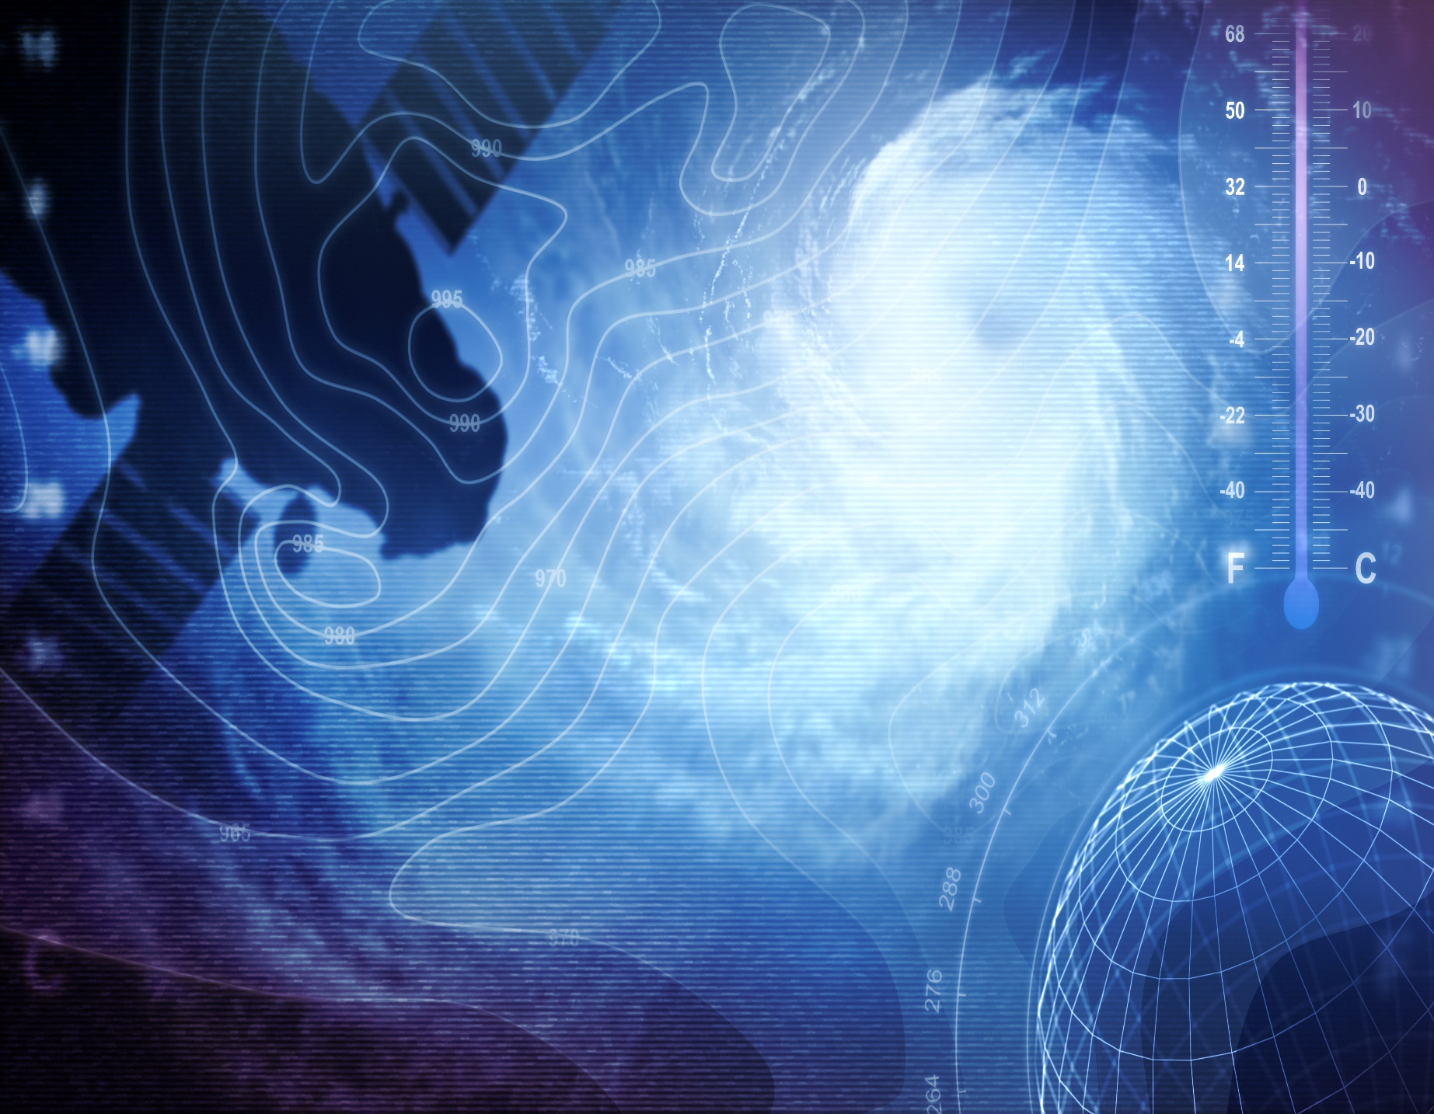
February 2023
Research Briefing
Office for Nuclear Regulation Expert Panel on Natural Hazards: sub-panel on meteorological and coastal flood hazards

Content
Purpose of the Research Briefings 1
Content 1
ONR’s Position 1
UK Climate Change Risk Assessment 2
Summary of CCRA3 Findings relevant to Hazards 2
Research Item 1 3
Hazards associated with high temperatures 3
Research Item 2 5
Hazards associated with changes in storms/storminess 5
Research Item 3 7
Hazards associated with summer precipitation 7

Purpose of the Research Briefings
The purpose of the Research Briefings is to highlight recently published research that the Office for Nuclear Regulation (ONR) may consider when developing its Technical Assessment Guide (TAG) on External Hazards and the supporting annexes on Meteorological Hazards and Coastal Flood Hazards. The Research Briefings are produced by our Expert Panel on Natural Hazards, specifically members of the Sub-Panel on Meteorological and Coastal Flood Hazards. The Research Briefings identify research relevant to meteorological and coastal flood hazards, including climate change.

Content
The papers included in the Research Briefings are selected by our Expert Panel on Natural Hazards on a sampling basis. As experts in their respective fields, the Expert Panel are best placed to identify and highlight to us changes in scientific understanding, research trends including shifts in the scientific consensus, and new areas of research.

There are an extensive number of books, scientific journals, research papers and notes published each year relating to meteorological and coastal flood hazards, and climate change. The Research Briefings will focus on research that meets the criteria described on the ONR website to provide insight into the evolution of scientific consensus and understanding of these topics. The research identified by the Expert Panel will be based on themes and words defined on the ONR website.

The Research Briefings will only sample some of the available research and are intended to be supplemented by the Expert Panel highlighting other relevant research to us, for example, via the Expert Panel meetings, minutes of which are published to the ONR website.

ONR’s Position
The Research Briefings provide us with insight into recent scientific advances in relation to meteorological and coastal flooding hazards, and climate change. Each research item included in a Research Briefing will not by itself constitute relevant good practice. Rather, the Research Briefings will highlight any trends or significant changes in scientific understanding in relation to these hazards. This information will ultimately inform our regulatory guidance in relation to meteorological and coastal flooding hazards.

UK Climate Change Risk Assessment
The UK Parliament Climate Change Act (2008) and Climate Change Act Scotland (2009) require the UK Government to produce UK Climate Change Risk Assessments (CCRA) on a five-year basis. The third CCRA (CCRA3) was produced in June 2021. CCRA3 comprises a suite of documents: an advice report, a technical report, research and analysis reports and sector summaries.
This Research Briefing focuses on the CCRA3 technical report. The document has seven technical chapters. Chapter 1 is entitled “Latest Scientific Evidence for Observed and Projected Climate Change” (Slingo, 2021). This chapter is addressed in this briefing note. Chapters 2-7 are not covered here, but discuss “Method”, “Natural Environment and Assets”, “Infrastructure”, “Health, Communities and the Built Environment”, “Business and Industry” and “International Dimensions”.

This Research Briefing addresses the hazard related aspects in Chapter 1 of the CCRA3 technical report only. Much of the emphasis in the report applies only for the next five years. However, Chapter 1 views the climate and weather changes on time scales of up to a century, which is particularly relevant for ONR. CCRA3 identifies 61 risks and opportunities in the UK resulting from climate change. This Research Briefing considers three meteorological drivers of future hazards, which could impact nuclear safety: winter storminess, high temperatures and summer precipitation. These hazards are addressed in the three following Research Items.

Summary of CCRA3 Findings relevant to Hazards
The key findings of CCRA3 relevant to meteorological hazards include:

- Prepare for extremes. Adaptation planning needs to accommodate unpredictability and the potential for sudden shifts in the climate, even at lower levels of warming.
- Overall, the UK is expected to experience warmer, wetter winters and hotter, drier summers as the climate changes.
- More frequent and severe extreme daily high temperatures will occur. The UK could experience an increase in annual average temperature of up to 4°C by the end of the century. This is dependent on the success of global greenhouse gas reductions.
- Rainfall is expected to decrease in summer, except in western UK. However, rainfall intensity is projected to increase across the year by as much as 25%. Later this century more of the rain in summer will come from short lived, high intensity precipitation events, increasing the likelihood of flash flooding.
- A decrease in soil moisture during summers is projected, consistent with the reduction in summer rainfall. This could lead to increased cases of drought.

Research Item 1

Hazards associated with high temperatures
Slingo, J. (2021) Latest scientific evidence for observed and projected climate change. In: The third UK Climate Change Risk Assessment Technical Report [Betts, R.A., Haward, A.B. and Pearson, K.V. (eds.)]. Prepared for the Climate Change Committee, London (chapter 1)

Key words: Heat Waves, Extreme Temperature, Climate Sensitivity, Convection Permitting Model

Summary
From the 2050s onwards, higher emission scenarios are projected to lead to greater increases in extreme weather and sea level both at UK and global scales. “In this high emission scenario, by 2080, 40°C temperatures are projected to be exceeded as frequently as 32°C is exceeded today in the UK. At the time of this assessment 40°C has not yet been reached in the UK but could occur with a return period of 3.5 years by the end of the century”, (Page 3). As a result, potentially longer summer dry spells with low wind speeds will occur, associated with longer high-pressure blocking anticyclone features. More frequent and more severe extreme daily high temperatures and Urban Heat Island effects are expected even though the mean warming is almost identical”, (Page 4). UK summer extremes, as expressed by the 95th percentile, are warming 15-48% faster than the UK Summer mean. “Future summers are projected to be even hotter and drier than earlier estimates” including the previous CCRA2 report, for equivalent levels of warming”, (Page 4). A heatwave period is now defined as existing for more than 3 days with temperatures over 25°C-28°C, depending on the region of the UK under consideration. There is now “a tendency for more heatwaves in London than in recent years”.

Context
The CCRA3 report primarily presents UK Met Office modelling and observational data. It essentially questions previous global reports, including the Intergovernmental Panel on Climate Change (IPCC) Assessment Report (AR) 6, Working Group 1 (WG1) (2021), for the reasons specified below. Slingo (2021), focuses on the model projections primarily from the UK Hadley Centre HadGEM3-GC3.05 model. This model has a higher climate sensitivity than older lower resolution models. IPCC6 WG1 2021 lists a range of Equilibrium Climate Sensitivity (ECS) from ~2°C to ~5°C with a best estimate of 3°C. HadGEM3 produces climate sensitivities of over 5.4°C, “…higher than in all climate models from previous generations used in the CMIP3 and CMIP5 intercomparison projects”, (Page 14). While temperature extremes are not captured well in climate models, higher resolution models tend to project higher climate sensitivities. Zelinka et al. (2020) shows that this increase in ECS is primarily associated with stronger positive cloud feedbacks from decreasing extratropical low cloud coverage and albedo in this sub-set of models compared to the corresponding models in the previous generation. “Establishing the plausibility of these higher sensitivity models is imperative given their implied societal ramifications”.
Expert Panel View: This research is consistent with the current ONR guidance with respect to high air temperature hazards.

Further commentary from the Expert Panel on Natural Hazards
CCRA3 Chapter 1 questions some of the previous findings from IPCC (AR3 – AR5) and IPCC6 WG1. The report emphasises the importance of extremes, in this case high temperature extremes, in understanding future climate risks and challenges for adaptation.

- It highlights the importance of extremes. This is consistent with ONR’s guidance in the extant Technical Assessment Guide for External Hazards.
- The accuracy of low resolution climate models is questionable and argues the need for higher resolution models of ~1km resolution which can resolve some important small scale cloud and weather events important in determining extremes.
- It highlights that the UK HadGEM3 model outputs produces a climate sensitivity of ~ 6°C. The IPCC6 WG1, 2021 provides a maximum of ~ 4.6°C with a minimum of ~ 2°C but associates this with their inadequate resolution.
- Temperatures exceeding 40°C are expected to become frequent in the UK.
- Projected increases in the duration of persistent low wind and hot dry days associated with longer semi-stationary anticyclones will lead to more heatwaves. The observation evidence discussed by Kendon et al. 2021, in the “State of the UK climate in 2020”, is used in support of the higher resolution model calculations.

Research Item 2

Hazards associated with changes in storms/storminess
Slingo, J. (2021) Latest scientific evidence for observed and projected climate change. In: The third UK Climate Change Risk Assessment Technical Report [Betts, R.A., Haward, A.B. and Pearson, K.V. (eds.)]. Prepared for the Climate Change Committee, London (chapter 1)

Key words: Storminess, Storms, Climate Change, North Atlantic Oscillation (NAO)

Summary
“Major storms can cause widespread damage” and are one of the “important climatic impact drivers” (Page 30). As such, potential changes in intensity and/or frequency of storms and storminess “needs to be addressed with some urgency”, (Page 31). “Currently the evidence base for changes in storminess is weak, but beyond the mean climate there is a growing body of evidence for changes in frequency and/or intensity of high-impact weather events”, (Page 31). Insufficient analysis and research in this area to date is the provided explanation. One of the main conclusions of CCRA3 Chapter 1 is that “The severity of extremes is projected to increase with global warming”, (Page 4).

Context
The behaviour of the North Atlantic Jet Stream (often associated with extreme weather) is complicated. It has three preferred positions:
- To the North of the UK (producing a European blocking pattern).
- Over the UK (positive NAO).
- To the South of the UK (negative NAO).

These positions control the tracks of storms and essentially determine the frequency of wind-storms, atmospheric rivers and extreme frontal rain. Future UK winter climate extremes will be partially determined by the behaviour of the North Atlantic Jet Stream. Winter weather is projected to be dominated by more mobile, cyclonic weather systems than was the case in previous assessments. This will affect western parts of the UK. It reinforces the current evidence that there may be more substantial increases in daily rainfall with associated flooding, as well as a higher incidence of strong winds and high waves. Winter extreme rainfall is projected to be up to 40% more than CCRA2 values before the end of the century.
Expert Panel View: This research highlights an area of uncertainty, and further research is needed on storminess.

Further commentary from the Expert Panel on Natural Hazards
The current scientific understanding of UK storminess is weak. With limited current observational evidence and modelling capability, the subject of storminess requires further research.
- “The severity of extremes is generally expected to increase with global warming”, (Page 4). CCRA3 highlights that future winter weather is projected to be dominated by more cyclonic systems than in previous assessments, which increase the risk of atmospheric river events and flooding. Winter rainfall is likely to be more than 40% greater than previous CCRA2 estimates.
- ONR’s guidance is consistent with CCRA3 and suggests increased storminess is probable, but that the topic will need future attention.
- Emanuel (1987 & 2020) demonstrates that hurricane (tropical cyclones) intensity depends on global warming and sea surface temperatures, but not frequency. An unresolved question is whether the intensity of mid-latitude storms and storminess follows a similar pattern?
- A review of storminess evidence is provided by Fesser et al. 2015, Krueger et al. 2019 and Kendon et al. 2021. All conclude there is no firm evidence for increased storminess yet. Apparent increase in storminess between 1960 and 1990 is likely part of a longer-term record that reveals multi-decadal variability. Several significant storms occurred before the global warming signal was visible including the 1824 storm that caused damage from Cornwall to St Petersburg and the great storms of 1703 and 1607.

Research Item 3

Hazards associated with summer precipitation
Slingo, J. (2021) Latest scientific evidence for observed and projected climate change. In: The third UK Climate Change Risk Assessment Technical Report [Betts, R.A., Haward, A.B. and Pearson, K.V. (eds.)]. Prepared for the Climate Change Committee, London (chapter 1)

Key words: Convective Storms, Convection Permitting Model

Summary
Beyond the mean climate there is a growing body of evidence for changes in frequency and intensity of high impact weather events such as extreme daily rainfall, with heat waves occurring more frequently. New records are now more frequently set, with the UK experiencing higher temperatures with associated heavy rainfall. For Summer rainfall, Fowler et al. (2020) concludes that:

- Heavy rainfall extremes are intensifying with warming at a rate consistent with the increase in atmospheric moisture, at a rate of 7% per °C warming for accumulation periods from hours to days. This value derives from the Clausius Clapeyron equation.
- In some regions, greater increases in short duration sub-daily extreme rainfall intensities have been identified; up to double the intensity that would be expected from atmospheric moisture increases alone.
- Greater local increases in short duration extreme rainfall intensities are related to convective cloud feedbacks involving local storm dynamics.
- Evidence is emerging that sub-daily rainfall intensification is related to an intensification of local flash flooding. This will have serious implications for flood risk management and requires urgent climate-change adaptation measures.

Context
Hand et al., 2004 shows that summer convective storms are associated with a significant proportion of UK flash flood events. These storms provide observational evidence to suggest that increased summer rainfall intensities are expected in a warming climate. Guerreiro et al., 2017 argues that the effects of global warming on the hydrological cycle are being manifested in changes in the frequency and intensity distributions of daily and sub-daily rainfall, even when averages over longer timescales are stable. These types of storms may be implicated in recent challenges to reservoir dams at Boltby in 2005, Ulley in 2007 and Todbrooke in 2019.
Expert Panel View: This research is consistent with the current ONR guidance with respect to rainfall hazards.

Further commentary from the ONR and the Expert Panel on Natural Hazards
CCRA3 develops the previous scientific understanding and supports current assessments that summer extreme precipitation events will increase in frequency and intensity, by as much as double the currently expected intensity. Increased precipitation rates are not included in low resolution models. The overall challenge is to estimate the magnitude of these increases for input to infrastructure planning. This rainfall intensification “will have serious implications for flood risk management”, with new records of temperature and rainfall being set more frequently. There is little discussion on:
- Detail of the “Super Clausius Clapyron” scaling that doubles the projected increases in precipitation (Lenderlink et al., 2017). The Clausius Clapeyron (CC) equation gives a ~7%+ increase in atmospheric water content for each mean °C temperature rise. The “2CC” increase doubles this to a ~14%+ increase for each mean °C temperature rise. The latter consistent with more frequent high intensity rainfall rather than the 7%+ increase. This was supported Kendon et al. 2014 and by Gadian et al. 2018 who found that near future extreme rainfall intensities may be up to 20% greater than 1990 values.
- The recent summer 2021 heavy rainfall semi-stationary Meso-scale Convective Systems (MCS) were associated with the European summer anticyclone blocking structures, which produced record UK temperatures. These, for example, caused the significant flooding events in Germany in July 2021. It is suggested in CCRA3 that these conditions are likely become more frequent.

© Office for Nuclear Regulation, 2023
Any enquiries related to this document should be sent to contact@onr.gov.uk
Published February 2023

A member of the Expert Panel led supporting research on flooding, but was not involved in drafting of this Research Briefing.
Climate sensitivity represents the equilibrium temperature response to a doubling of atmospheric Carbon Dioxide (CO₂) concentrations above pre-industrial levels.

