ONR/Environment Agency Final Report
Regulators’ Pioneer Fund (Department for Science, Innovation and Technology): Pilot of a regulatory sandbox on artificial intelligence in the nuclear sector

ONR/Environment Agency Report
Regulators’ Pioneer Fund (Department for Science, Innovation and Technology): Pilot of a regulatory sandbox on artificial intelligence in the nuclear sector

Contents
Executive summary 5
Acknowledgements 7
Details of the project and context 9
What did you do and how? 10
Development of a nuclear regulatory sandboxing approach 10
Problem/opportunity statement 12
Mock safety, security and environment case 12
Sprint workshops 13
Deep dive workshops 14
Application 1 – AI and structural integrity 15
Sandboxing task 15
Sprint workshop 15
Deep dive workshop 16
AI and plant data workshop 19
Application 2 – AI applied to a robotic glovebox 20
Sandboxing task 20
Sprint workshop 21
Deep dive workshop 21
What were the key outcomes of your project? 23
Outcome of the approach taken to regulatory sandboxing 23
Outcome of the AI sandboxing 24
General considerations for the use of AI 25
Development of the system containing AI 26
Understanding the performance characteristics of the AI system 27
Developing confidence in the performance of the AI system 27
Identifying and dealing with failure 27
Developing skills and experience 28
What were the key lessons learned? 29
What problems did you face, and how did you overcome them, if at all? 31
What are the next steps? 31
Regulatory sandboxing 31
Regulation of AI in the nuclear sector 32
List of abbreviations 33
References 34

Executive summary
The Office for Nuclear Regulation (ONR) and the Environment Agency have developed approaches to the regulation of innovation in the nuclear sector. ONR’s approach to innovation is centred around supporting the adoption of innovative solutions by the nuclear industry and its supply chain where it is safe and secure to do so. This support has been trialled in three forms: expert panels, the provision of advice, and regulatory sandboxing (ref. [1]). Similarly, the Environment Agency has made clear that it is committed to helping enable green growth and a sustainable future, including regulating to support sustainable innovation (ref. [2]). The Environment Agency uses a number of approaches to help support innovation and its Radioactive Substances Regulation function is exploring regulatory sandboxing alongside ONR as an additional tool.
Artificial intelligence (AI) is starting to enter the nuclear sector with substantial investment. The industry is requesting engagement with regulators to understand our regulatory views. ONR horizon scanning activities have also identified AI as a key trend. At present, there is limited established relevant good practice that can be used as a benchmark for regulating AI.
To address these matters ONR convened an expert panel on the regulation of AI and an opportunity emerged out of this work to sandbox the regulation of two applications of AI in the nuclear sector. ONR and the Environment Agency jointly developed a proposal and were successful in applying to the Regulators’ Pioneer Fund (RPF) to explore the sandboxing of potential methods to aid AI deployment in the interest of safety, security and environmental protection. The RPF is a grant-based fund to enable UK regulators and local authorities to help create a UK regulatory environment that encourages business innovation and growth. The current £12m round is being delivered by the Department for Science, Innovation and Technology (DSIT) (ref. [3]). The Control and Instrumentation Nuclear Industry Forum (CINIF) is also interested in the use of AI in the nuclear sector and provided additional funds to contract Adelard (part of NCC Group) to support the project from an industry perspective by producing elements of a mock safety, security and environment case, as well as facilitating the sandboxing process. Adelard is experienced in safety cases and digital technologies such as AI and has worked with ONR previously. Licensee representation on the expert panel proposed a number of potential applications of AI and defined the two problem/opportunity statements to enter sandboxing.
The sandboxing process involved sprint workshops to consider the key aspects associated with the deployment of AI in the two problem/opportunity statements and the associated mock safety, security and environment case structures. These key aspects were then prioritised into four deep dive topics for each of the two AI applications and explored through regulatory sandboxing sessions.
The sandboxing approach and AI aspects have benefitted from an increasing stakeholder interest in this work over a number of engagement sessions run throughout the project.
The key findings were:
- The benefits of AI should be clearly articulated and compared with alternative (traditional) technologies.
- The risks associated with AI need to be understood and managed through robust arrangements, e.g.,
  - The level of authority associated with the AI system;
  - The level of safety, security and environmental significance; and
  - The level of continuous learning.
- Deployment of AI systems should be phased in order to build confidence and experience.
- Key considerations for the use of AI differed for the different applications, which may suggest a principles-based approach to regulation is preferred.
- Substantiating the reliability of AI systems is difficult and so a basis of establishing performance is required, for example, through meeting functional requirements.
- When transferring an AI system to a new operation or phase, it should be assumed the existing training data is no longer adequate.
- Benchmarking an AI system to indicate performance and operational envelope should be considered.
- A hazard analysis of an AI system is needed for each potential deployment mode.
- Three key aspects of development of skills and guidance have been identified:
  - Need to access AI expertise;
  - Operational experience of the AI application; and
  - Behaviour and culture, to retain a challenging safety, security and environmental culture.
- It is important to understand the complexity of the human/system interaction.
- Guidance and relevant good practice (RGP) should be developed and disseminated, initially in the form of principles and case studies.
Note these are not formal regulatory positions, but rather the findings of sandboxing two specific applications of AI. However, this work will help inform the development of a regulatory approach to AI.
The project has been evaluated as successful from a regulatory and industry perspective. ONR plans to continue offering regulatory sandboxing as part of its approach to regulating innovation, where it is in the interest of society and consistent with safety, security and safeguards expectations. The Environment Agency is keen to continue to explore the application of regulatory sandboxing to sustainable innovation. It is working with ONR and licensees to look at other innovations in the nuclear sector and identify further areas where regulatory sandboxing may be beneficial. This work demonstrates how ONR and the Environment Agency are collaborating to ensure an aligned approach to sandboxing and innovation. It has also contributed to developing a regulatory benchmark for AI, a technology that could have significant safety, security and environmental opportunities and challenges in the nuclear sector.
The output from this sandbox pilot is being fed into existing work on AI within the UK nuclear sector, including the Nuclear Institute’s AI4Nuclear initiative. We are sharing our learning with regulators outside of the nuclear sector via the UK Health and Safety Regulators Network – Innovation subgroup. We are further sharing our work with the wider regulatory community through the Alan Turing Institute’s AI Standards Forum for UK Regulators. Our lessons learned from this work have also led to the development of the concept of an international regulatory sandbox. ONR, the US Nuclear Regulatory Commission and the Canadian Nuclear Safety Commission are developing a principles paper on the regulation of AI.
The Environment Agency is feeding the outputs from the regulatory AI sandbox pilot into broader considerations around the regulation of digital and robotic innovation in regulating radioactive substances, which will help inform future guidance and regulatory capability needs.

Acknowledgements
This work would not have been possible without the funding, collaboration and expert input of organisations including:
- Adelard (part of NCC Group)
- Advanced Nuclear Skills and Innovation Campus
- Canadian Nuclear Safety Commission
- Civil Aviation Authority
- Control and Instrumentation Nuclear Industry Forum
- Department of Transport
- EDF Energy
- Environment Agency
- Health and Safety Executive
- International Atomic Energy Agency
- Medicines and Healthcare products Regulatory Agency
- National Nuclear Laboratory
- Nuclear Innovation and Research Office
- Office for AI
- Organisation for Economic Co-operation and Development, Nuclear Energy Agency
- Rolls Royce
- Sellafield Limited
- The Regulators’ Pioneer Fund
- United Kingdom Atomic Energy Authority
- University of Birmingham
- University of Bristol
- University of Manchester
- University of Oxford
- University of York
- US Nuclear Regulatory Commission

Details of the project and context
This project piloted a nuclear regulatory sandbox process, using artificial intelligence (AI) as the test case. Regulatory sandboxing allows industry to explore with regulators how innovation proposals can progress to deployment. It has contributed to developing a regulatory benchmark for AI, a technology that could have significant safety, security and environmental opportunities and challenges in the nuclear sector.
The Office for Nuclear Regulation (ONR) and the Environment Agency, two of the principal regulators of nuclear sites in the UK, have worked together to deliver this project. This is helping to ensure a joined-up approach to regulating innovation. We have engaged with experts and stakeholders on innovation including nuclear dutyholders, national laboratories, other highly regulated sectors and academia.
AI was chosen as the pilot topic because it has the potential to improve nuclear safety, security and environmental protection and is an area where there are limited regulatory benchmarks in the UK nuclear sector. We worked with a panel of AI experts in industry and academia to identify two challenging applications of AI in a nuclear environment for the regulatory sandbox pilot:
- AI to ensure appropriate and targeted plant maintenance; and
- Real-time use of AI to facilitate the safe operability of robots in constrained spaces.
The sandboxing included engagements to discuss the AI proposals, areas of future development and regulatory expectations on the evidence required to support the deployment of AI, based on these two examples.
The objectives of the regulatory sandbox pilot were to:
- Gain access to regulatory expertise;
- Identify risk reduction mechanisms and approaches;
- Reduce the cost and time of entry for innovation;
- Allow regulators to test their arrangements;
- Test technology and process innovation in a controlled environment;
- Accelerate diverse and inclusive practices across the sector; and
- Inform future challenges and opportunities and develop capability within the sector.
This is the first application of a regulatory sandbox in the nuclear industry anywhere in the world, drawing on the work of other regulatory bodies such as the Civil Aviation Authority, and we plan to share our learning with the UK Health and Safety Regulators Network.
This project reflects the purpose of the Regulators’ Pioneer Fund (RPF) programme by putting the UK at the forefront of regulatory development and engagement on innovation in the nuclear sector. The pilot sandbox has enabled innovators in nuclear applications of AI to access regulatory advice in a safe space to de-risk future deployment while maintaining independence from regulatory decision-making. This project has helped identify a regulatory sandbox process as a tool that present and future dutyholders and nuclear site operators can use to adopt innovative technologies and approaches that ensure the safety and security of people and the environment.

What did you do and how?

Development of a nuclear regulatory sandboxing approach
UK nuclear regulation is largely non-prescriptive and goal-based and, as such, is inherently flexible to accommodate innovation, provided nuclear site licensees and operators can adequately demonstrate that safety, security and environmental requirements have been met. This can be challenging for particularly novel innovations where there is little relevant good practice and limited experience of deployment to draw on.
Sandboxing in a nuclear regulatory context gives regulators and industry the opportunity to work together to explore how such a demonstration could be made for the real-world application of an innovation. It also delivers broader lessons and understanding for regulating the innovation and provides important input for the development of regulatory frameworks.
During the first expert panel meeting on AI, convened by the Advanced Nuclear Skills and Innovation Campus (ANSIC) and ONR in March 2022, the group identified that, rather than looking at the application of AI in general terms, it would be more valuable to consider specific potential applications of the technology within the regulatory sandbox. Prior to the second expert panel meeting, panel members were asked to prepare example applications of AI. During the meeting these examples were discussed and scored, and two favoured examples were selected and adapted to ensure as much value as possible was extracted within the sandbox.
Our initial approach was based around a three-workshop session model, looking at nuclear operators’ safety and environment cases in increasing levels of detail, using claims, arguments and evidence (CAE). This was based on our successful generic design assessment approach (ref. [4]) but applied in a lighter-touch fashion within the sandboxing environment.
By engaging with the expert panel, we recognised producing sequential CAE structure and evidence under the initial high level plan, there was potential for significant issues that would be revealed towards the end of the project (ref. [5]). Therefore, we reviewed agile and shift-left project management approaches and developed a new approach: a sprint workshop followed by two deep dives with ongoing review, learn and improve (RLI) assessment to maximise learning and take account of emerging opportunities and risks.
To help benchmark the process, we approached the Civil Aviation Authority (CAA) to understand their experience of sandboxing. CAA had been using regulatory sandboxing for three years, based on a build-test-learn process. The method used by CAA and the proposed method put forward by ONR and the Environment Agency were agreed to be similar, with the following key points identified:
- Be prepared for applications to fail – CAA sandboxing experiences a high failure rate;
- Despite this high failure rate, the sandboxing process enables issues and benefits associated with applications to be understood at pace; and
- Open sharing of views is key in undertaking sandboxing.
The two independent applications put forward for the sandboxing involved slightly differing groups of individuals, including representatives with specific relevant experience. ONR and the Environment Agency agreed a process to follow for both applications (Figure 1). Two mock safety, security and environment cases were produced, but a single sprint session was held with most participants covering both applications. The deep dive topic sessions used participants with skills and experience in the specific applications to independently review the topics.
Sandboxing Process
Problem statement
Mock safety,
security, and
environment case
Sprint
Deep dives
Reporting
Specific innovation(s)
Figure 1: Overview of the sandboxing process.

Problem/opportunity statement
An important aspect of scoping each of the sandbox AI applications was the development of problem/opportunity statements. These were produced and refined with insights from those undertaking sandboxing. The following problem/opportunity statement was taken from the AI and plant data workshop:
- We will look to explore the use of AI and plant data to inform structural integrity claims in a safety and environment case to help demonstrate reliability.
- This would be beneficial because it could support the development of digital twins and probabilistic assessment to demonstrate asset in-service operational life.
- We struggle to use AI in this way at the moment because of the uncertainty associated with the prediction of the location and progressions of defects and the nuclear safety significance of certain structures and components.
- Running this workshop is beneficial because it will allow a diverse group of people to explore the opportunities and challenges associated with use of AI for informing the safety, security and environment case and for stakeholders to understand each others’ views.

Mock safety, security and environment case
To initiate and structure the discussion in the sprint workshop, licensees and contractors from industry developed a mock initial safety and environmental case structure.
As part of the AI sandboxing project, Adelard produced a mock high-level assurance case (Figure 2) for the group of licensees to identify how AI-based systems can be assured, what claims will need to be met, and what key evidence is required to support these claims.
The proposal was an AI-centric approach, focusing on the impact of using AI on an overall assurance case. It identified the properties of the AI component that could impact the safety, security and environmental performance of the overall system (including the surrounding environment and human operators), and then constructed arguments to highlight that these impacts are suitably controlled. This has the advantage of allowing the project to focus on the impact of the AI on the assurance demonstration, whilst considering the whole system.
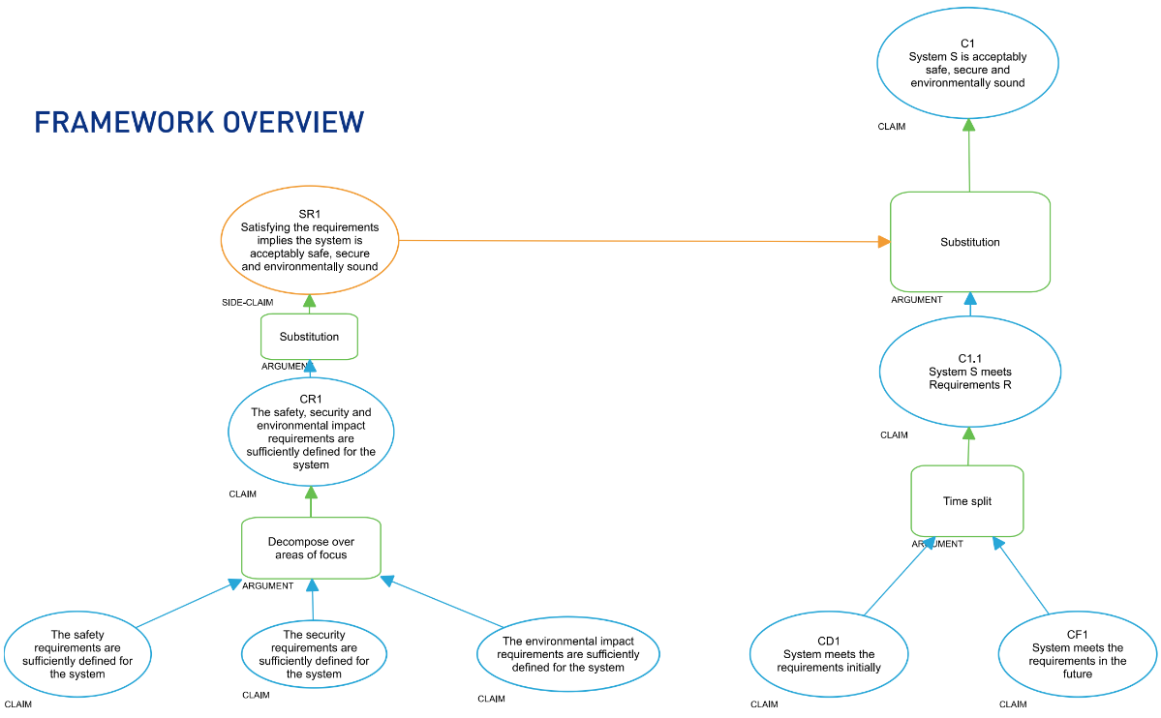
Figure 2: Safety, security and environment case framework overview produced by Adelard to aid discussion in the initial sprint workshop.

Sprint workshops
The aims of the sandboxing sprint workshops were for regulators and industry to work through the problem/opportunity statements and their associated mock safety, security and environmental case structures for each application, and to identify key topics to further explore in the deep dive workshops.
The sprint workshops first challenged the problem/opportunity statement to ensure it was fit for purpose, after which Adelard gave an overview of the mock assurance case to initiate further discussion, in particular to identify the most significant opportunities and risks. This was done through a group mapping exercise (Figure 3). Towards the end of the workshop, several deep dive topics were selected, and Adelard took this information away to produce a more detailed mock assurance case for the subsequent deep dive sessions.
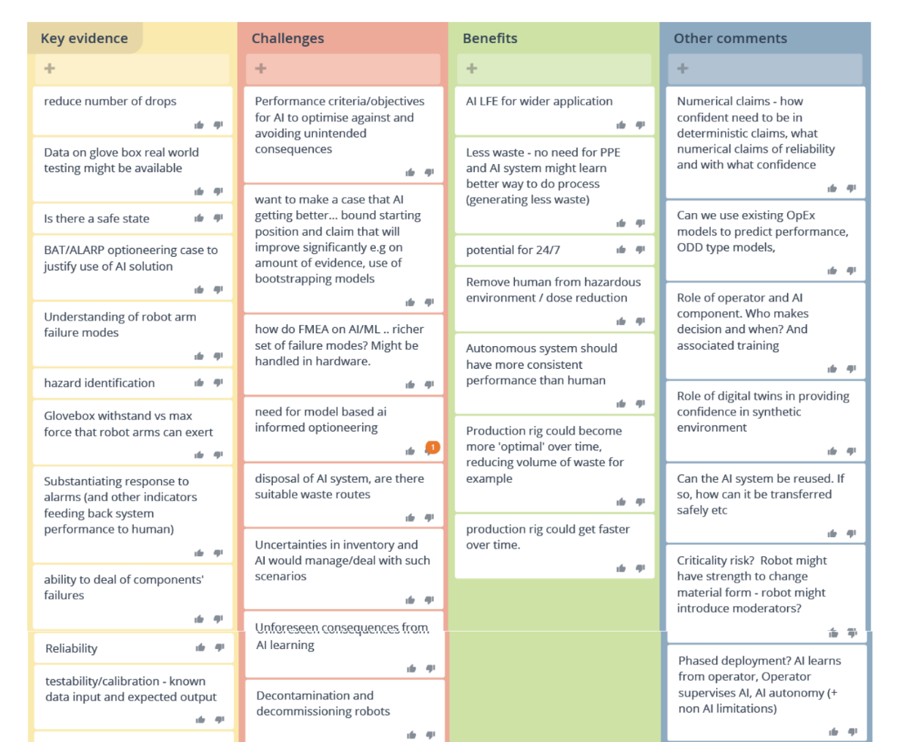
Figure 3: Group map produced as part of the initial sprint workshop.

Deep dive workshops
The aims of the sandboxing deep dive workshops were to identify:
- Key claims, arguments and evidence to support each safety, security and environment case fragment;
- Whether each topic presents a show-stopper to deployment in the current regulatory environment, or whether sufficient evidence is likely to be available to adequately support this part of the case;
- Any regulatory benchmarks that may assist in the development, design, operation, maintenance and decommissioning of the system; and
- What further work the sector (including the regulators) can do to support the regulation of AI technologies.
It is worth noting there were some common themes across the workshops in the different deep dive topics, which are highlighted where appropriate in this report.

Application 1 – AI and structural integrity
The AI structural integrity example was originally defined as:
Use AI to derive information from plant to inform structural integrity claims in a safety and environment case to help demonstrate reliability. It is thought that this will assist in the development of digital twins and probabilistic assessment to demonstrate asset in-service operational life.
However, given the challenges associated with the use of digital twins and probabilistic assessment to demonstrate asset in-service operational life of structural integrity components, this aspect was removed and discussed in a separate workshop setting (reported in the ‘AI and plant data workshop’ section).

Sandboxing task
There were concerns raised at the start of the sandboxing sprint that the problem/opportunity statement might be too broad. The following revised statement was used in the sandboxing:
The structural integrity AI system is intended to support structural integrity claims in the plant safety and environment case. It can be used to support the claim that the inspection techniques can provide adequate detection of defects earlier in life before they fail. Currently, these inspections are done by human inspectors, supported by modelling, with around 90% probability of detection. The system could be used in a number of deployment contexts, for example as an advisor (where the system can recommend things for inspection), or as a supervisor (where, if the system suggests things need not be inspected, they are not). This could help where there may be excessive conservatism in existing strategies; it may still be considered ALARP if the inspection resources are used elsewhere, or it avoids an inspector receiving an unnecessary radioactivity dose.

Sprint workshop
During the sprint workshop the following deep dive topics were identified for further consideration:
- Developing a phased approach to deployment, including deploying the system first in an advisory role, then in a supervisory role, building up operational experience on systems with no safety, security and environmental significance and monitoring or procedures that may be required to manage deployment;
- How AI systems and humans interpret diverse data sources to inform decision-making;
- How the safety and environment case can remain robust if the system is continually (or periodically) updated through training and configuration management; and
- Defining competencies for designers, operators and the operating organisation.

Deep dive workshop
The output of the four deep dive topic discussions is described below.

Developing a phased approach to deployment
Note: aspects of this topic are also covered in the ‘General considerations for the use of AI’ and ‘Develop confidence in the system’ sections.
The phased approach to the deployment of AI could be split into three categories:
- Assisting design;
- Managing the lifecycle of plant; and
- Aiding operation (e.g., frozen algorithm or continuous learning).
Parallel running with a static model, zero-base benchmark or diverse AI model may assist in understanding an AI system’s performance. Even with these measures it may be difficult to identify failure due to uncertainties in the system and its application environment, and it may only be possible to assess success by the output. For example, users will need to know that the system meets its requirements to the defined reliability, and that failure modes are known and recognisable, so there is confidence in the whole system delivering its function. When an existing AI model is transferred to a new phase of operation it should be assumed that any previous data used to train the AI system will not provide the whole picture and therefore is likely to strongly influence the outcome of the AI system.
There are several aspects that can indicate the complexity of use and therefore the level of uncertainty associated with the application of AI. Any phased approach should take account of aspects such as:
- The level of authority associated with the AI system: being used as input to a decision-making process, making decisions that are checked by a human or making and acting on decisions without checks;
- The level of safety or environmental significance: being deployed to monitor different types of failures with different safety or environmental implications; and
- The level of continuous learning: being deployed as a static model or whilst learning.

Data interpretation
Initially the workshop considered that the use of AI would be offline (i.e., the AI would be a tool with its output unable to affect the plant without human action). Therefore, the focus of the group was to consider the assurance necessary for robust data interpretation across a number of potential users, as depicted in Figure 4.
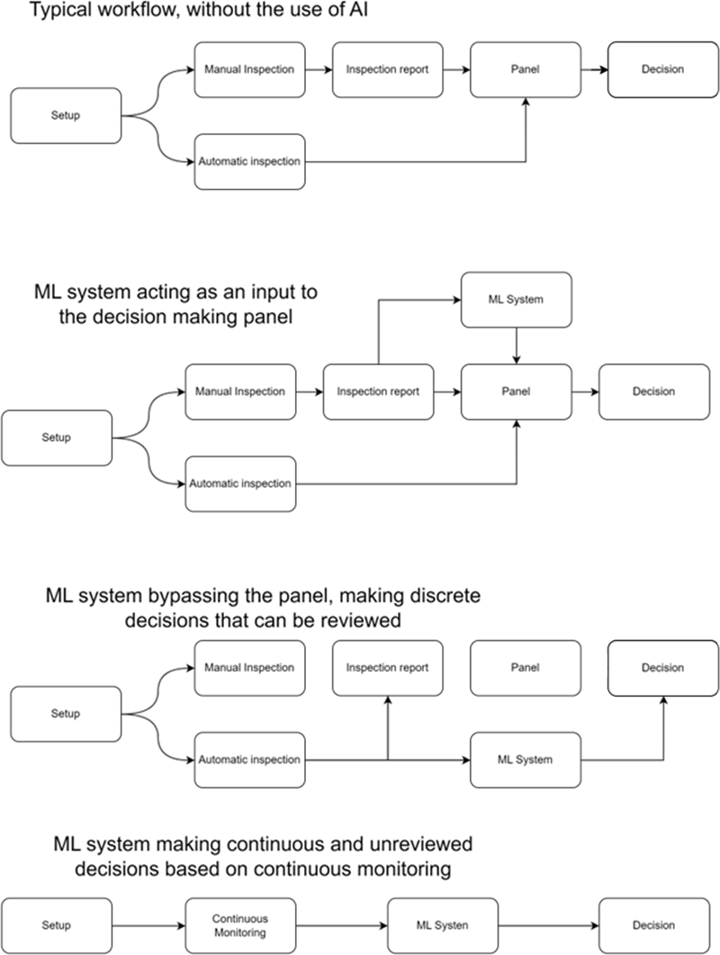
Figure 4: Potential configurations for the use of AI in structural integrity claims.
It is important to understand the complexity of the interaction between humans and the AI system, including having clear requirements for the system and an understanding of the data that will be fed into it. The group thought that currently these systems would be offline, but there may be a proposal in the future to use AI for inline decision-making systems.
Initially, human experts will make decisions for high significance, but AI could provide evidence for such a panel – it may be useful for a panel member to represent the AI system in discussions. This could support the use of AI to make decisions inline, at least initially for applications with no safety, security, or environmental significance.

System training and configuration management
Note: aspects of this topic are also covered in the ‘General considerations for the use of AI’ section.
The sandboxing focused on using AI to inform a mathematical model and identify potential new correlations that could inform further research. It is likely that an AI system and its operational environment would change with time, so the group considered what changes could occur and how they could affect the validity of an AI system’s output. These included ageing of system and environmental components, evolution of organisational culture over time, change in attitude to defect tolerance over time (e.g., tolerability of graphite defects), and hardware changes (e.g., quantisation changes in digital systems). Therefore, control and associated procedures are needed to:
- Clarify any assumptions that are being made;
- Define learning protocols; and
- Calibrate the AI system outputs effectively with a benchmark, so long as the benchmarking model remains valid.
The group considered that it would be difficult to train the system to identify failure of the system components (e.g., camera or lighting), so non-AI protection systems should be implemented.
Research is needed to develop good practice for maintaining the quality of AI systems’ outputs over time. AI systems can be very sensitive and the introduction of new data can have a big impact on the performance; for example, introducing data with different levels of noise can impact the output negatively. At the same time, natural changes in training data may make the system more robust. The use of multi-stream data could be beneficial as its output will be less susceptible to small changes in any one data stream. The group also considered other options to make the AI system more robust, for example, through the introduction of a voting system such as 2 out of 4 (2oo4).
The AI output is an interpretation of the system and uncertainty of the inputs. This means that determining the precise overall level of uncertainty of the system will be difficult or even impossible, and therefore arrangements are needed to ensure AI outputs are used appropriately. Given this, the group considered that it would be difficult to define and understand the level of conservatism in the AI output. Limiting an AI system’s output to best estimate applications may not help with the safety and environment case arguments due to the high levels of uncertainty, but best estimate AI-derived data may assist in operations.

Competencies for designers, operators and operating organisations
Note: aspects of this topic are also covered in the ‘Developing skills and experience’ section.
The group considered it useful to look at competencies in the context of, for example, duly authorised persons’ (DAP) responsibilities. It is necessary to have robust arrangements to ensure the appropriate use of the AI and, if necessary, to overrule the AI. Initially it is important to engender a spirit of distrust and for users to challenge the output of AI where appropriate. However, ultimately the operator may need to justify why they are overruling the AI system. This is a difficult area as humans tend to trust technology, but maintaining a clear and challenging safety, security and environmental culture is important.
Development and use of an AI system requires a specific skill set for the software development, as well as expertise in applying the system. Operators should be adequately trained to understand the AI system and interpret any output.
Companies should develop and use clear standards. All current operational arrangements remain relevant for AI systems, but standards for AI systems are likely to differ from existing standards due to the particular characteristics of AI. The Nuclear Regulatory Commission Human Factors Engineering Program Review Model (NUREG 0711) is an example that can be used to define an approach and processes to gain confidence in a complex technology, including what is needed for humans to get to reliable operations.

AI and plant data workshop
This workshop was an opportunity for regulators and industry to discuss how AI and plant data could be more widely used for structural integrity-related safety cases. Representatives from the nuclear sector (including operators, supply chain and research organisations) and the Health and Safety Executive (HSE) participated. The topics for discussion were selected by industry representatives prior to the workshop.
The group identified potential applications for AI, including:
- Natural language processing to mine knowledge from sets of information;
- Generating numerical safety case claims at a high confidence; and
- Generating numerical data at a best estimate confidence level for the purposes of probabilistic safety analysis (PSA).
The focus of the session was on the use of machine learning (ML) and probabilistic techniques to support reliable quantification of uncertainty associated with predicting degradation mechanisms of safety significant structures and components. The aim was to provide increased safety, reliability, availability, efficiency and targeted effort.
ONR stated that its current guidance encourages a deterministic approach for higher reliability structures, systems and components (SSC), but that there may be cases where using AI and plant data gives new insights to support the structural integrity safety case. In the case of lower reliability SSC, where the known degradation mechanisms dominate, using AI and plant data in probabilistic approaches may underpin the safety case more directly.
The group recognised the importance of a graded approach to the use of ML for structural integrity, as illustrated in the following three areas:
- SSC with low safety significance: ML could be used to inform automated processes and prove concepts in a safe environment.
- SSC with a higher safety significance: AI could be used to optimise margins if the level of uncertainty associated with the application was treated in a conservative manner.
- SSC with the highest safety significance: ONR considered it difficult to use ML as a primary argument within a safety case, but it was recognised that ML may provide insight from component data and help understand the level of conservatism used in safety margins.

Application 2 – AI applied to a robotic glovebox
The AI glovebox example was originally defined as:
AI for real-time application to inform operations to optimise robotic movements.
However, during the sprint workshop it was decided that this was not defined sufficiently and was not complex enough to gain full benefit from sandboxing. As a result, the problem/opportunity statement was developed further.

Sandboxing task
The following revised problem/opportunity statement was used in the sandboxing:
The robotic glovebox will process a highly radioactive material that needs to be processed in a challenging operational environment where minimising human exposure is critical/important. This is currently done manually by technicians and is very labour intensive.
Main hazards are leakage into environment (generating large amounts of radioactive waste) and danger to the operator. There are multiple possible deployment modes –from full mission-based automation, to acting as a supervisor for a human controlling the robot.
The focus of this work will be on the case both for the supervisory robot (where the arms are teleoperated by a human, but the AI system provides haptic feedback to prevent collisions or other dangerous behaviour) and autonomous mission-based modes (with a human supervising the operation remotely).
The arms could be handling tools during operation.

Sprint workshop
During the sprint workshop the following deep dive topics were identified for further consideration:
- The possibility of placing a numerical claim on the AI component itself;
- Design of the whole system, including wraparounds and other systems to support the safety, security and environmental case;
- Human/AI coworking, managing handovers from AI to humans, recovery from faults and defining a safe state; and
- Modifications and future behaviour, maintenance procedures and through-life behaviours.

Deep dive workshop
The output of the four deep dive topic discussions is described below.

Numerical claim
The group did not consider it possible at present to put a numerical claim on an AI component within a system and felt that attributing reliability numbers to an AI system could drive the wrong behaviours. This judgment was consistent with previous unsuccessful attempts to attribute a safety integrity level to AI. The sandboxing considered examples of good practice, which may help to reduce uncertainties associated with the use of AI. These are discussed further in the ‘Outcome of the AI sandboxing’ section.

Wider system design
The sandboxing considered software-based, physical, operator-based and systems architectural methods of reducing the risks associated with the use of AI. Insights included the following:
- It is likely to be difficult to substantiate software associated with AI components due to their complexity, as well as difficulties with gaining access to code and understanding, for example, the basis of machine learning algorithms. However, compliance with coding good practice (e.g., IEC 61508) is important.
- Robots containing AI components are likely to be high value assets and could have many hours of industrial operation. Therefore, the use of operational reliability values (proven in use) could be an option for production excellence associated with lower reliability claims.
- System design should use systems engineering techniques and decision trees to break down tasks (e.g., robotic movements). Non-AI-based systems could be used to confirm movements on a vector-by-vector basis rather than using a global positioning confirmation system.
The sandboxing considered what would be necessary to justify autonomous operation of a robotic glovebox. The key engineering modification was identified as moving away from a glovebox design to a containment that was designed to withstand all postulated fault forces from the robotic arm. Other options were also discussed, such as reducing the forces of the arm or designing out impact of containment. There would need to be systems for replacing any safety or environmental system components (e.g., cameras). Implementing systems that looked to identify unintended consequences (e.g., greater dust or waste quantity) would assist and the dutyholder could potentially consider qualification of the output rather than the process.

Human/AI coworking (creeping use of AI in applications)
The group noted that ‘the human’ cannot be removed from the system altogether. Human input is needed in, for example, design, configuration and installation, but operation of the system by humans should only be needed if the AI fails. In these cases, the system should automatically be placed in a safe state and sufficient time allocated for the operator to make an informed decision (e.g., whether reassessment, recovery or maintenance is required). In addition, systems should provide clear indication of faults.

Modification and future behaviour
Subtle changes in the AI operational environment have the potential to change the performance significantly. For example:
- Small changes in training data: the limits and conditions of the operating envelope need to be defined and monitored to ensure the system operates within the training scope of the system. Training data should form part of any assurance and configuration management arrangements. It should be managed to maintain representativeness of operational envelope and any edge-case data.
- Change of state of system components, such as ageing of motors: monitoring systems should be used to monitor any drift in behaviour of the AI system, to ensure it is still delivering its safety, security and environmental requirements and not inadvertently defeating safety and environmental protection measures. This needs to be captured in suitable and sufficient procedures.
- Changes in environmental conditions, such as lighting or temperature: training data will have assumptions that need to be replicated in the actual system. Testing that would traditionally be performed as part of factory acceptance testing may not be suitable and may instead need to be performed as part of site acceptance testing due to the potential impact of operating environment.
The sandboxing revealed that there may be a gap in the availability of good practice for the examination, maintenance, inspection and testing of AI systems.
It was recommended that AI algorithms should be locked down and arrangements put in place to control modifications. Deep, continuously learning systems could be used as a non-safety aid but are unlikely to be justifiable for use in any safe operation. It was considered that self-learning systems may challenge current guidance for Licence Condition 22/Radioactive Substances Regulation permit condition 4.3.5 (modification or experimentation on existing plant) and Licence Condition 24/Radioactive Substances Regulation permit condition 1.1.1a (operating instructions).

What were the key outcomes of your project?

Outcome of the approach taken to regulatory sandboxing
The regulatory sandbox allowed industry representatives (and the broader sector though reporting and engagement) to gain access to the regulatory view on the application of AI in the nuclear sector. It also allowed the regulators to gain an understanding of potential applications of AI and how licensees are progressing with their plans to use AI.
Through the sandboxing approach, experts including topic specialists, regulatory specialists, AI and data science specialists, human factor specialists and facilitators provided a diverse set of views, demonstrating positive attitudes and behaviours. This enabled us to consider the practical application of AI in a nuclear setting in depth. It was beneficial to have individuals from Adelard with experience in AI and safety cases facilitating the sandboxing through challenging and summarising views. Creating a safe space to allow experts (including regulators) to express their views was also important. These behaviours allowed all attendees to explore the issues and solutions in an open-minded and inclusive manner.
The sandboxing approach facilitated good discussion around specific practical applications of AI, which allowed the discussions to get to the crux of the issues relating to AI deployment in the nuclear industry. It also enabled attendees to identify good practice and allowed regulators and licensees to test their own arrangements. The deep dives enabled the group to get into details where necessary, while broadening consideration of AI and improving competency in this area.
The outcomes of the sprint workshops – i.e., the two sets of four deep dive topics – were very different for the two applications of AI. This indicates that the nuclear regulatory framework needs to be sufficiently flexible to take account of the specifics of a particular AI application, suggesting a framework- or principles-based approach would offer advantages over a more prescriptive rules-based approach.

Outcome of the AI sandboxing
This section of the report contains the findings of the AI regulatory sandbox pilot undertaken by representatives of nuclear site licensees and operators, regulators and contractors. It should be noted that the regulators remain independent from industry, but to maximise the value of the sandboxing process a safe space was provided for all participants to express views.
The pilot looked at the regulation of AI through the lens of two nuclear-relevant applications. It is recognised that this is a narrow view given the wide range of potential applications of AI. Therefore, it must be stressed that that the process has not resulted in a definitive outcome for the regulation of AI, but has added useful data points to support other ongoing work in assurance methods for the use of AI. This will help contribute to the developing framework for regulating AI in the nuclear sector.
The regulatory sandboxing looked at applications of AI in the nuclear sector that are not trivial in terms of the potential safety, security and environmental consequences in the event the AI component fails. For this reason, the sandboxing tended to focus on determining overall assurance via a whole-system approach to assessing the use of AI rather than focusing solely on the AI component (see Figure 5). The system containing the AI components will include methods of limiting the impact or consequences of the AI component failure and therefore plays an important part in any overall safety, security and environmental case for the use of AI.
AI
component
System containing AI
Figure 5: Illustration of the AI component and the broader system designed to protect from AI failure.
The AI expert panel that supported this work identified five components they considered as playing an important part in the regulation of AI. These components are:
- Development of the system containing AI;
- Understanding the performance characteristics of the AI system;
- Developing confidence in the performance of the AI system;
- Identifying and dealing with failure (including unintended consequences); and
- Developing skills and experience (including behaviour between humans and AI).
The remainder of this section provides general considerations and compiles the outcome of the regulatory sandboxing around these five assurance components.

General considerations for the use of AI
Throughout the sandboxing, all those involved recognised the value in using AI in many applications. However, due to the complexities and uncertainties associated with the use of AI, the benefits need to be clear and justified at the outset for any specific application of safety, security or environmental significance. Such benefits should be clearly articulated and compared with alternative, more traditional, techniques as part of the decision-making process – for example, as part of optioneering to demonstrate that AI represents the best available technique and that risks are reduced as low as reasonably practicable (ALARP). These risks need to be understood and managed through robust arrangements that deal with the inherent uncertainties, and include:
- The level of authority associated with the AI system – for example, being used in an advisory capacity as input to a decision-making process, making decisions in a supervisory capacity that are checked by a human or making decisions as part of an autonomous control system;
- The safety, security and environmental significance of the application;
- The level of continuous learning – whether the AI is deployed as a static model or continuously learning; and
- The complexity of the application.
Given these uncertainties, deployments of AI systems with potential safety, security and environmental significance consequences should be be undertaken in a phased manner to build up confidence and experience. It may also be prudent to consider AI components as a black box system.
The sprint workshops were intended to identify and address the most challenging aspects of the applications to ensure safe deployment of AI. An observation was made that the key considerations were different for each application, which may indicate that the nuclear regulatory framework for AI needs to be sufficiently flexible to take account of the specifics of a particular AI application, suggesting a framework- or principles-based approach would offer advantages over a more prescriptive rules-based approach.

Development of the system containing AI
The starting point for demonstrating that risks are reduced and safety, security and environmental protection is adequate is ensuring the normal requirements of good practice in engineering, operation and safety management are met. These requirements should include the intended use and benefits, functional requirements, and data definition of any AI component. The operating domain of the AI component (i.e., the whole system) can have a significant impact on operation and should also be clearly specified. In addition, the approach to AI training should be robustly defined and recorded in clear requirements.
Optioneering allows the comparison of options to determine the approach that results in the risks being reduced ALARP whilst also realising the benefits of the use of AI and demonstrating that the use of AI represents the best available techniques (BAT).
AI is no different to other technologies in that the risks associated with its use need to be managed in line with relevant good practice, including:
- The application of the hierarchy of control with the necessary defence-in-depth measure in place; and
- Modular design of the system containing AI, with clear AI sub-system requirements to aid system understanding and whole system architecture to support effective use and protect against failure.

Understanding the performance characteristics of the AI system
The system containing AI should be validated to a level based on the nuclear safety, security and environmental consequences of failure or of potential unintended consequences that could reasonably occur.
Given the difficulty substantiating the reliability of any AI component, assessment of the system’s success should be carried out on the basis of the whole system’s ability to meet its functional requirements as defined by its outputs. For example, does the whole system containing AI meet its requirements to the defined reliability, and are failure modes known and recognisable?
The entire system containing AI and its operational environment will likely change with time due to ageing, environmental changes, evolution of organisational culture (including changes in attitude to defect tolerance) and hardware changes (such as quantisation and timing changes in digital systems). When an existing AI model is transferred to a new phase of operation, it should be assumed that any previous data used to train the AI system will not be adequate, unless demonstrated otherwise.

Developing confidence in the performance of the AI system
It should be assumed that it will not be possible to fully substantiate an AI system; it is currently not possible to put a numerical claim on an AI component.
Rigorous testing is likely to be essential in building confidence in the use of AI applications. However, given the complexity and uncertainty associated with AI systems, testing alone may not provide sufficient evidence of meeting a reliability claim. Determining the overall level of uncertainty of an AI component will be difficult, and potentially impossible, and therefore arrangements are needed to make sure the output of AI components are used appropriately.
A mechanism to benchmark the performance of an AI system should be considered. This should give an indication of the performance of the whole system, including the extremes of the operational envelope.

Identifying and dealing with failure
Where the safety, security and environmental consequences of failure of AI components are significant or unintended consequences of their use could be significant, the user should assume failure or that these unintended consequences have been realised (i.e., a probability of failure of the AI component set to 1). This approach would apply a reasonable level of conservatism in analysing systems containing AI until such a time as techniques and measures are available to assess the uncertainty inherent to AI.
Systems containing AI should be automatically placed in a safe state and sufficient time allocated for the user or operator to take an informed decision (e.g., reassessment, recovery and/or maintenance).
A hazard analysis of the system containing the AI, including AI failure modes, should be considered for each potential deployment mode. This should incorporate an understanding of any unintended consequences, such as loss of skill base due to the introduction of AI or overreporting of positive outcomes.
The use of diverse monitoring systems should be considered to help identify any drift in behaviour (including those associated with ageing). These should be accompanied with arrangements to oversee drifts in the AI system’s behaviour to ensure it is still delivering its safety, security and environmental requirements and not inadvertently defeating any protection measures. These monitoring systems should be able to place the AI component into a known safe state (e.g., safe or slow mode) if AI operation goes beyond a defined safety, security and environmental protection envelope. For example, a diverse monitoring system could look to identify unintended consequences if greater volumes or activities of radioactive waste than anticipated are generated by the system, helping to highlight sub-optimal system operation.
The introduction of diversity may assist and provide a level of independent challenge to any AI system. This diversity could come from:
- Diverse AI systems;
- Digital twin comparators;
- Voting systems based on multiple models or independent AI systems; or
- Conventional systems.
It is recognised the some of these controls may only be available for new designs and could be challenging to retrofit effectively. One potential application of AI may be to monitor existing systems and to look for deviations in data that may provide an early indication of failure.

Developing skills and experience
The regulatory sandboxing identified requirements relating to the development of skills and experience needed to deploy AI effectively and safely. These have been subdivided into the following three areas of equal importance:
- Access to AI expertise: it is likely that access to relevant expertise will initially come from outside the nuclear sector. Essential skills will include experience of AI systems development, software development and data science.
- Operational experience: end users of systems containing AI that could impact safety, security and environmental protection should have clear responsibilities. They should have the operational and application knowledge, including understanding the limits and conditions of operation, to ensure any inherent uncertainty in the AI systems leads to decisions that maintain conservatism.
- Behaviour and culture: the deployment of innovation (including AI) should be accompanied by a challenging safety, security and environmental culture. Such a culture should take a phased approach to deployment and apply a precautionary approach to safety, security and environmental protection.
One key element of the sandboxing discussions relating to AI was the importance of understanding the complexity of the interaction between humans and the systems containing AI. Considerations included enunciating faults clearly and having a human representing the output of the system containing AI in engineering panels.
The group undertaking the sandboxing considered that humans should only be needed if operation of the AI component enters an undefined fault condition. In these cases, systems containing AI should be automatically placed in a safe state and sufficient time allocated for the operator to take an informed decision on next steps.

What were the key lessons learned?
In general, this regulatory sandboxing trial has been viewed as a success, with ONR and the Environment Agency receiving very positive feedback from stakeholders.
The openness of both regulators and industry to exploring challenging innovations has been recognised by not only those involved, but also wider industry and regulatory stakeholders, including our international nuclear regulatory counterparts. The sandboxing approach encouraged participants to undertake a genuine exploration of the issues and solutions in an open-minded and inclusive manner. Collaboration and good knowledge sharing were clearly demonstrated.
The representation of diverse views from attendees with a range of backgrounds is vital to the success of sandboxing. The make-up of a group undertaking sandboxing is important to consider and needs to be proactively managed to get the necessary diversity of views and background. During this pilot we benefitted from the views of experts in technology, application, safety cases and nuclear-relevant subjects, as well as regulators, licensees, and subject matter experts from other disciplines. It was beneficial having both ONR and the Environment Agency nuclear regulators present to consider aspects of mutual interest. A group size of around 15 was most conducive to productive discussions. Regular consultation with a broader expert panel to assist in the refinement of the problem and process was also beneficial.
The use of problem/opportunity statements provided a valuable focus to the sandboxing and generated a common understanding of the purpose. Discussing the statements provided a good introduction to each session.
Effective facilitation is needed to engender the desired open behaviours, maintain focus, encourage a diverse set of views and test understandings. It was noted that the appropriate introduction of challenge in a sandboxing session increased creativity and the expression of diverse views.
Sandboxing around specific applications of AI, rather than abstract consideration, allowed discussions to get to the crux of the issues surrounding AI deployment in nuclear. The sprint workshop considered the case as a whole and identified key areas of focus, while the subsequent deep dive sessions allowed attendees to explore the application and develop a deeper understanding of the key areas of challenge. This approach enabled discussions to be both broad and include an appropriate level of detail where needed.
It was harder for remote attendees to engage as readily in the sandboxing, so where possible discussions should be held in person. However, using an electronic collaboration system worked well and allowed multiple people to enter views concurrently. This facilitated a diverse group of experts to develop a collective view and helped to identify and develop the deep dive areas.
The provision of the industry contractor (Adelard) helped develop a joint purpose between regulators and industry. In particular, having the industry contractor assist in the development of the mock safety and environment case added a great deal of value. This gave the broader group a clear framework to base discussions on and, as necessary, challenge in a productive manner. This approach allowed attendees to prepare for the sessions and helped focus the discussions.
The democratic and open approach this project took allowed organisations to publicise the work within their organisations, helping to maximise the work’s value and gain a broader perspective. It has also meant the project could benefit from the engagement of other regulators. Input about sandboxing from CAA and HSE, as well as wider learning from the UK Health and Safety Regulators Network – Innovation subgroup, has highlighted the need for a sandboxing process that takes account of the nuclear regulatory regime and the sector-specific context. For example, there are relatively few nuclear site licensees, operators and dutyholders compared with other sectors. The nuclear sector also has a relatively high level of compliance, as well as an inherently flexible, non-prescriptive regulatory regime. These factors have all informed our approach to regulatory sandboxing, but there is unlikely to be one approach that is suitable for all regulators.
Monitoring effectiveness and performance of less quantifiable topics such as innovation is a challenge. Delivery and effectiveness of the sandboxing has been or will be monitored in three ways:
- We have been monitoring delivery against a project plan and tracking progress. It is important that this plan includes a clear stakeholder engagement strategy and plan as stakeholder support plays a key part to the delivery of any collaborative project. Monitoring delivery is enhanced by keeping logs of activity and learning.
- Every sandboxing and stakeholder engagement session has ended with a discussion of lessons learned. These have used an agile approach to review, learn and improve – i.e., what went well, what did not go so well, and what will we do differently next time?
- ONR will monitor long-term impact through a corporate longitudinal stakeholder survey.

What problems did you face, and how did you overcome them, if at all?
A project risk register was implemented at the outset and used to identify and implement mitigation measures. This was added to as necessary and updated on a monthly basis. The following were identified as key risks; an indication of the measures taken to mitigate these risks is also provided.
It was identified that getting an industry-funded contract in place to develop a mock safety, security and environment case would help the delivery of the project in the very tight timescales (start to finish in eight months). Securing funding from the Control and Instrumentation Nuclear Industry Forum (CINIF) was key to enabling this. The successful contractor provided a great deal of additional value, with the support of subject matter experts in nuclear site licensees and operator organisations.
Agreeing the scope of work and developing a fit-for-purpose governance framework provided by the industry steering group also supported timely delivery of the project.
Successful sandboxing requires all stakeholders to demonstrate behaviours that are conducive to open discussions. Early engagement with attendees to explain the sandboxing approach, share its purpose and encourage appropriate behaviours helped create a good foundation for discussions. It was also helpful to run the early engagements with industry collaborators and regulators in separate sessions, as this helped attendees feel more able to express any initial views and concerns.
Collaborative projects require effective stakeholder engagement to be maintained. It was beneficial to call on the previously established AI expert panel and maintain engagement with them via the ANSIC’s support. Risks were mitigated further by having a clear communications plan.

What are the next steps?

Regulatory sandboxing
Regulatory sandboxing has become a key element in ONR’s approach to enabling innovation in the nuclear sector. In particular, it helps ONR demonstrate that it is open to innovation where it is in the interest of society and consistent with safety, security and safeguards expectations. The Environment Agency is keen to continue to explore the application of regulatory sandboxing to sustainable innovation in collaboration with ONR and is currently working with ONR to look at other innovations being explored by nuclear licensees and identify where regulatory sandboxing may be beneficial. This work demonstrates how ONR and the Environment Agency are working to ensure that our approach to sandboxing, and innovation more generally, can be aligned when considering innovations of mutual interest.
The Environment Agency is additionally feeding the AI-associated output from the regulatory sandbox pilot into its broader considerations around digital and robotic innovation in regulating radioactive substances, which will help inform its guidance and regulatory capability needs.
Whilst not the focus of this project, the lessons learned from this work have led to the development of the concept of an international regulatory sandbox with active engagement with US and Canadian nuclear regulators. These are very early discussions but could help with the next steps to develop a harmonised approach early in a project’s lifecycle. We are sharing the sandboxing approach outside the nuclear industry and this report will be in the public domain. We will continue to collaborate internationally through our innovation initiatives.

Regulation of AI in the nuclear sector
ONR and the Environment Agency are keen for this project’s outcomes to be fed into existing work, for example, the work being undertaken through the Nuclear Institute’s AI4Nuclear initiative. We are in early discussions to ensure the lessons learned from the sandboxing are fed into the development of assurance techniques for AI in the nuclear sector.
ONR, the US Nuclear Regulatory Commission and the Canadian Nuclear Safety Commission are developing a principles paper on the regulation of AI. The output of the sandboxing is feeding into this work and will assist in development of a regulatory approach to sandboxing.
ONR and the Environment Agency will continue working to define a regulatory approach to the use of AI in the nuclear industry, informed by the sandboxing approach and the findings relevant to AI regulation contained within this report.
Our findings on regulatory sandboxing and AI considerations will be made available in the public domain in the autumn.

List of abbreviations
AI Artificial intelligence
ALARP As low as reasonably practicable
BAT Best available techniques
BE Best estimate
CAA Civil Aviation Authority
CAE Claims, arguments and evidence
CINIF Control and Instrumentation Nuclear Industry Forum
DAP Duly authorised persons
HSE Health and Safety Executive
ONR Office for Nuclear Regulation
ML Machine learning
PSA Probabilistic safety analysis
RGP Relevant good practice
RPF Regulators’ Pioneer Fund
SSC Structures, systems and components

References
- ONR’s approach to regulating innovation (onr.org.uk)
- Environment Agency regulatory statement - GOV.UK (www.gov.uk)
- Projects selected for the Regulators' Pioneer Fund (2022) - GOV.UK (www.gov.uk)
- New nuclear power plants: Generic Design Assessment guidance for Requesting Parties - GOV.UK (www.gov.uk)
- Advanced Nuclear Technologies - ONR-NR-CR-22-388 - NRD - Innovation Hub - Expert Panel - Regulation of Artificial Intelligence Meeting 3-12 December 2022

